Project report „Robots ‚‘R Us“ – 4th Meeting in Kotka, Finland
Monday, 27th January 2020

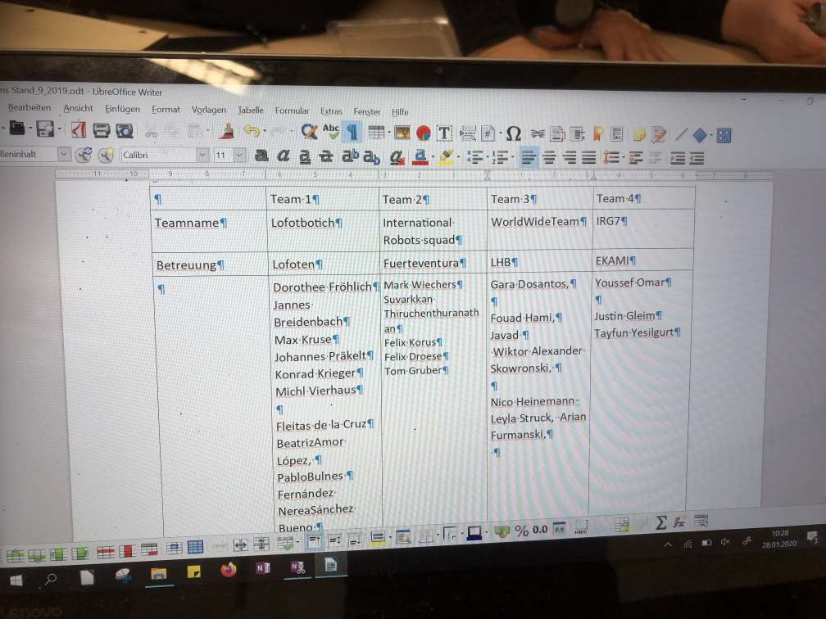

After having been introduced into the schedule for the week by the project coordinators Kairi Leitila and Eemeli Halme, the students went into their International teams. These had to be updated because in some groups more members could be integrated while in other students had left the robotics work shops in order to prepare themselves for exams or other qualifications. In this picture you can see the first updated team. You find all groups updated on etwinning.

At the beginning of the meeting the German students presented the result of their interim survey about ICT competences. All in all one can say that all competences except for Excel were improved (as Excel has never been used in this project). The most important results were, that the students improved their handling of computers and data in general and gained a lot of new skills like coding electronic systems. Unexpectedly, they also improved their critical view on sources from the internet and their safer use of social media. This happened as a side effect of dealing with robots, especially when dealing with internet sources and communicating with other members in the project via WhatsApp and etwinning. Bravo! The results of this interim survey will be uploaded by the other schools till April 2020.

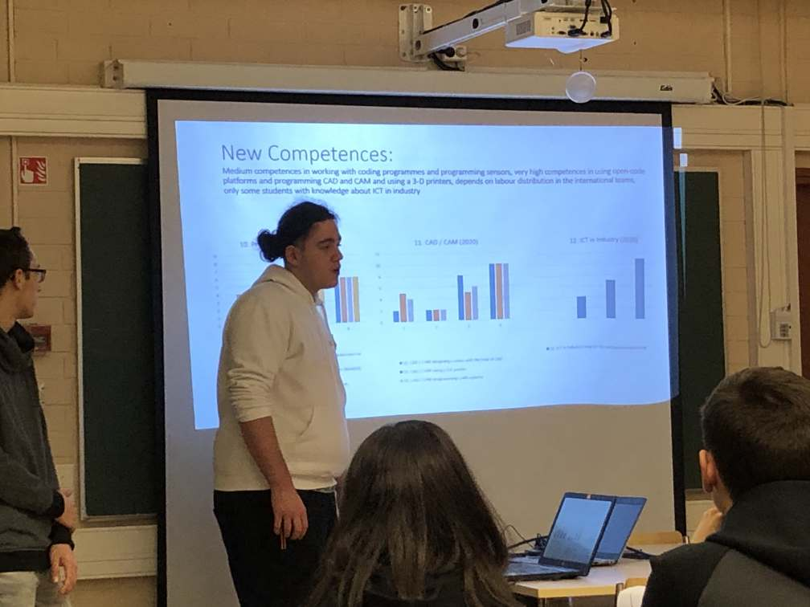
Then the groups showed their results and objects or Arduino components that they have brought to the meeting to the other teams.

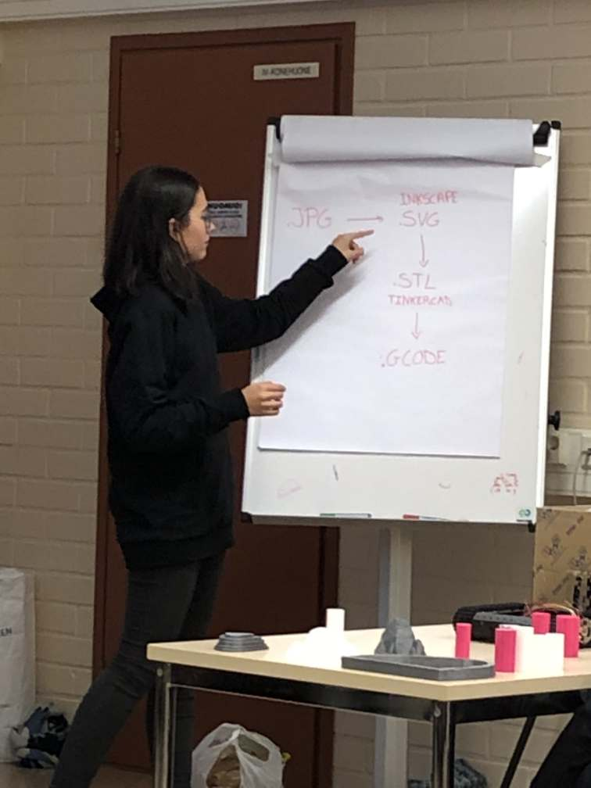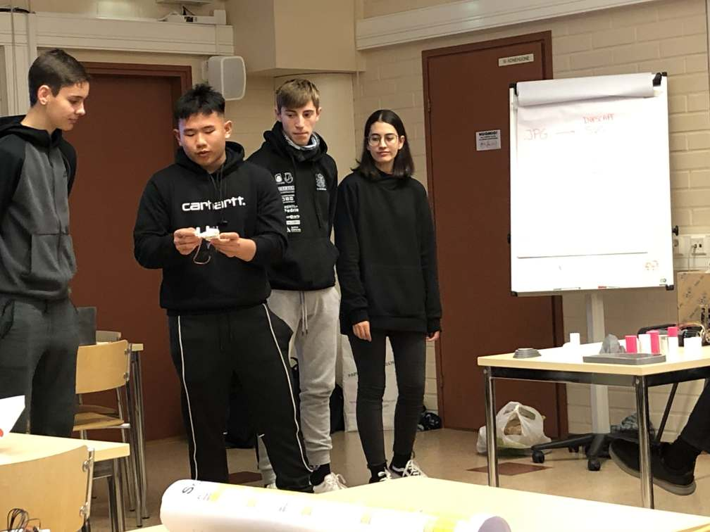

Here you can see the International Robot Team (supervised by Fuerteventura) showing their coding results and their work on their idea of a gripping arm.
The students looked at platforms that can be mounted on the Arduino chassis and talked about the question whether there should be one or two platforms, just as well as different picking-up mechanisms like improved brushes, shovels and nets or a gripping arm. The size and types of the wheels was also an issue.

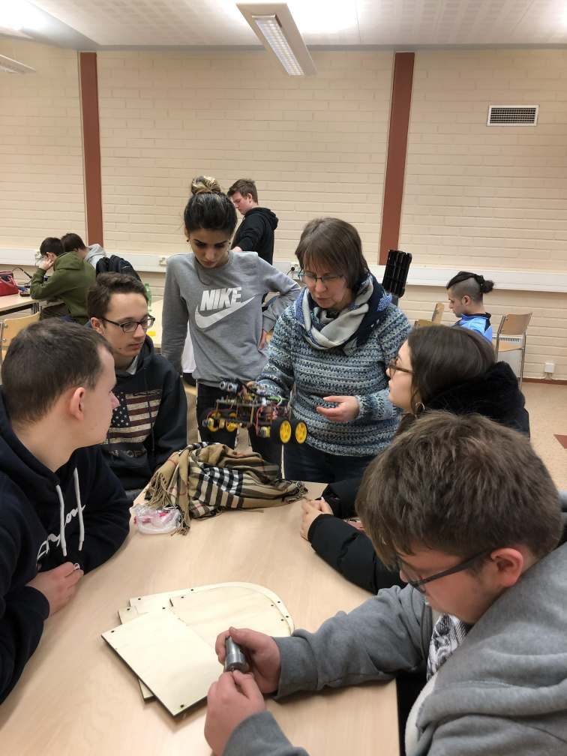 , 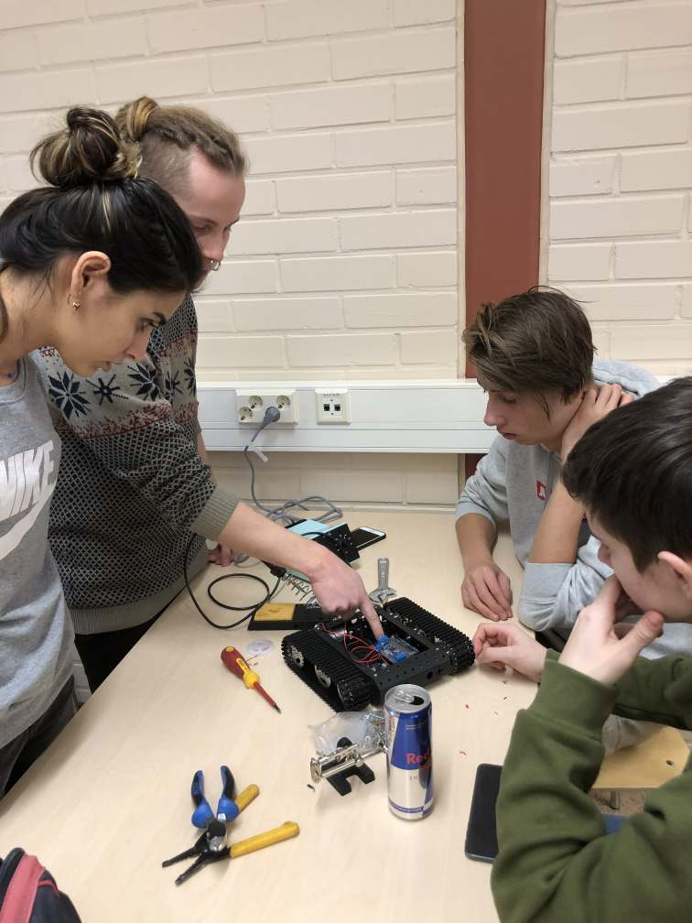
Then students discussed positions for battery packs (here: IRG 7 team, supervised by Kotka)

Here you see the Lofotbotich team (supervised by Svolvaer, Lofoten) with their box system and the IRG 7 Team (supervised by Kotka) with their motor position.
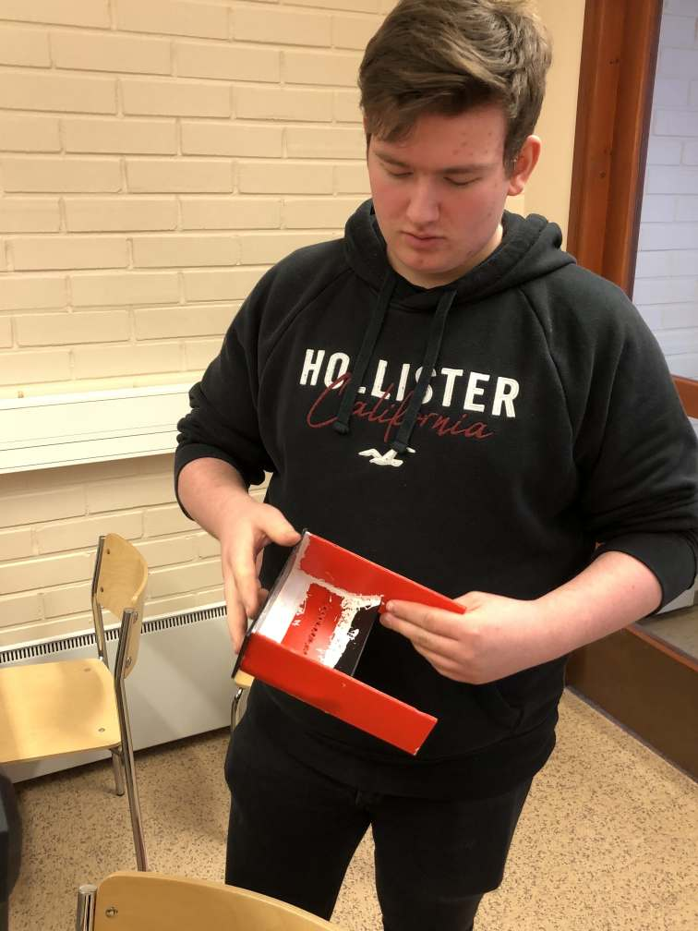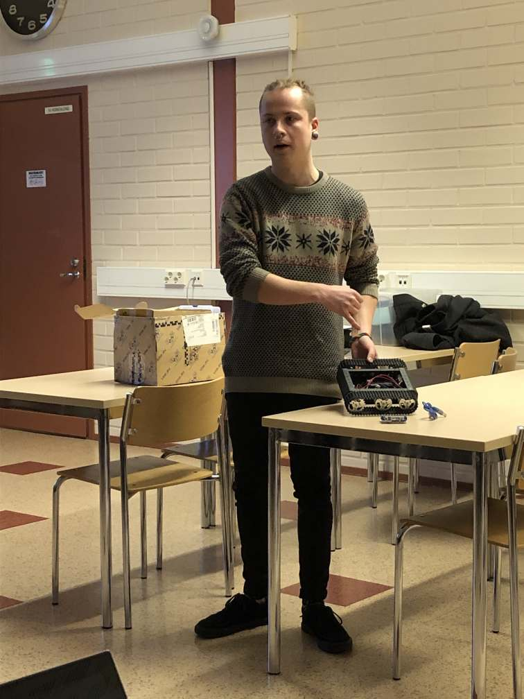

A construction of a drawer that can be pulled out was also discussed (Team Lofotbotich, supervised by Svolvaer, Lofoten). The ideas of two or more wheels or a track chassis and their positions in the front and /or back for the robots were discussed as well.

The track chassis with a brush solution was presented by the Lofotbotich Team.
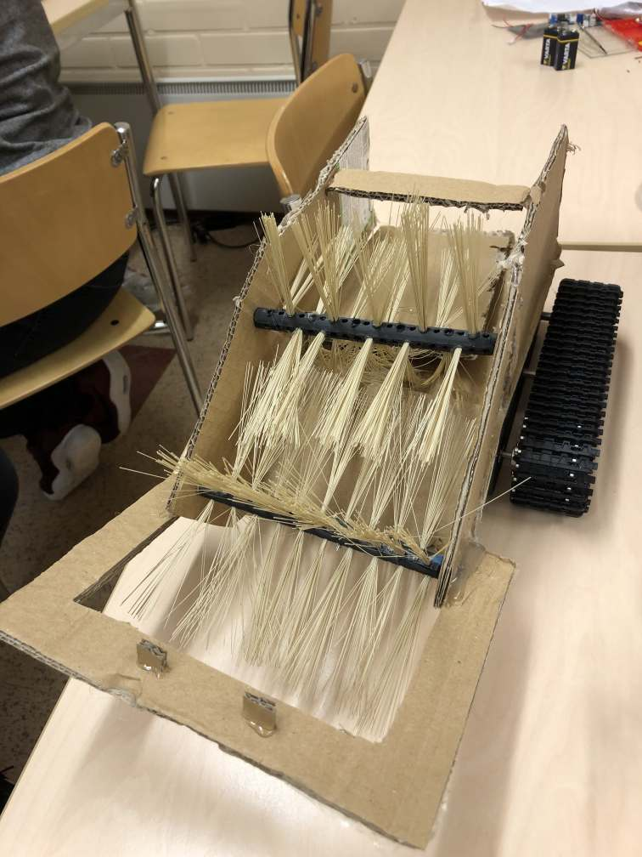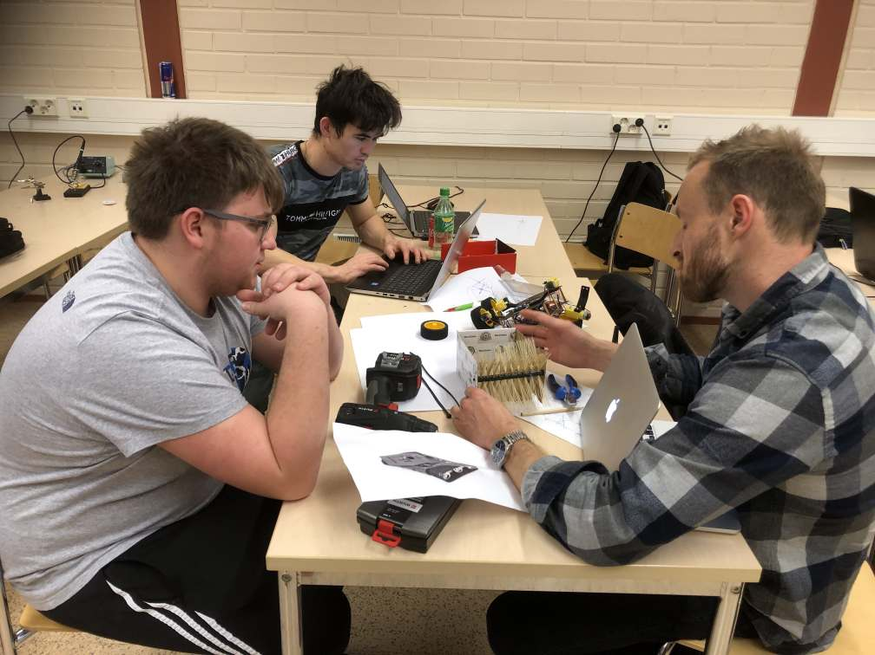

A metal ball (ball caster) was another alternative for a rounded vehicle type by the World Wide Team, supervised by Dortmund:

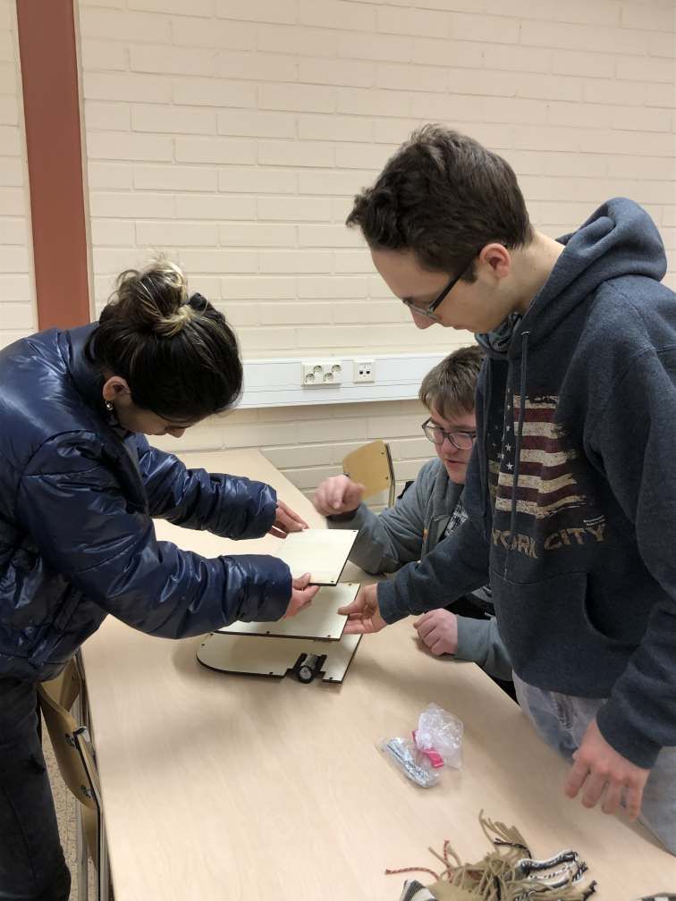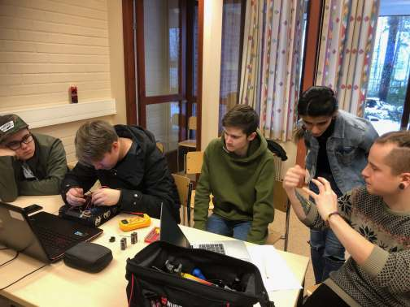

Then, the way how to store the rubbish was talked about, would it be collected in a bag or in a box? When talking about the sensors, their positions was also discussed. Would they all be on one level or not? (World Wide Team and IRG 7 team)

As a lot of decisions about the realisation of the robots’ function to lift up the rubbish had to be taken, Susanne Rielage (supervising World Wide Team) showed the other teams the great method of the ‘Morphological Box’which has been used by the World Wide Team in order to make the decisions for their robot.

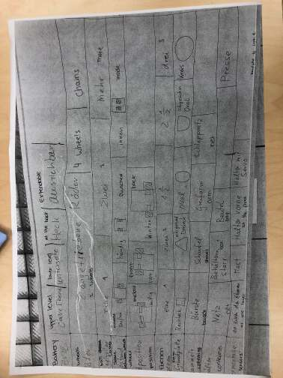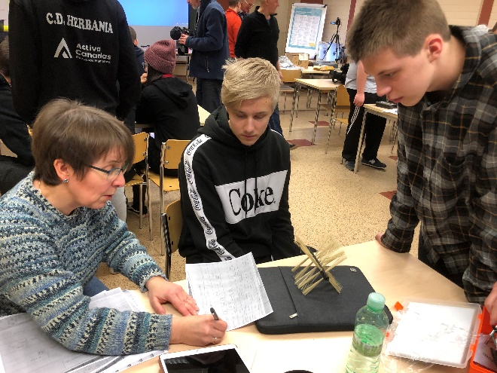

This method has the advantage that different choices can be discussed and decided upon in an organised way. The groups decided to have the decision making process done by Thursday. If the decisions have been taken and marked the zig-zag-pattern leads the way to realising the decisions in different steps. Everybody found this was a great method to apply.

Tuesday, 28th January
For Tuesday the groups had decided to do the coding and print out the last objects for the parcours and they did.

Team Lofotbotich:
They made a new wheel with a connection to a motor, which the World Wide team had suggested. They designed a 360 degree wheel for the World Wide Team and the latter printed both of them in 3-D. They also made a prototype on how to gather the trash.

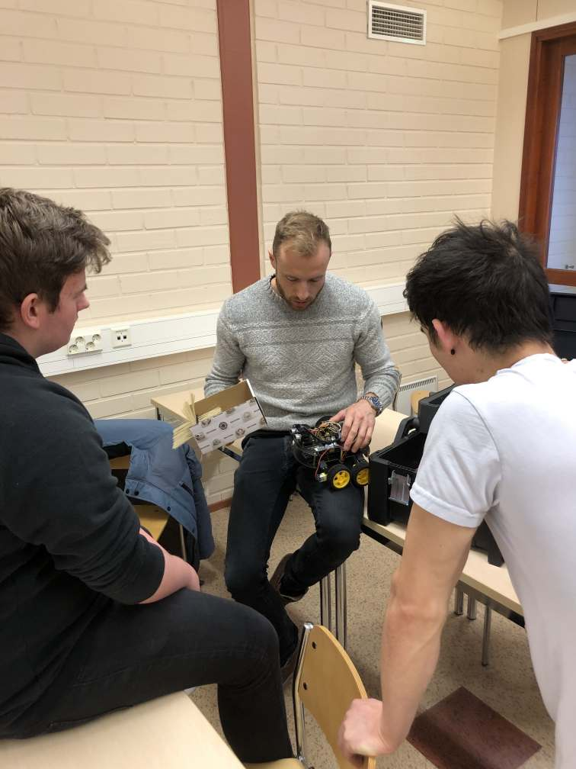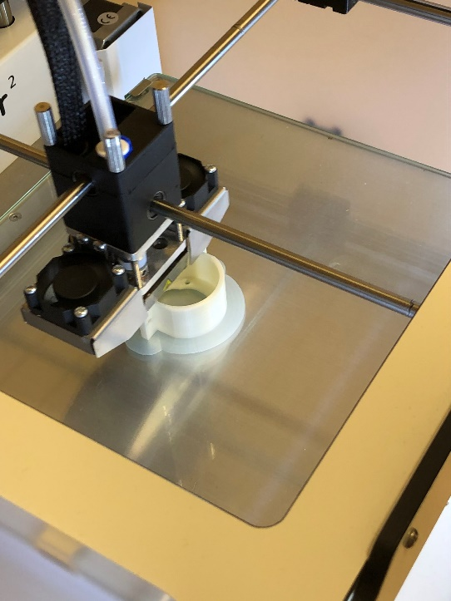

World Wide Team:
They worked on the further design of their robot with a rounded chassis and did some first 3-D sketches by CAD, then they worked on a motor mount modification and on the first driving prototype.
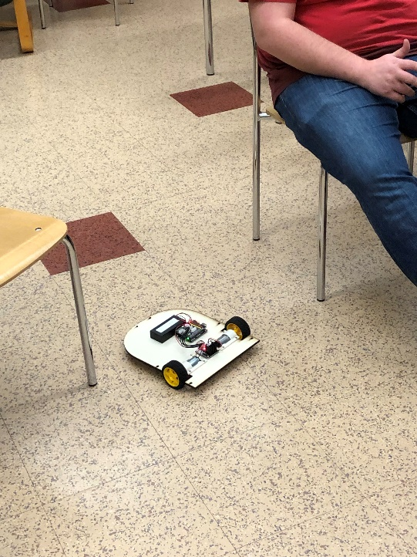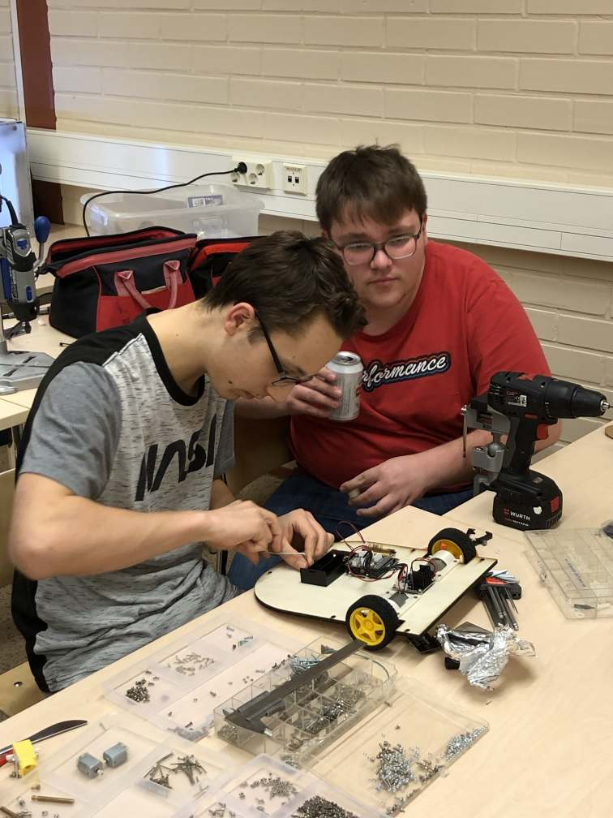

They modified the robot, especially the driving skills of the robot and organized their work space by sorting tools and materials (e.g. screws). Then they made a remote control prototype and soldered the motor control for the brush.

The International Robot Team (supervised by Spain) printed one wheel for the World Wide Team and showed the cylinders the robot is supposed to pick up and explained the rocks that they made which will be the obstacles on the playground. The stone obstacles were printed out in grey colour and the objects which symbolize the cans which have to be picked up were printed out in red and white. These were produced by the International Robot Team (supervised by Fuerteventura) after having created them in a CAD programme:

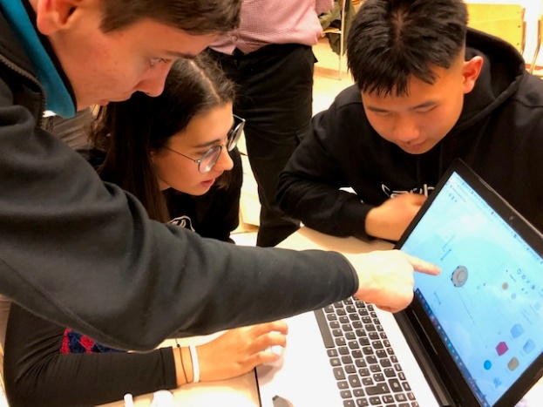

The gripping arm was further worked on. The team realised that it is an extraordinary challenge to make the robot grab the obstacles (see below).
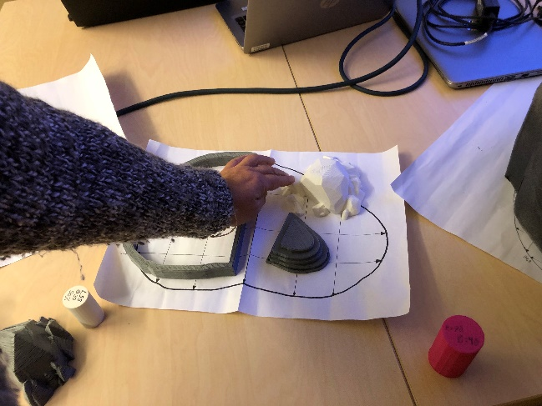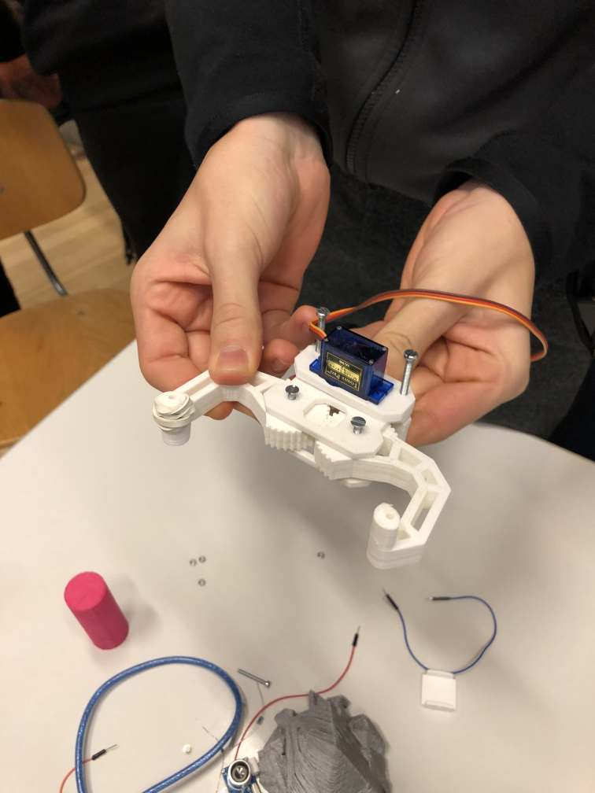

Then they tried to fix their gripper and started making a code using the two ultrasounds and the gripper to catch the cylinder.

Team IRG 7:
This team (supervised by Kotka) assembled the robot as far as possible, they soldered the cables, produced a motor and a battery connection to mount them on the chassis. They also practised some Arduino coding.

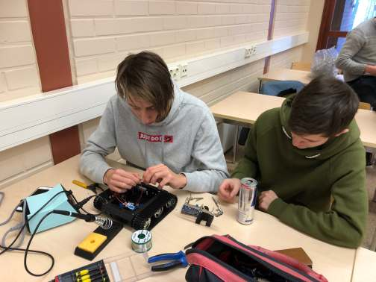

A help for simple commands and functions for Aduino, the so called “Cheat Sheet” was introduced to all groups. With the help of Google Translator it could be used by all nationalities.

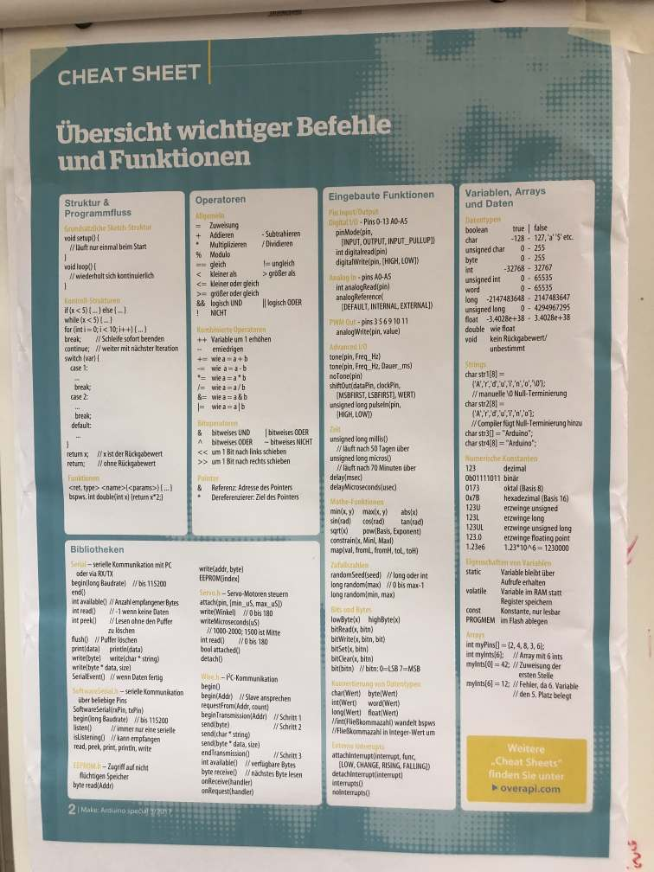

A group of Finnish students filmed the activities of all international groups and will edit the film for our etwinning website. We can’t wait to see the results!

Wednesday, 29th January

On Wednesday all participants visited the EKAMI campuses to learn about ‘robot patients’ which help during the education of nurses-to-be. The students were very impressed to see that the robot even breathed and was able to make sounds of pain and calling for help. Very spooky!

Another robot which is in use in health care education in Kotka is one to entertain children and older patients. It can even dance and talk to you! A funny little lad to watch!

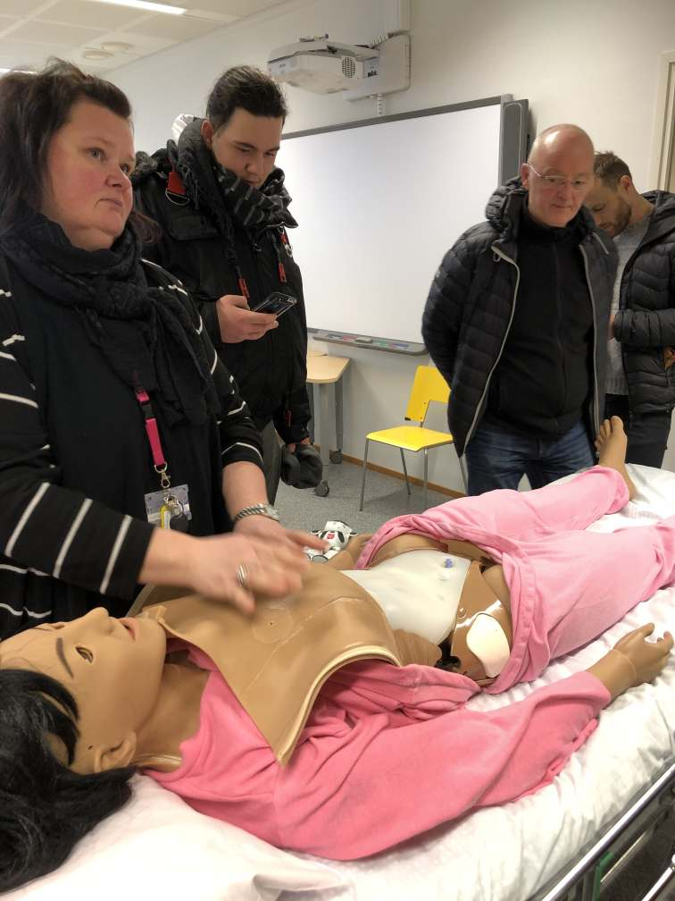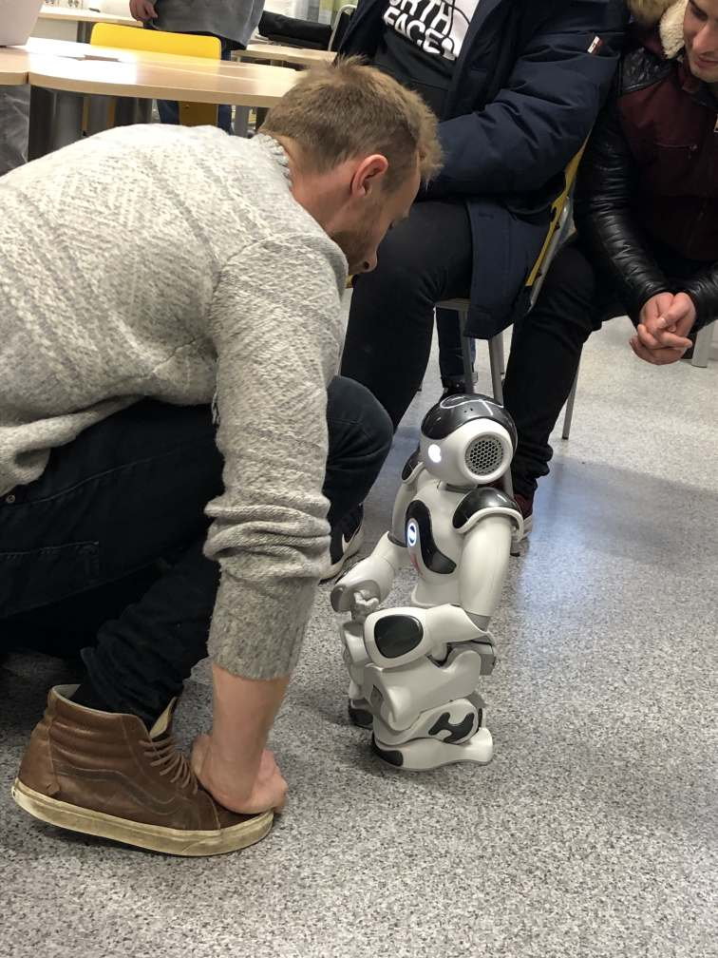
At the electronic workshop the students learnt how to solder circuit boards. Everybody enjoyed working on the boards and finding out that it is quite a challenge to work as precisely as those robots in the electronics industry which usually do the job (see numerous Youtube films on that.)
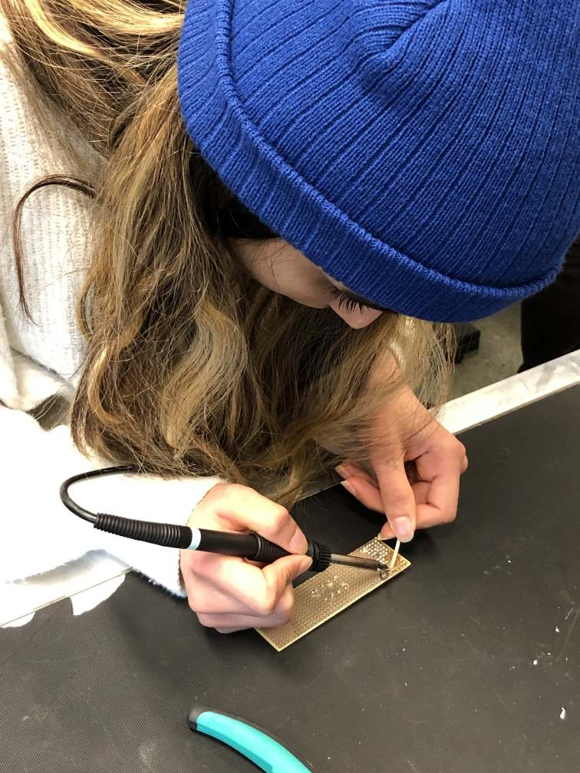
Thursday 30th January 2020

On Thursday, all international groups of the Robots ‘R Us project had the opportunity to show their robots to other students at the EKAMI vocational college in Kotka. On a fair the students could show their results to representatives from other schools from the area who all gathered for this event.

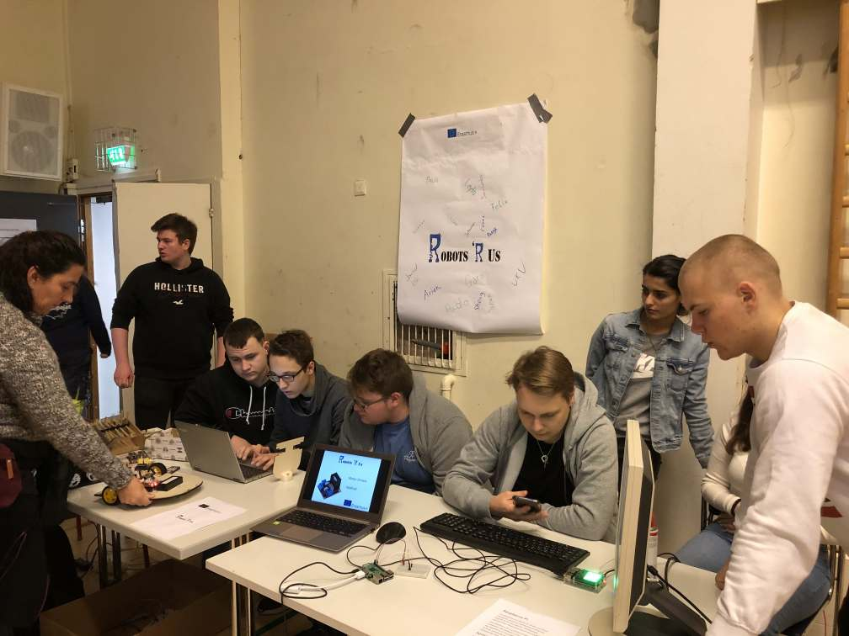

The teams also got the opportunity to visit other parts of the campus where they could learn about navigation simulators and related programmes.

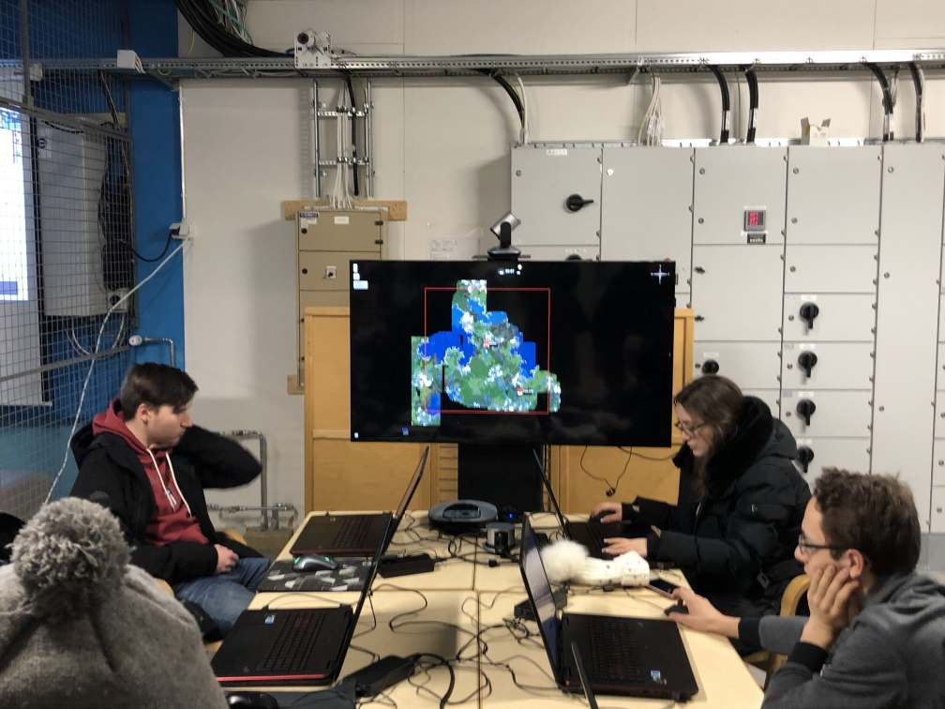

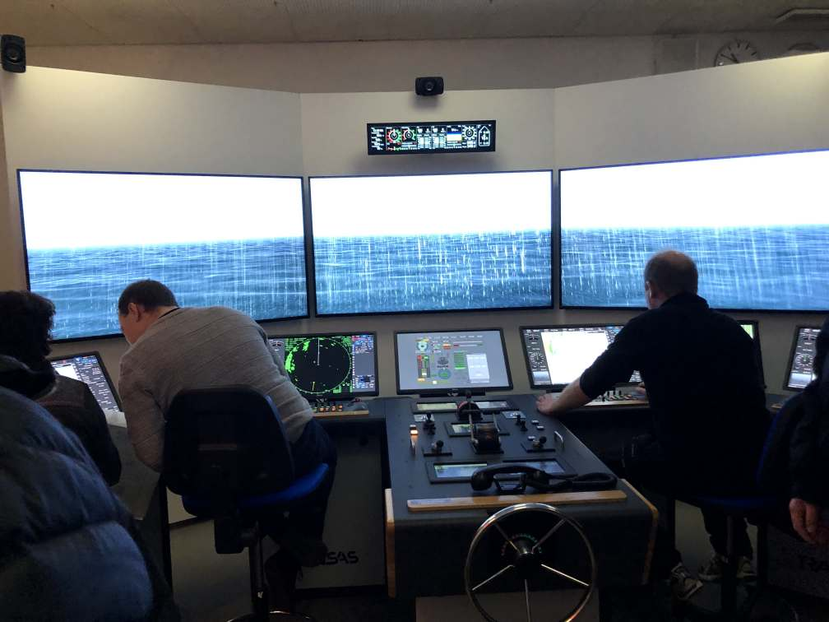
Just incredible how real these screens looked! Just like on a real navigation bridge!

Friday 31st January 2020

After all that work for days, all teams got the opportunity to visit the Maritime Museum of Finland. There everybody enjoyed looking at beautiful boats and ships and a lot of navigation equipment through the centuries. Another interesting visit for our students who are so technically interested.
Another highlight of that day was the visit to the Maritime Center Vellamo where all project participants enjoyed looking at extremely big aquariums to see different fish which live in the waters of Finland. At the end of the day the students’ evaluated this international meeting and were filmed doing so.

The teachers who accompanied the students took part in a meeting with two experienced social workers and coaches for students with learning difficulties. On the basis of their presentation and the following discussion, their scheme has lead to a new scheme for support of these student groups (see project results), that each of the other schools – may it be a vocational college or a secondary school - will integrate into their support policy. A visit to other parts of the school where former truants or students with low motivation are being taught and supported lead to a modification in the former scheme that had been developed on the subject matter in Norway at the beginning (see project results). We can see, schemes to support students who need more support and help are in constant development and can never be fixed for a long time. But this is exactly what makes them so exciting.
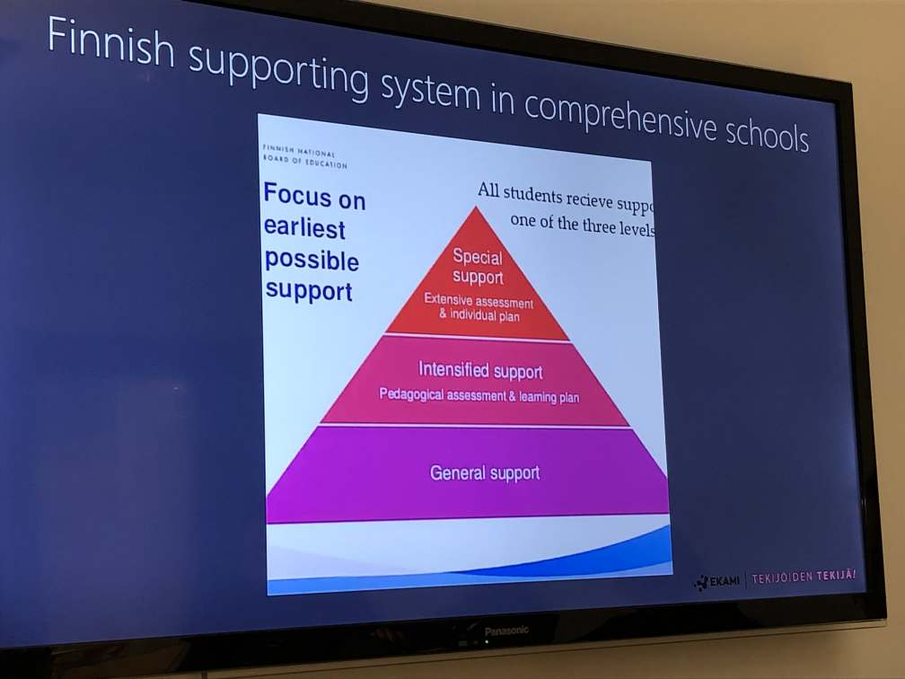
The students from Fuerteventura were especially lucky! They had not made any experience with snow before and then it really did snow! For the whole week Kotka was a winter wonderland and the remote youth hostel offered warming up in the sauna and cooling down in the snow.

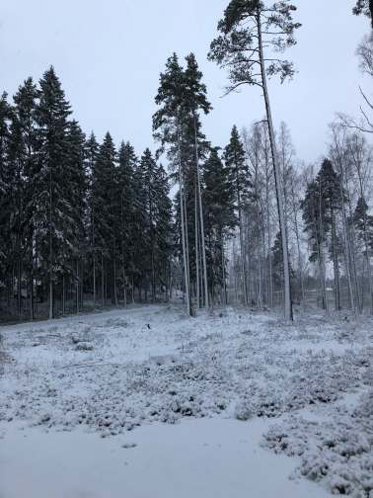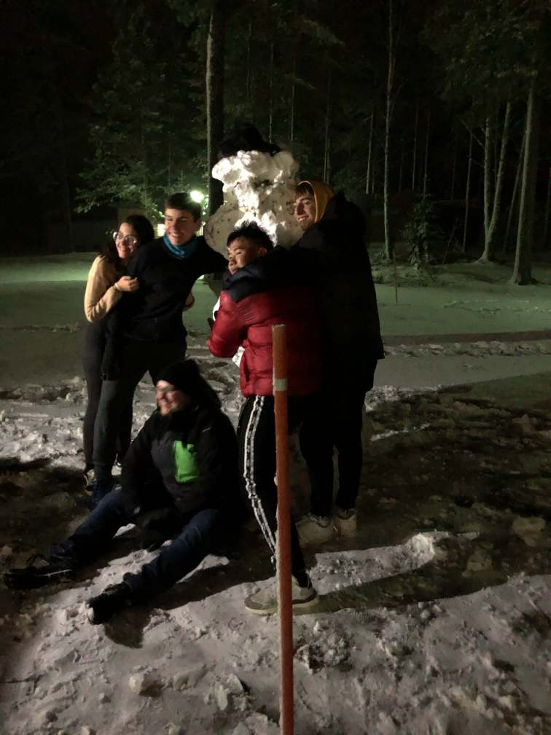

Pedagogically most interesting was the fact that all teams decided not to be in competition at the final meeting in Dortmund but to share all information and skills in order to get all the different approaches robots to pick up trash on the beach realised.

Consequently, at the end of the meeting all teams made a list of objects or know-how they want to share and a list of objects and support they need from another team. A kind of ‘market for robot solutions’ emerged on the last day.

Now all teams can contact other teams for help regarding their own specific robot solution and work on them until we all meet again in Dortmund.

Some students were a bit disappointed that none of the robots could totally be finished for its job, but just like in real life, projects often take longer than planned. Everybody was positive, however, to present a functioning robot model at the final meeting in Dortmund in May 2020.

So then, see you in Dortmund!

