PE WORKSHOP ( 1st group: 10:00 – 12:00 ; 2nd group: 12:00 – 14:00 )

1st hour:
„Play and sell “ – creating a commercial
5 groups of pupils choose a „ barrel “ with the hidden sport equipment (soccer, handball, basketball, table tennis, rhythmic gymnastics ).
Working in teams, each team will exchange ideas and create a commercial for any product, using the chosen equipment or actual game (doing basic technical elements of sport).
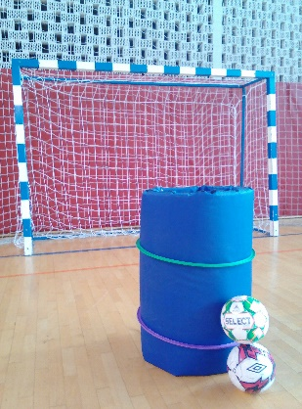
Each team will make a video (approximately 30 seconds) of the commercial by cell phone or tablet, save and upload it on the twin space (help: IT teacher/classroom)
Targets:
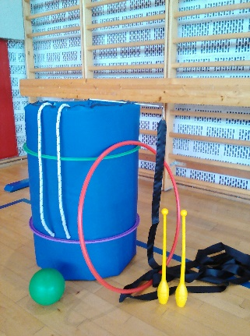
- commercial with sport or exercise background,
- creativity, imagination, humour,
- reasons to buy the product,
- satisfaction and happiness of using it.
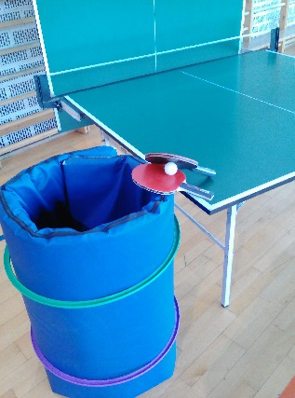
Examples: https://www.youtube.com/watch?v=Frwep1T9AO4
https://www.youtube.com/watch?v=96oN6n1JI1w
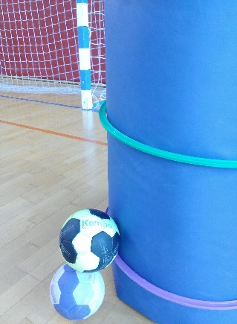
https://www.youtube.com/watch?v=ssKuOcQq48Y
https://www.youtube.com/watch?v=CRfQnmmVhRU
https://www.youtube.com/watch?v=_BVKUNnF3VI

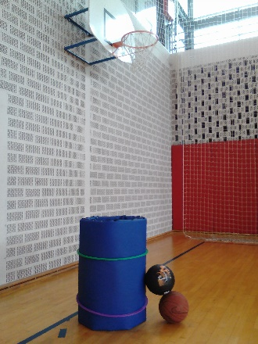
2nd hour:
Tournament in sport game by choice / mixed teams
- Soccer
- Handball
- Basketball
- Table tennis
(warm up, game by rules, relax and hygiene)

- OBLIGATORY FOR ALL PUPILS: DRESS CODE (training clothes and sneakers) !

