The joy of creation – a task in an Erasmus + project “Creativity knows no Borders”
Author: Jakub Wacławek, a student of class ID with extended curriculum in humanities, translated by Karolina Ksit, a student of class IIC
Place: Żyrardów, Liceum Ogólnokształcące im. Stefana Żeromskiego
Duration of the workshop: 1 hour 50 minutes
Subject: Interpretation of graphics by Polish artist Zdzisław Beskiński and their theatrical expression.
- Objectives of the workshops
- Adoption of an attitude contrary to encyclopedism as a superior value
- Introduction of Zdzisław Beksiński’s work to the students and analysis of particular works in the group (3 graphics)
- Development of acting and improvisational skills of the participants
- Promotion of modern forms of theatre and contemporary art.
- Work plan
- Teacher: Introduction of the programme of the workshops to the participants: 5 minutes
- Teacher: Presentation of the life of Zdzisław Beksiński: 7-10 minutes

In the presentation it is worth mentioning the artist’s private life and historical context of the period of his most intense creativity.
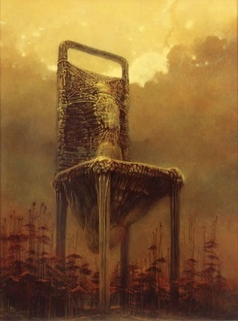
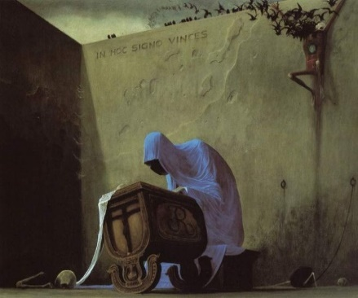
- Teacher: Presentation and a brief overview of three graphics by the Polish artist: 10 minutes
The overview may concern the historical context or the author's autobiographical motifs, the first impressions of the audience, the technique of painting, etc. The choice of the graphics depends on the teacher. The pictures presented beside can be used.
- Teacher: A film show „Katedra” (“The Cathedral”) by Tomasz Bagiński: 7 minutes
The animation by the Polish director draws on Zdzisław Beksinski's work and can be another source of inspiration for the workshop groups.
- Teacher: Division of the participants into three groups, a random allotment of a graphic that is going to be the subject of an acting interpretation, to each group of students, for example, by drawing lots: 3 minutes
- Teacher Assignment of workspaces and props to the participants: 5 minutes
Task: Each group of students prepare a mini play (10 minutes) on themes related to the artwork by Beksinski allotted to them. It is up to the participants what form of a mini play they present – it can be a dialogue, pantomime or sketch. The interpretation of the painting depends on the group.
- Students: Preparation of a theatrical scene referring to the subject of the picture allotted to the group: 20 minutes
- Students: Presentation of the mini plays: 30 minutes
- Students and teacher: Summary of impressions: 10 minutes
Questions
- What in Beksiński's art affects the audience the strongest?
- What is the source of this power?
- What was the most difficult in adapting the content of the graphics on stage?
The end of the workshops.
- Materials and props
- An A4 white sketchpad and scissors
- A set of coloured markers and pens
- White bandages and tourniquets
- Bales of linen fabrics, strings, strands
- Garments: a black coat, hat, gloves, scarf
- Two folding screens and two chairs
- Laptop, speakers, projector and white screen
- Three prints of Zdzisław Beksiński’s paintings in A3 size

