Welcome aboard the Healthy and Cool Contest of our Erasmus+ YEAH Project – Year 2!

The aim of this contest is to help students become more aware of the different aspects of a healthy lifestyle. It also aims to help bring students closer so that they can create strong, healthy bonds of friendship while sharing experiences and wisdom in a challenging and fun way!
The Healthy and Cool Contest consists of five challenges in total all aimed to raise students’ awareness of the effect of sugar, sweeteners and honey on our health. Each challenge comprises different activities and requires the production of different end-products. All end products aim to help students become more aware of the effect nutrition may have on human health.
Students are expected to work collaboratively in groups of two or three partners, develop initiative, assume responsibility, organise and prioritise tasks, research authentic material and help each other towards the successful completion of all activities, required by the project.
All groups need to complete all five challenges and submit all the required end-products. The end-products must be presented in class as part of a lesson; presentations will be followed by a class discussion and evaluation by the teacher.
Each student/group will be assessed on the basis of:
- The quality of their work,
- The variety and accuracy of the content,
- The originality and quality of the presentation of the end-products, (use of audio-visual material, special effects, etc.)
- Participation in class discussions,
- Punctuality in submitting the end-products within the set deadlines,
- The active involvement of all group members during the preparation period and during the class presentations.
General rules:
- The group is successful when each member of the group is successful!
- All group members need to be actively involved in all the challenges.
- Points will be allocated for each challenge.
The group who will have collected the most points are the winners in each class! In case more than one groups have the same results/score, then there will be a draw!

Challenge 1:

Break the code to find out the general title of the Contest:

VSOZHVM WBGWRS CIH:

O GOBS AWBR,

WB O VSOZHVM PCRM!

(Clue: M)

_ _ _ _ _ _ _ _ _ _ _ _ _ _ _ _:

_ _ _ _ _ _ _ _ _,
_ _ _ _ _ _ _ _ _ _ _ _ _ _!

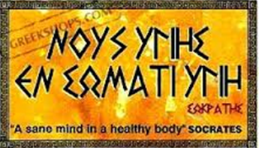

Healthy Inside Out: a sane mind, in a health body!
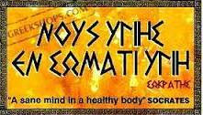
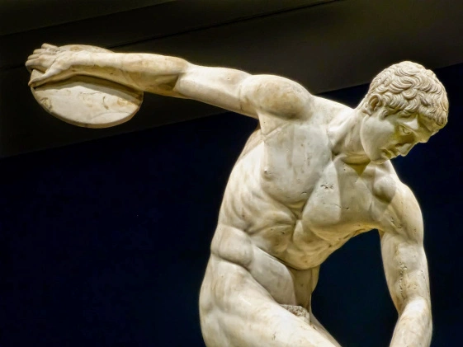

What does it take to be healthy and remain healthy in our body and mind?
Sugar, No Sugar or Sugar Substitutes?
Take the challenges to find out how sugar, sweeteners and honey affect our health!
The following infographics are indicative of the consumption of sugar and sugar substitutes in the world. The quantities consumed are amazingly high!

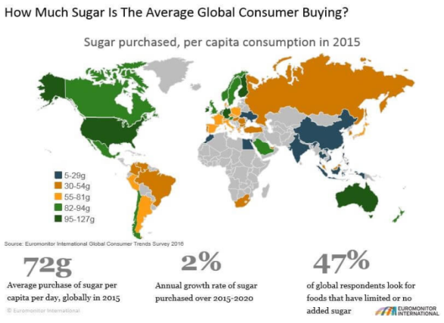
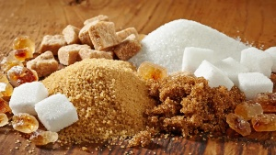
Challenge 2: Sugar or Sugar free? Chart-it!
This challenge aims to help you realise how our body metabolises sugar and reflect on your sugary habits. Watch the video entitled How Sugar Affects Your Brain and do activities I-V, using information from the video:
http://dailynexus.com/2014-01-17/sugar-10-ways-its-ruining-your-college-experience/
- List the seven different types of sugar that are contained in the foods we eat, and explain whether they are monosaccharides, disaccharides, oligosaccharides or polysaccharides.
- Which foods that you consume on a regular basis contain these sugars? Make a list of at least 10 different types of food that you and your families consume on a regular basis and which contain sugar in their natural form. For example, fruits, vegetables, milk, etc. Explain what percentage of that food content is sugar and what type of sugar it is.
For example:
Type of food | Sugar content | Type of sugar
Fruit:  one apple | 10gr sugar/100gr fruit | fructose (monosaccharide)

- Each member of the group needs to track their eating habits over a period of one week and keep a record of all the food and drinks each member has consumed for breakfast, lunch, dinner and as a snack, the time they consume it and the quantity in portions or servings.
Which of this food contains sugar or sugar substitutes? Estimate in grams/teaspoons how much sugar or a sugar substitute there is in each serving. Calculate your total amount of sugar intake by day and for the whole week.
Once you have gathered this information, it is time to reflect: Do the group members have similar habits or not? Is there a pattern in your habits? Does any of you seem to crave for a specific type of food at a specific time of day?

For example:
Date: Monday, 21 October 2019
Student’s Name: | Type of food | Time consumed | Servings | Contains:  Sugar/ Sweetener/  None | Amount of sugar contained:
 | All bran flakes | 7:00 am | 3 spoons  (1 serving) | sugar | 19gr
 | Milk | 7:00 am | 1 cup  (1 serving) | Lactose | 5gr

- Complete the following cross-words puzzle based using the following terms which were used in the video. You will not need to use all the words given:
http://puzzlemaker.discoveryeducation.com/code/BuildCrissCross.asp

Tongue, sweet receptors, forebrain, cerebral cortex, brain’s reward system, stomach, sugar receptors, insulin, dopamine, domino effect.

Across
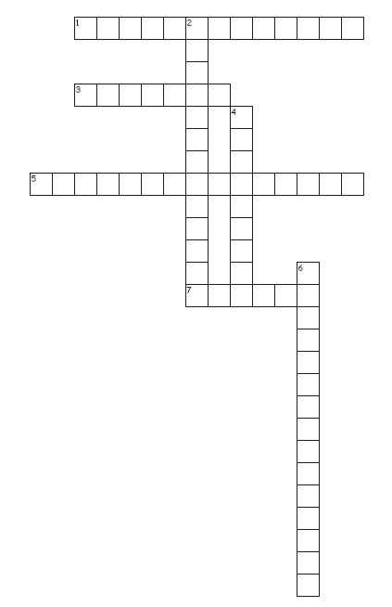
1. The system used to reward somebody in exchange for a useful idea, good behaviour, excellent work, etc.
3. A hormone in the body that controls the amount of sugar in the blood
5. They help you recognise sweet taste
7. The organ in your mouth that you can move, and is used for tasting and speaking
Down
2. The situation in which something, usually something bad, happens, causing other similar events to happen
4. It helps controls your body temperature, eating and sleeping functions and the display of emotions.
6. The part of the human brain which is responsible for thinking and understanding

- Create a diagram which explains how our body processes sugar. In your diagram you will need to include all the stages of the process, as these are explained in the video. Make your diagram as pleasant and explicit as possible!

Challenge 3 – The Truth about Sweeteners! K-W-L
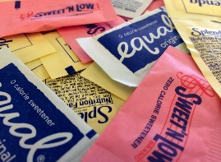
Challenge 3 aims to help you realise how artificial sweeteners are metabolised in our body and to what extent they may affect our health.
Watch the video entitled Why you Should Ditch Artificial Sweeteners and do activities I-V:
https://drhyman.com/blog/2015/12/02/why-you-should-ditch-artificial-sweeteners/

- Name 5 artificial sweeteners mentioned in the video:
  - ……………………………………………….
  - ……………………………………………….
  - ………………………………………………
  - ………………………………………………
  - ………………………………………………

- Give an example of ten types of processed food or drinks which contain a sweetener that you consume in your families. Write the type of food or drink the name of the brand and the type of sweetener it contains, as well as the quantity per serving or glass. How regularly do you consume these types of food or drink?
Some smart phone applications may help you record and estimate your intake of artificial sweeteners. In case you decide to use such an app please write the type of app you are using, and produce evidence of the report it gives you.
For example:
Type of Food/ Drink | Brand Name | Type of Sweetener | Quantity of sweetener contained in one serving or one glass | Frequency in the use:
Soft drink | Pepsi Max | Aspartamine,  acetolithium potassium | 1/100ml  (3.3 gr/ glass) | Once a week

- Answer to the following questions about the video:

- Who is the video addressed to, in your opinion?
…………………………………………………………………………………………………………….
- Does Dr. Hyman sound reliable? Why? Why not?
…………………………………………………………………………………………………………………………………………………………………………………………………………………………

- Refer to three possible negative effects artificial sweeteners may have on the human body.
………………………………………………………………………………………………………………………………………………………………………………………………………………………………………………………………………………………………………………………………………

- Explain what happens inside the human body once an artificial sweetener has stimulated the taste receptors.
………………………………………………………………………………………………………………………………………………………………………………………………………………………………………………………………………………………………………………………………………

- Decide whether the following statements are true (T) or false (F) according to the video.
- A variety of studies has linked artificial sweeteners to health problems.
- Artificial sweeteners are not as sweet as natural sugar.
- Artificial sweeteners affect the way our brain works.
- Artificial sweeteners are more addictive than some drugs.
- An average person consumes more than 68 kgs of sugar hidden in processed foods every year.
- Stevia is the only artificial sweetener that is good for your health.
- It is better to eat natural sugar in small quantities, rather than use artificial sweeteners.

- Use a K-W-L table to write down:
K - what you already knew about sweeteners before you watched the video,
W - what you would like to learn about sweeteners, and
L - what you have learnt about sweeteners:

Artificial Sweeteners
K – already Knew | W – Want to learn | L – have Learnt

Challenge 4 – Hidden Sugars: Foes or Allies? Infographic
- Watch the documentary entitled That sugar! and answer the questions that follow: https://www.youtube.com/watch?v=jVQrMgG7T2c

- When was the film released?
- Where was it shot?
- What kind of film is it?
- How long is the film?
- What’s the name of the main character in the film?
- What was the main objective of the film?
- Can the film be considered innovative, in your opinion? Explain why/ why not!
- How long did Damon’s experiment with food last?
- Name six types of ‘hidden’ sugars mentioned in the film and: explain which foods contain them, whether they are monosaccharide, disaccharide or polysaccharide types of sugar and how they are used by human body:

Name of ‘hidden sugar’ | Type of ‘hidden sugar’ | Foods containing it | Usefulness in human body

- According to the American Heart Association (AHA), the maximum amount of added sugars you should eat in a day are (7):
Men: 150 calories per day (37.5 grams or 9 teaspoons) Women: 100 calories per day (25 grams or 6 teaspoons) Jun 28, 2018.

How much sugar is hidden in the healthy foods we consume according to the documentary?
- What was the effect of the consumption of healthy foods on Damon’s body?
- Would you recommend to any of your friends to watch this film? Why? Why not?

- Create an infographic in which you promote a message about hidden sugars that you think is worth sharing with your schoolmates!
In your infographic you may refer to the guidelines of WHO (World Health Organisation) concerning daily sugar consumption, explain what effect sugar may have on human metabolism, and present statistic information about the frequency of illnesses that result from overconsumption of sugar, such as obesity, diabetes and heart diseases amongst the world population.

Remember: An infographic is a collection of imagery, charts, and minimal text that gives an easy-to-understand overview of a topic. Infographics use striking, engaging visuals to communicate information quickly and clearly.

Challenge 5 – Honey: Liquid Gold – Class Presentations
Prepare a PowerPoint Presentation on one of the following topics. Be ready to present it to your classmates. Prepare an interactive activity to play with your classmates:
  - The chemistry of honey and its effects on human health
  - Medicinal and cosmetic use of honey in our days
  - Medicinal and cosmetic use of honey in the ancient world, with specific references to its uses in ancient Greece, Rome, Egypt and China
  - The use of honey in traditional Cypriot cuisine

Challenge 6 – My Sugar Free Day Stop-motion Video
This is a real challenge! It’s time to test yourself: Can you spend one day totally free of sugar or sugary products? Give it a try!
For this challenge, you will need to do without added sugar and also avoid any processed foods which contain hidden sugars or sweeteners.
Keep a record of what you eat, how much you eat (quantity in servings), what time you eat each food and how it makes you feel, from the moment you wake up in the morning to the moment you go to bed at night. Calculate the number of calories each food contains and the total amount of calories you have eaten on that day. You may use a mobile phone application that helps record your intake of a variety of foods and drinks or keep a personal diary which will enable you to make your own calculations about the sugar content and the number of calories you have consumed on that day.
Take a picture of the foods and drinks you have consumed and choose a quote or message you would like to communicate to your classmates.
Write comments about how you felt throughout the day!
Use the material you have collected to produce a stop motion-video.

Final Report:
Refer to the way each member of your team has contributed for the successful completion of each challenge in the project:
Student’s name | Contribution in the Challenges
 | Challenge 1:
 | Challenge 2:
 | Challenge 3:
 | Challenge 4:
 | Challenge 5:
 | Challenge 6:
 | Challenge 1:
 | Challenge 2:
 | Challenge 3:
 | Challenge 4:
 | Challenge 5:
 | Challenge 6:
 | Challenge 1:
 | Challenge 2:
 | Challenge 3:
 | Challenge 4:
 | Challenge 5:
 | Challenge 6:

To be submitted by: ………………………………………………………………………………

