Gazpacho
Nutritional fats:
19kal fats

Preparation:
- Cut the bread in slices and let dip in water
- Peel the tomatoes, the peppers, the cucumber, the onion and the garlic, remove the seeds and cut in cubes.
- Mix them and mash with the electrical mixer
- Add the bread, oil, salt and vinegar
- Strain the mixture to eliminate the rest of vegetable skin
- Add water if it is necessary to obtain a texture of liquid cream
- Serve it cool

Time: 60min aprox.
Ingredients:
6 mature big and beefy tomatoes
2 green peppers
1 red pepper
1 cucumber
1 onion
- (optional) clove of garlic
2 slices of bread
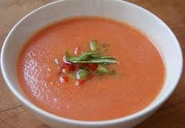
salt, olive oil, vinegar

