Paella
Preparation:
- Wash the clams in cold salted water, open them in a saucepan with water, strain and reserve the clams and broth separately
- Wash the peppers, remove the seeds and chop them. Wash the chicken and cut it. Wash the squid and cut into strips.
- Peel the prawns and cook the shells and heads for 10 minutes, strain and
- reserve the broth
- Heat oil in a frying pan and fry the chicken, add the squid, sauté a couple of minutes and add the diced onion, peppers, peas and peeled tomatoes. Sauté for 15 minutes.
- Add rice, stir and pour the hot broth and clam shrimp (over water),
- calculating the volume twice that of the rice.
- Make a paste with garlic cloves, parsley and saffron and add to the pan,
- season and add food coloring.
- Reduce heat and cook for 6-7 minutes add the shrimps and clams. Let stand 3-4 minutes and serve

Nutritional fats:
200 kal fats

Time: 60 min aprox.
Ingredients:
Rice, 600 grams
Clams, 500 grams
Prawns, 300 grams
2 tomatoes
Green Pepper
Garlic
Parsley
Chicken, 800 grams
Squid, 200 grams
1 Small onion
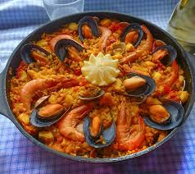
Peas, 150 grams
Saffron
Salt
Olive oil

