Mediji linkovi

https://www.zadarskilist.hr/clanci/08122018/ucenici-gimnazije-vladimira-nazora-na-mallorci-tematizirali-drustvene-mreze-i
http://www.narodni-list.hr/posts/434135001

http://gimnazija-vnazora-zd.skole.hr/Oglasna/ploca_copy?cal_ts=1525125600

https://www.jutarnji.hr/vijesti/hrvatska/novi-angazman-omiljenog-novinara-nakon-odlaska-s-televizije-nema-odmora-ovo-mi-je-ogromni-gust/8697401/

https://www.tportal.hr/showtime/clanak/nedavno-je-rastuzio-gledatelje-odlaskom-s-malih-ekrana-nasmijani-sime-vicevic-bavi-se-fake-newsom-20190405

https://www.vecernji.hr/showbiz/bivsi-reporter-nove-tv-pohvalio-se-novim-angazmanom-nema-odmora-1311379

https://radio.hrt.hr/radio-zadar/clanak/mladi-o-eu-i-europskim-izborima/194817/?fbclid=IwAR0vpRCOlTGFurSPS4Ct53bJrvqa6FmuSXaJ00_NDPbvG778a9Mi6jNOSoU

ADRIATIC TV
https://www.youtube.com/watch?v=cUmSxWRAZp8

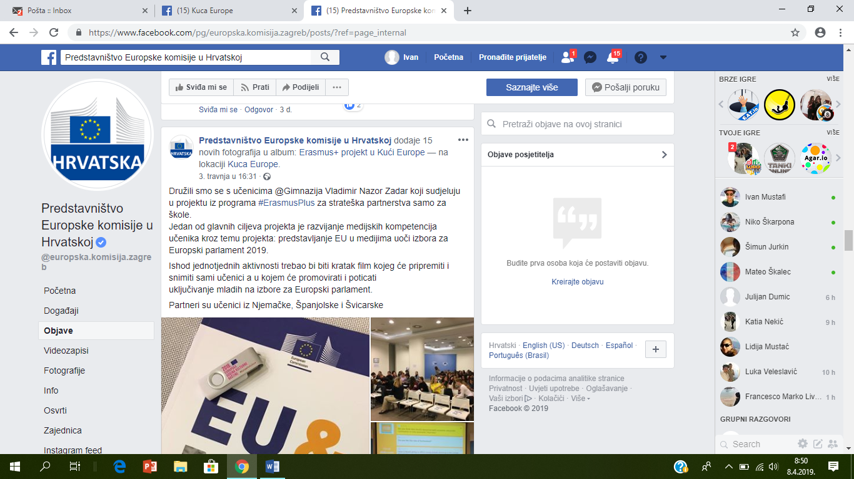

https://www.facebook.com/pg/europska.komisija.zagreb/posts/?ref=page_internal

HRT Indeks 7. travnja 2019.
https://hrti.hrt.hr/videostore/moviedetails?referenceId=416318014&refer=home%7Chomenew&player=True&heading=Posljednje%20dodano

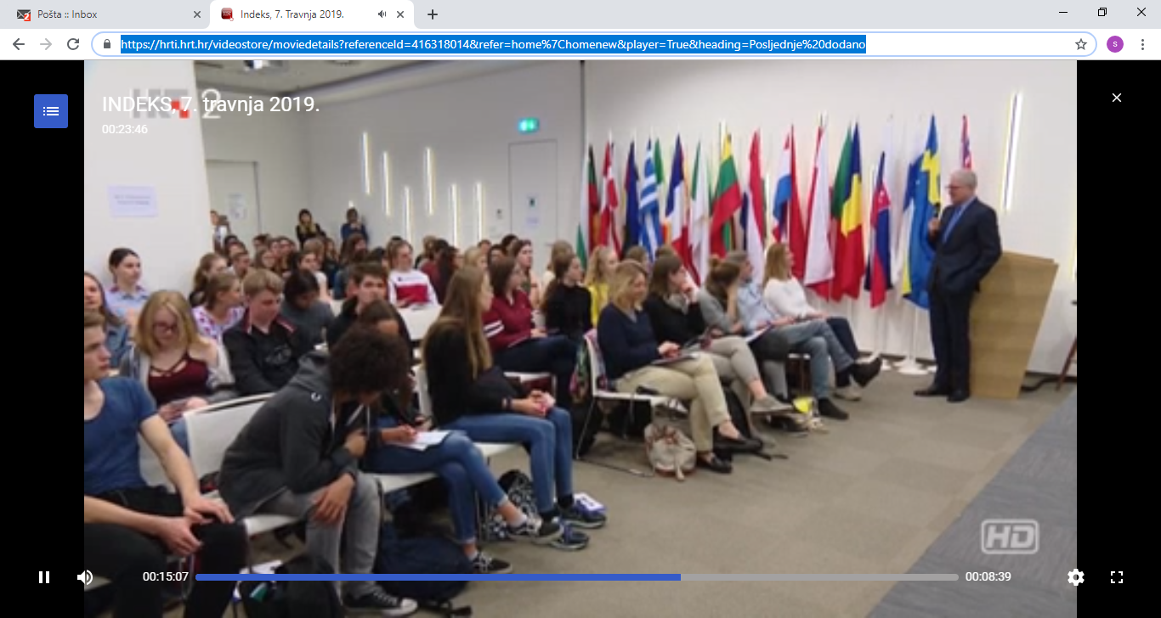

Zadarski list, 17.4. 2019.
https://www.zadarskilist.hr/clanci/16042019/zadarski-susret-analizirali-europske-izbore-u-medijima-i-upoznali-prekrasni-donatov

http://edic-zadar.com/wp-content/uploads/2019/05/EU_tjedan_program-1.pdf

