KSTA (Kölner Stadtanzeiger)
DuMont Mediengruppe is a newspaper publishing company.
The guide, Mrs Zenz, introduced herself to us and started the tour with the talk about the origin of DuMont Mediengruppe. She explained us the relationships in the DuMont family tree.
Marcus DuMont (1784-1831.) was a lawyer and he founded the company.
In January 1st 1803, he published his first newspaper. In that time the news were messaged by carrier pigeons.
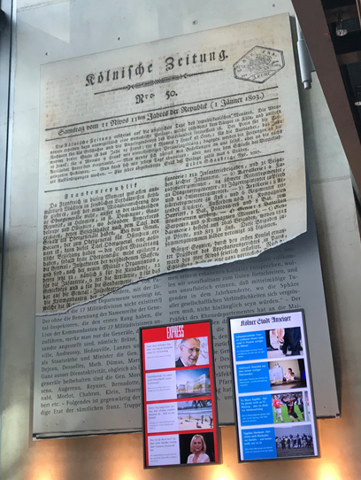
The media company provides local and national news they publish two separate newspapers: ´Kölner Stadtanzeiger´ and ´Express´ which is a kind of tabloid. With the help of technology, the company can now approach the statistics of online news. They can see where do the visitors come from, which articles are the most popular ones and how many subscribes are there.
Mrs Zenz showed us the statistics which say that people read the newspapers mostly between 8 and 10am, at noon and around 8pm, probably during breakfast, lunch breaks and after work. They also showed that people spend approximately 20 minutes on the internet page of KSTA daily. There is a difference between online version and the printed one, it could be written by the same author, but from a completely different point of view. The advertising journals are usually free for the customers, but their making is paid by the bigger companies who pay to be advertised in them.
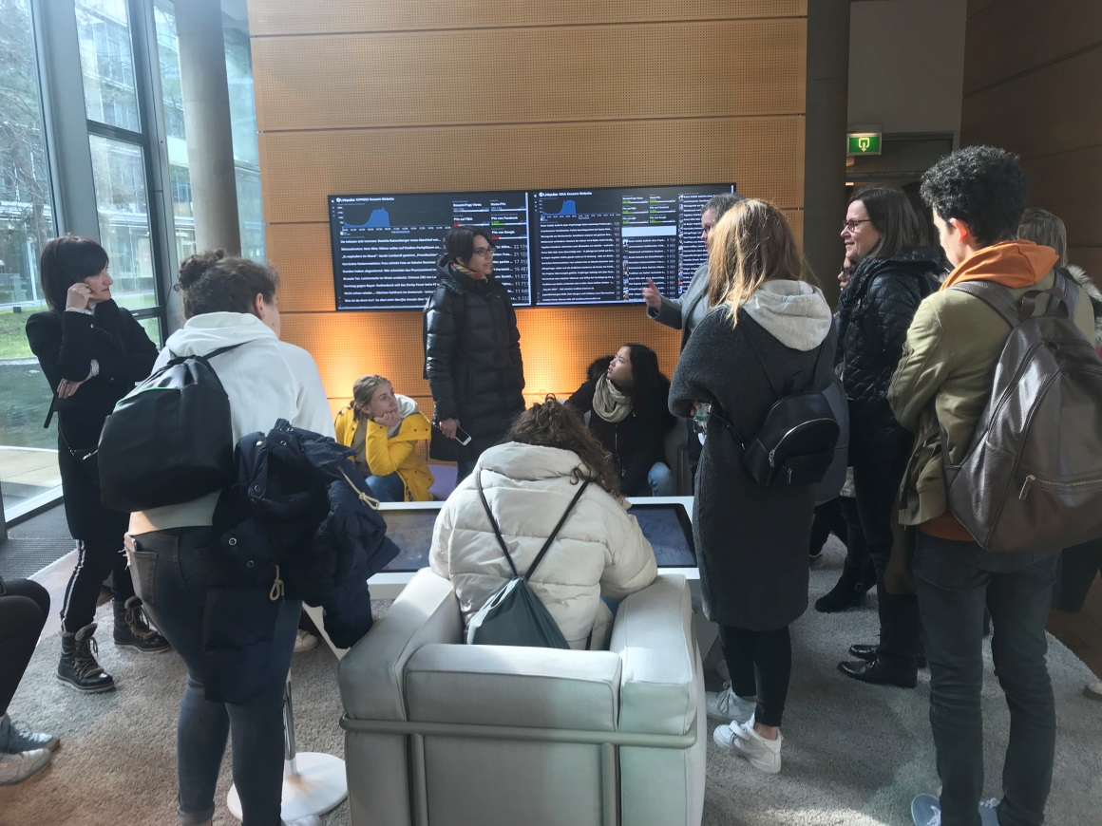
THE WORK
Employees are collecting information until midnight. Then the editing stops, and the printing of the newspapers starts. They also use the pre-printed versions to have a vision of the final product.
The news usually come from national and international press agencies but they have also correspondents in other countries or share so-called pool correspondents with other newspapers. For example they subscribe to the German Press Agencies, contact the local newspapers and exchange information. The text they receive can be a rough information or a never ending novel. It is never the finished product, so it takes a lot of work to verify if the information is true, so they have to check it in open information sources like homepages.
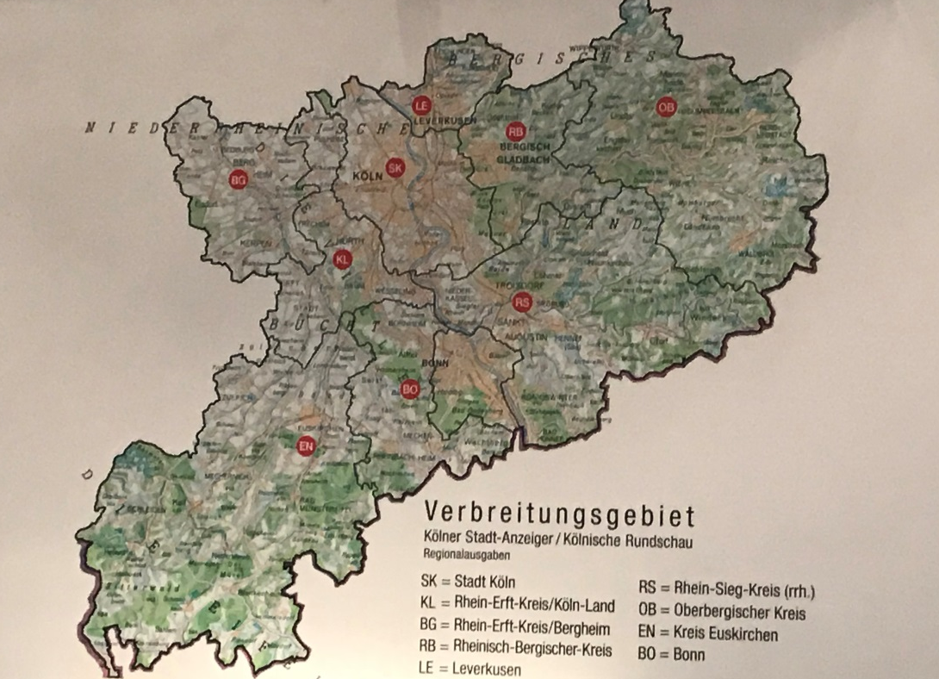
FAKE NEWS
If an author uses information to manipulate the readers, e.g. by leaving out things or emphasising others, that is called ´fake news´ which is prohibited.
If the topic of the article is political, you, as a journalist, are obligated to write two points of view, pro and con.
The question of the origin of fake news often appears. Fake news existed before, but when Donald Trump became a president of the USA people started thinking that fake news were invented because of him and that he used them to become a president.
If a big company gets involved in a scandal, journalists must write about the scandal but it doesn´t have to be on the front page with a big title, they usually put that kind of news in less spotted place, for example in a corner.

