CODING…

STEP 1. Create two Scripts.
ScrIni:
global.c[0]="United Kingdom";
global.c[1]="Slovakia";
global.c[2]="Poland";
global.c[3]="Turkey";
global.c[4]="Other";
global.c[5]="Italy";
global.c[6]="Belgium";
global.c[7]="France";
global.c[8]="Germany";
global.c[9]="Austria";
global.c[10]="Greece";
global.c[11]="Spain";

global.p1p[1]=0;
global.p1p[2]=0;
global.p1p[3]=0;
global.p1p[4]=0;
global.p1p[5]=0;
global.p1p[6]=0;
global.p1p[7]=0;
global.p1p[8]=0;
global.p1p[9]=0;
global.p1p[10]=0;
global.p1p[11]=0;
global.p1p[0]=0;
global.p2p[1]=0;
global.p2p[2]=0;
global.p2p[3]=0;
global.p2p[4]=0;
global.p2p[5]=0;
global.p2p[6]=0;
global.p2p[7]=0;
global.p2p[8]=0;
global.p2p[9]=0;
global.p2p[10]=0;
global.p2p[11]=0;
global.p2p[0]=0;

global.playerElegido=0;
global.players=0;

ScrQuestions:
Example:
// UK
if (global.countrySelected==0) {
global.tpr=5;
pr[1]='When the broadway tower was built?';r1[1]='XVIII';r2[1]='XV';r3[1]='XVI';r4[1]='XVII';
pr[2]='Where is the palace of westminster?';r1[2]='London';r2[2]='Edimburg';r3[2]='Cardiff';r4[2]='Belfast';
pr[3]='When Skara Brae get to UNESCO?';r1[3]='1999';r2[3]='1888';r3[3]='1456';r4[3]='1482';
pr[4]='Where is Stonehenge?';r1[4]='Wiltshire ';r2[4]='London ';r3[4]='Dublin ';r4[4]='Oxford ';
pr[5]='When Royal Kew Gardens were build?';r1[5]='1759';r2[5]='1325';r3[5]='1874';r4[5]='1760';
}
Repeat this code for every country and all the questions. The number of every country is in ScrIni.

STEP 2. Coding Screen1.
Create a new object, objCScreen1, and put this code in the evet ‘Create’.
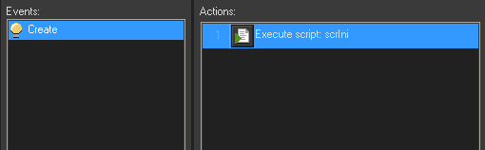

In the button put in Screen1, create this Event:
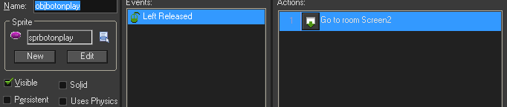

STEP 3. Coding Screen2.
Coding 1Player button…
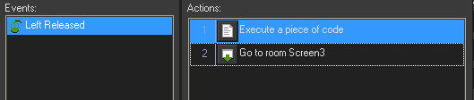
And the Script has this code:
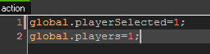

Coding 2Players button…
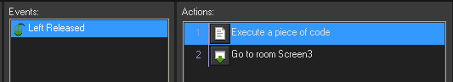
And the script has this code:
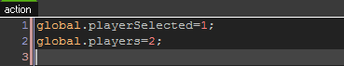

STEP 4. Coding Screen3.
We have to create the code for every country. This example is for Spain:
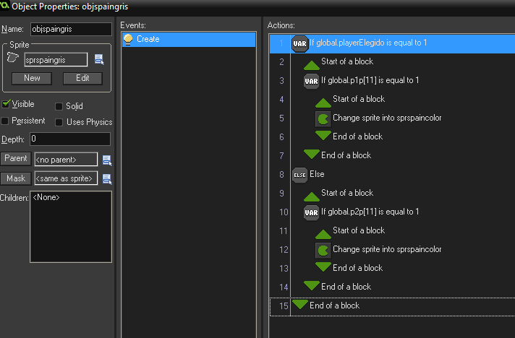
You have to use the number of every country (from scrIni)
And code the buttons ‘Ready’ …
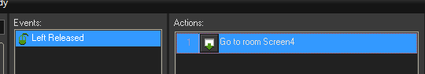
… and ‘Exit’:
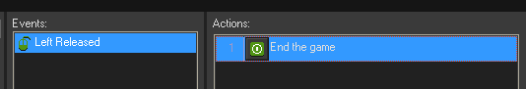

STEP 5. Coding Screen4.
Create a new object,objCScreen4, and put this actions:
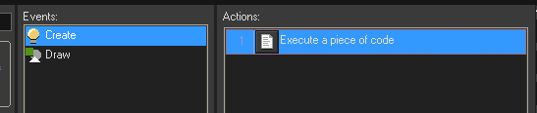
The code for Event Create is:
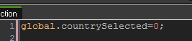
And the code for Event ‘Draw’ is:
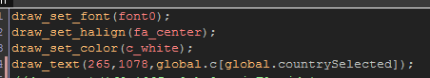

We are to code the button ‘Push’. We are going to have some events:
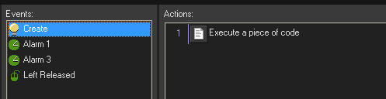
In the evnt ‘Create’ we are to code this:
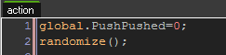

In the event ‘Alarm 1’ we are to code this:

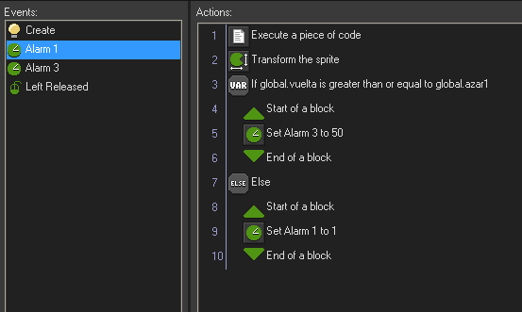
And the code for the script is:
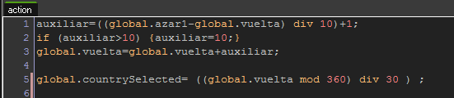

In the event ‘Alarm3’ we code this:
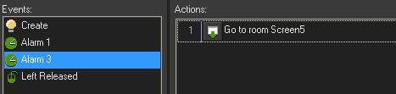

And in the event ‘Left Released’,we code this:
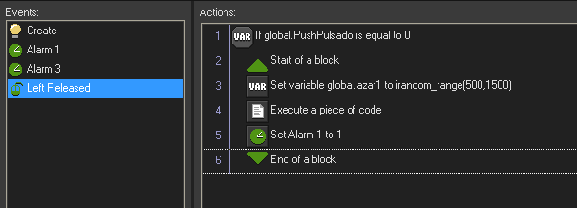

The code in the script has to be:
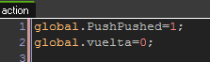

STEP 6. Coding Screen5.
Create an object objCScreen5 and code this:
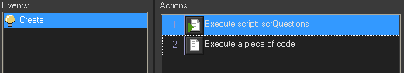
The code for the second script has to be:
randomize();
azar2=irandom_range(1,global.tpr);

global.pregunta=pr[azar2];
global.resp1=r1[azar2];
global.resp2=r2[azar2];
global.resp3=r3[azar2];
global.resp4=r4[azar2];

for (i=1;i<5;i++) {
azar2=irandom_range(2,4);
azar3=irandom_range(2,4);
if (azar2==2 and azar3=3) {
aux=global.resp2;
global.resp2=global.resp3;
global.resp3=aux;
}
if (azar2==3 and azar3=2) {
aux=global.resp2;
global.resp2=global.resp3;
global.resp3=aux;
}
if (azar2==2 and azar3=4) {
aux=global.resp2;
global.resp2=global.resp4;
global.resp4=aux;
}
if (azar2==4 and azar3=2) {
aux=global.resp2;
global.resp2=global.resp4;
global.resp4=aux;
}
if (azar2==3 and azar3=4) {
aux=global.resp3;
global.resp3=global.resp4;
global.resp4=aux;
}
if (azar2==4 and azar3=3) {
aux=global.resp3;
global.resp3=global.resp4;
global.resp4=aux;
}

}

global.correcta=irandom_range(1,4);

if (global.correcta==2) {
aux=global.resp2;
global.resp2=global.resp1;
global.resp1=aux;
}

if (global.correcta==3) {
aux=global.resp3;
global.resp3=global.resp1;
global.resp1=aux;
}

if (global.correcta==4) {
aux=global.resp4;
global.resp4=global.resp1;
global.resp1=aux;
}

We have to code the map in the middle, like this:
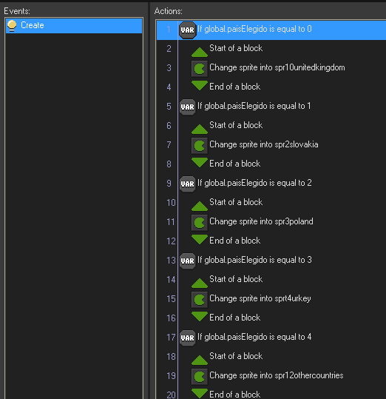
You can finish the code with all the countries.
And code the button ‘Go!’ :
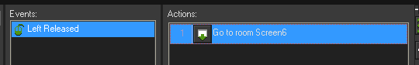

STEP 7. Coding Screen6.
Create a new object, objCScreen6, and code it:
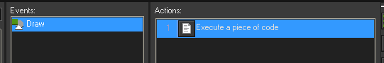
The code of the script has to be:
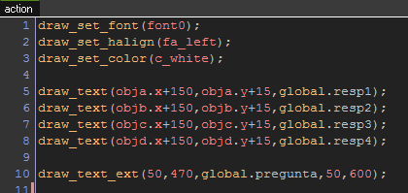

Code the answer buttons:
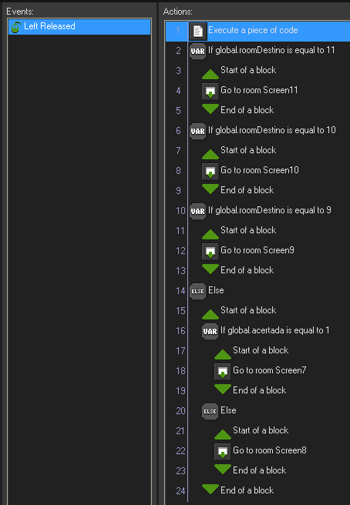
The code of the script has to be:
global.acertada=0;
global.roomDestino=0;
if (self.id==inst_EDAA48C4)
{
if (global.correcta==1)
{global.acertada=1;}
}

if (self.id==inst_A689B036)
{
if (global.correcta==2)
{global.acertada=1;}
}

if (self.id==inst_D07725FB)
{
if (global.correcta==3)
{global.acertada=1;}

}

if (self.id==inst_95E6B1B3)
{

if (global.correcta==4)
{global.acertada=1;}
}

if (global.acertada==1)
{
if (global.playerElegido==1)

{

global.p1p[global.paisElegido]=1;
}
else
{

global.p2p[global.paisElegido]=1;
}

// Y vemos si acaba el juego.
global.roomDestino=0;
if (global.p1p[0]==1 and global.p1p[1]==1 and global.p1p[2]==1 and global.p1p[3]==1 and global.p1p[4]==1 and global.p1p[5]==1 and global.p1p[6]==1 and global.p1p[7]==1 and global.p1p[8]==1 and global.p1p[9]==1 and global.p1p[10]==1 and global.p1p[11]==1 )
{
if (global.players==2)
{
global.roomDestino=10;
}
else
{
global.roomDestino=9;
}
}
if (global.p2p[0]==1 and global.p2p[1]==1 and global.p2p[2]==1 and global.p2p[3]==1 and global.p2p[4]==1 and global.p2p[5]==1 and global.p2p[6]==1 and global.p2p[7]==1 and global.p2p[8]==1 and global.p2p[9]==1 and global.p2p[10]==1 and global.p2p[11]==1 )
{
global.roomDestino=11;
}

}
else
{

if (global.players==2)
{
if (global.playerElegido==1)
{global.playerElegido=2;}
else
{global.playerElegido=1;}
}

}

STEP 8. Coding Screen7.
The code for the button ‘Playing’ is:
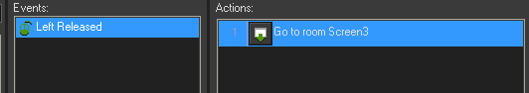

And the button ‘Exit’ was coded before.

STEP 9. Coding Screen8.
Allthe objects were programmed before, so you have to do nothing.

STEP 10. Coding Screen9.
Button ‘Play again?’ has this code:
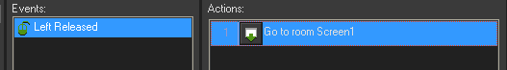

And with this code we finish.Screen 10and Scree11 has all the objects coded becauses they appears in other screens.

