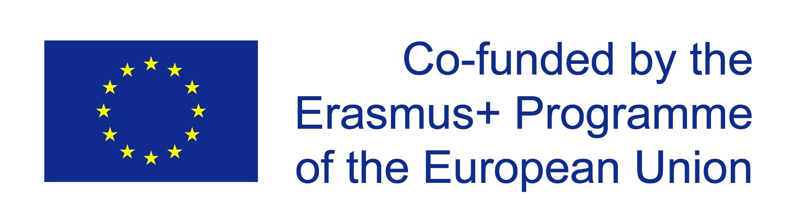
Erasmus+ 2017-2019 – “Work in progress” – Students managing public relations projects in schools – Products and topics
 | Final project product | Topics “European challenges”
Germany | Debate (British parliamentary style) | How to make our cities more breathable
Finland | Panel discussion | Political participation of young people
Estonia | Website including documentary video clips | Smart and sustainable use of energy
Scotland | Panel discussion with video conference | Young people entering the world of work
Italy | Website including podcasts | Migration / Concepts of integration

