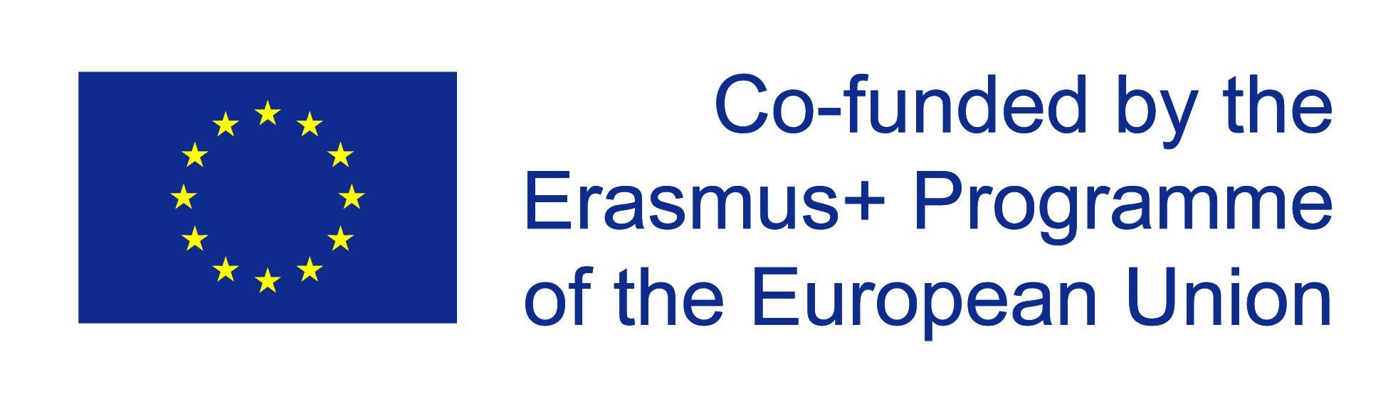

Erasmus+ 2017-2019 – “Work in progress” – Students managing public relations projects in schools – Dates

Germany 23/11 – 29/11/2018
Finnland 18/02 – 24/02/2018
Estonia 03/10 – 09/10/2018
Scotland 25/11 – 01/12/2018
Italy 07/02 – 13/02/2019

