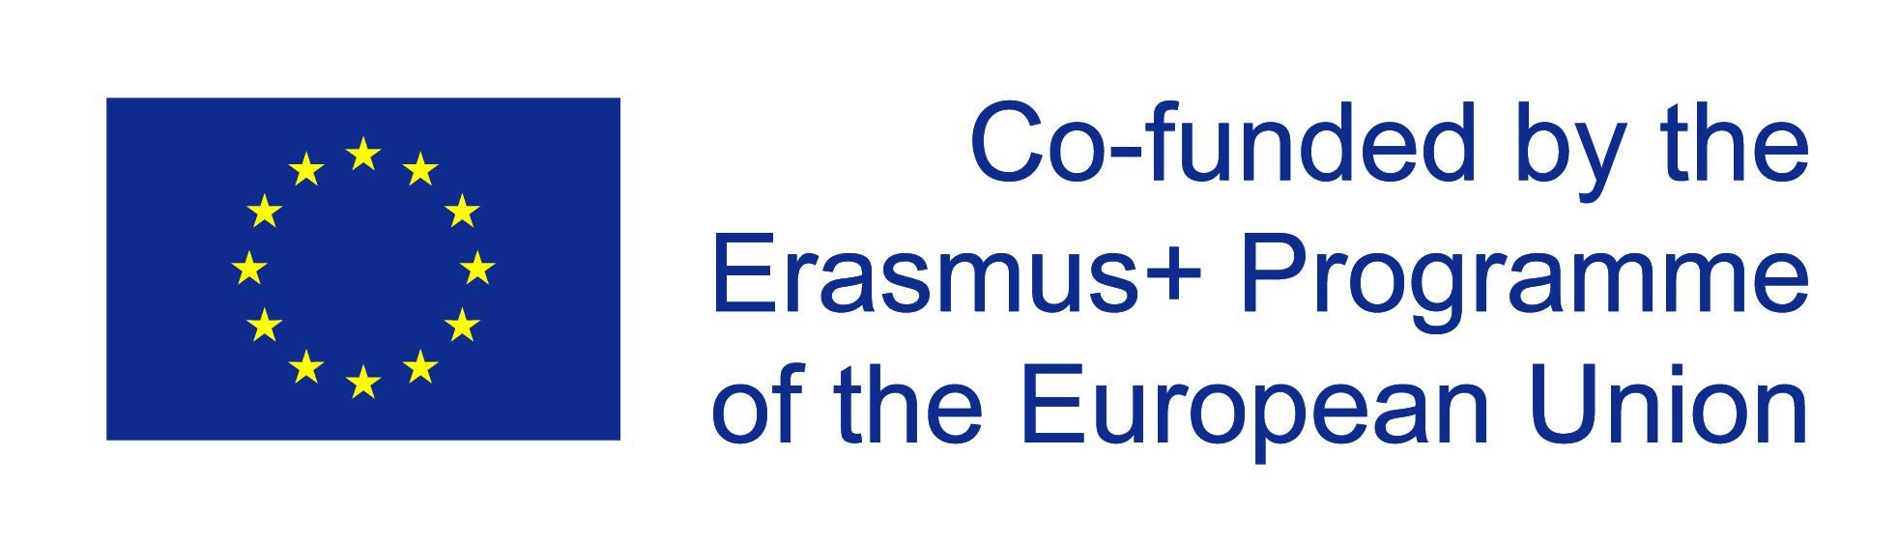
Erasmus+ 2017-2019 – “Work in progress” – Students managing public relations projects in schools – Schedule for meetings
Before meeting | Preliminary research on given topic according to research questions  Exchange of information on Twinspace
While meeting | Preliminary survey on specific project management skills and expectations of teachers and students
Introduction to project
- introductory workshops on project management methodology and on specific project product (e.g. How do conduct a debate or a panel discussion, How to create websites, documentary video clips, podcasts)
- presentation of project activities (see programme)
- setting up the different work groups
- …
Project work in international teams according to the programme
Documentation of project activities in form of a brochure (one team)
Documentation of project work in individual logbooks
Presentation of project product
 | Evaluation of project management and project product
After meeting | Project management techniques and tools are applied in home schools and project activities documented on Twinspace and on the European Project Results platform

