Thursday 23.11.2017 - Let’s say allons-y to an adventure

Our Erasmus+ -journey began at 8AM at the train station in Vammala. We arrived to the Helsinki-Vantaa airport around 11AM, checked in and went to a restaurant to eat.
After we all were done eating, we all went to walk around the airport and check out the shops and the airport in general. I didn't buy anything but of course I took pictures.
At 13:30 the boarding for the plane to Frankfurt started (but we had to wait for our teachers, who weren’t anywhere to be seen..). But we did get onto the plane and found our seats. The plane ride was couple hours long but it felt like an hour maximum. Most of the time I was talking with Katja, who was sitting next to me.
s
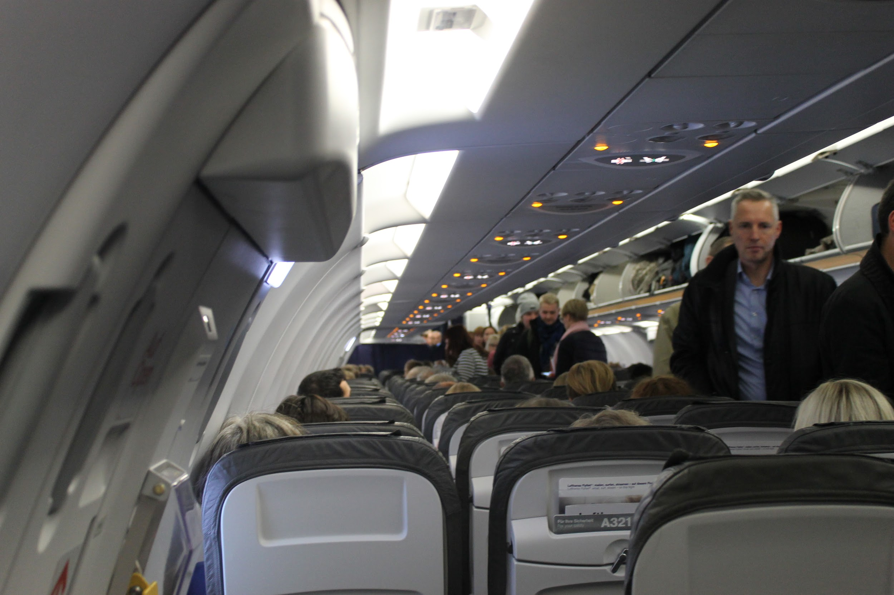
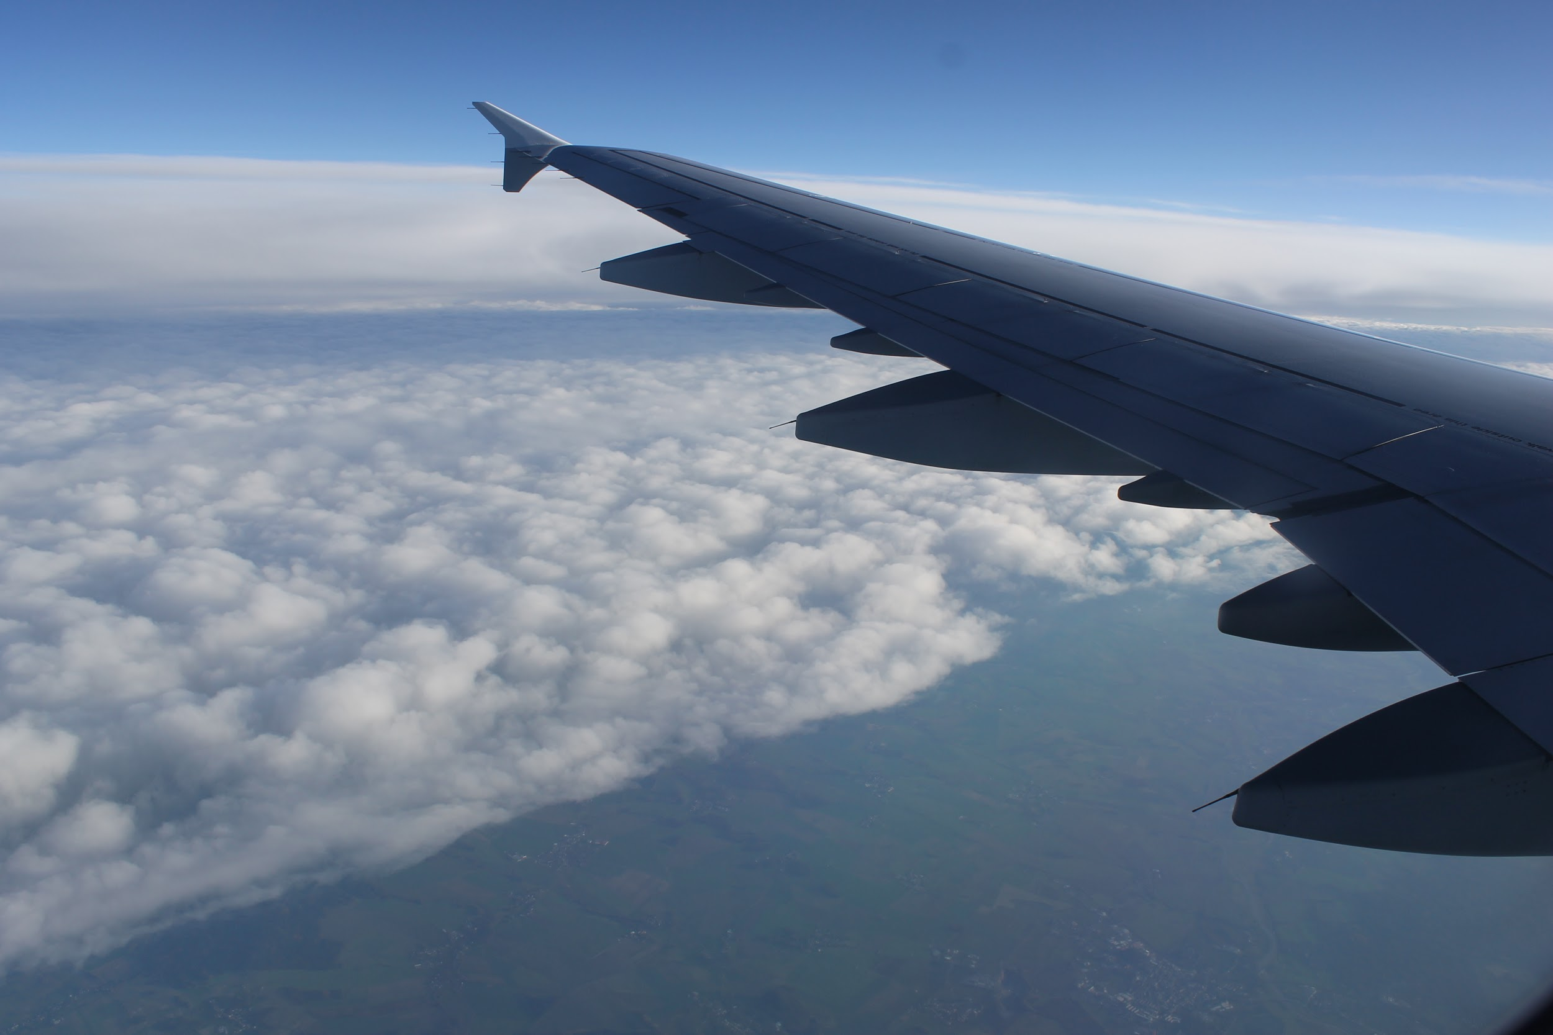
In Frankfurt we went straight to our port and waited for the plane to start boarding (we didn't have much time). It was kind of funny that we went to the plane by the airport bus (I had JUST talked about those buses with Katja).
The plane ride to Stuttgart was even shorter than the first one (obviously, because it was only 40 minutes). (Nightflight!)

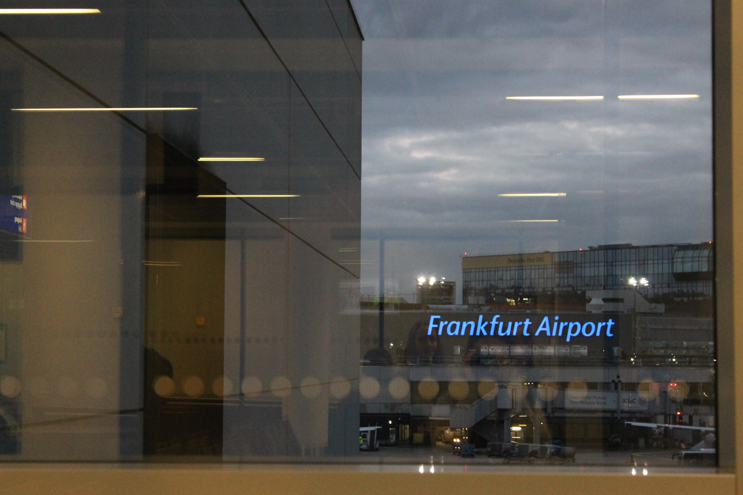
At Stuttgart, we went to get our luggage right away (after some waiting...). Best thing about it was that just outside the luggage-claim area, our hosts and one of the teachers were waiting for us. I was really nervous because I didn't really know what my host looked like, I only knew her name and hair color. It turned out that I was worrying over nothing because as soon as we got to them, they came to us and we found each other.
Me and my host, Nora, left right away and I met her dad (who is really nice, though). On the ride to home, Nora and her father were telling me about the area and the cities in Germany in general + getting to know me, of course.
When we arrived at their place, Nora showed me around the house and the room where I'm staying in for the following week. She also introduced me to her brother.
After changing my clothes quickly, we got to the kitchen to eat dinner and continue the "getting-to-know-each-other" conversation.
We had a good dinner and dessert which after me and my host played some board games. We played three different types of games and I have to say I'm a little salty about her board game skills, because I won only one at one game.
Anyway, we played for some time (during which her mom got home and we exchanged our names etc.) and then we started to get ready for bed because we had an early morning.

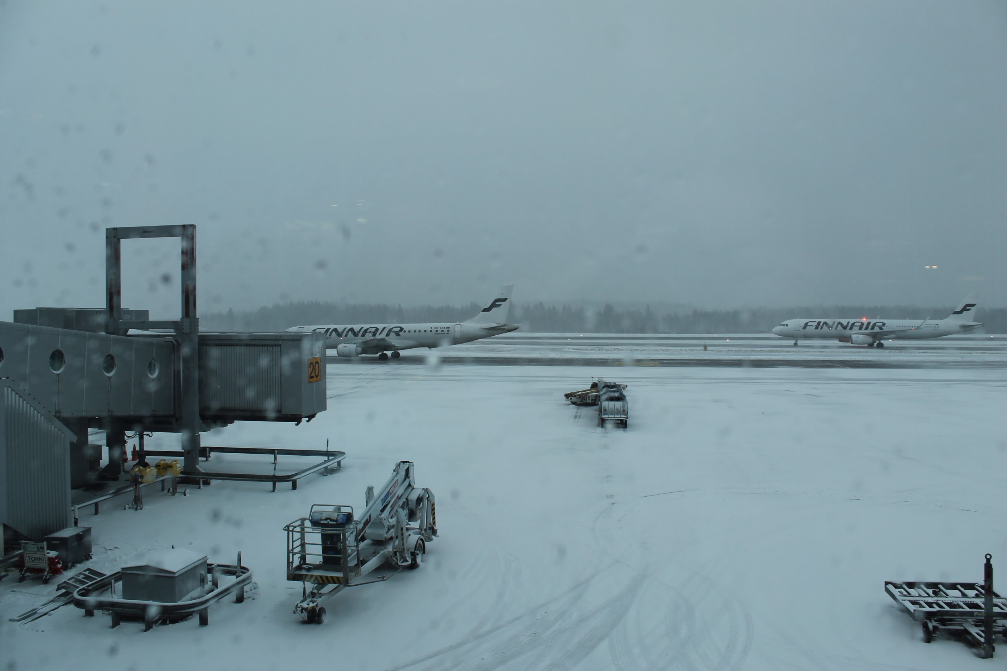

Friday 24.11.2017 - Getting to know each other and beginning to work on our projects

My alarm went off at 6:30 on Friday morning. After I got dressed and put some makeup on, Nora and me went to eat breakfast (during which my host mom, Dagmar, packed us a snack). Time flew by us and suddenly Nora noticed that we needed to leave in three minutes, so it got real hurry real fast.
We made it on time to the train station (after running) and I met two other Erasmus+ participants. The train itself was really crowded and I was sweating so much.
When we arrived to the school, we went to the auditorium, where I saw my friends so I went to say hi to them. After some talking, we went to take seats in the auditorium, where we had the headmaster's welcome and some information about this week. We also had a little trip around the school (points to the Avenger (Abivengers) painting and the trip outside via classroom window!).
We also had a introduction to the projects we are supposed to do (and a model debate, which was really helpful by the way). Not to forget about the little coffee break (pretzels, yay!), which was a call for my praying, because I was getting a little hungry and too shy to start eating my snacks, yikes. Anyway, here's pictures of our coffee break goodies and Ella eating a pretzel:
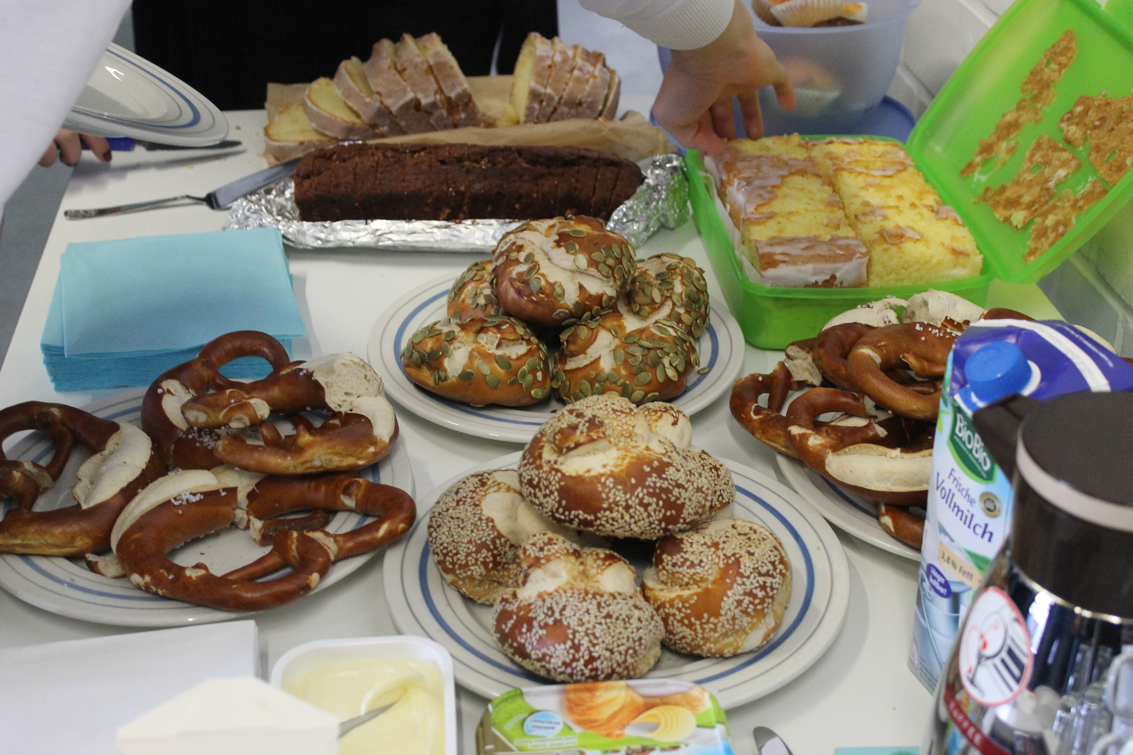
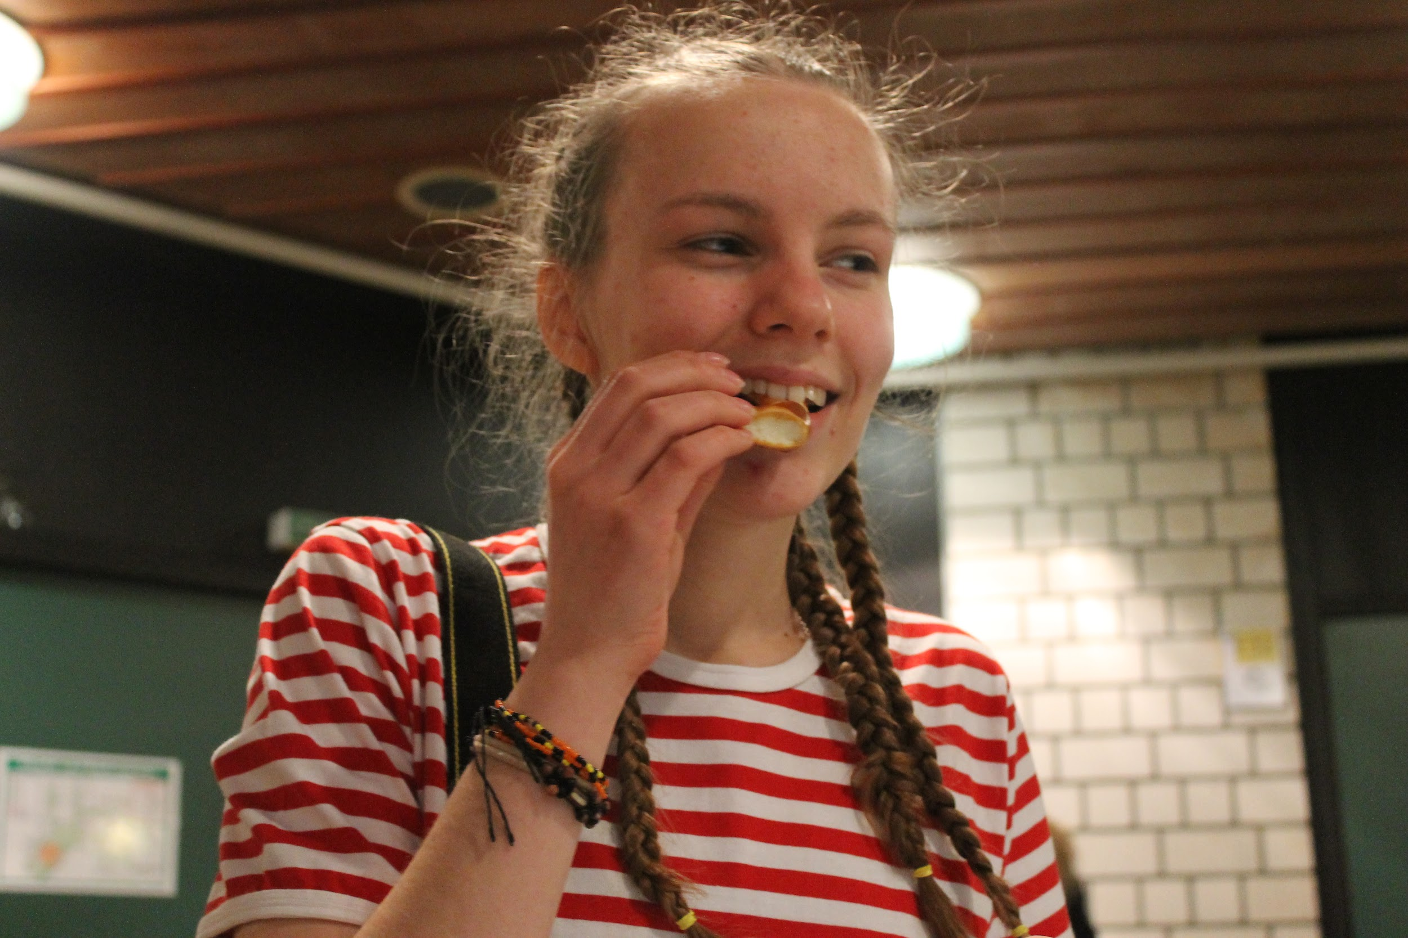
Before our actual lunch break, we had five little workshops where on each we had different kinds of little activities, which we fun. We worked on the project groups (go Team Yogurt!).
On lunch break, me, Nora, her friend and guest went to this little pizza place, where actually two of my friends were too with their hosts (plus some others, but I don't really know who they were). The pizza itself was good but huge (and cheap as heck!). Due the pizza being huge, I didn't have time to eat all of it at once, so me and my friends took them with us on a doggy bag back to the school gym, where the sports session waited us (sports after pizza? fun...)
The gym where we had our sports session, was so big, our whole school would have probably fit in there with no problem. Anyway, in the sports session, we played volleyball, knock off (some sort of a basketball game) and a game Round the Table, which was definitely my favorite.
After the sports session, we had some free-ish time with our groups, so we went to work on our project, which was creating a brochure. We made a plan and got to work; we wrote down some questions, which we are going to ask the debating groups and I took some photos of them working.
At 15:00 we all went to the auditorium to listen to a presentation about air pollution sensors from OK Lab (picture on the right). After the presentation, we discussed about how air pollution affects cities and our countries. We also looked at some of the data from the air pollution sensors (luftdaten.info). We also learned that these devices were made because the citizens of Germany didn't trust the politicians, so they made their own data.
The OK Labs presentation lasted for about two hours (give or take), after which we all were free to leave with our hosts. I left with some other people (my host included, obviously). In the train, we were planning some activities we could have at some point and ended up making plans for that evening. When me and Nora got home, we ate some quick snack, I changed into more comfortable clothes and we left to one of the other hosts', Sarah's place.
The walk to Sarah's place was about five minutes, so it was definitely close by. When we got to her place, her mom greeted us and gave our chocolate cake. Our plan was to play some (board) games, so we ended up playing Jungle Speed, which was so much fun.
Me and Nora couldn't stay long, because we were going to go bowling to Stuttgart. We went back home and got ready to leave with her parents.
On the car ride to Stuttgart bowling center was nice; my host mother asked about our day and little bit about Finland and I answered the best I could. The bowling itself was really fun (even though I wasn't good at it, but that's not the point). When we drove back to Ostfildern, we saw this beautiful view of the city of Stuttgart with all the lights twinkling beneath us. Too bad I couldn't get that view saved on my camera, since there's no way the view would look so breathtaking than it was in front of us at that moment.
Shortly after we got back home and got ready for the night. Me, Nora and her mother had a conversation about different christmas traditions and finnish words and such. I think it's safe to say the day was a success and that I cannot wait for tomorrow. Good night, folks.
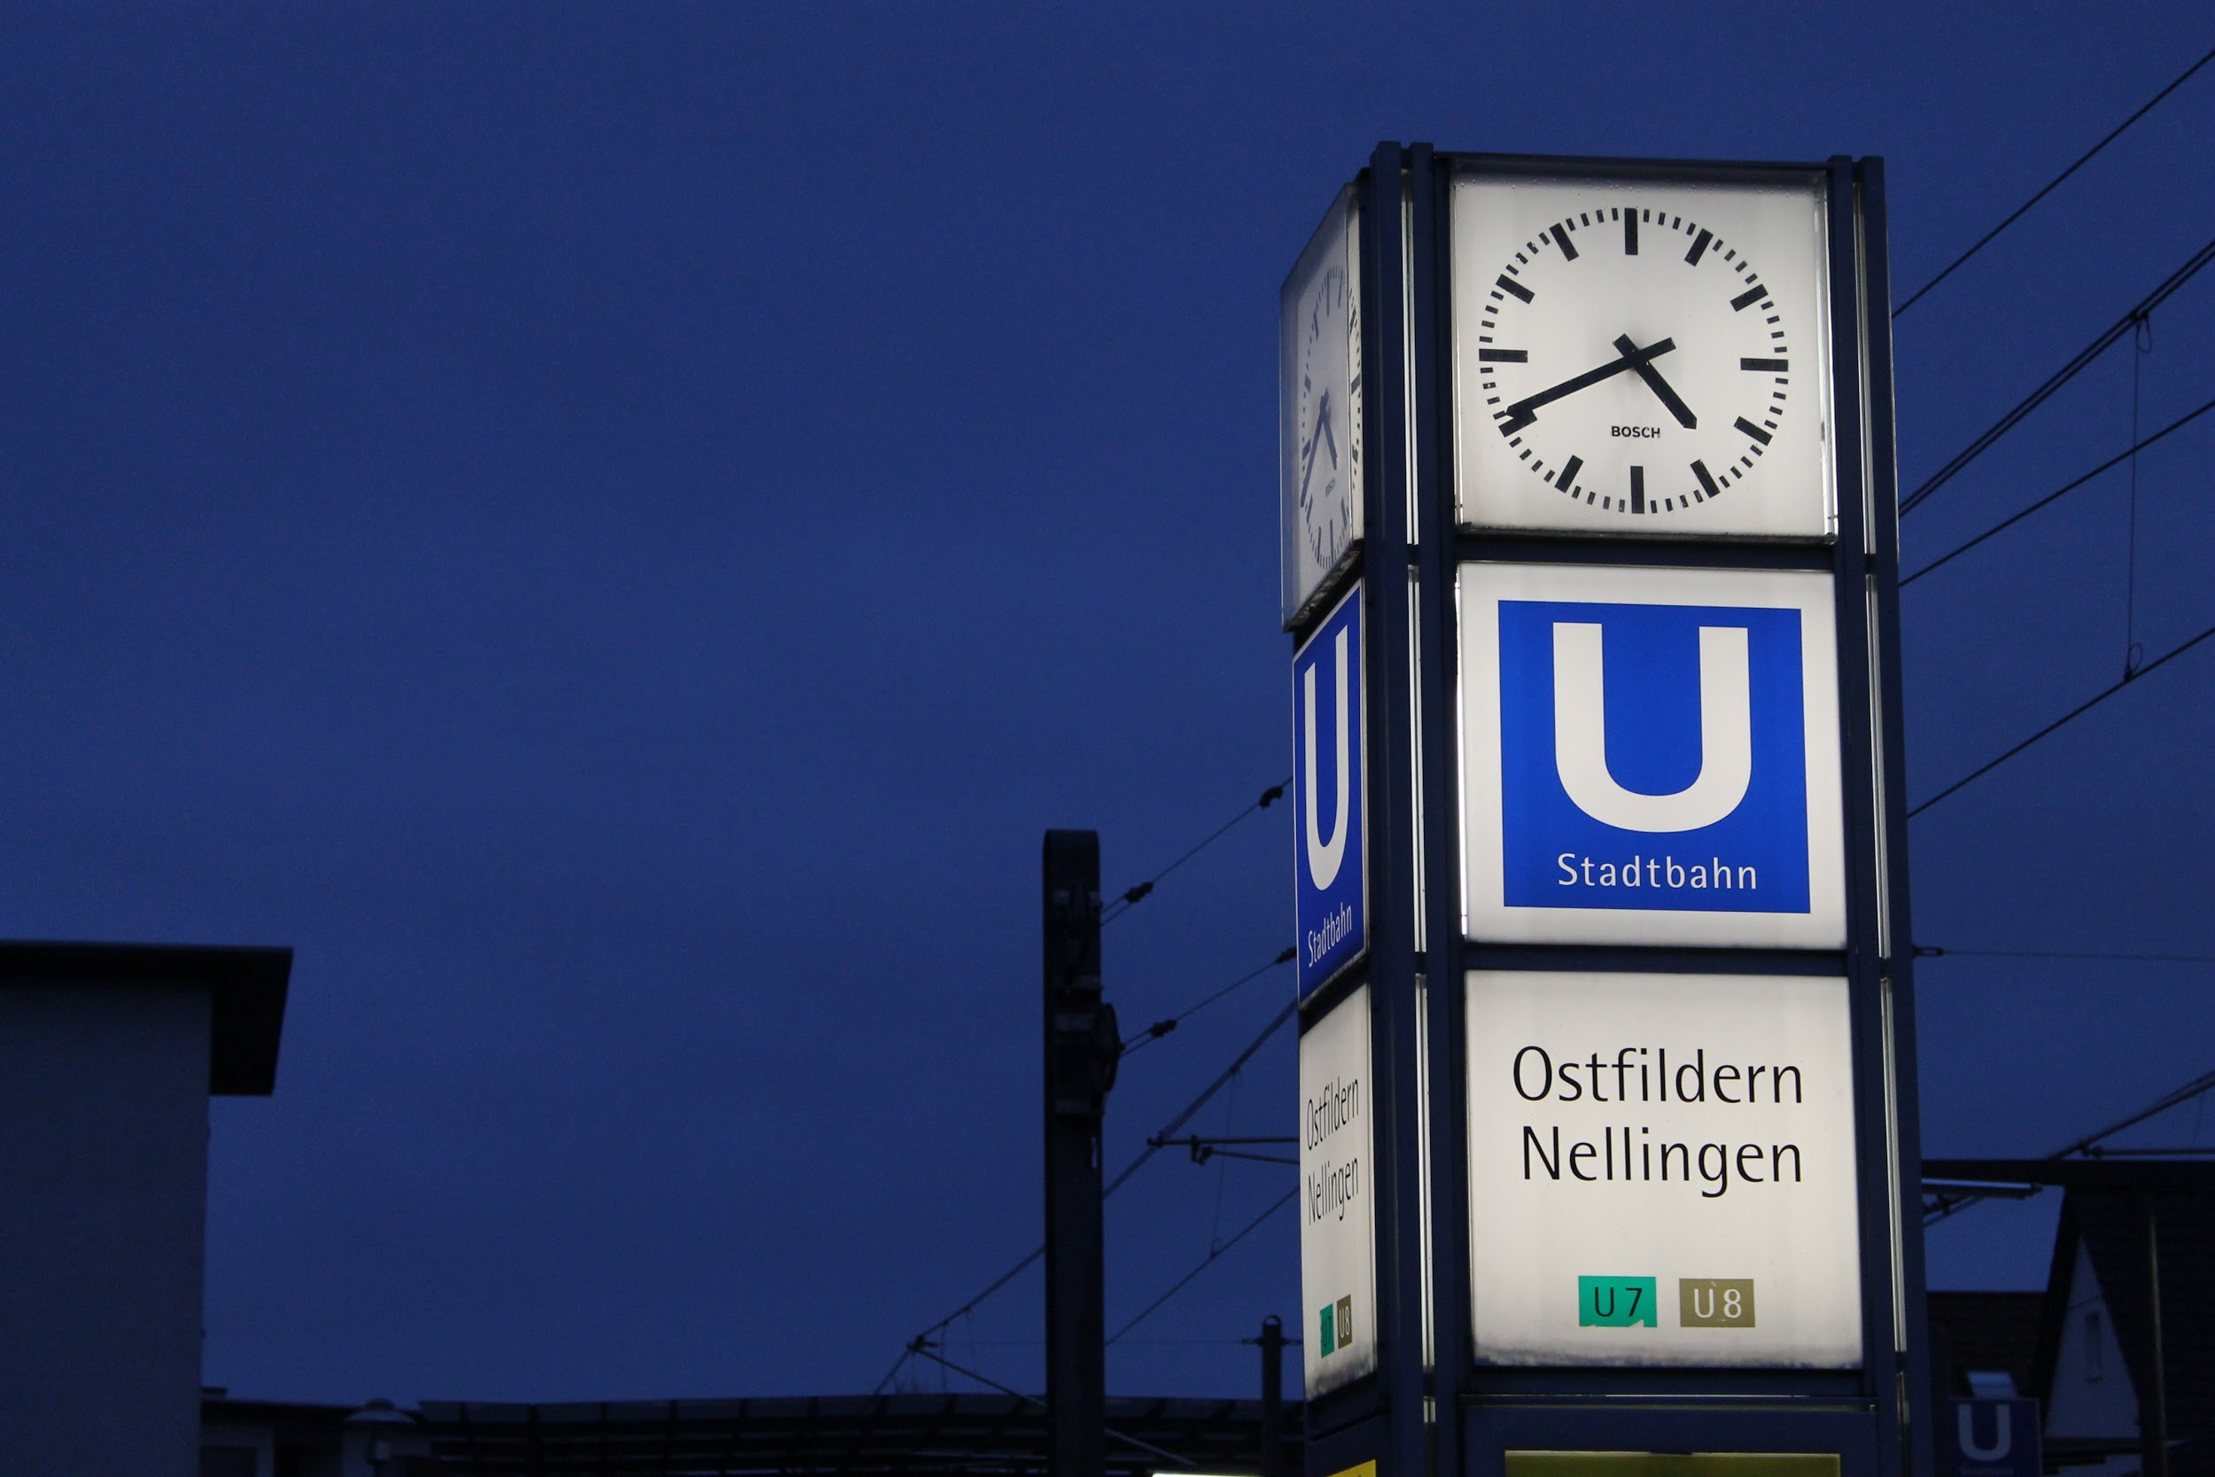
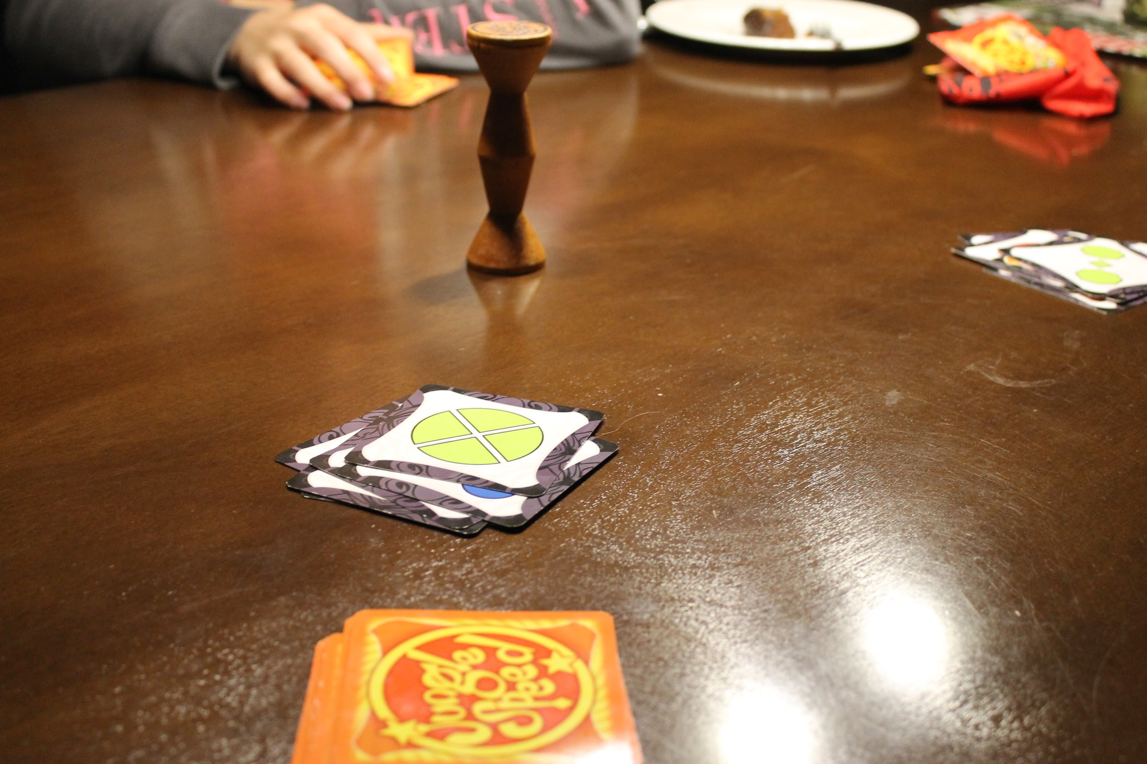
Saturday 25.11.2017 - Daimler -museum and Mister X

Saturday wasn't an ideal morning in many ways: 1) it's weekend and 2) it was raining quite hard and 3) the rain itself wasn't warm. Anyway, we all got to the bus station around 8:40AM from where we all headed to the Daimler museum.
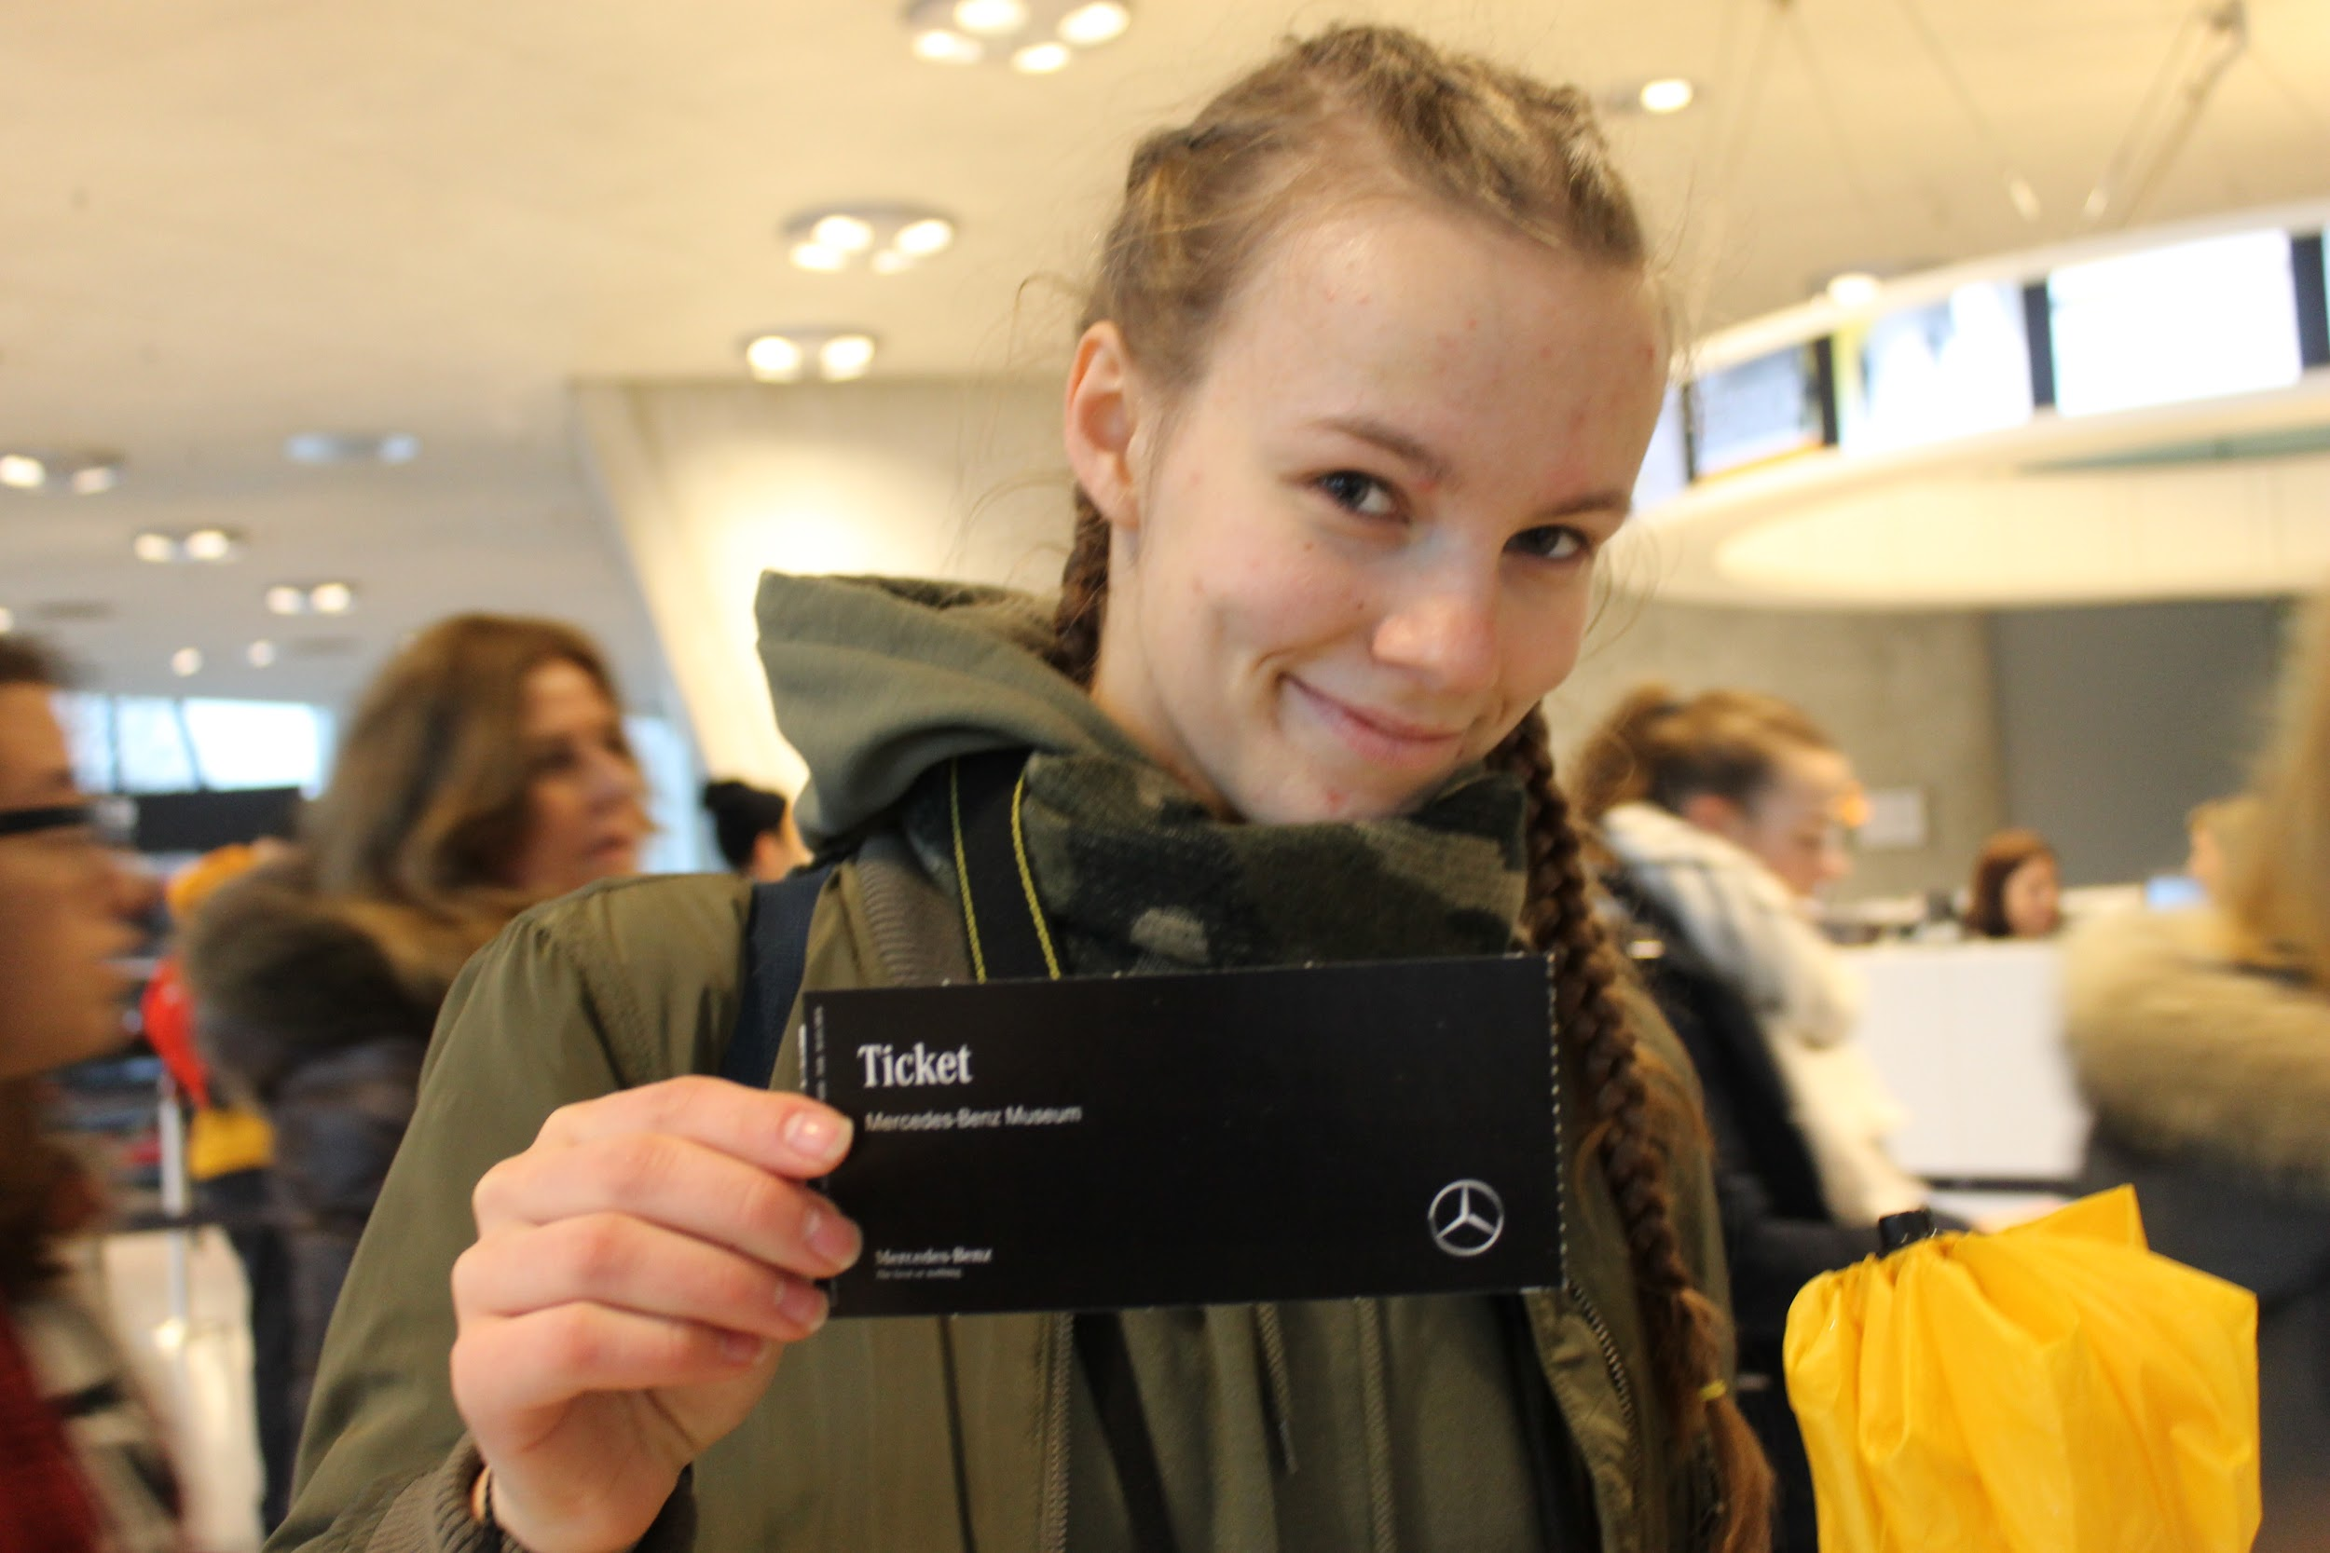
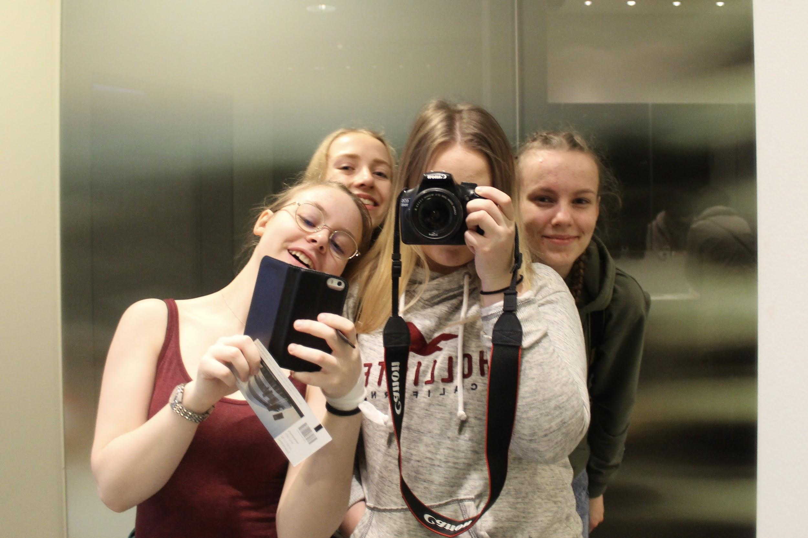
I'm not that big of a fan of vehicles and such but the Daimler museum was quite impressive in many ways; the building was beautiful (I love architecture), the chronological timeline order of the vehicles was well thought (the floors and the hallways) plus the audio guide was a good idea! I think my favorite part of the museum was the formula exhibition, well because, I like formula, duh. I took a lot of photos at the museum and here is some of them:

We spent about two hours at the museum and then headed to the main train station of Stuttgart. Luckily, the rain had stopped. At the train station, our teachers left and we were supposed to start playing a game called "Mister X". We were supposed to play this game so we would get to know the public transport system in Stuttgart. In the game, we were supposed to find this mister X from some of the many stations in Stuttgart. Of course, we didn't catch this mister (the team), but we still got to look around a little bit. The game was really boring but exhausting, because we often ran from one stop to another station and we played the game for four hours, maybe? You can only imagine the numbness of my feet.
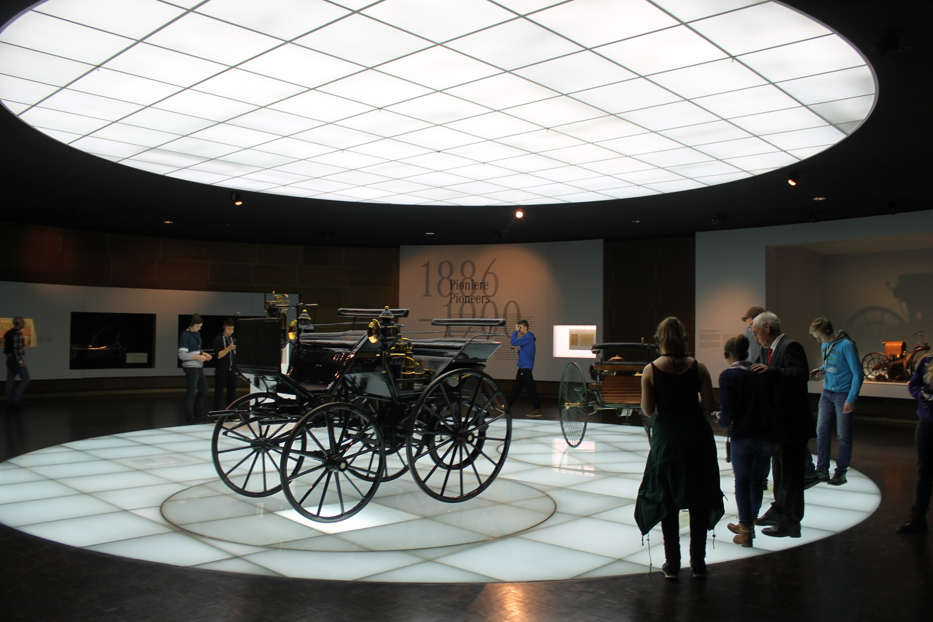
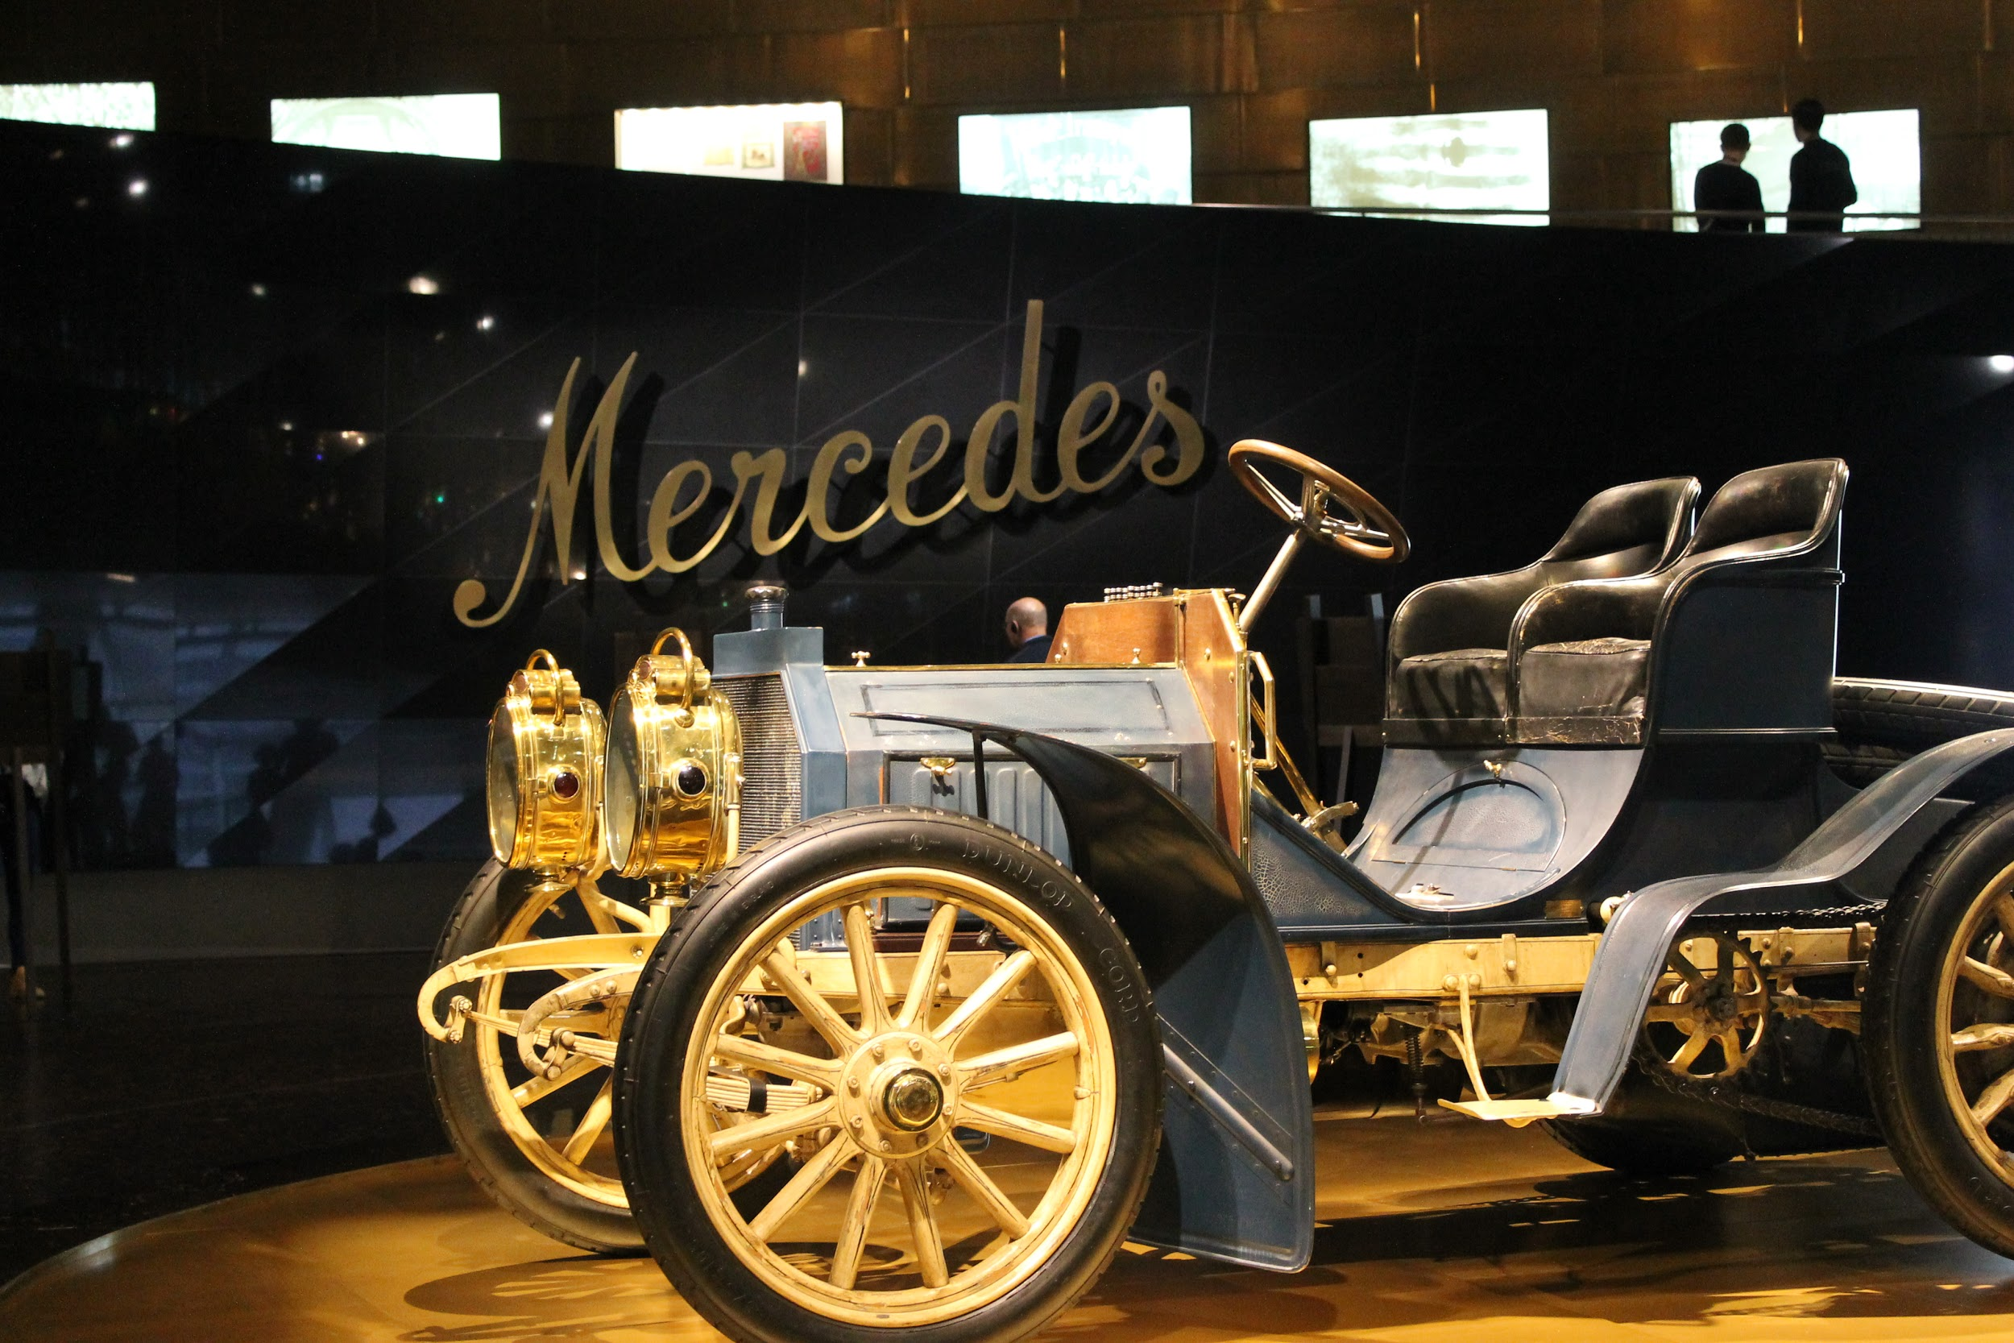

After the game, we had the rest of the day off, so me and my host (and couple of other people) stayed in Stuttgart to go shopping. We first went to the Königsstraße, which is a street filled with stores. We shopped there for some time until we moved to the shopping centre Milaneo, which was huge. At Milaneo, I got to fulfill some of my life goals aka 1) go to Primark and 2) go to Dunkin' Donuts. Downside of the shopping center was the loudness and crowdedness, but hey, what can you expect from a huge shopping center in a huge city, eh?
Me and Nora ate some food at the center so I got to taste some food called Spätzler und soße. Apparently it's something every german knows. And I'm not surprised why; it was delicious; perfectly spiced and there's was the right amount of sauce in my opinion. Also, I've got to say; iced yogurt is really good. (No wonder most of the germans eat yogurt so much.)
After eating, me and Nora left to go home. The train ride was the longest we have so far had and because the day was quite exhausting, we both almost fell asleep on the train. When we got home, we didn't do much anything else than get ready for the night. It was an interesting day and thank god there's still three and half days in front of us.
Gute nacht, folks.

Sunday 26.11.2017 - Sleeping and bowling

What a good morning: I finally got to sleep late and wake up with no rush. The morning started with a brunch style breakfast with the whole family. The breakfast was really interesting; we talked about many things such as languages in Europe, sports (ice hockey and formula, hehe), religion (yikes because I’m not religious) and of course about the day's plans.
After breakfast we had some time to get ready for Nora's handball games. Nora herself left earlier because she needed to go warm up, but the rest of us left later by car. I also realized that this family has some sort of a thing for whistling, since they're doing it almost all the time...
The game was really interesting and I learned a lot about handball, because while we were watching the game and the referee did something, Dagmar explained to me why the referee did so. Unfortunately, Nora's team lost only by two goals (I don’t know if they’re called goals but anyway).
After the game we got home, and my host dad, Martin, started to bake some sort of traditional christmas dessert for his sister and Dagmar started on the lunch. While we waited for the potatoes, me and Dagmar played a game of Triple-Domino (which I won, yay). Then she had to go finish the lunch, so me and Nora played couple of games (we both won once).
At dinner I got to taste red cabbage, which I hadn't tasted before (even though it’s not like I couldn’t eat it in Finland…) (but it was a good thing, since apparently, the germans really like it). We also had the food me and Nora ate the day before at Milaneo.
My host brother, Jan, also had a handball game today, so after lunch, he and Martin left. Me, Nora and her mother stayed at home and played a game called Metzler. It was really fun (and I won)! I think I have to teach it to my friends and family back at home.
Around 5:30PM, me and Nora left to go to one of the other german host's place, since they were going to give us a ride to the bowling alley in Esslingen. On the ride to the place, we talked for one thing about the school system in Finland (and about studying swedish).
When we arrived to the bowling alley, we found couple of other host pairs waiting in the lounge, so we joined them and talked about our days. After a while, everyone (who was coming) arrived and we went to get lanes and shoes. Not a surprise that I sucked at the game – again – but I had so much fun. We spent about two hours there and then we all split up to go home to get some sleep. Me and Nora pretty much went straight to bed when we got home.
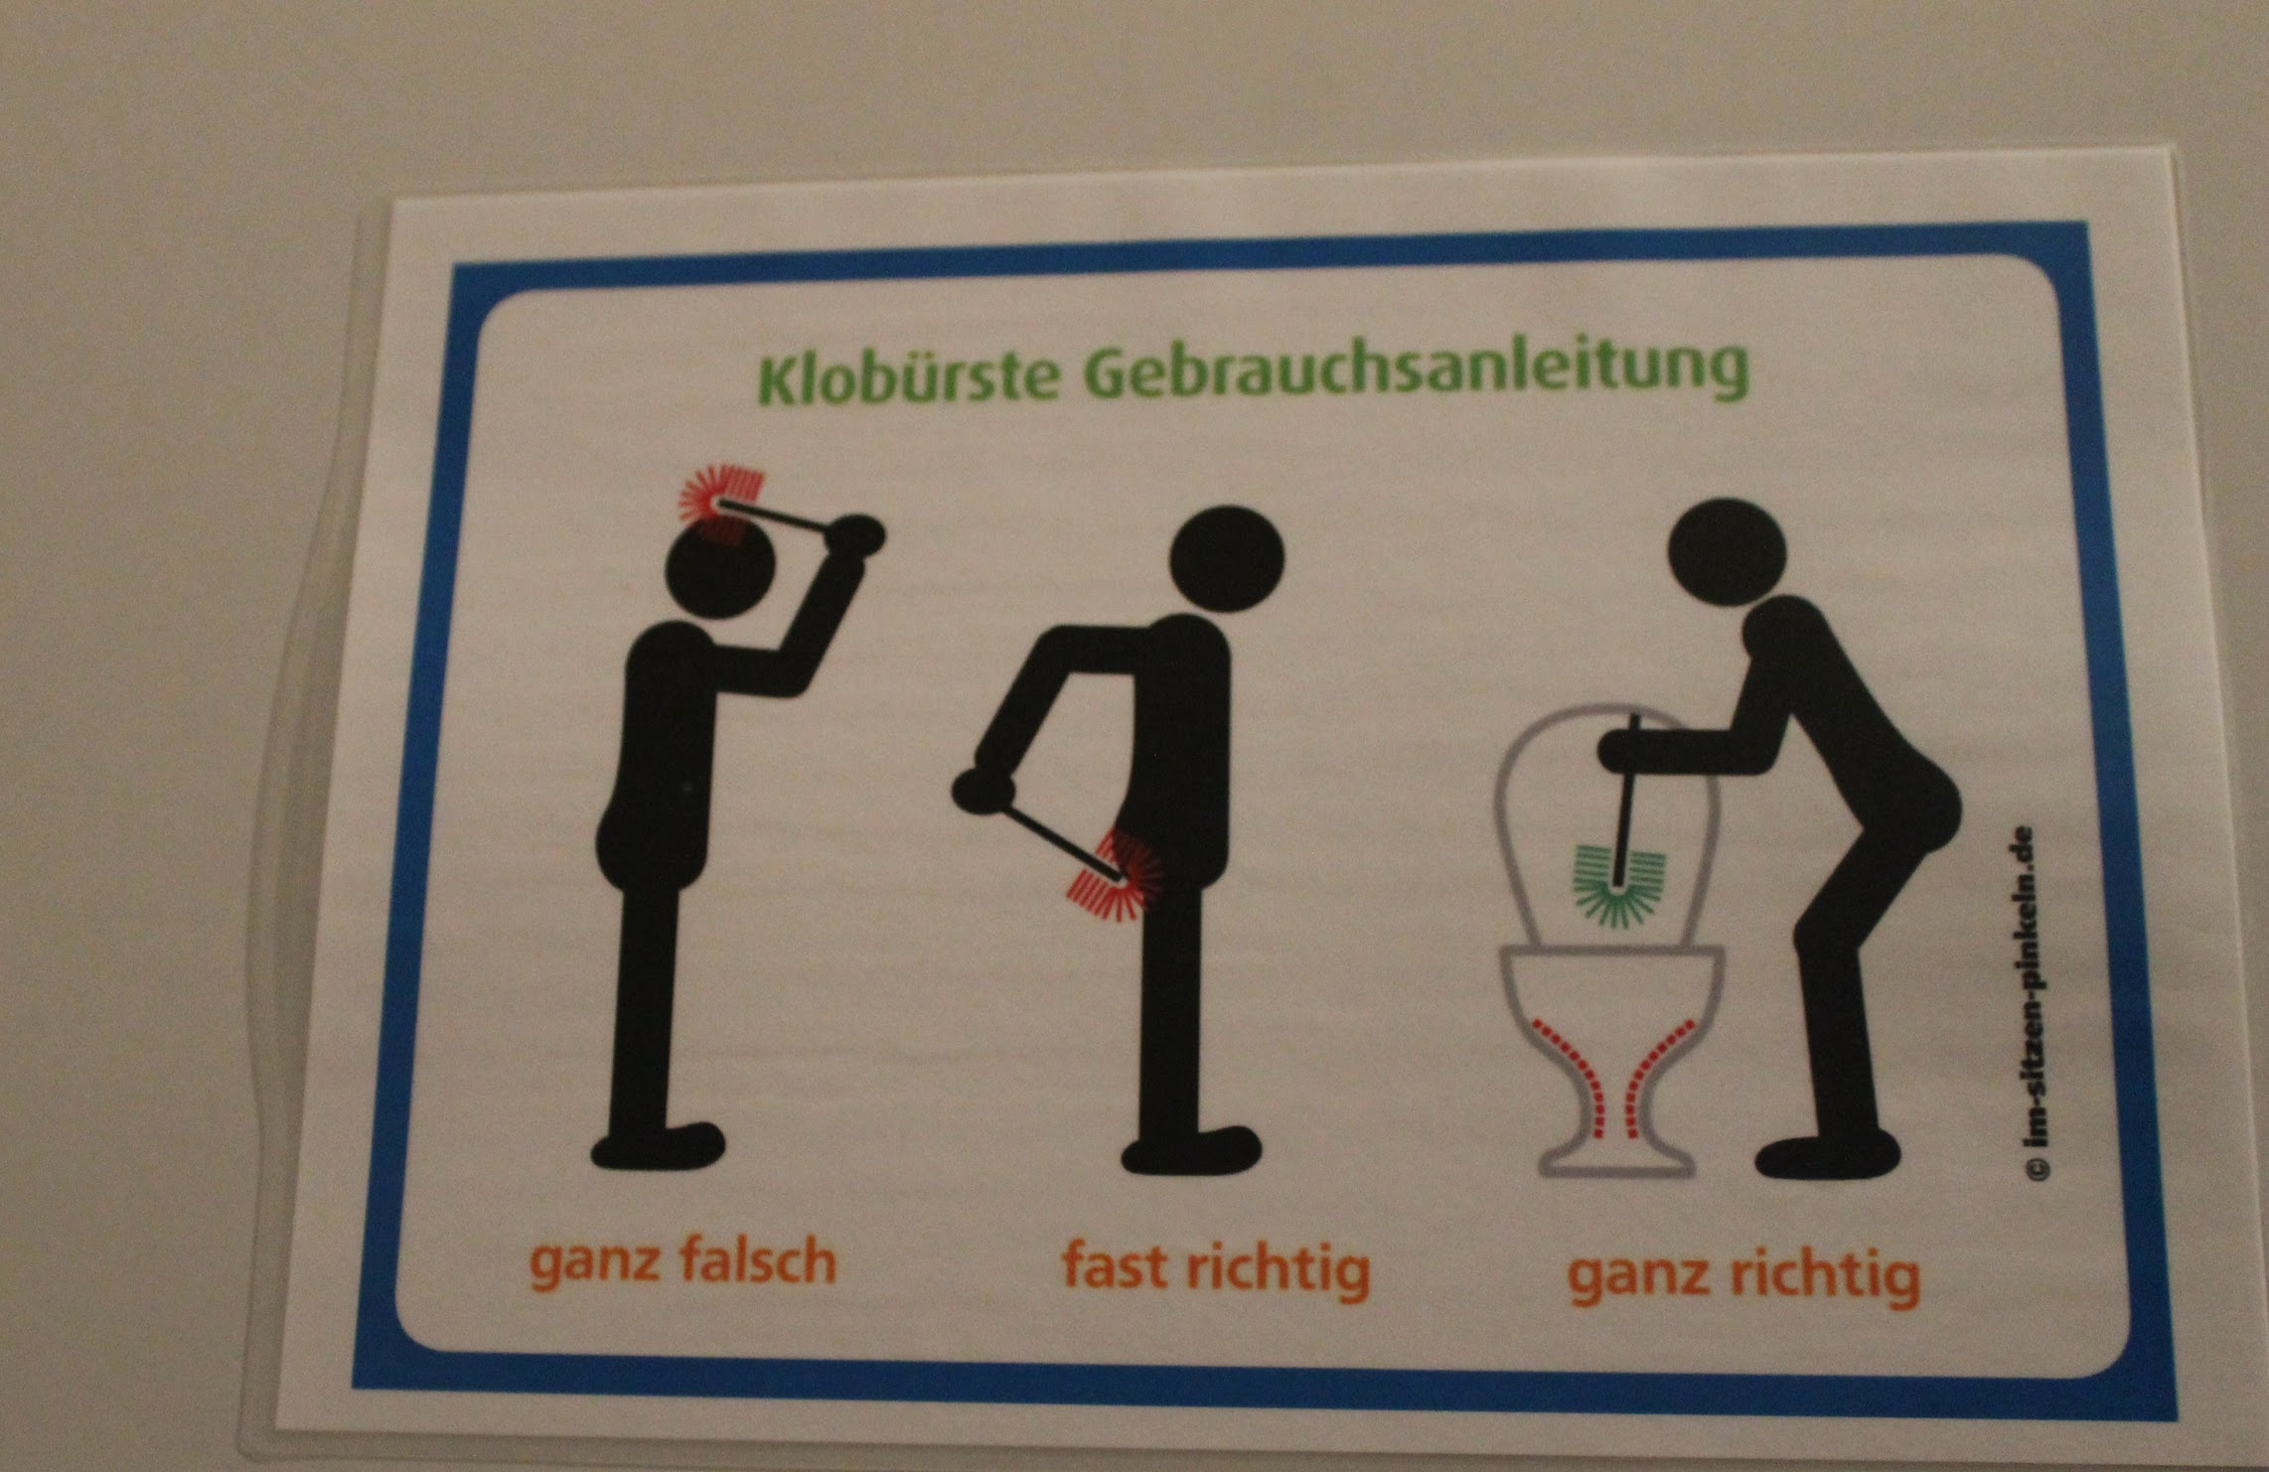
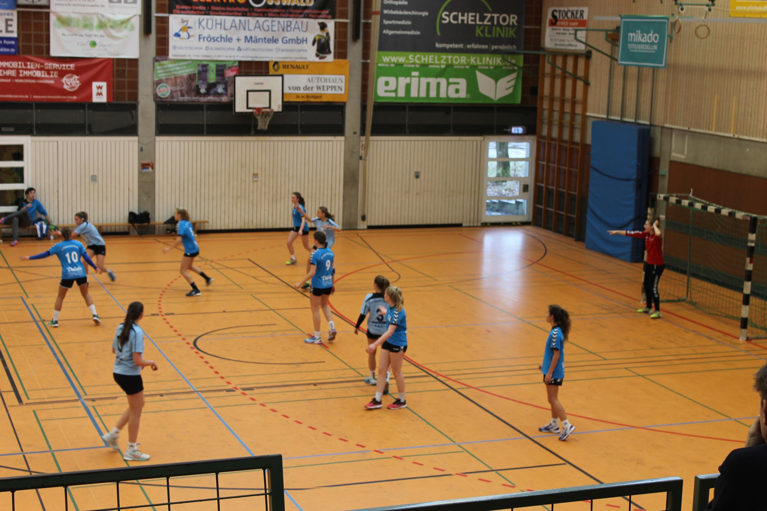

Monday 27.11.2017 - Research in Stuttgart and baking Christmas cookies

The morning was the same as usual; dressing up, eating breakfast and then out the door to the train station to catch the train to school.
At the school, the Germans went to their classes, while us, the guests, went to visit the mayor of Ostfildern. What comes first to my mind when I think about the visit, is the story the mayor told us about the baker who invented pretzels. We also had pretzels, apple juice and german candy at the office. (There was also someone from the local press and now there’s a picture of us at the local newspaper!)
After visiting the mayor we went on a guided tour in Stuttgart, where our guide gave us information about the air pollution in Stuttgart. He also showed us some of the monuments in the city and told about the history of the city. During this tour, me, Ella and Katja fooled around with the estonian boys, Ken and Rauno. Anyway, I really enjoyed this tour and got so many pictures of the beautiful city.
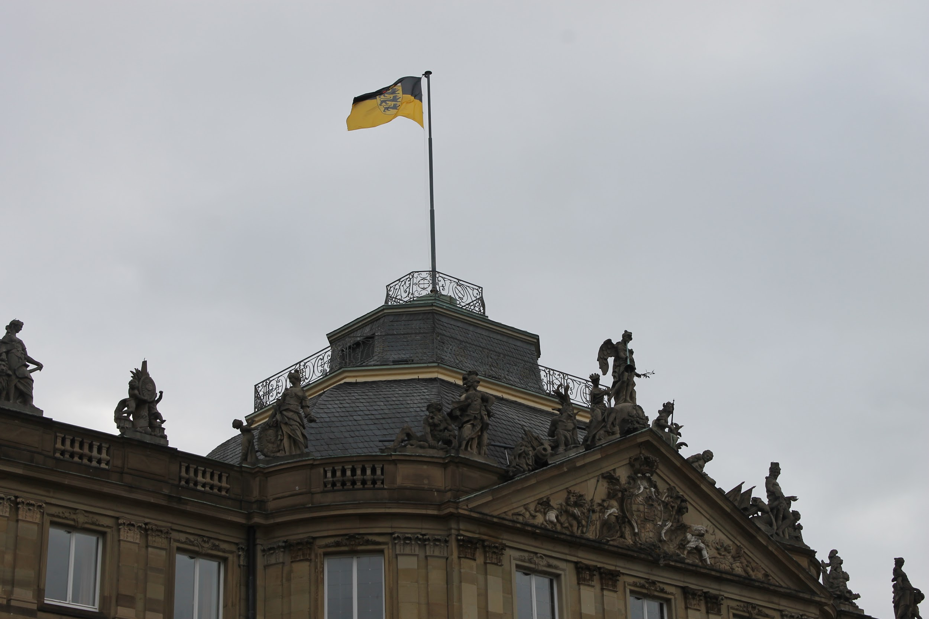
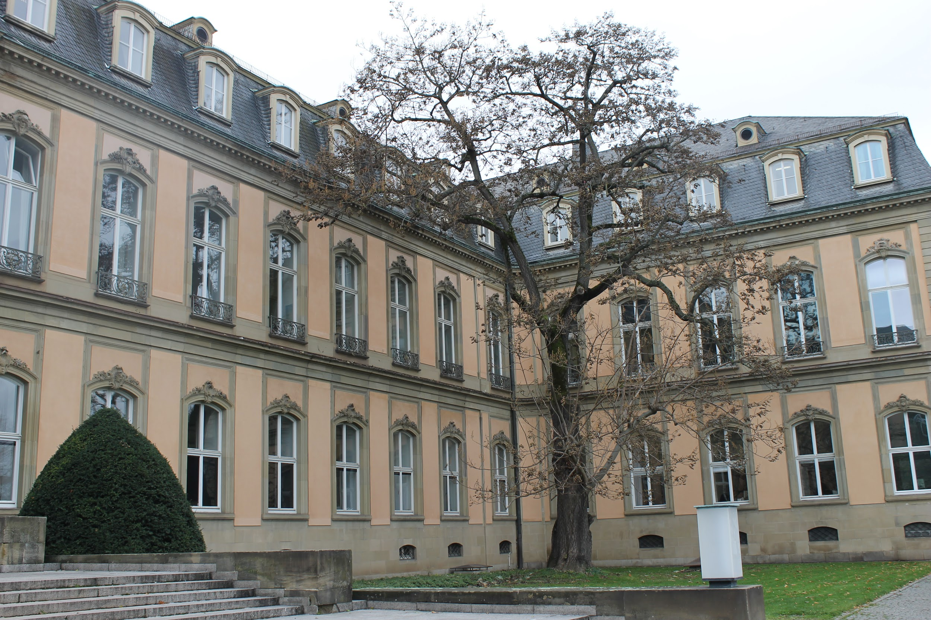
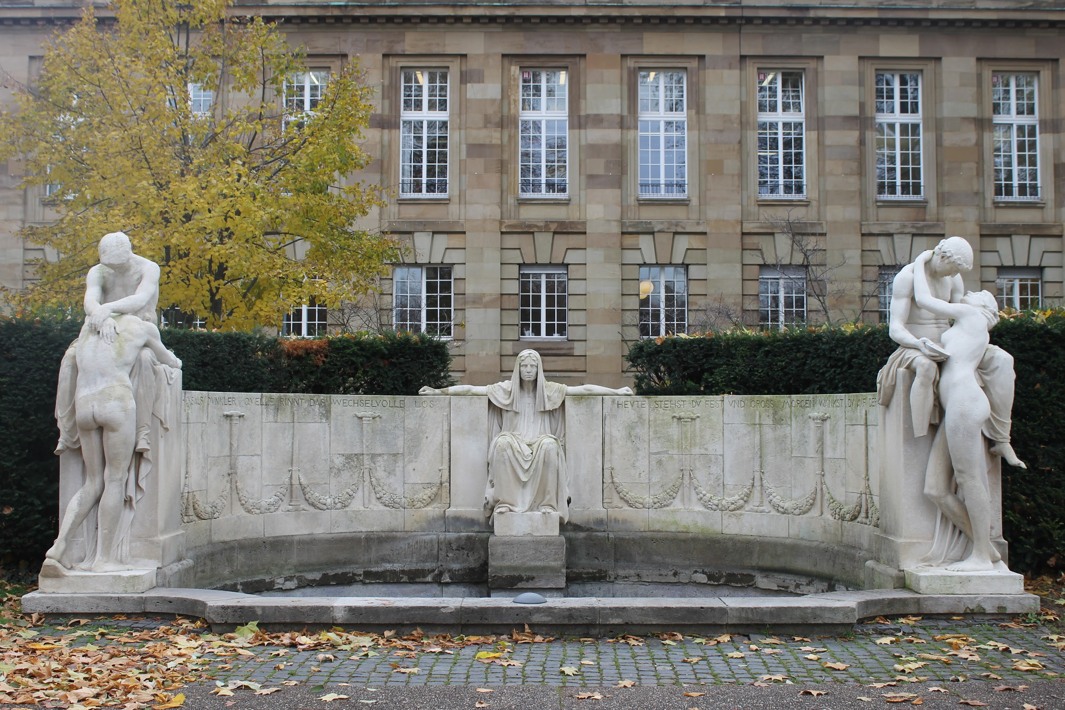
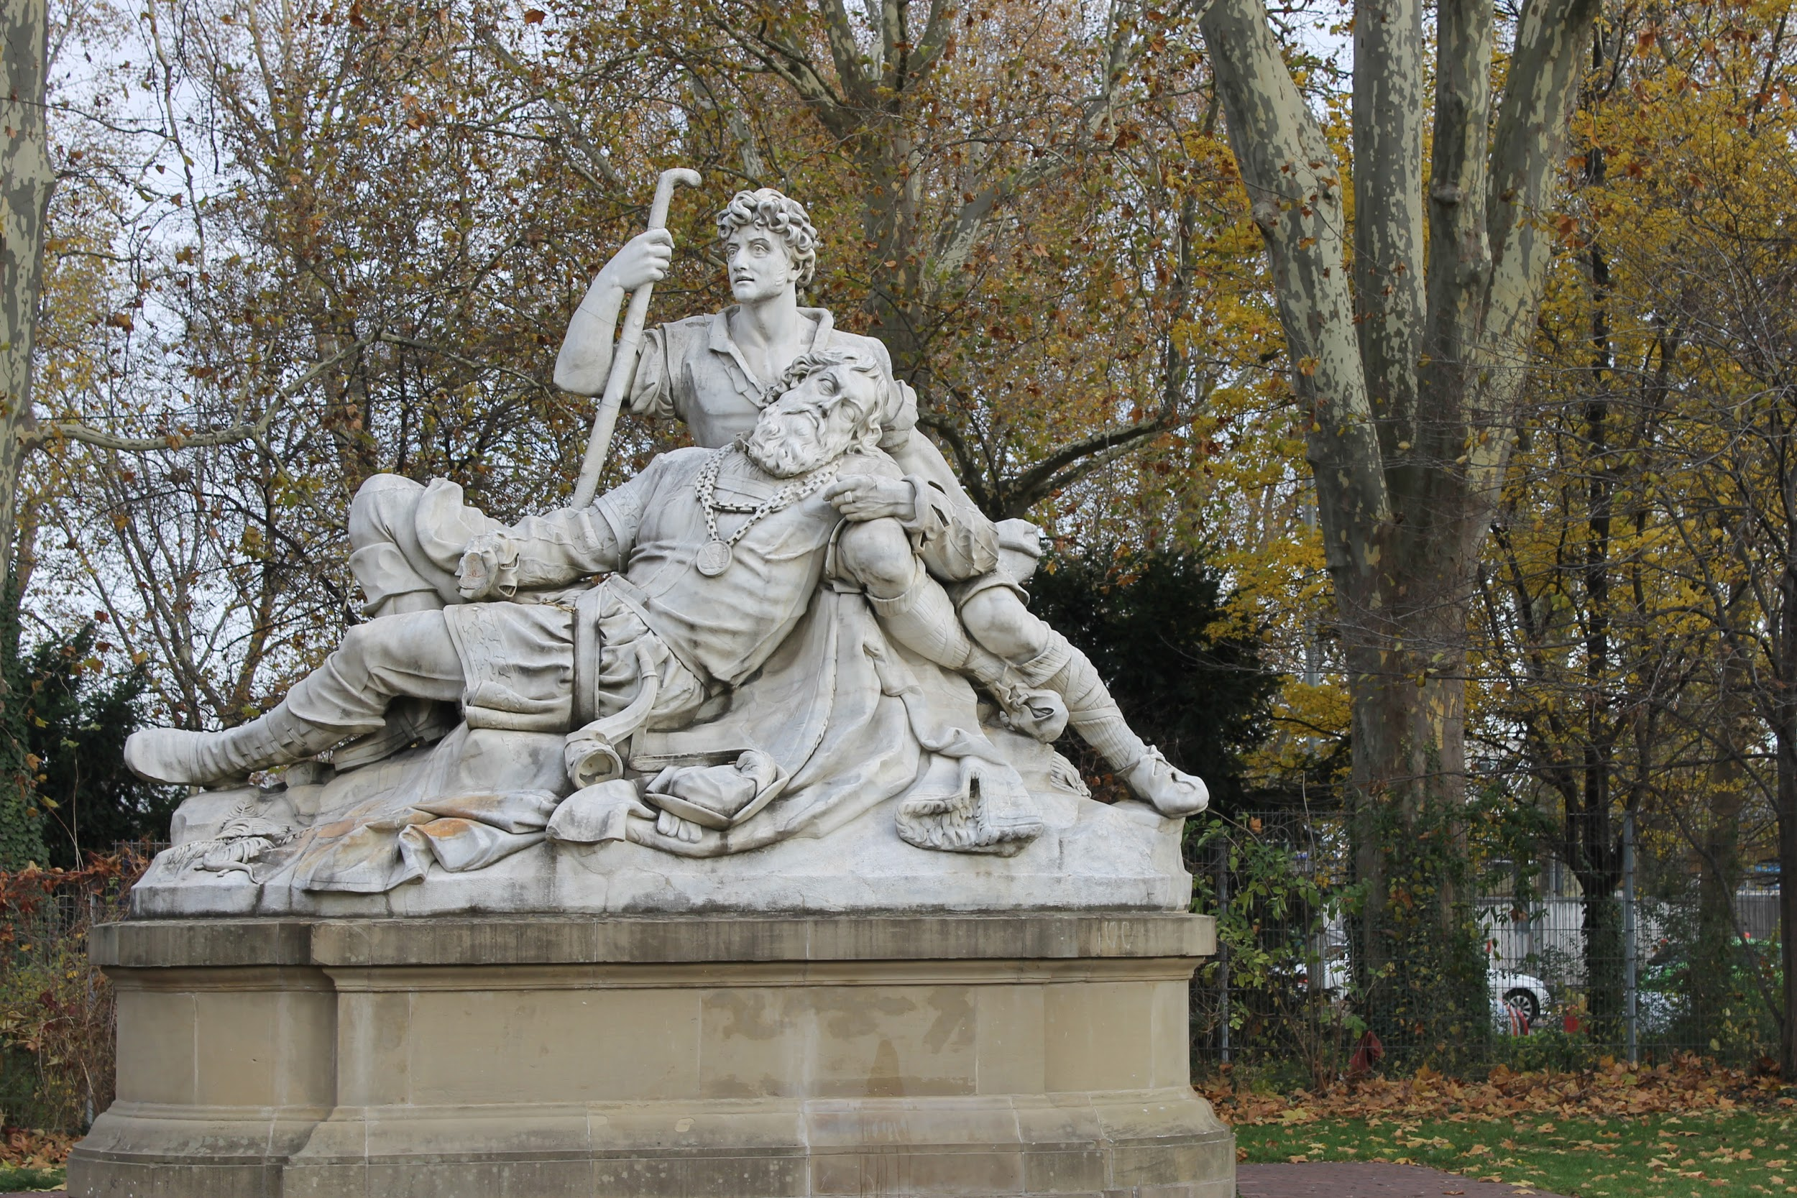

We had some free time after the tour. Me and the other finnish girls went to get some coffee (to be honest, we just went looking for place to stay and warm-up). We also did some shopping and generally looked around. After a while, we left to go back to school to work on our projects (interviewing people) for a moment before going to bake some Christmas cookies.
Baking the cookies was so. much. fun. I didn’t really do anything (except I did break some eggs for our dough!). I was the cameraperson.
Meanwhile everyone’s cookies were in the oven, we all just hang around (a.k.a. talked and fooled around) and waited for our cookies. Some of us (Katja and Rauno & Ella and Johannes) had a flour war… I got some sweet photos of those wars (on Ella’s camera, sadly). I think almost every single one of us had so much fun that night. I also found out that Lennart was a huge nerd like me; and a bonus; both of us are Ravenclaws.
After cooking, we left to go home. There my routine was almost the same as usual; light snack before bed, small talk-ish conversation with host family and then to my room. However, I didn’t go to bed yet; I had to write down the interviews for our presentation.

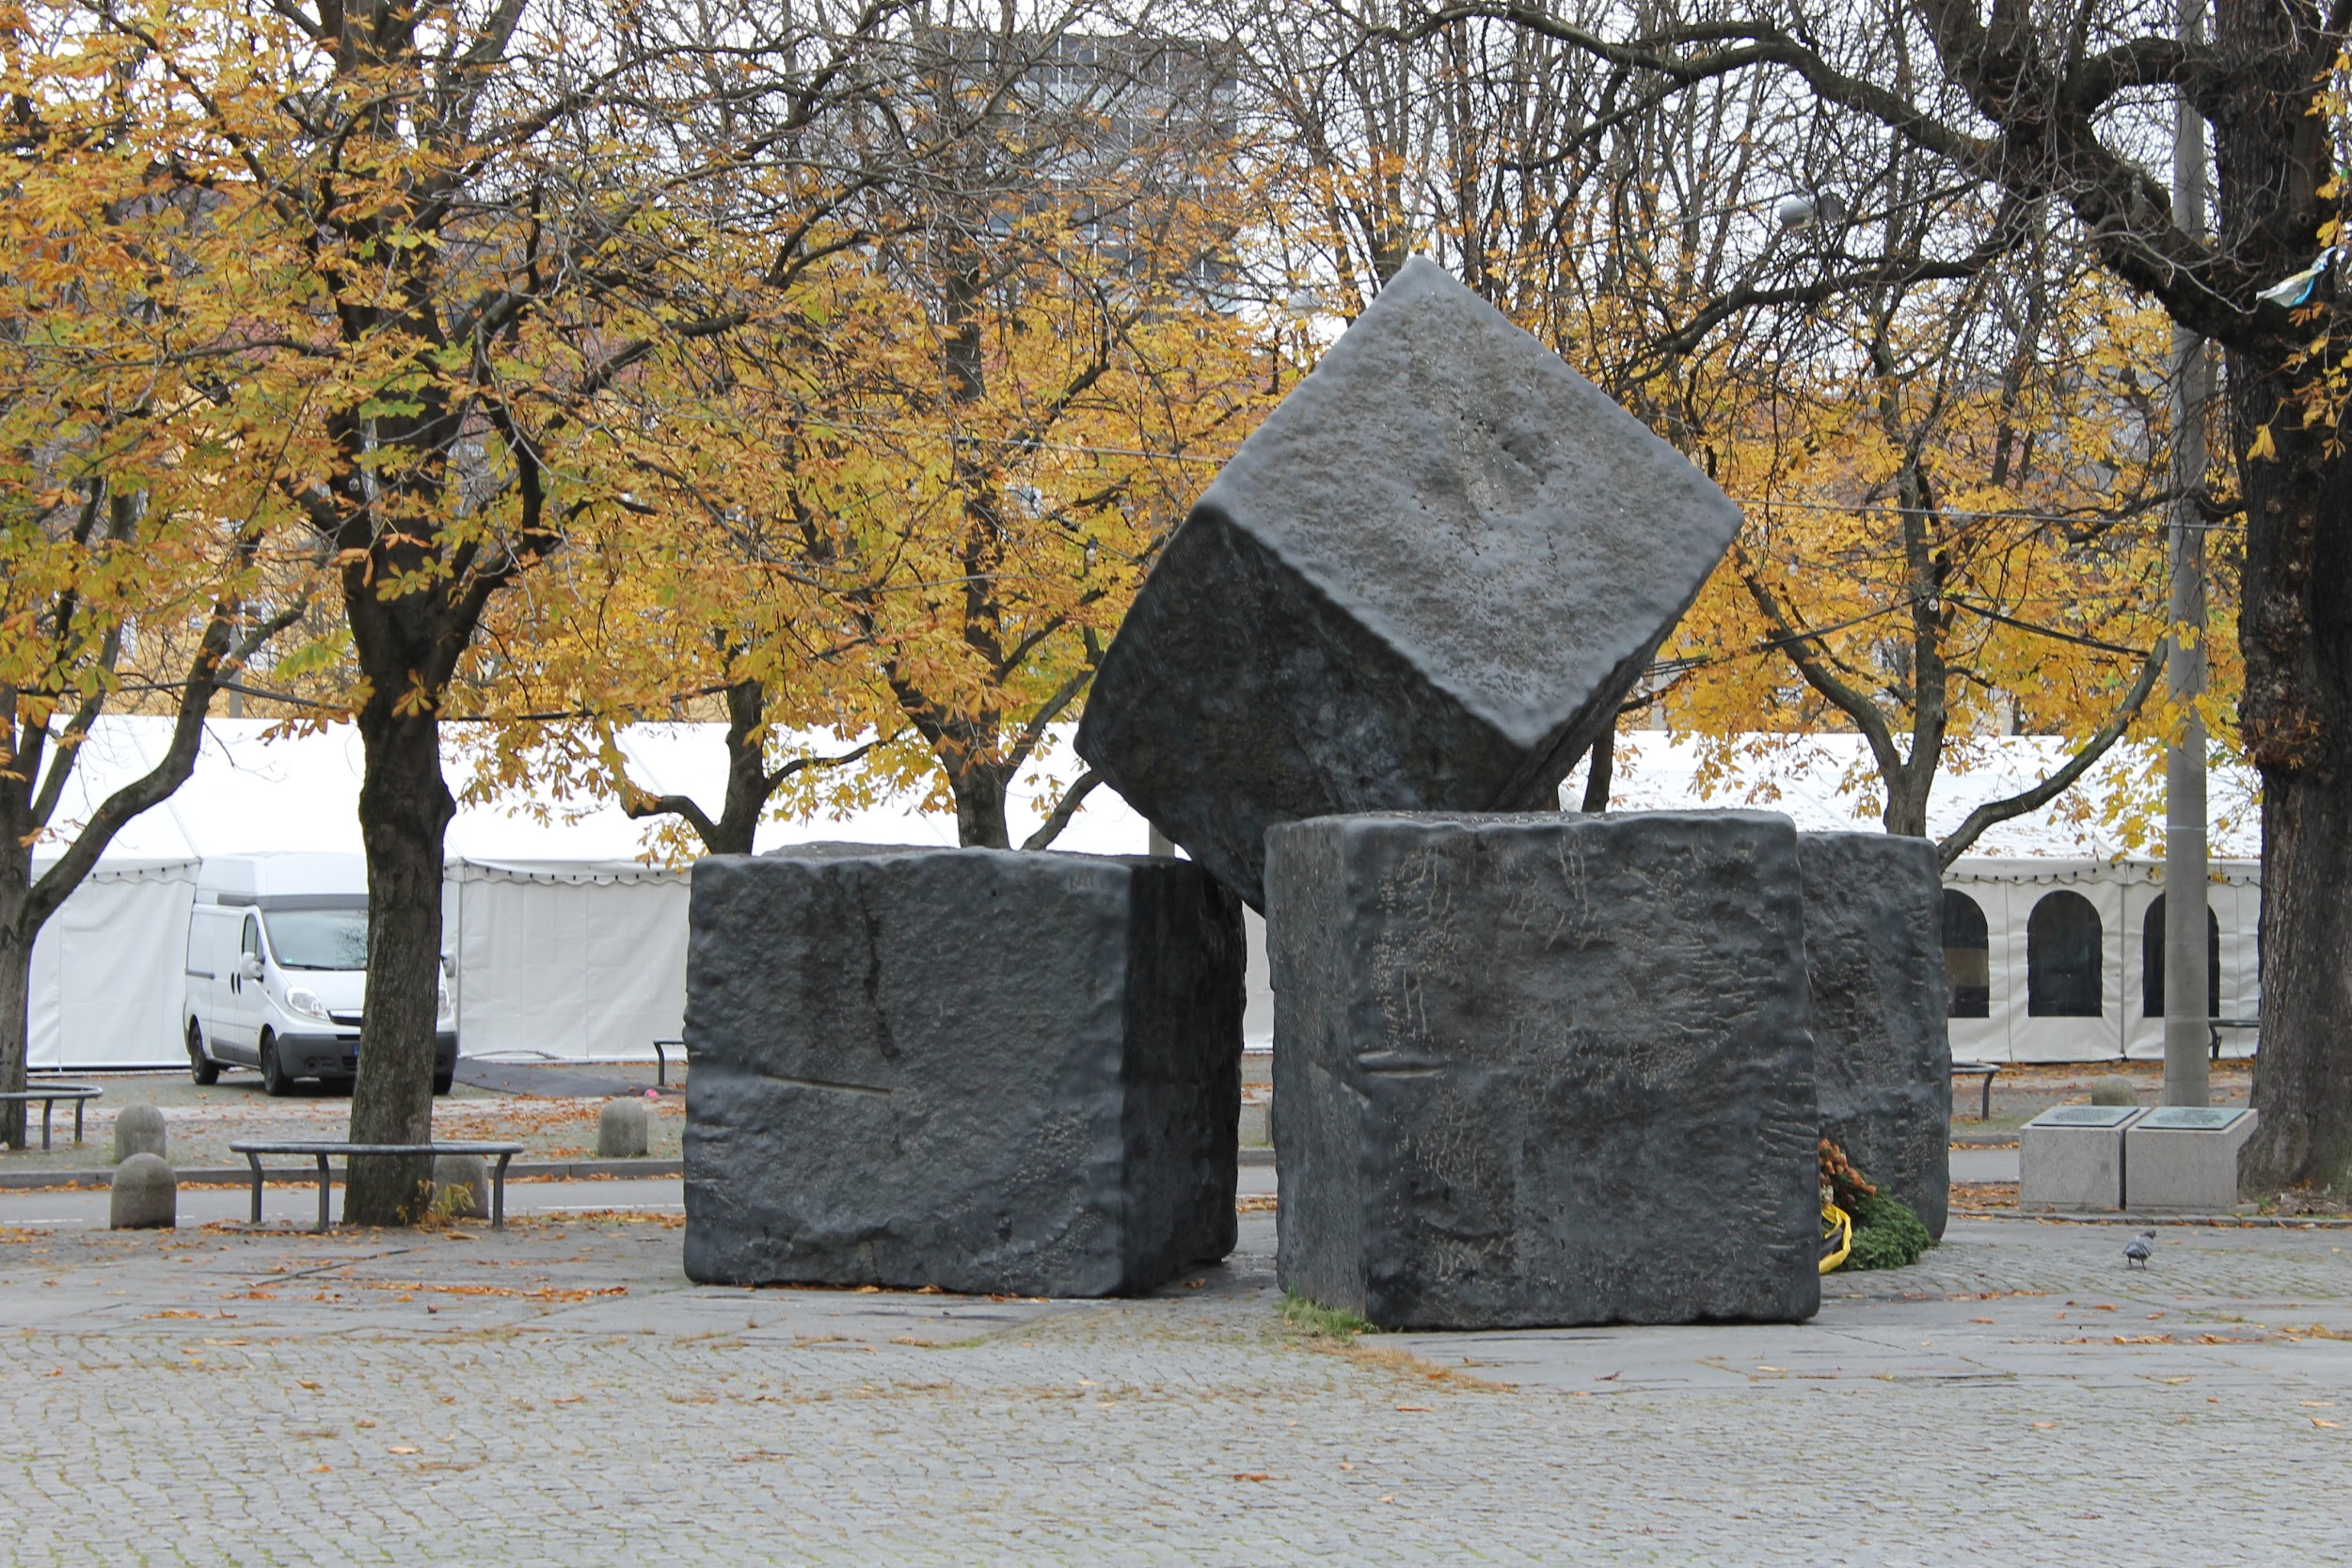
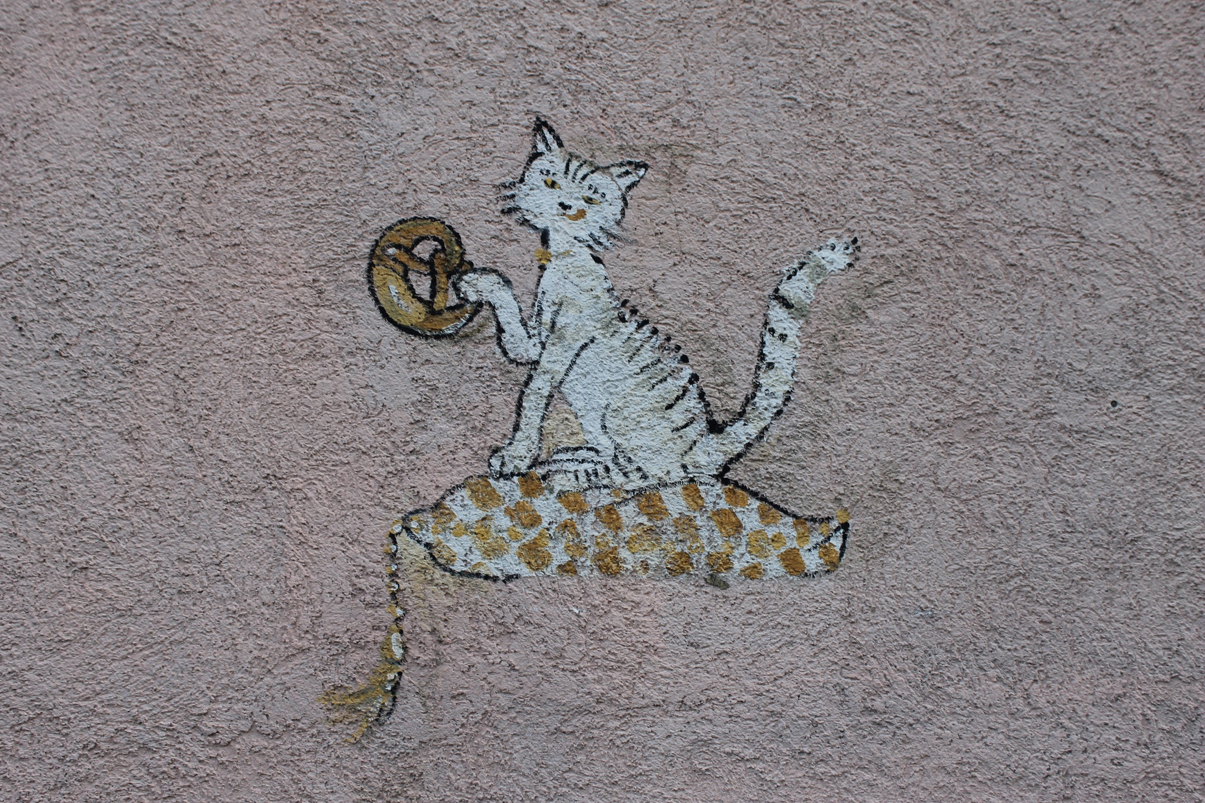
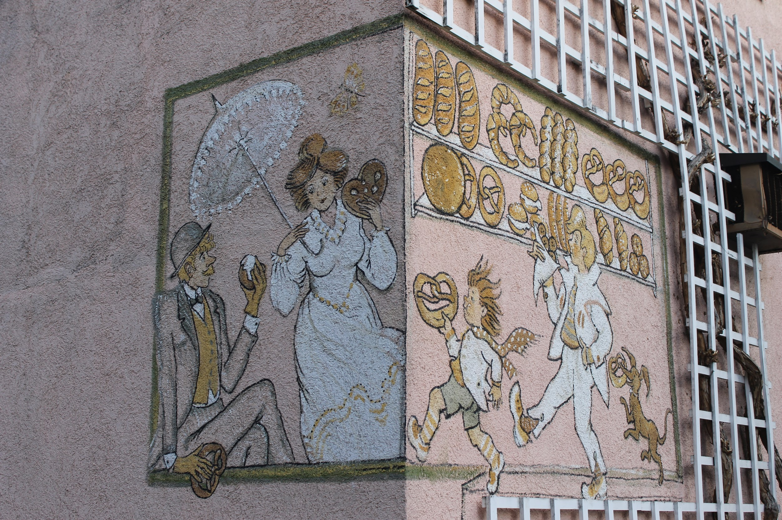
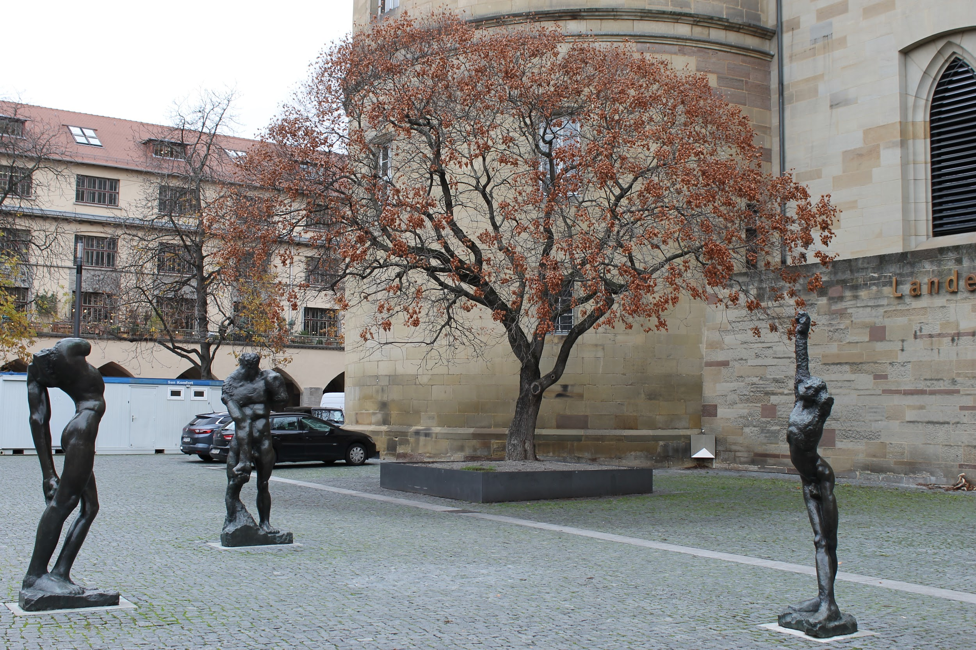

Tuesday 28.11.2017 - debating and visiting the Christmas market with lovely new friends

After a quick breakfast with Nora, we were ready for school. At the school, I started to panic about our presentation because it was nowhere near being ready. We had a quick briefing before going to finish our projects. I’ve got to say, my team was amazing! We did our (almost) whole brochure in an hour. Well, luckily we had all the material we needed, so all that we had to do was to put them together for the presentation. I was actually quite proud of us and our work.
In our team, we decided who all were to present and who were going to work as a chairperson. Me and Henriette were quick and took the job as the chairpeople, because it was obviously better choice than presenting (in my opinion). Being the chairperson was quite interesting (and easy, because we had a form, from where we just read what needed to be said).
After the first debate, we had a quick coffee break before it was time for the other debate. I have to say, I was really impressed by everyone who talked in a debate, because they did a great job.
Our day was over (at the school) around noon, but some of us still stayed at the school, including me. We did visit the town to go buy some food and this is the story of how I almost died. Why and how? Because the Germans do not know basic safety (in case of a fire) and have decided that it’s a good idea to have doors that open that open inward. Well, we visited this bakery and I opened the door but because I’m not used to the doors opening inwards, I slammed the door right on my toes so I couldn’t walk properly for an hour.
At the school I hanged out with Ella, Lennart and Katja (Rauno and Johannes were there too at some point). We didn’t really do much else but fool around.
At 4PM, we all (hosts and guests and teachers) met at the school hall and walked to the bus stop for our bus to Esslingen. In Esslingen, we headed to the Christmas market, which was so beautiful, but cramped. The weather wasn’t ideal either; it was cold and raining. No matter that, I took some beautiful pictures from the market.
Me and Lennart had so much fun nerding around at the market, especially the medieval part of the market, because we just talked about one of my favorite shows, The Adventures of Merlin.
What also comes to my mind about the market, was this little finnish shop called “Honig aus Finnland” (which I think translates to “honey from Finland”). Of course, me and Ella where super excited about this little shop and went to take a closer look. As we were saying the names of the honey jars out loud, the cashier said “moi tytöt” and I grinned like a fool when I said hi. Of course Ella, the dumb one of us (haha, not really), didn’t hear that and started to explain in English that we are also from Finland… Sigh. 😄
We looked around the market for two hours and then headed home. When we got there, I changed into more comfortable clothes (I was wearing jeans earlier…) and went downstairs to the kitchen to drink some tea. There, my host mom gave me some souvenirs to take home.
Since it was unfortunately our last night, Nora had planned a little “goodbye game night” at my host’s place. Ella and her host Julia, Rauno and his host Lennart and Pille and her host Hannah came over for the game night. We had so much fun, and I think me and Ella were on the border of a breakdown (because of the leaving) or something, since we kept laughing and laughing and laughing. We did manage to play two rounds of the game we were playing, though.
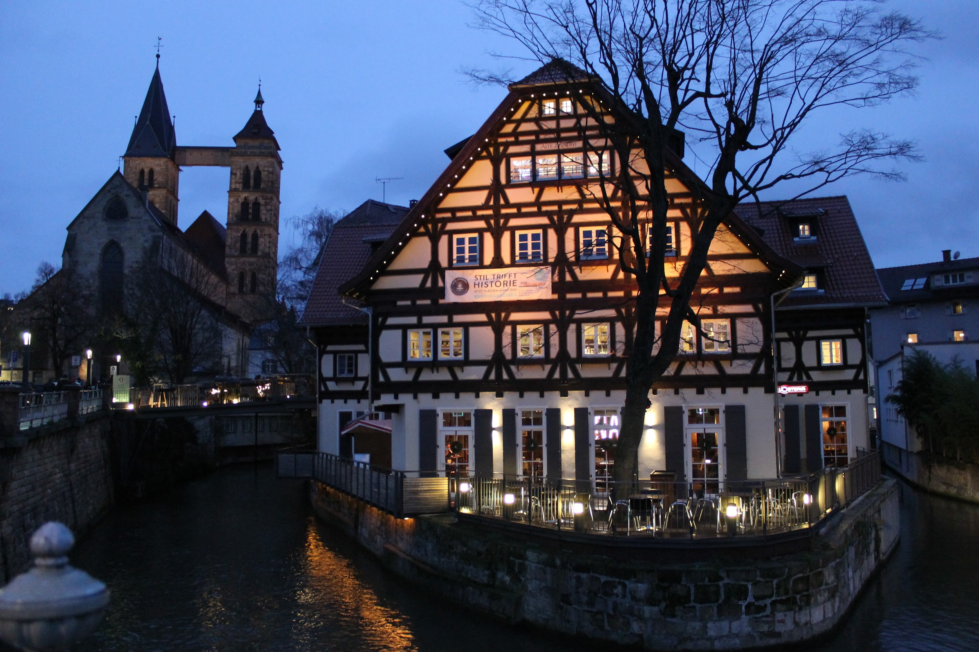
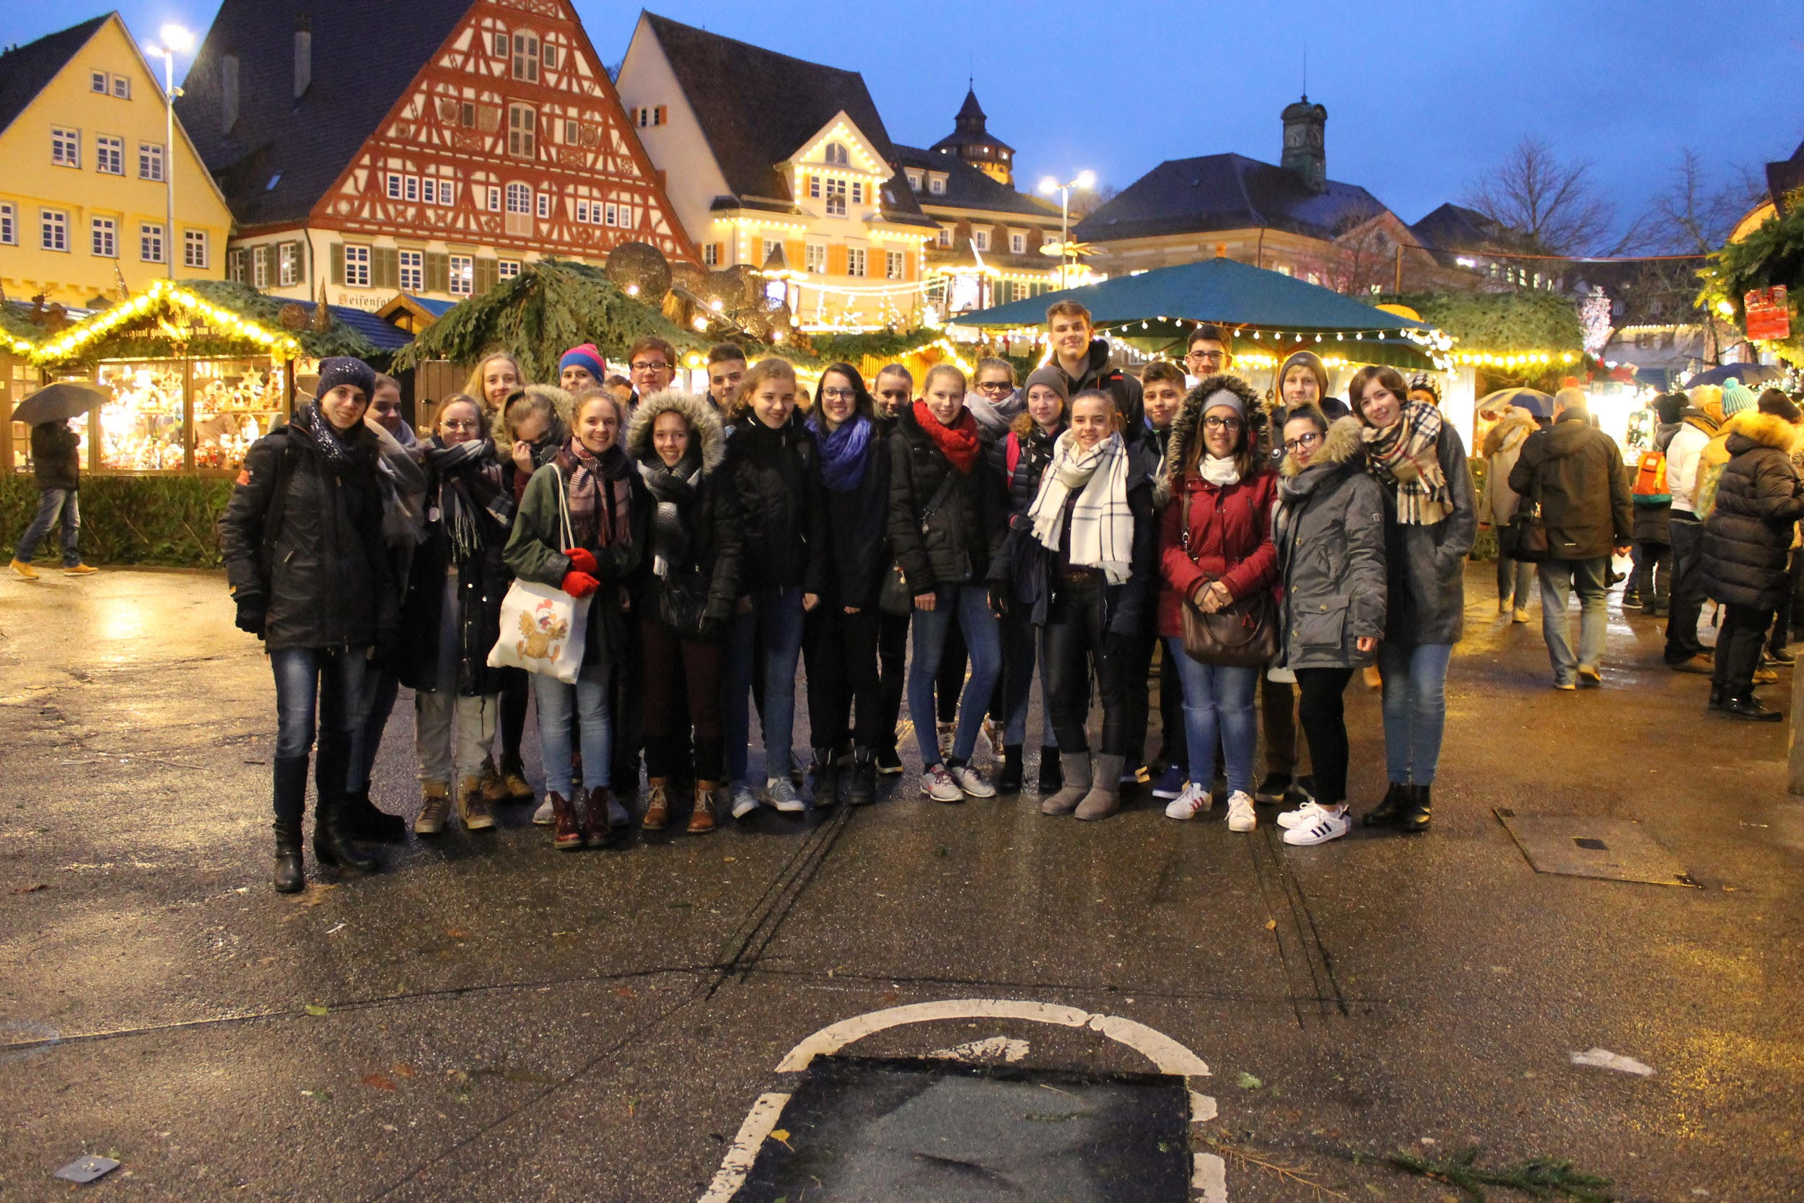
Then came the time, when the extra guests needed to leave. We took some group selfies, exchanged snapchats and instagrams and of course many hugs with everyone. They left around 11:30PM, then me and Nora went to bed. I remember thinking in bed that I don’t want this journey to come to an end, because we had JUST started to get so close to each other. The week went by too freaking fast. This following week has been so amazing and I couldn't feel more blessed and thankful.
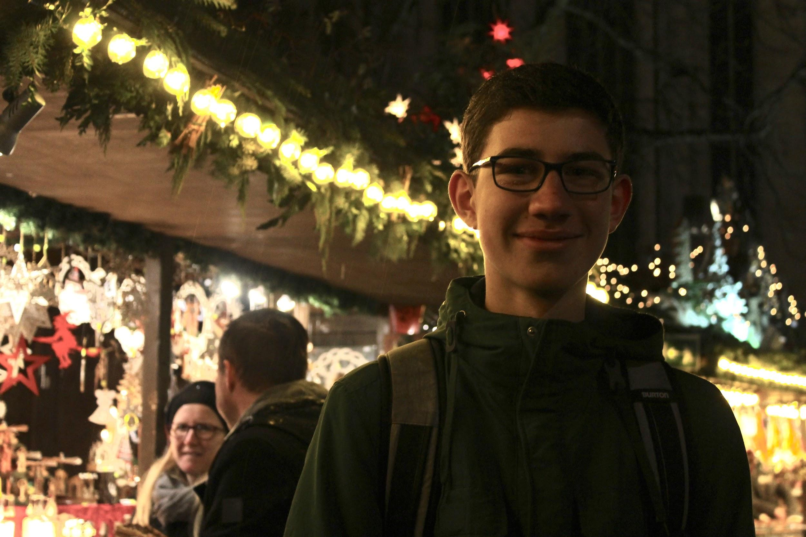
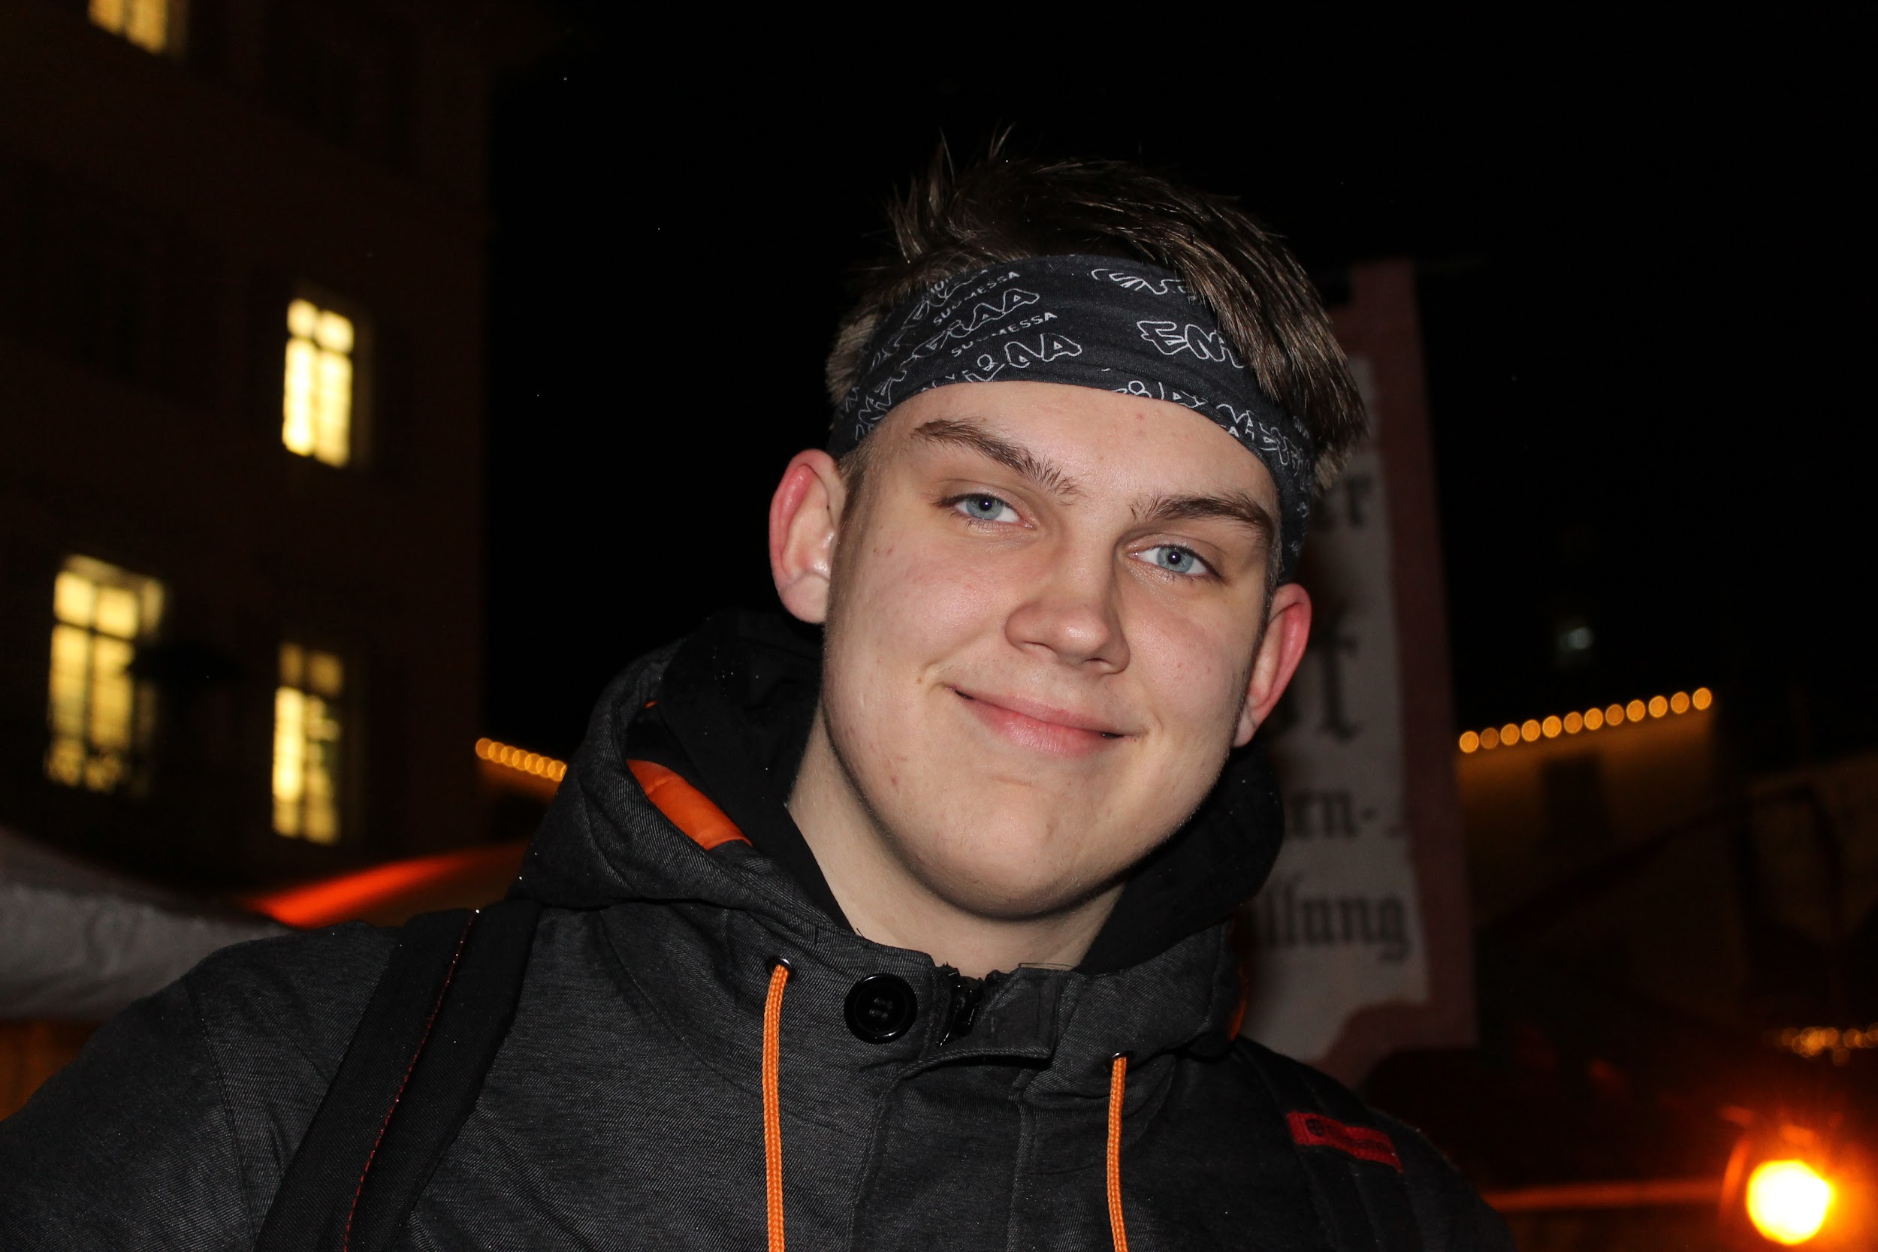

Wednesday 29.11.2017 - time to shed some tears, share hugs and say auf wiedersehen

Fair warning; I postponed writing this day until the deadline came across. I knew that writing this day would make me so sad, so I dreaded writing this.
Wednesday morning wasn’t the greatest morning in a long time. I slept as long as I could, packed my hand luggage quickly and then went to have breakfast with Nora and Jan. After the breakfast we left to the train station with my luggage. The morning was really pretty; the sky was clear and it was quite warm. (Bear in mind that it was raining the night before.)
When we got to the school, I wanted to run. I knew that this is it; we’re leaving. As the other arrived, most of us cried and all of us gave everyone hugs. Goodbyes are the hardest (but then again I am so, so lucky to have something that makes saying goodbyes so hard).
Anyway, the Germans’ classes started so we all hugged one last time (we thought) and then we were alone until some teacher came and opened the door to some empty classroom where we we left our luggage, until we needed them.
Not long after, one of the Germans, Julia, came back to be with us, because her teacher wasn’t at the school, so she technically didn’t have a class to attend to. We went to the supermarket near by the school in Ostfildern, bought some things and rushed back to school hoping Julia won’t get in trouble if she’s late from her class.
When we got back to the school me, Ella and Salla bought pretzels for the journey home. After our teachers came the classes ended and the Germans came to see us once again, which meant more hugging and crying. Anyway, around 9:30 AM, we sadly began our journey home, which was quiet and teary. I was so scared for the future; will our friendships last and will my friendship with my new Finnish friends change once we get home?
When we arrived at the airport and got through the check-in, we had “lunch” and then had some time to do some shopping until the boarding for the plane to München started. I didn’t buy anything from the airport.
All that I can remember about our plane to München was so small. When we arrived to München, we did some shopping, again. This time, I did some shopping too. I bought a pretzel magnet (and some other things too, but I don’t think the readers are interested in them).
Not long after, our boarding for the plane to Helsinki started. In the plane me and Katja were having maybe too much fun. I think we both were extremely tired and sad so we just laughed at everything we did or said.
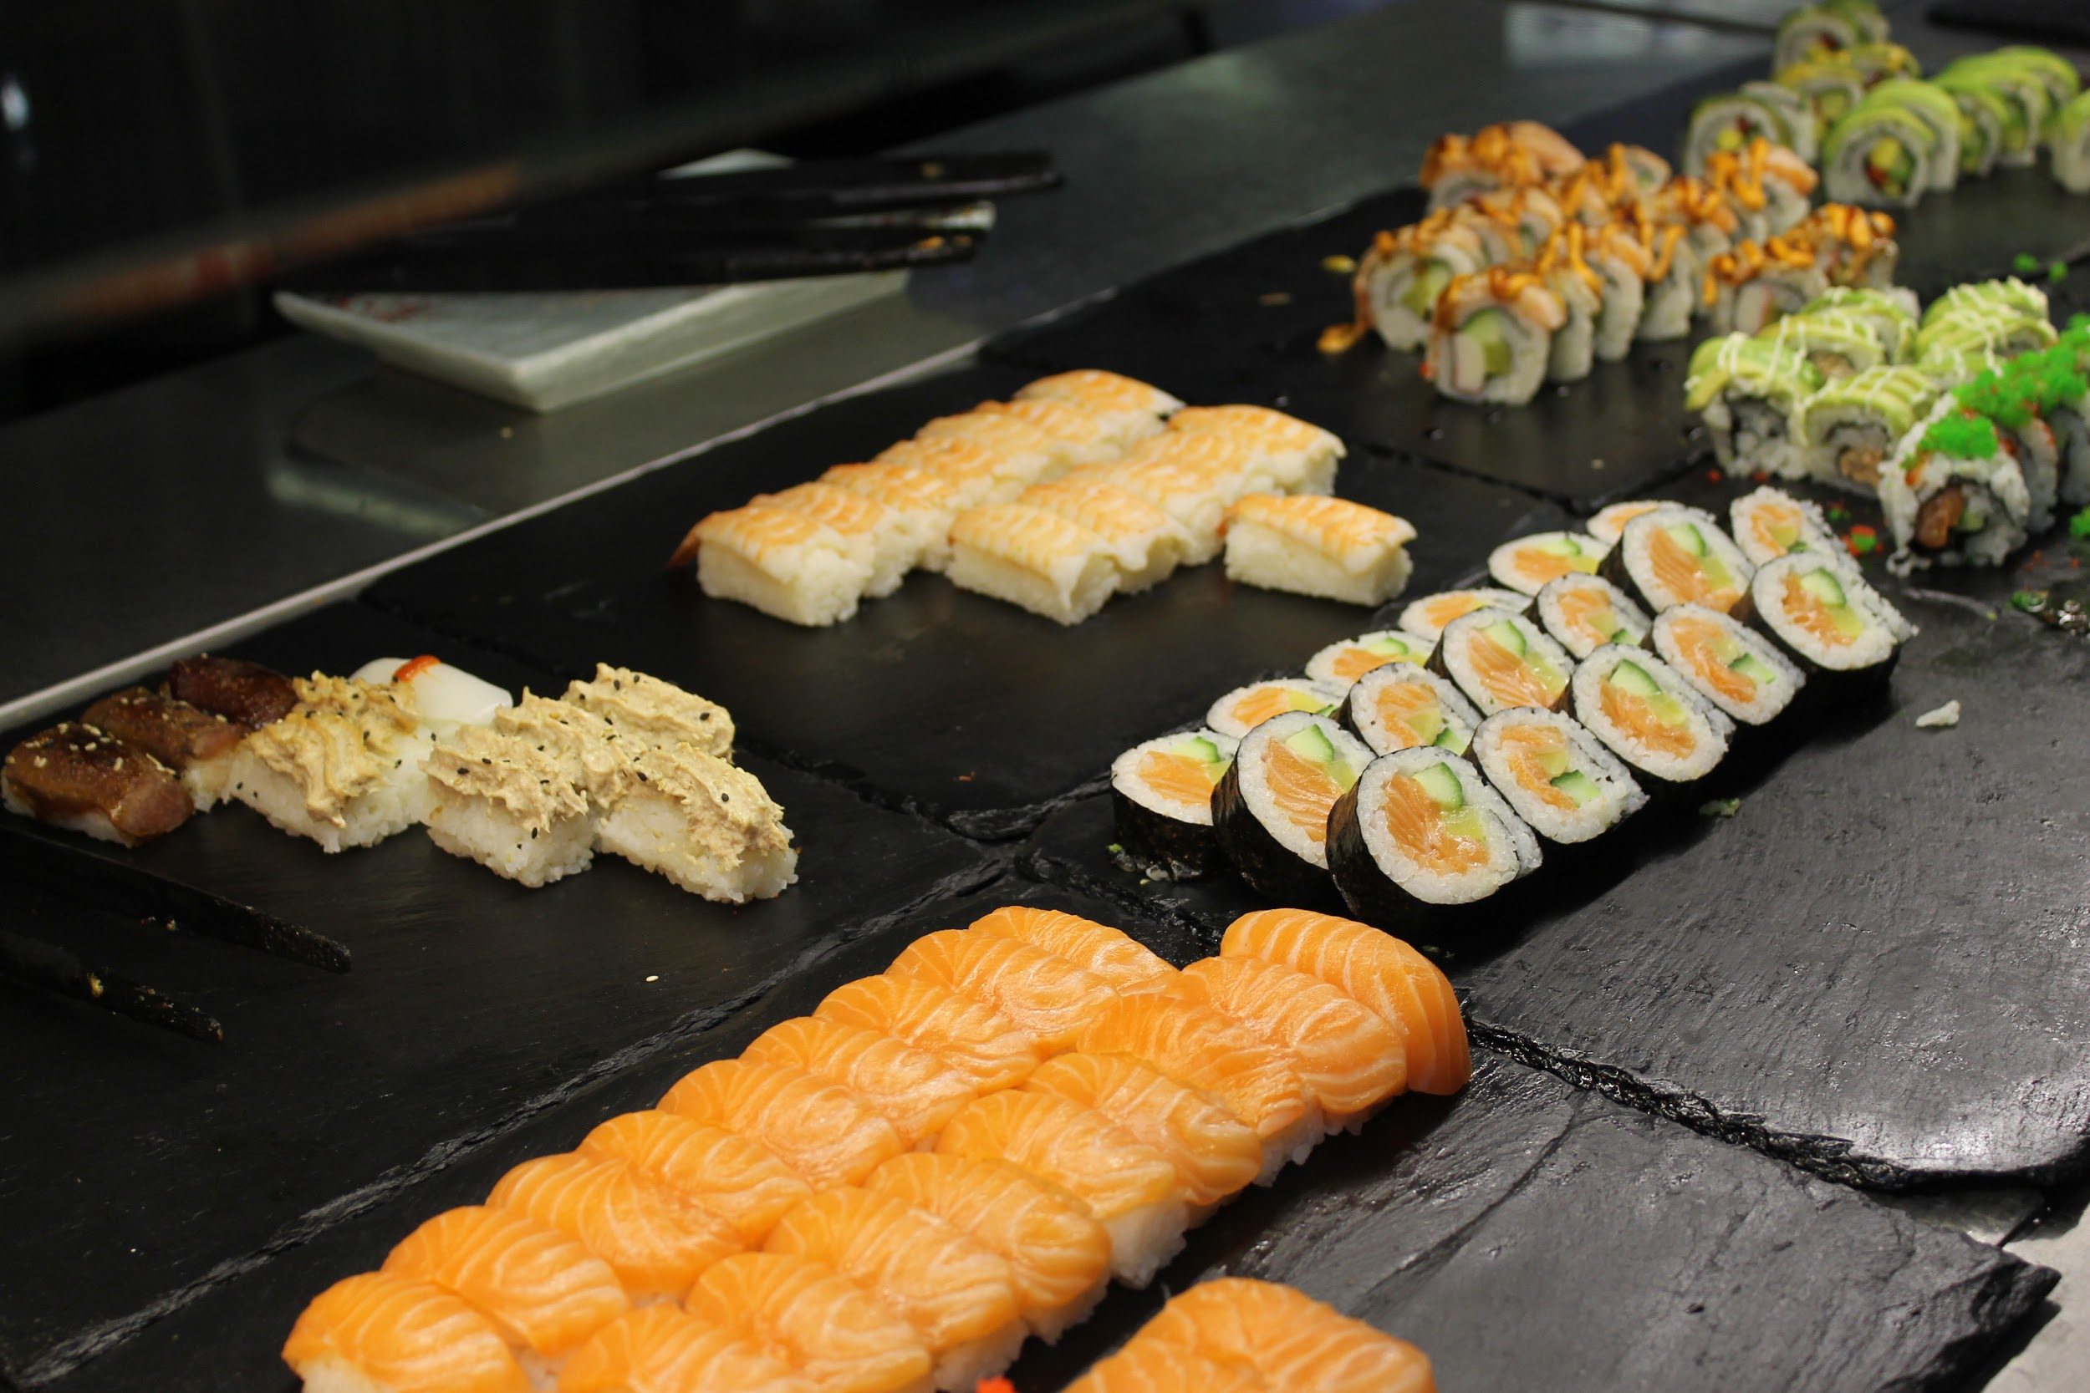
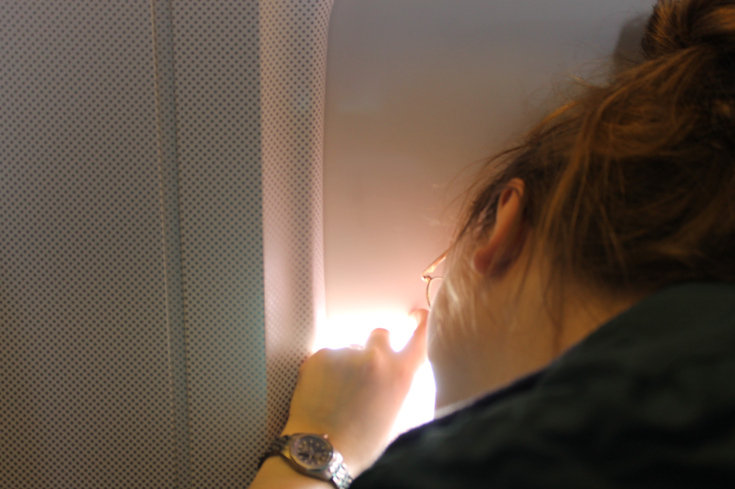
Anyway, after arriving to the Helsinki-Vantaa airport and getting our luggage, we were off to Tikkurila’s train station. There we had lunch (sushi). It was quite nice to be home, even though I would’ve gladly stayed in Germany. We weren’t in any rush so we had time to eat in peace.

Not long after we were done eating, we were on our way to Tampere by train. The train ride was filled with talking about the trip and watching photos from the trip. Salla was busy with writing her logbook while me and Ella were making jokes with Katja. At Tampere we separated with Väisänen and continued our journey home to Vammala.
Around 11PM we arrived to the train station in Vammala and that’s it, the trip was done. When I got home, I unpacked so quickly and then I just listened to music and fooled around in kitchen (drinking green tea). It did feel kind of relieving to have some own space and quiet without the worry of disturbing someone.
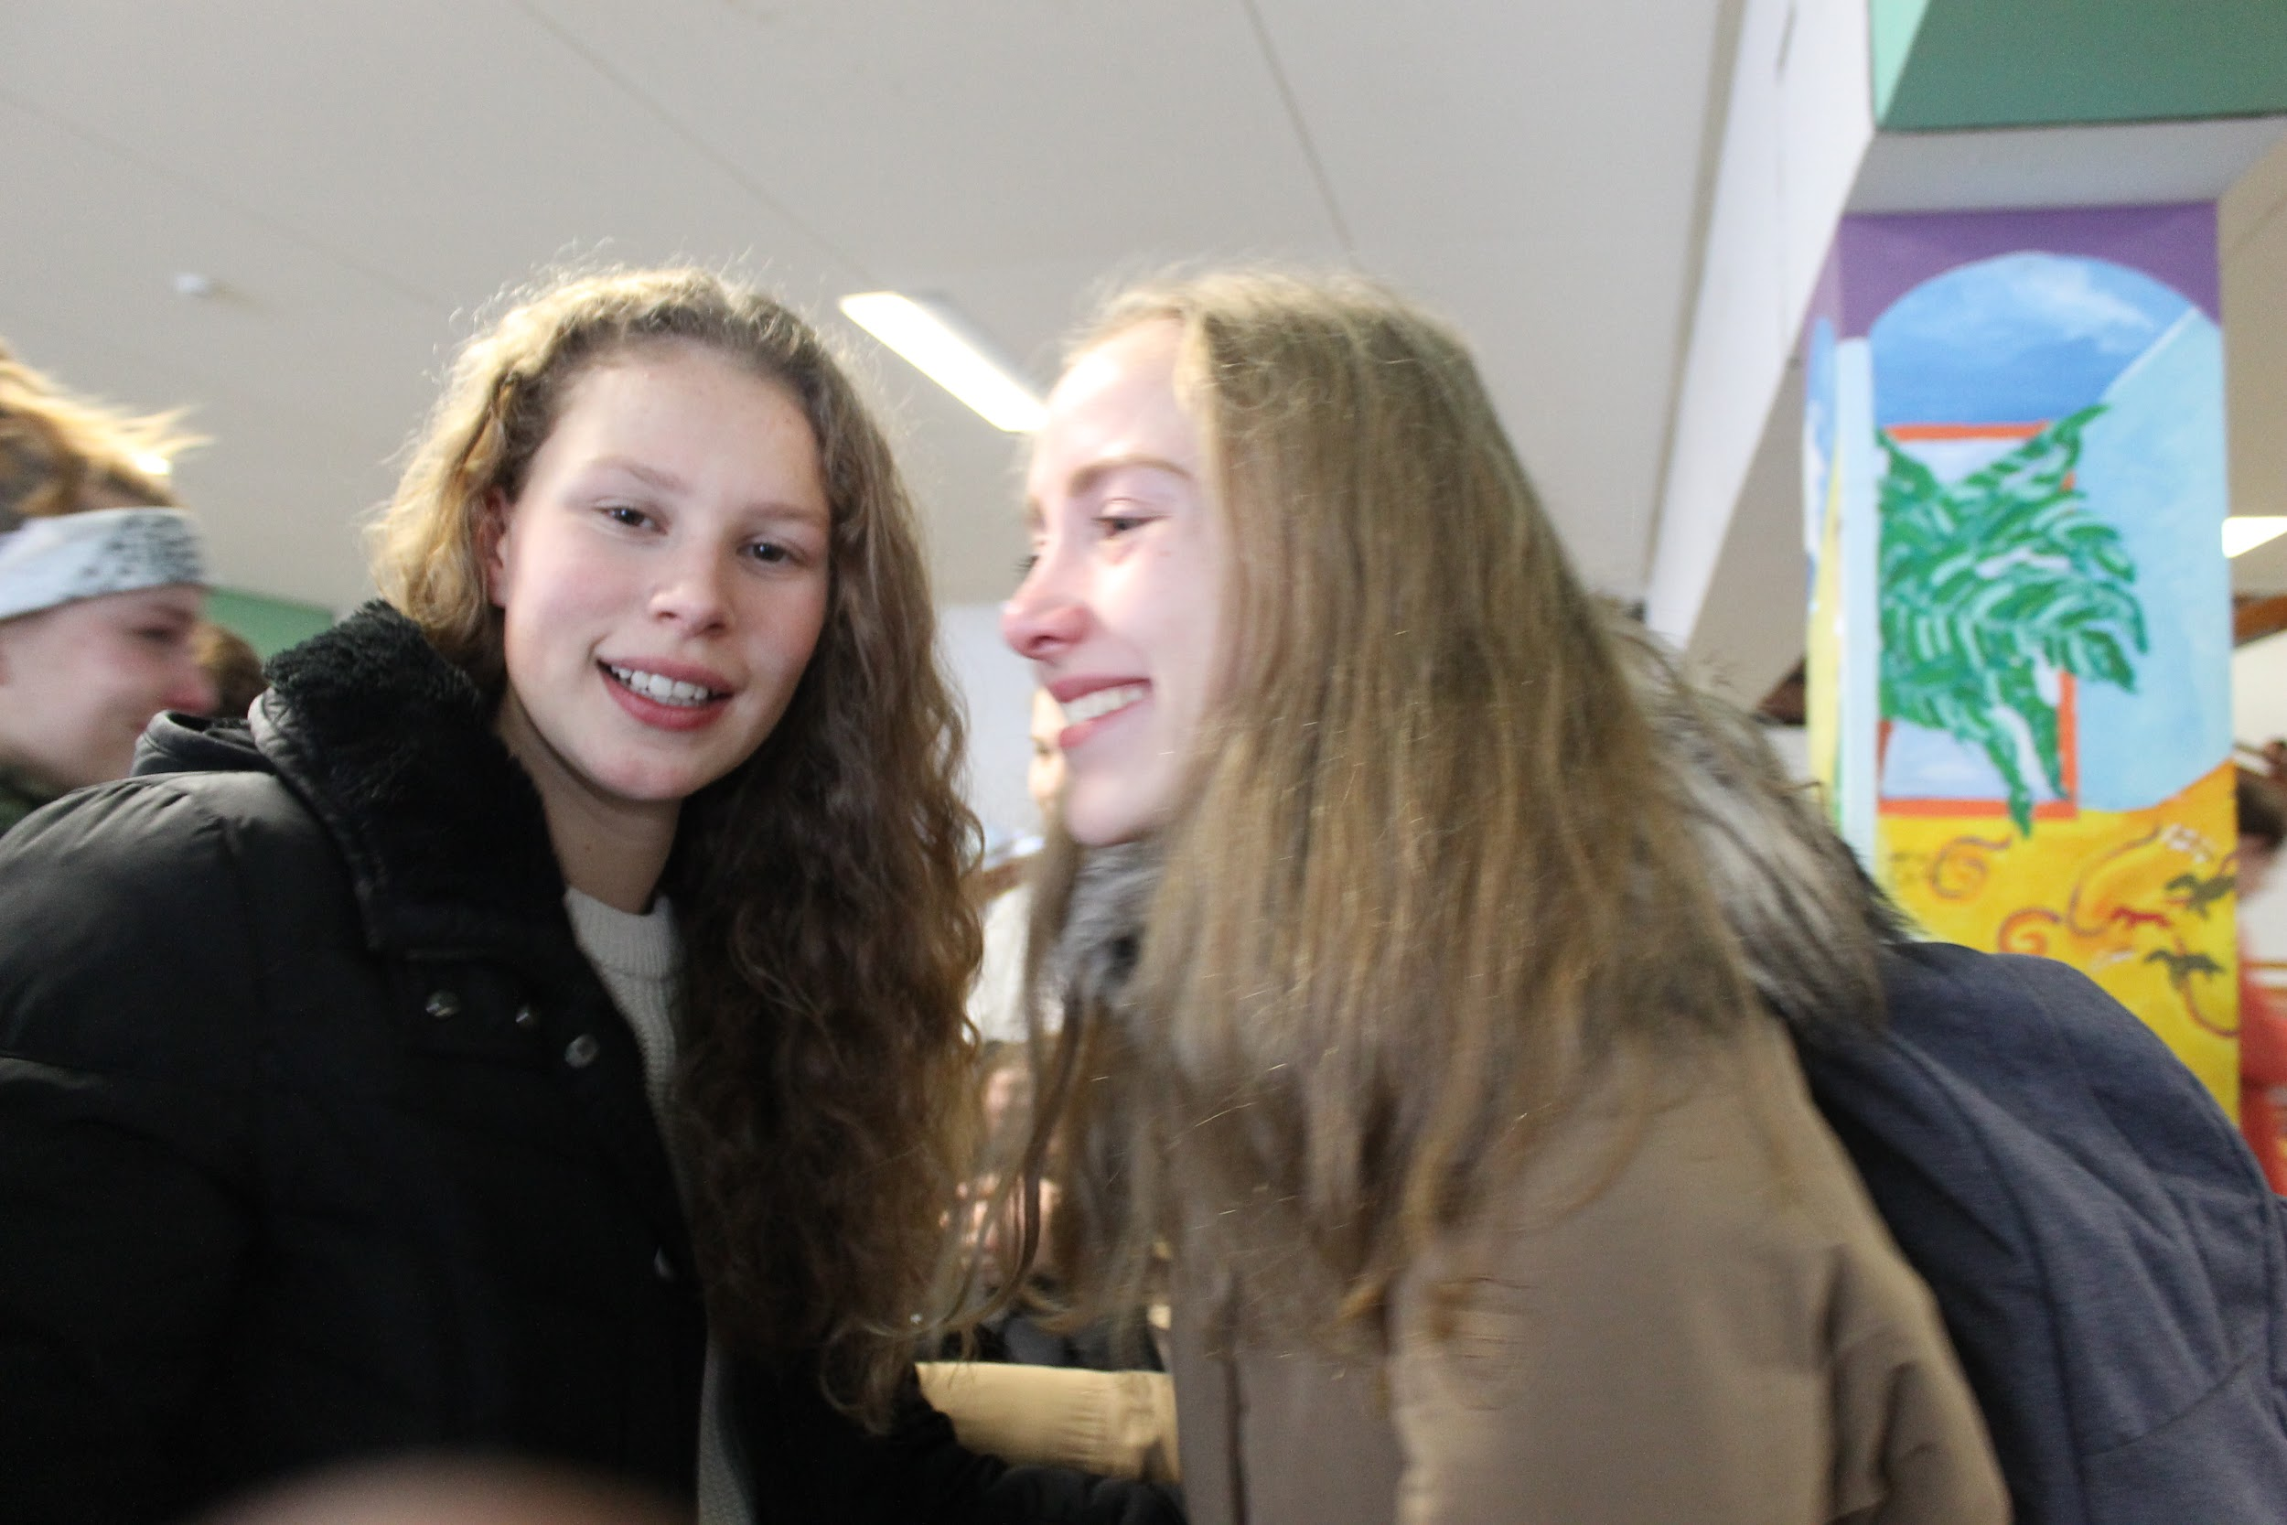
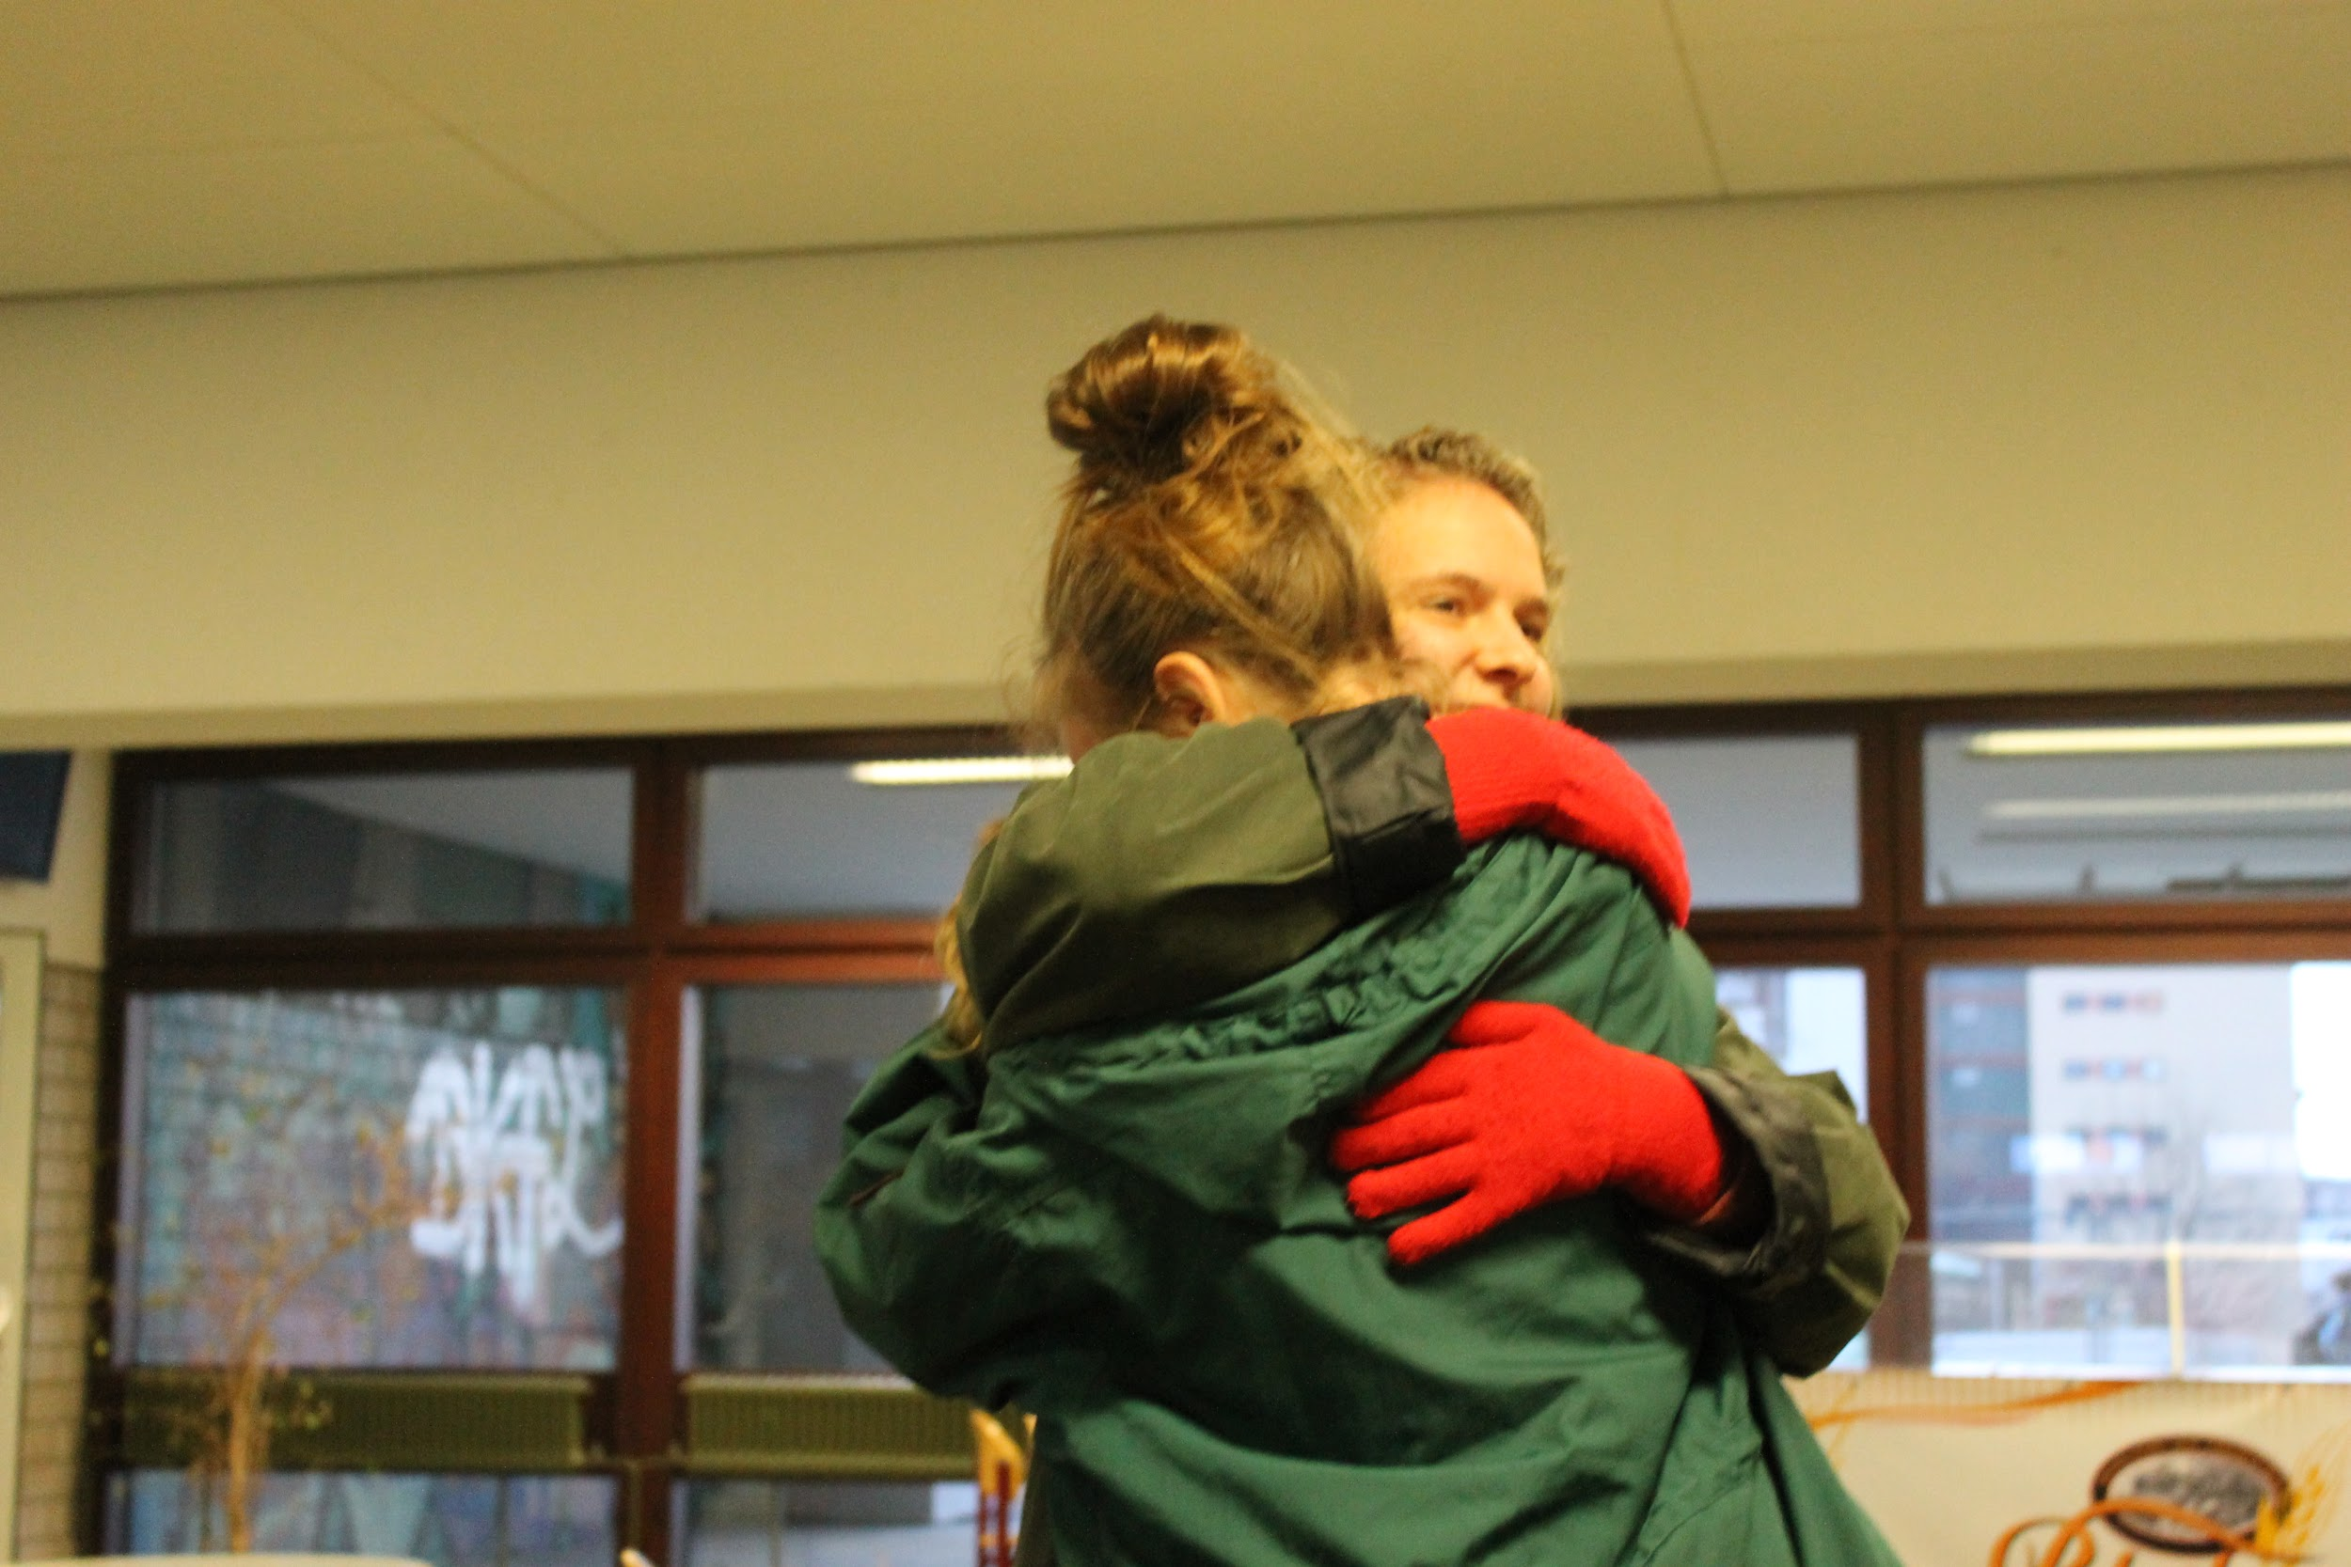
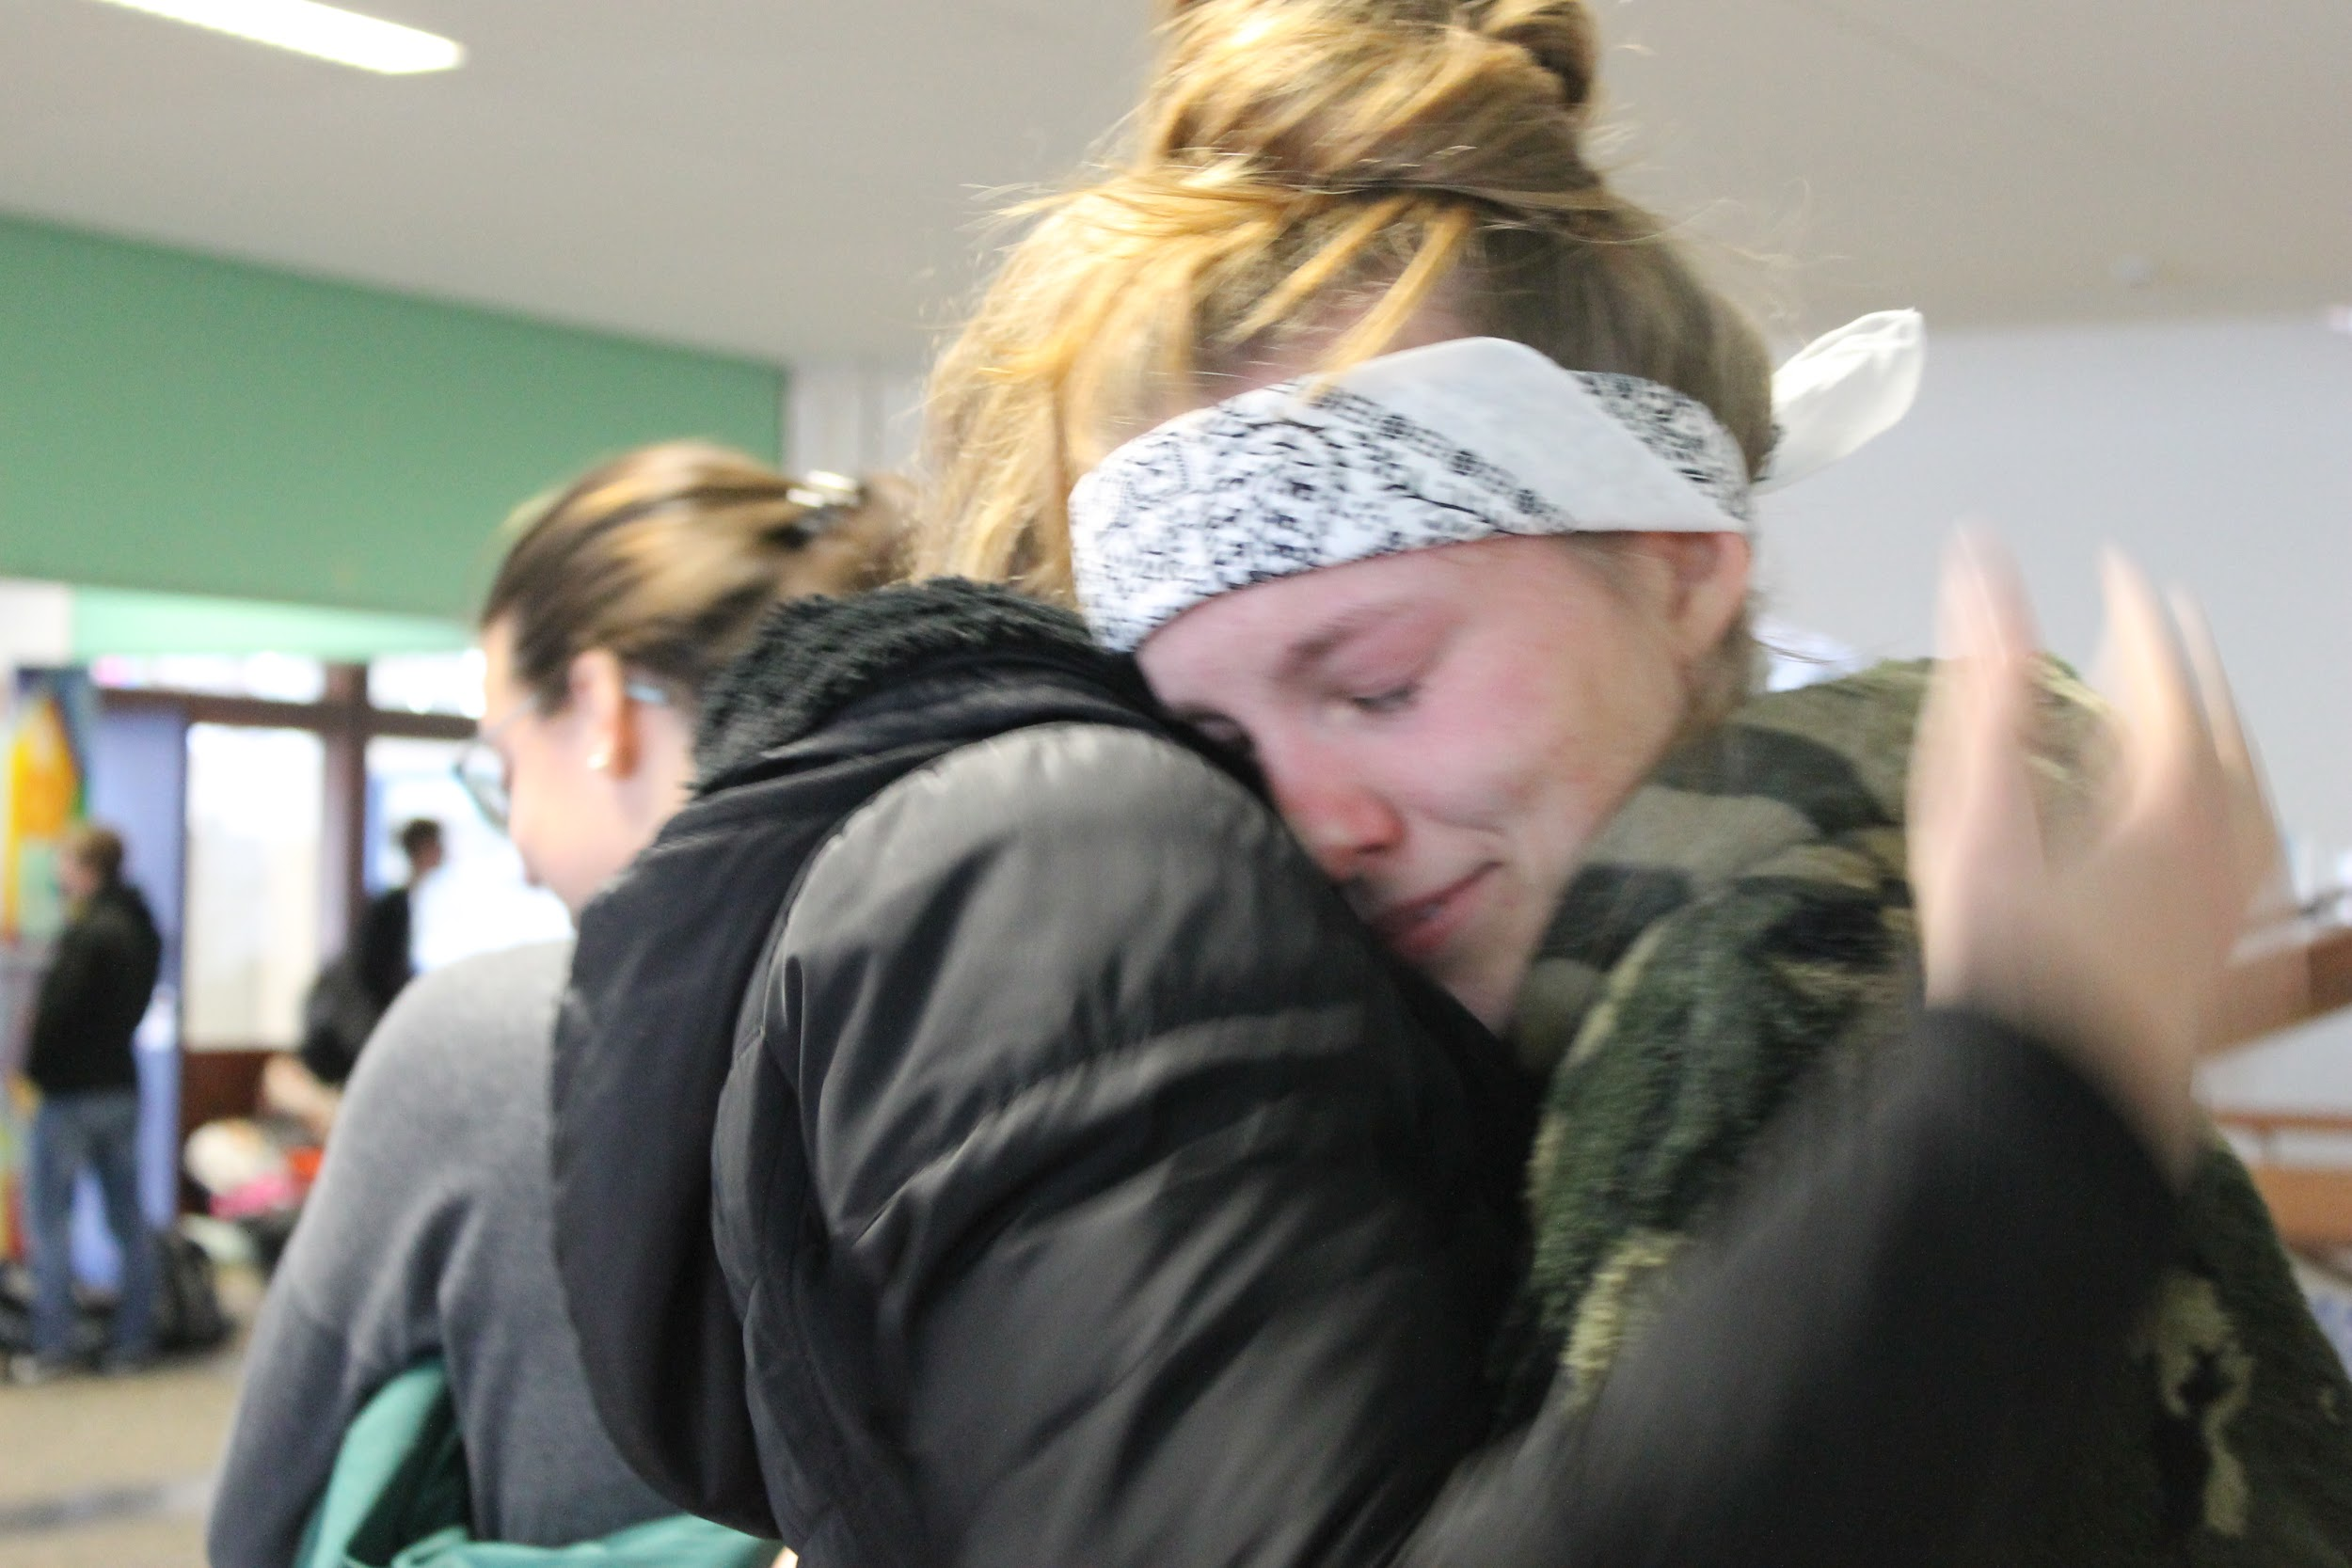
Nevertheless, the week was one of the best weeks of my life. Thank you all. I’m counting days until Finland’s project week so I can see some people again and meet new amazing people.


