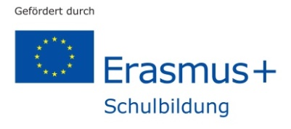
Erasmus+ “Work in progress” – How to conduct a debate

Evaluation of project meeting

Dear student,
we would kindly like to ask you to evaluate your project meeting in Germany.
Please answer the following questions.

First, please indicate your nationality:_______________________________________________

Project work in general

- What have you learnt about project work in general?

- What did you like / not like about doing project work? Why?

- Did you enjoy working in an international team? Why? Why not?

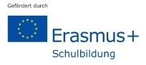
Project work in particular – How to conduct a debate / Air pollution in big cities

- Did you achieve the main goal of your project task? What went well? What went wrong? Which difficulties did you encounter? How did you solve them? …

- Which skills and competences have you developed or practised when carrying out the project “How to conduct a debate” / “Air pollution in big cities”?
What have you generally learnt about air pollution in big cities?

- What did you particularly like / not like about carrying out the project “How to conduct a debate” / “Air pollution in big cities”?

- Evaluate which activities, workshops, excursions etc. helped you best to accomplish your task, i.e. to conduct a debate on air pollution. Explain.

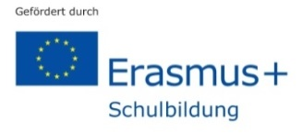
Project meeting in general

- Which activities, workshops, excursions etc. did you generally enjoy? Why?

- What would you improve with regard to the organisation of the project meeting?

- In what way have you personally profited from this international project meeting?

- Is there anything else you want to say?

Thank you for your cooperation!

