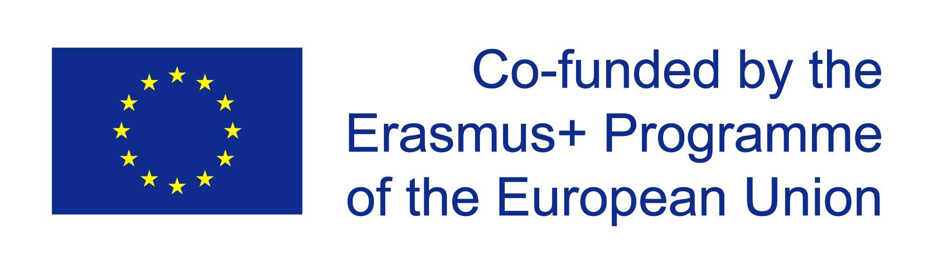
Project title:
PROPAGANDA ACROSS THE ATLANTIC – A bilingual history project on war propaganda in Germany and the USA during the World War II era.

Main topic(s)
Analyzing war propaganda in Nazi-Germany and the USA
What is propaganda?
What is propaganda allowed to do?
How far can propaganda go?
Propaganda vs. Advertising
Propaganda’s influence on Germany and the USA during World War II

Subjects included
History, English

Duration
5 weeks (approx. 10 lessons)

Group of students (age, level, …)
Year-9-students (14/15 years old), intermediate level

Main goal(s) and objectives
Cooperative learning in peer-groups,
Bilingual History – using English in historical context,
Understanding and analysing war propaganda and its influence,
Critical and creative work by destruction and construction of propaganda material

Activities
Working with historical texts and sources
Analysing visual material (cartoons, short movies, advertisements, pictures)
Deconstruction of propaganda
Construction of propaganda
- Mostly done in cooperative methods such as peer-feedback, group-work, jigsaw puzzles etc.

Resources
Bilingual History books
Historical texts and sources
Posters, movies

Project product(s)
Constructed propaganda posters, vocabulary lists, student presentations

General tips
Especially in classes without any experiences in bilingual school programmes, scaffolding is inevitable for work and results. Students should have a certain level of English in order to cope with material and be able to talk about the topic. Moreover, cooperation between courses (subject and language classes) could be very helpful in order to organize language work and historical work.

