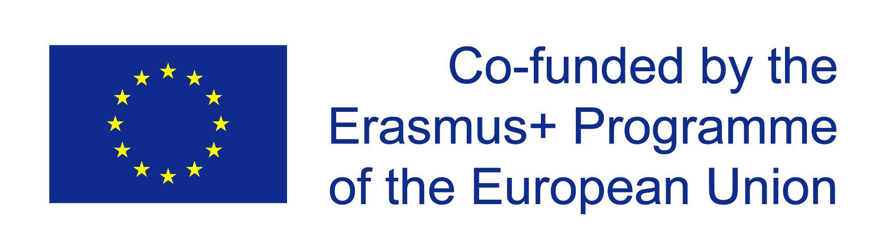

Erasmus+ KA2
Work in progress – Students managing public relations projects

Our project in Finland
“Young People and Political Participation” (panel discussions)

You are expect to conduct research on the issue of young people’s participation in politics in your country. Please find out about the following questions:

- Has the voting age been changed in your country since WWII?
- Are there any differences in voting ages in different kind of elections (e.g. municipal, parliamentary, presidentials etc.)? Please elaborate.
- What were the voter turnouts among the young in the previous elections in your country?
- Has the situation among the young in your country changed since WWII (e.g. are there less young voters now than before)? If so, how?
- If the voter turnout among the young in your country is considered alarmingly low, what is being / has been done about it?
- Your personal POV: how to increase young people’s interest and participation in politics in general?

Summarize your findings in a Word document / PDF / Power Point presentation. You can add suitable photos / statistics / graphs etc. Please, do remember to include a proper bibliography!
Your teacher will then upload your findings to the project’s e-Twinning platform.

