Aapeli Kuusela 1C

Matkapäiväkirja Eramus 2017-2019 Saksa (23-29.11 2017)

Thursday 23rd of November
Here we are in Vammala’s Railway station. I’m ready for my first ever trip to Germany and Ostfildern. No parents, no brother or sister for the next week. Finally, some own time. My dad brought me to the station. ”Have a good trip and remember to call us”, said my dad. ”Don’t worry I won’t forget”, answered I. Now we just wait for the train.
After the train trip we got to the airport. We dropped our bags to the bagdrop and went to restaurant to eat. Boarding to the first plane started at 13.30 local time. The flight went well. No problems or delays.
First, we flew to Frankfurt. We changed our plane there and then we flew to Stuttgart. My host was waiting for me at the airport with his dad. Even though this was my first day in Germany I was already impressed about my host dad’s driving skills. You really needed very good driving skills there. My hosts’ house was typical German house.
My host family was very kind to me. We had our first dinner together at the evening. Of course, they had Bretzels. I liked them, but they were a bit too salty to me.
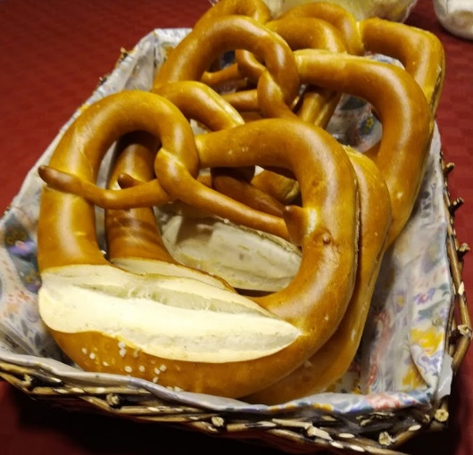
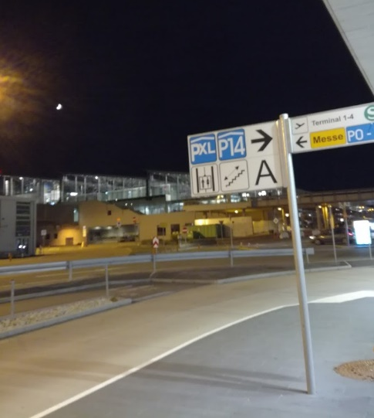
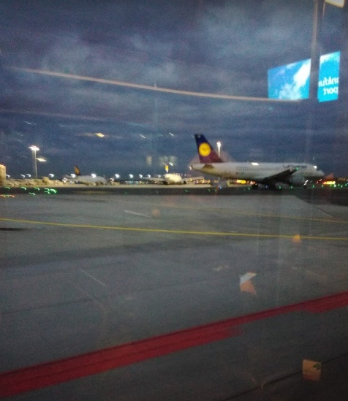
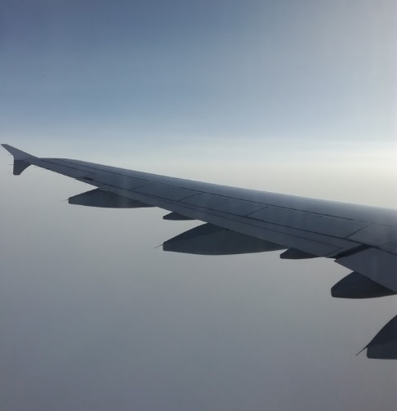

Friday 24th of November
First day at the Otto-Hahn Gymnasium. The school building was big. Day started from the auditorium by headmasters’ welcome. We were taken to a guided tour at the school. After that we went back to the auditorium. We had to prepare a debate in international teams. Our team’s name was GIFE group. Germany, Italy, Finland and Estonia all together. We had a few hours to start planning the debates. At 12 o’ clock we had a lunchbreak. I went with my host and a couple of his friends to McDonald’s. Apparently, their shortcuts were ”the best in the world”. My newest shoes were so muddy and dirty after that. We had to run back from the McDonald’s because we were late from the sports session. I ate my cold chicken nuggets after the sports session in the locker room. After sports we went back to the auditorium. We had a model debate and some workshops about debating at schools. Before we ended the day, we had a small presentation about OK Lab. OK Lab was a device which told about air pollution in some areas. The presentation was very interesting, and we were free to leave after that. I spent the whole evening at my host’s house and played PlayStation.
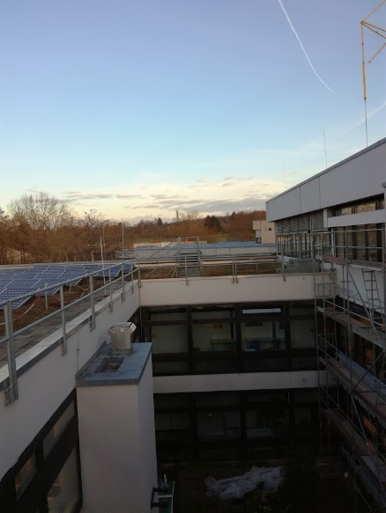
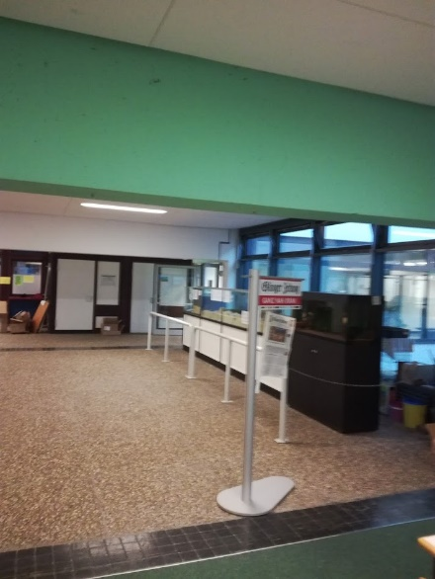
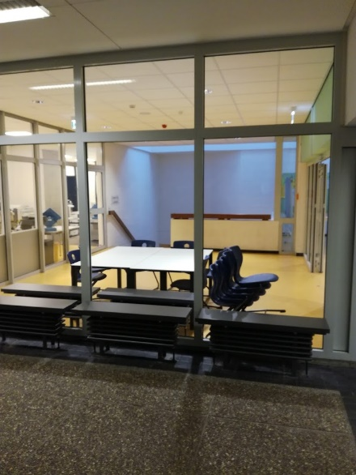

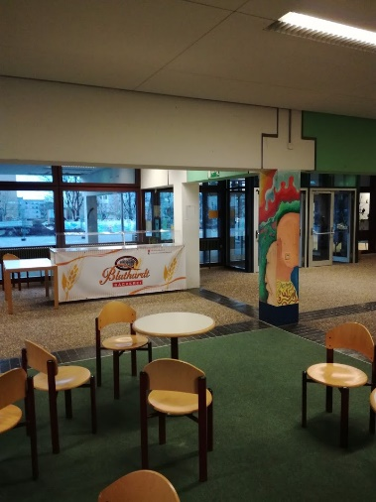
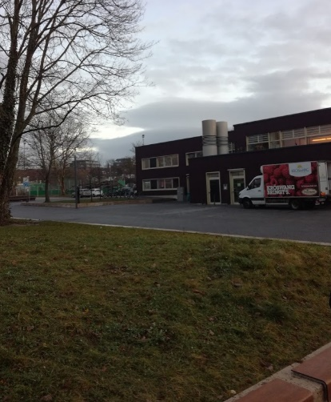

Saturday 25th of November
Saturday’s program started at the same time as a normal school day, but we had different plans for today. We went to the Mercedes-Benz Museum in Stuttgart. It was a big and fantastic place. There were so many cool-looking old and new cars from Mercedes-Benz. My biggest interest was in the racing cars. I got a change to pose in front of Mika Häkkinen’s 1998 formula one championship winning car. I bought a Mercedes-Benz shirt and a museum magnet from the Mercedes-Benz shop. I really want to visit there again. It was such a cool experience.
After leaving the museum we split into our international teams and we played Mister X. It was a game how we became familiar with the transport systems in Stuttgart. After we ended the game we had free time to hang around in Stuttart. I visited in a Tesla shop with my host. It was nice because I haven’t never sit in Tesla’s car. Unfortunately, I don’t have a photo from there. We spent about two hours in Stuttgart and then we just took train back to Ostfildern.
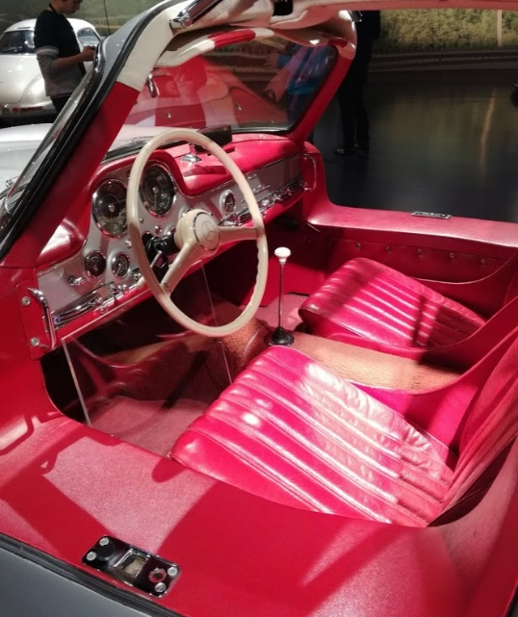
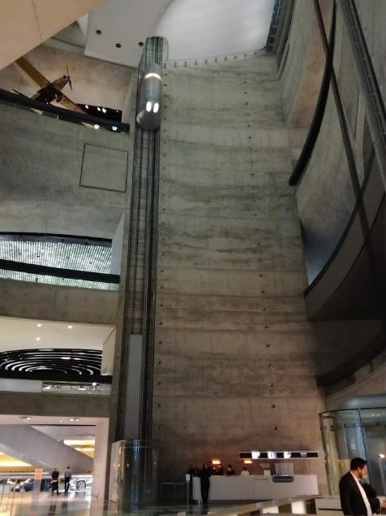
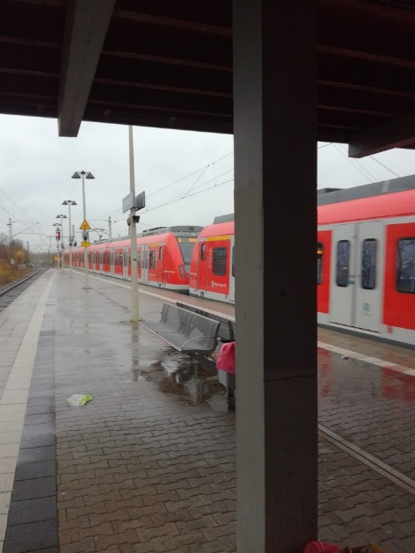

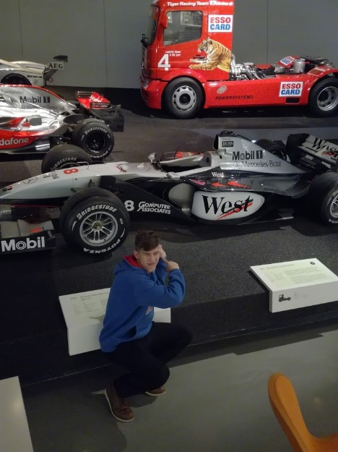
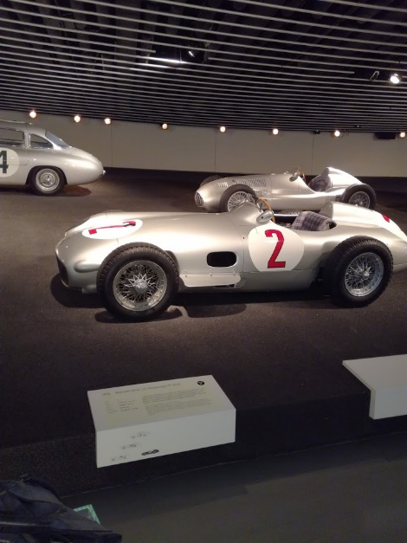
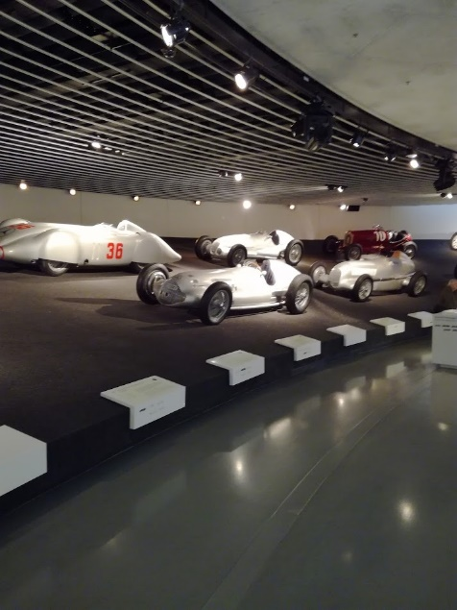

Sunday 26th of November
This day was free day with our hosts. My host family slept very long but I didn’t. As usually. First, I went to swim in Esslingen with my host family. I didn’t start very well. I left my keys to my locker. I had to go back and get them. No problem. We swam a while in the warm pool. Then we went to the cold pool. But it wasn’t cold water at all. I showed it to my host. I also tried German sauna. But it wasn’t a real sauna like we have in Finland. Then another round to the cold pool. It was relaxing. Then we went to jump towers. 3 meters. Not bad at all. But I lost my keys. Again. But now it was down on the pool. I had to dive to get it from a 3-meter deep pool. After that it was time to leave because they had limited swimming time there. And when we were driving back to the house my host’s dad felt like a rally driver not a normal human driver. But the landscapes were something unbelievable. You don’t see something like that in Finland.
We went back to the house and I played a little bit Fifa with my host. I lost but at least we had fun together. I enjoyed it, but the best was just coming. Bowling evening with the whole Erasmus family. I think that was the best day in Germany.
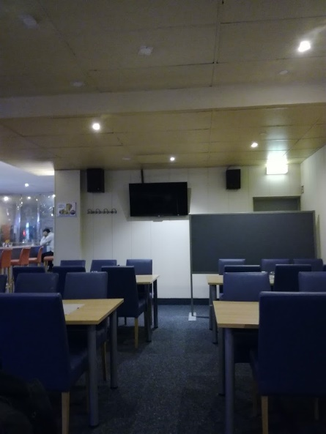
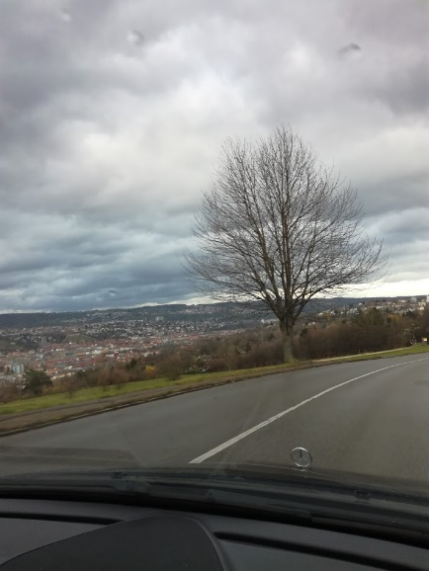

Monday 27th of November
This day started from the school as usually. But today program was different. Only the guests would visit in Stuttgart today. They would have a guided tour in Stuttgart and of course free time to run around Stuttgart which was my favourite thing on this trip. Ok maybe not .

Firs, we visited in Nellingen and we went to see the mayor of Ostfildern. He gave us some information about the town and they offered us bretzels and juice from Stuttgart. It was very interesting to meet him.

The guided tour in Stuttgart used to give us some arguments to our debates. And I think it really gave some good arguments to my team mates. At the tour I noticed some great things about Stuttgart. Like that the Opera house was the only building which wasn’t fully destroyed in the second world war. I also spotted a beautiful car in the streets of Stuttgart. An Alfa Romeo 4C. After the tour I strolled around in Stuttgart with my Estonian friends Rauno and Ken. We searched through many shops because my Rauno needed new shoes. We went in about 7 shops with no results. Finally, we found a shop called TK MAXX. It looked interesting, so we went inside. But this time it was worth to go. Rauno founded new shoes, Ken also bought new shoes. And what about me? Well I found also new shoes and many other cool clothes. And it cost under 100 euros. In Finland it would have cost at least 200 euros maybe even more. The girls didn’t believe their eyes when they saw us and our very full shopping bags.
At the evening we had a lesson of Christmas cookies baking. The cookies were good and very tasty. I liked them very much. That’s all I can say from that.
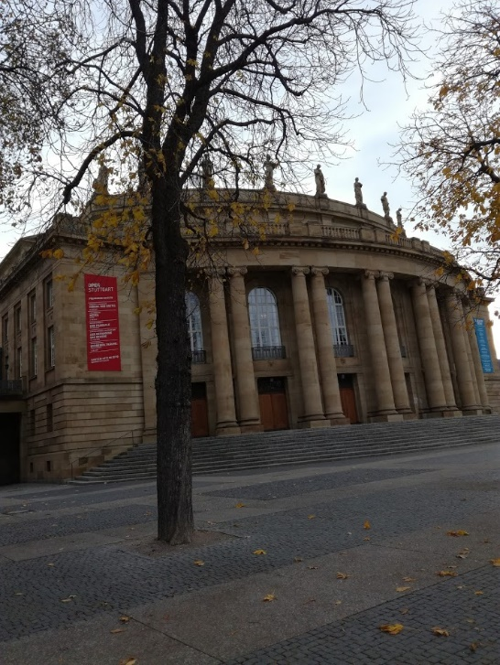
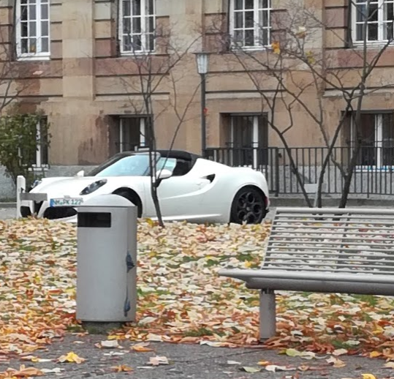
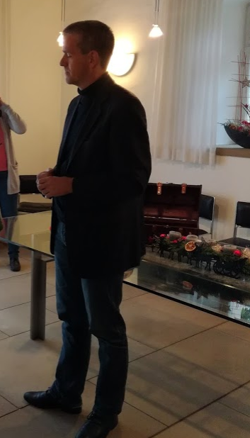

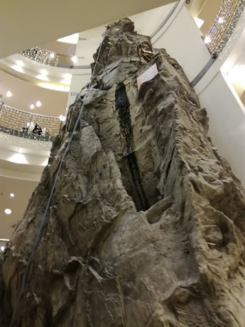
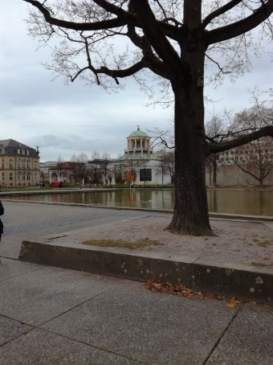

Tuesday 28th of November
Today it was finally time for the debates in the school. We had two debates. ”How to make our cities more breathable” and ”Cars should be banned from city centres”. I wasn’t speaking but I was an important part of my team. Debates went really well in my opinion. After debates there was one group who told about the week in Germany. What we had done, what we had seen and other stuff.
At the evening we went to the Christmas market in Esslingen. I tried some local crisps and bratwurst there. Both of them tasted really good. I also tried archery. I couldn’t make the perfect, but I had fun. I found some good presents to my family and myself. When we left the market, I bought another bag of those delicious crisps. I was very tired so when we came back to the house I fell asleep almost immediately. The last full day in Germany and the last funny day. Tomorrow at this time we won’t see each other.
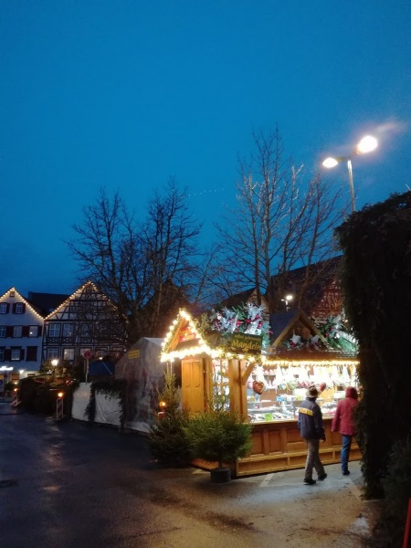
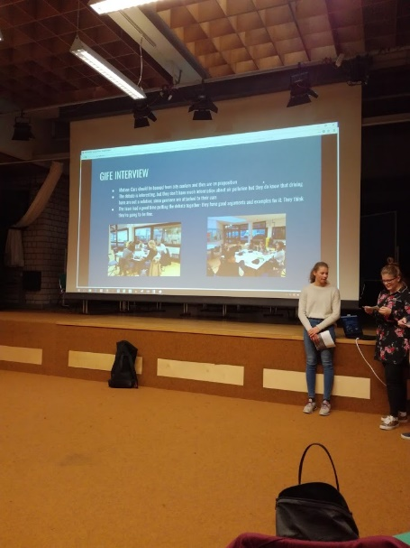
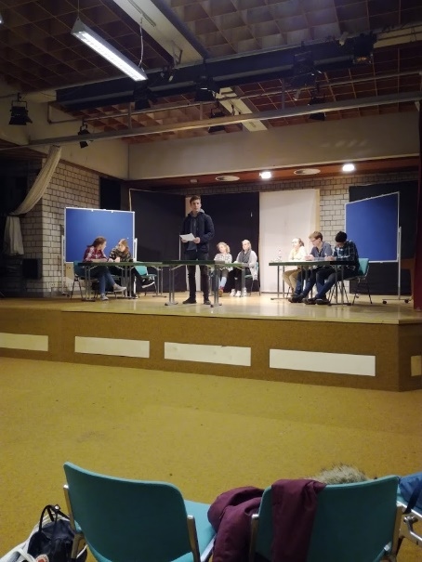

Wednesday 29th of November
Today it’s the last day here in Germany. I don’t want to leave. I want to stay another week. This was an amazing experience. It’s really tough to say goodbye to these amazing people who I’ve met here on my stay. Big thanks to the Ströle family who looked after me like I was a part of their family. I’m really looking forward to Adrian’s visit in Finland. I can’t wait to see them again.
We went to the airport by bus. We spent some time waiting for the flight from Stuttgart to Munich. The flight went well. There was nothing to worry about. It took about 50 minutes.
After we arrived in Munich we ate first. I was very hungry because I hadn’t eaten anything for a long time. After the meal we went to almost every tax-free shop we saw. I bought many presents what I would give away in Finland. After I bought the presents I was ready to go home.
And now I’m on my way back home. I know my family has missed me. I’ve also missed them. It feels great to be back even though I had a great time with the Erasmus family in Germany. This won’t be the end. I am already planning my comeback to Ostfildern. I really want to meet them again.
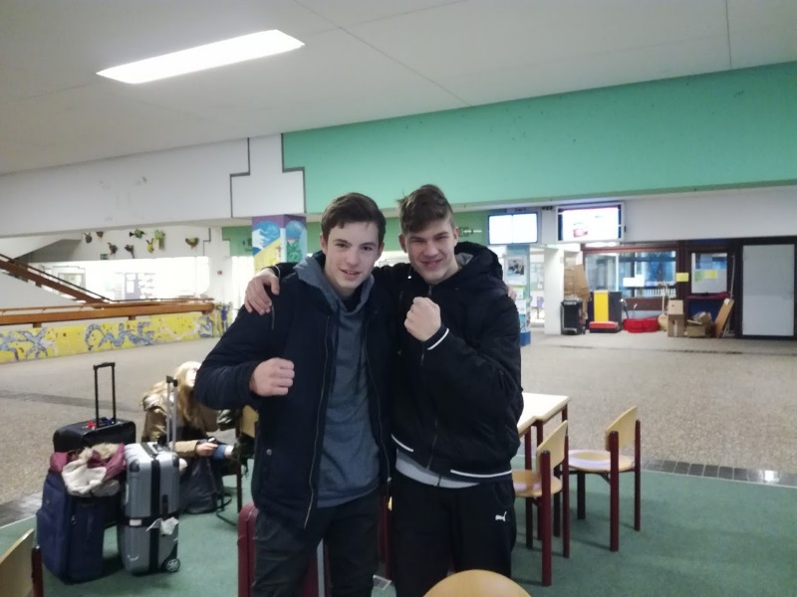
Big thanks for the teachers who made this Erasmus trip possible. It is a pleasure to be a part of this project. I can’t wait for the Finland visit. Thank you.
