Logbook

Wednesday 3.10, day 1

My morning start just a normal way. Except I went to Sampo’s place because I wouldn’t got ride later. We left on railway-station at 8.02am to Tampere. There we changed the train which took us to Helsinki. When we arrived to Helsinki we took a tram and we went to the harbour. We waited the ship about hour and a half.. Luckily there was a table football so we played that all the time.
We arrived in Estonia about 15.30. After landing we took a taxi and then we drove on the bus station. Over there we waited about half an hour. I so exhausting only wait something. Everyone just sat and played their phones. After that waiting, our trip continued to Tartu by bus. The bus trip took about two hours. So much sitting on one day.
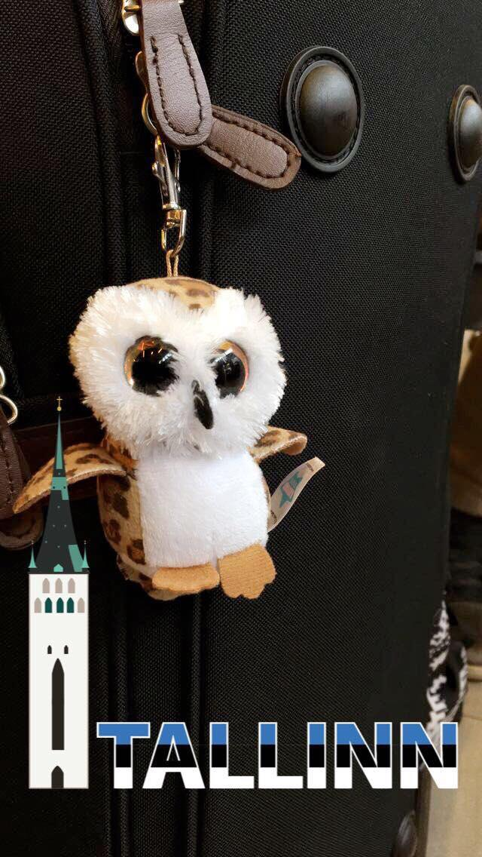
When we arrived to the hotel, we took our luggages
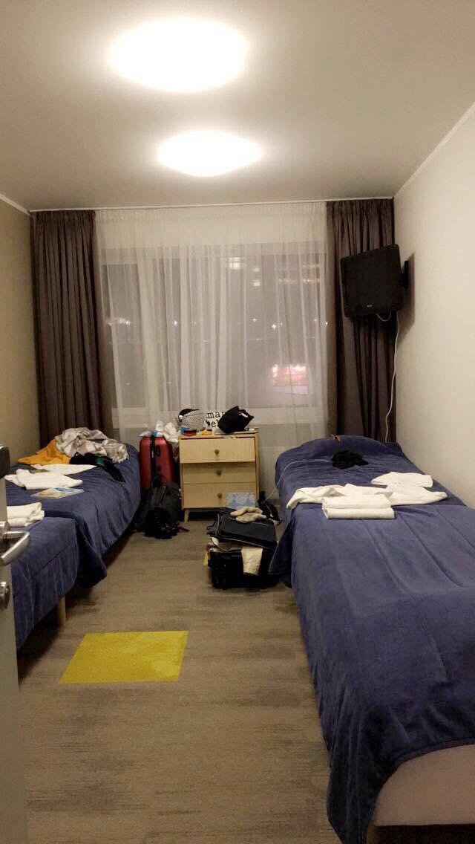
to the rooms. Our roommates were not there yet, so we got choose which bed we can sleep. :D Only Italians were there before us. But because they were not with me and Noora there was still 4 bed left. Then we went to eat and looked around the places. Late in the evening other students arrived to the hotel too.

Here is my and Nooras room after 10 minutes when we got there.
Here is Sampos mascot. It don’t even look that bad in the picture.
I don’t remember what
was it name.. :)

Thursday 4.10, day 2

Today we were in the school. Over there Estonians told us about their school and land and kept a presentation about renewable energy. Scots ja germans kept too their presentations. There wasn’t enough time to keep finnish and italians presentations, so them moved to Monday. We got a tour too there. After school we visited the energy class of the Estonian University of Life Sciences in Tähtvere. I was a little bit tired so it was hard to concentrate. We walked there and back. All in all we walked about 6km. It wasn’t fun because there was so cold and the wind was awful.
In the evening me and my friends were seeing my friend, who were in Finland in February. She wasn’t anymore that school which is part of this project so I didn’t saw her in the school. We went eat to Taverna and we have fun. Taverna is maybe the best place to eat pizza!

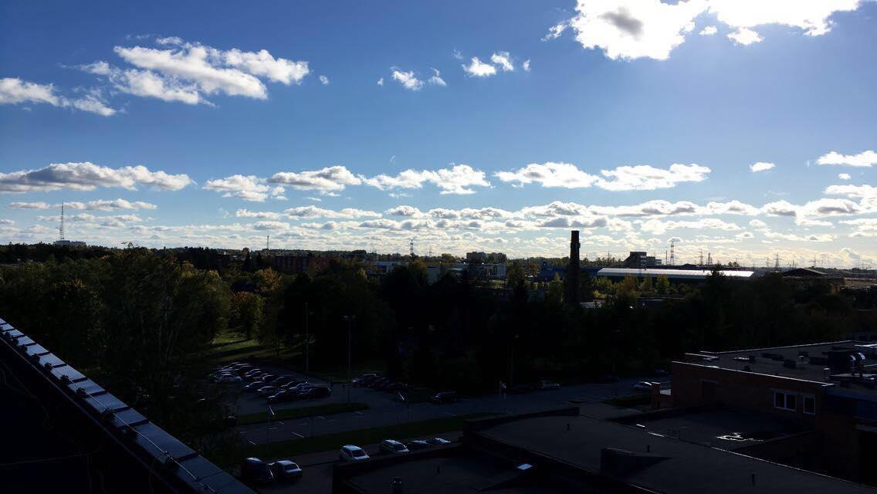
This photo is on the roof of the Estonian University of Life Sciences in Tähtvere.

Friday 5.10, day 3
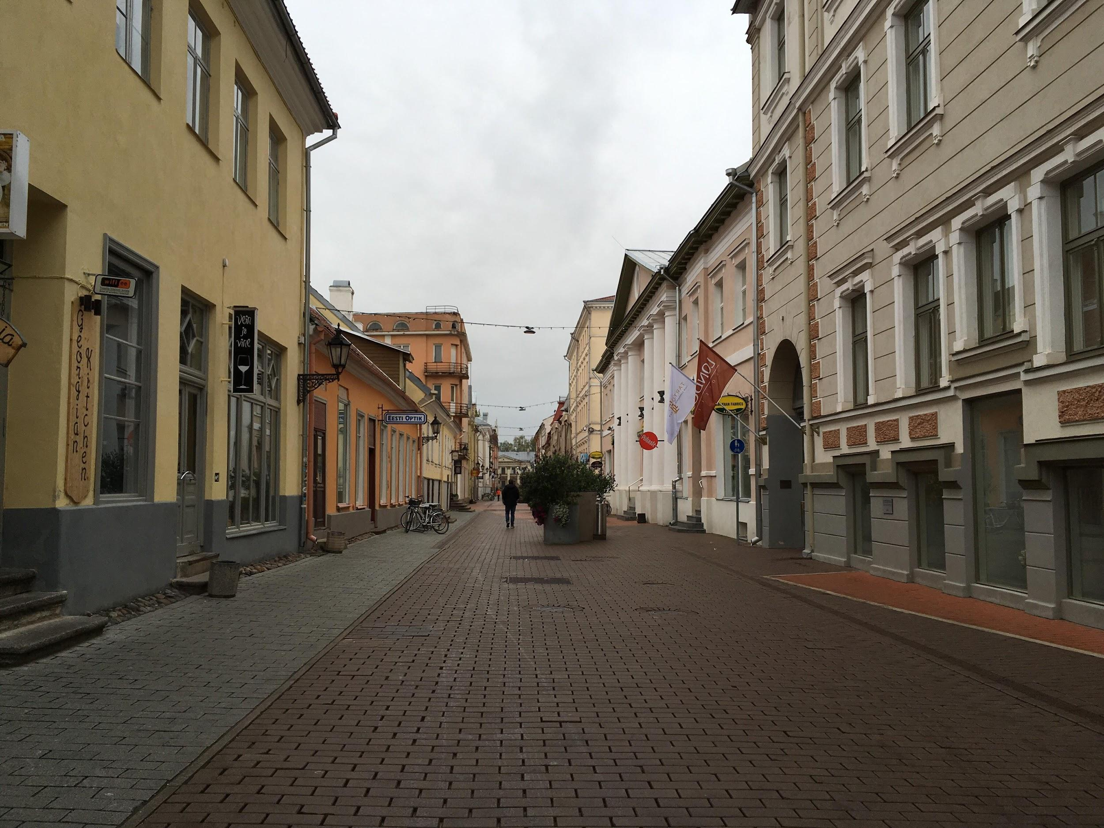
We started the day with breakfast like an every day. After breakfast we left to Tartu tour. I don’t even remember where we were because there was so cold and again rainy day. The tour took about 2h. After the tour we had been booked an appointment in the city hall, where some man (don’t remember his name) told us about Tartu. The man, who told us about Tartu, was positive and
he praised Tartu and told why Tartu is “best” place in Estonia.
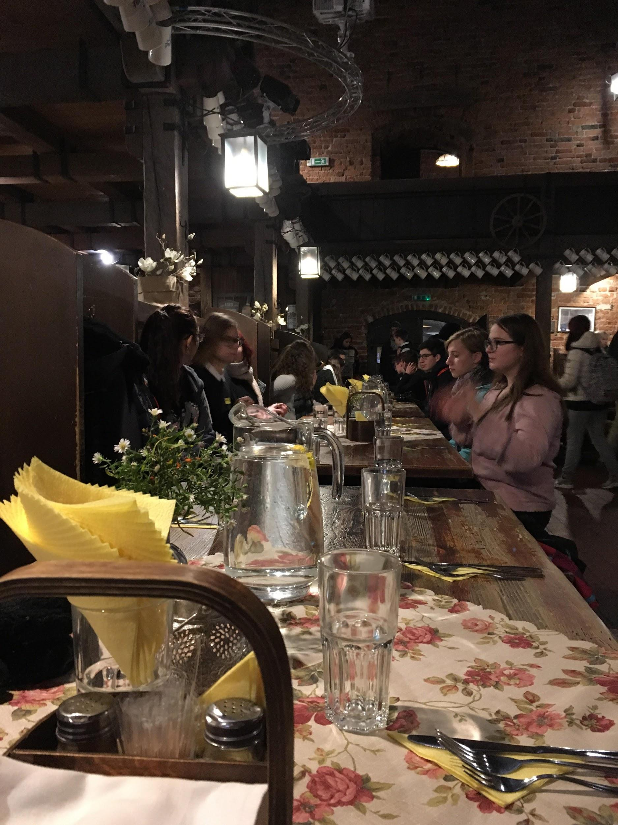
At 12 o’clock we had lunch. The food was so good and delicious! Dessert size is huge in Estonia if I compare it to Finland. After lunch we went to Tartu Environmental Education Centre. There was some greenhouse, which was a beautiful, but the smell inside was very strong. After that the bus took us to Ice Age museum. There were something ice age things and some videos and texts which told a lot of information. We also had there some buffet and one of the student had birthday. Everyone sang to her. :) In the evening we went to the AHHAA. AHHAA is like Heureka in Finland.
This is the place where we
were at the lunch.
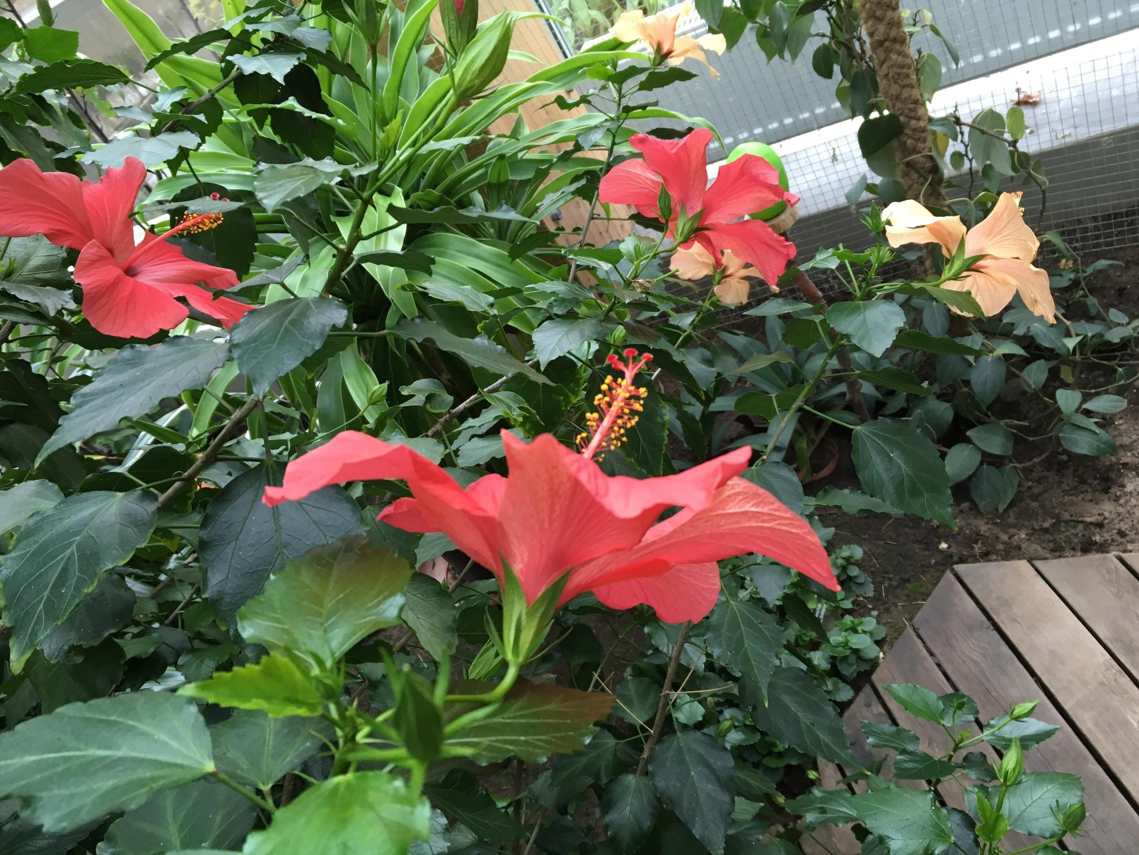

And this flower was in the greenhouse.

Noora <3
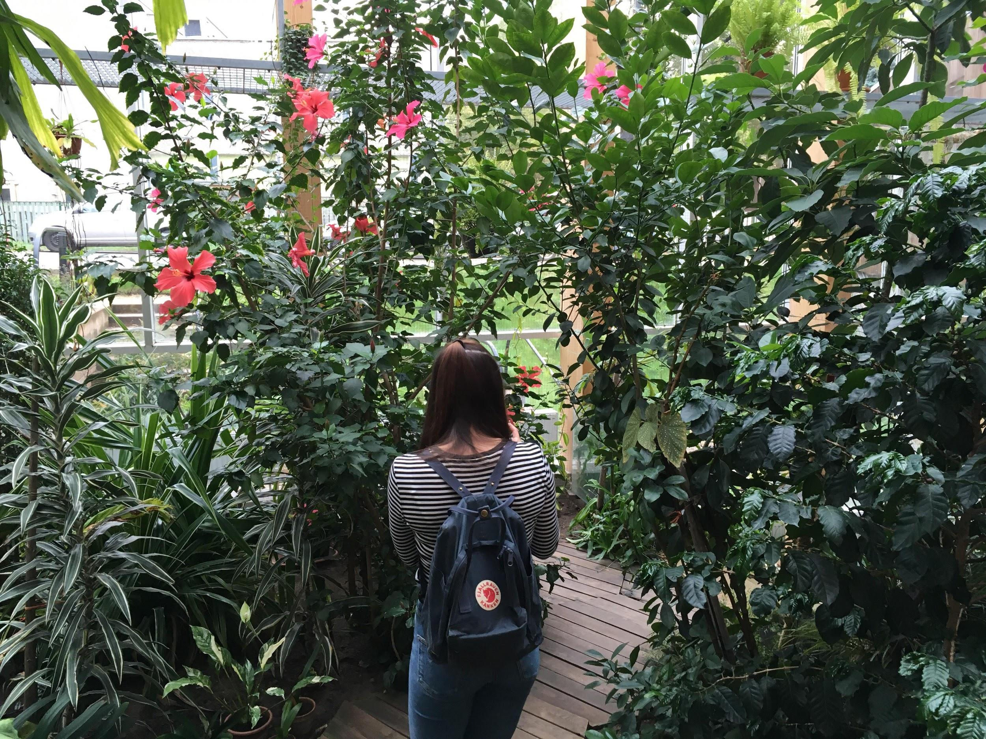

Saturday 6.10, day 4

Saturday was a fun day, because we were in Tallinn. The bus left from the hotel’s parking lot towards to Tallinn around 8am. When we arrived there, our guide took us to a tour. It did half by bus and half by walking. This tour took about 2 hours too. And of course was raining the whole time.

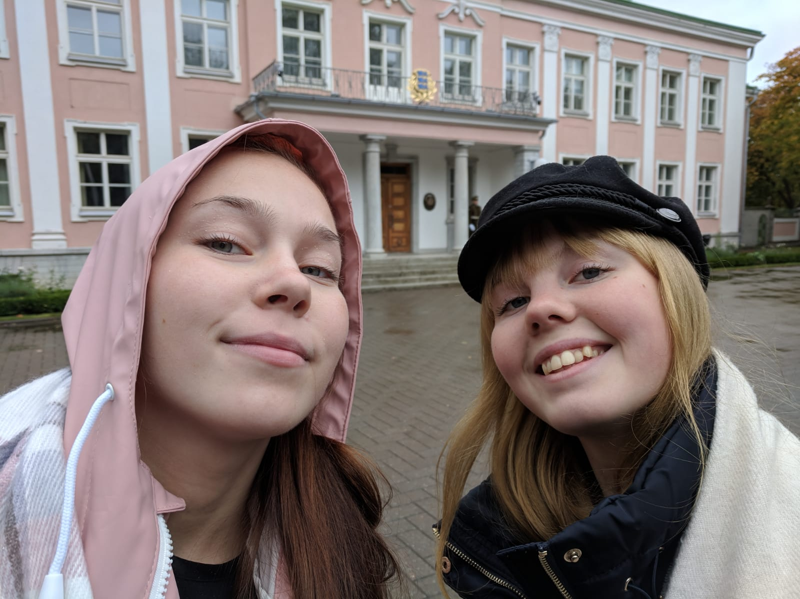
After tour we went to ate. When we were ate we had also a little bit free time. Around 3 o’clock we went to energy museum. There we were about hour and a half. It was interesting. We got some presentation there too. When that time was a full we had a free time till seven. Many of us went to shopping. We were back to the hotel around ten o’clock.
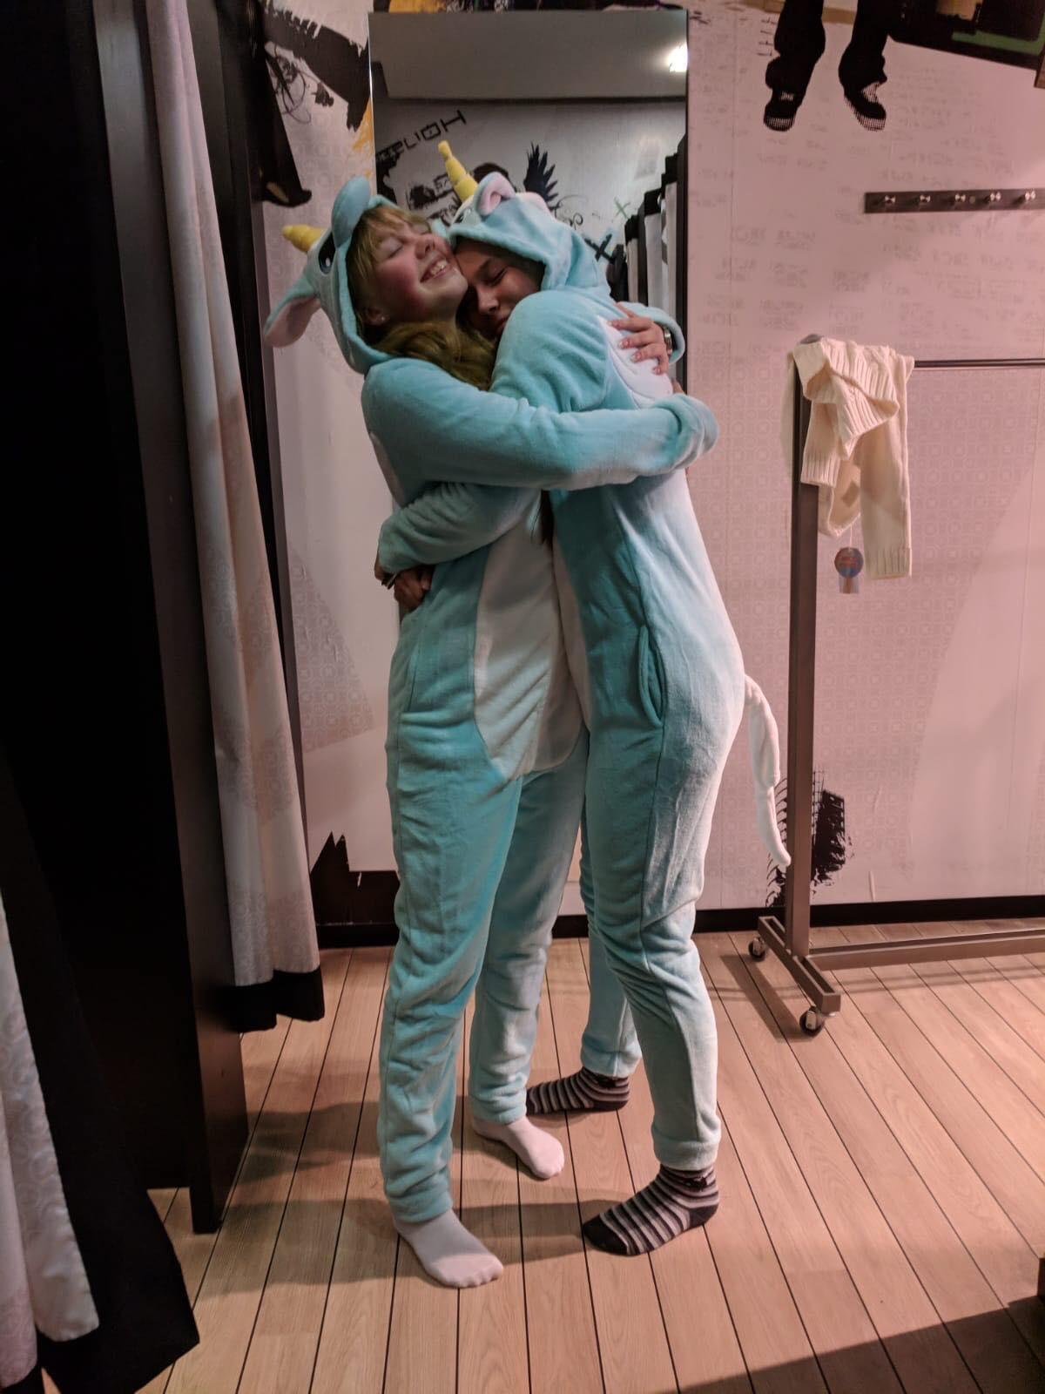

<3 <3

Sunday 7.10, day 5

Sunday was relaxing day. I was so tired when we left by bus towards to South Estonia. We went to swamp. We walked there about 2km. We stopped there some dock and drank some water and then we took a group photos. When we arrived our destination, teachers just started bringing us food. I was really happy then, because I was starving. We ate some fish soup and it was pretty good. The bread wasn’t that good so I gave it to Sampo who ate that.
When everyone was ready we went to the bus and we continued our next place. I was still so tired so I just slept the whole time. The second place was much more beautifully and prettier. Or I think so. Because the first place was a swamp and in Finland we have swamps too, so it felt just like Finland.
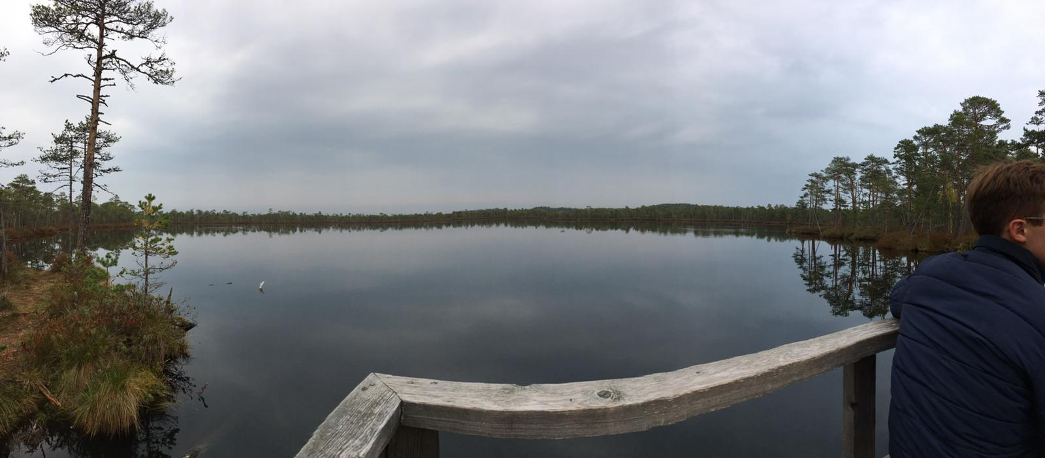
This is on the dock were we stopped to the group picture. Some of us drank that water, because it was so clean.

When we arrived back to the hotel we left to swim to AURA water park. Finnish people were only ones who went to swam because estonians were some were and germans couldn’t come because they need some person who have a lifesaving training. And I don’t know what was the reason why italians ja scottish didn’t come. We were there a couple hours and then we left to eat. Ones again we went to Taverna. We went there with few estonian people.
And late in the evening almost everyone sat in the hostels hallway and just talk and listen some music.

Monday 8.10, day 6

Today we were almost the whole day in school. Well in the morning we had some free time. When we arrived to school we kept our presentation about renewable energy. Luckily we were not the only ones who had to do that. I was so nervous because english is hard to talk to me and when I have to speak in front of everyone I just go lock. All words just disappears. But I did it and I’m still alive. That is only a good thing. When the presentations were over we split our groups and started to work our things.
Working was actually pretty fun, because our group did brochure. Noora and I just wrote a summing up the whole week.
In the evening, about 18.00 o’clock, every group showed what they did and created. After that we listen some Estonian national music, I’m not sure what it was, but it sounded funny! Then we put the chairs aside and just started dancing. It was crazy! I wore a sweater so I had very very hot! After all that we went back to the hotel and did something together and this time we all sat the hallway. It was maybe the best thing on the trip!

Tuesday 9.10, day 7

Our last day here in Estonia. Beginning of the week I thought that when is Tuesday I don’t want to leave home and exactly that happened. We went to the harbour by bus. This time everybody was in the same bus. In the bus was so quiet and peaceful because almost everybody just slept. Before we went to harbour we drove to the airport. It was so sad to say goodbye to everyone because the week was nice. Ones again the bus trip took a couple hours. When we arrived to Helsinki we waited the train almost 2 hours. We were tired, so we just sat and played phone. Train trip took 3 hours and we were in train peaceful and quiet. When I got home the clock was about 21.15.
I hope that I see some of this people again. They were so nice! <3 And I want to get back to Tartu because I really liked that place!

Erika Ossberg

