https://www.youtube.com/watch?v=cyjDmZlHq6w&list=UUDXxWFv6cv_5mt8rglHhr_A

https://www.youtube.com/watch?v=tbypiPNIItM&list=UUDXxWFv6cv_5mt8rglHhr_A&index=4

Attachments area
Preview YouTube video Erasmus+ Itaalia
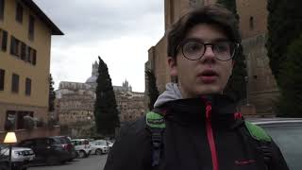
Erasmus+ Itaalia
Preview YouTube video Erasmus+ project
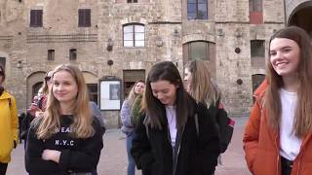
Erasmus+ project

