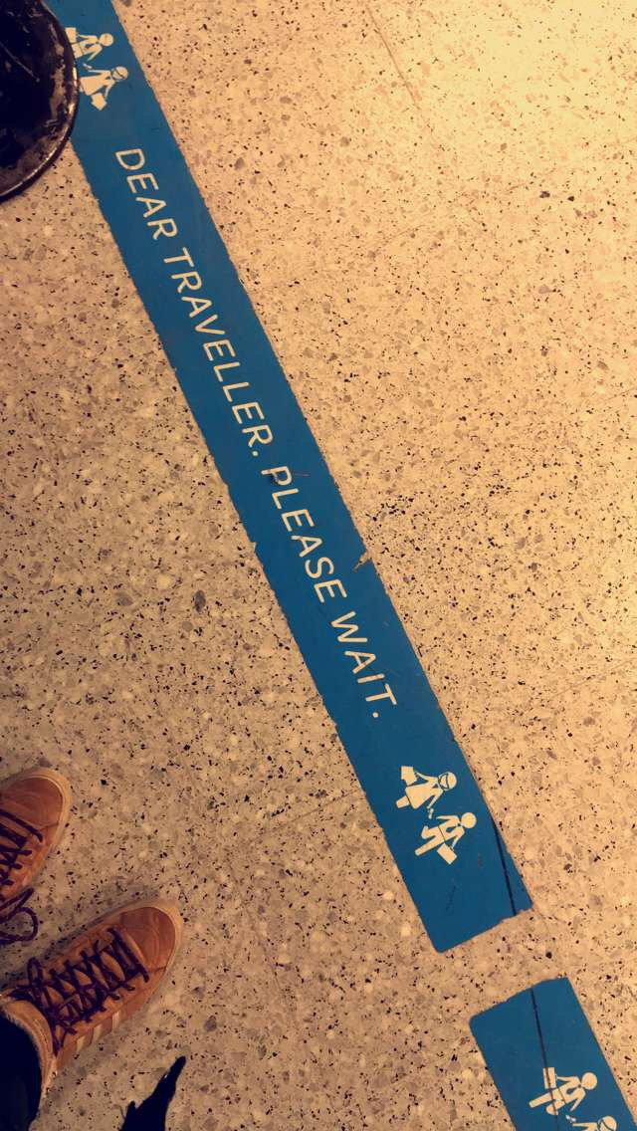
23.11.2017 Thursday, The train of thought is leaving the station
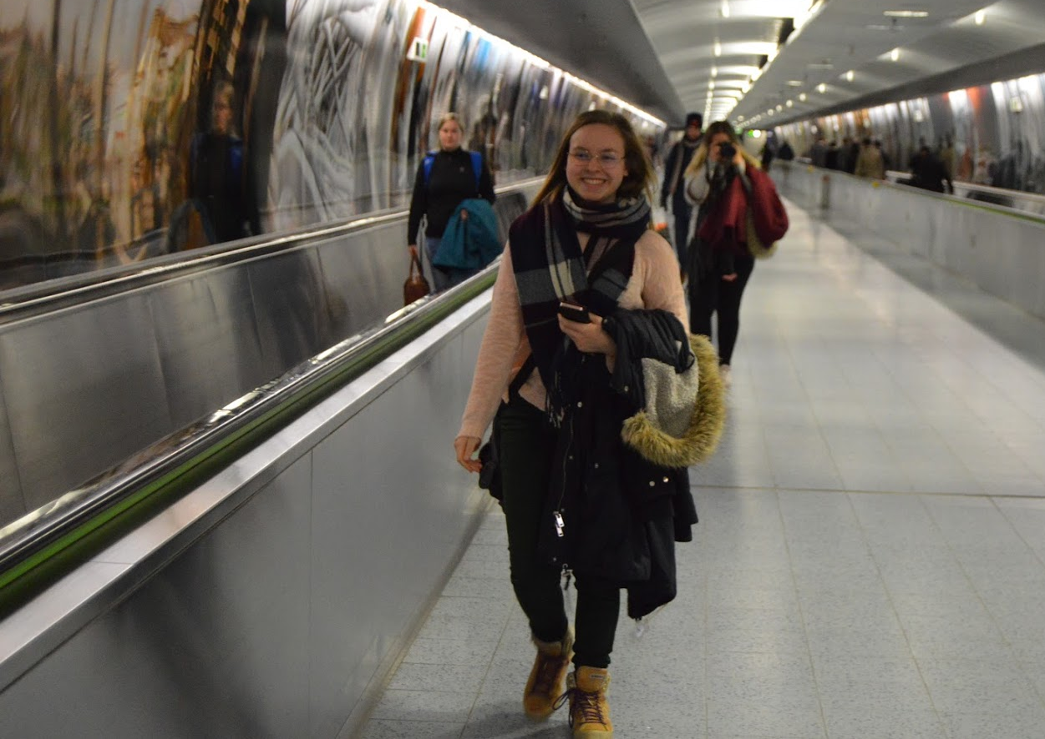
I had already forgotten everything about school and the worries I had at home when we got on the train that would take us to Tampere. I had very contradictory thoughts about this journey. I kind of felt like I had made a huge mistake attending this course, but then again I knew this was going to be so much fun and I wouldn’t regret it.
I really love travelling; it gives me the opportunity to look anywhere new and see beauty in new things, I get to widen my imagination and there’s always something I’ve never seen before. Because of the new things, I don’t need to think about the past so much, because my mind is too busy marvelling over everything that’s before my eyes. I can’t wait to actually see my host family, even though I am also quite nervous about that. But I’m sure it will be just fine. It’s actually quite alarming that I’m not too nervous about it. Normally I would be really anxious, but now I’m just excited.
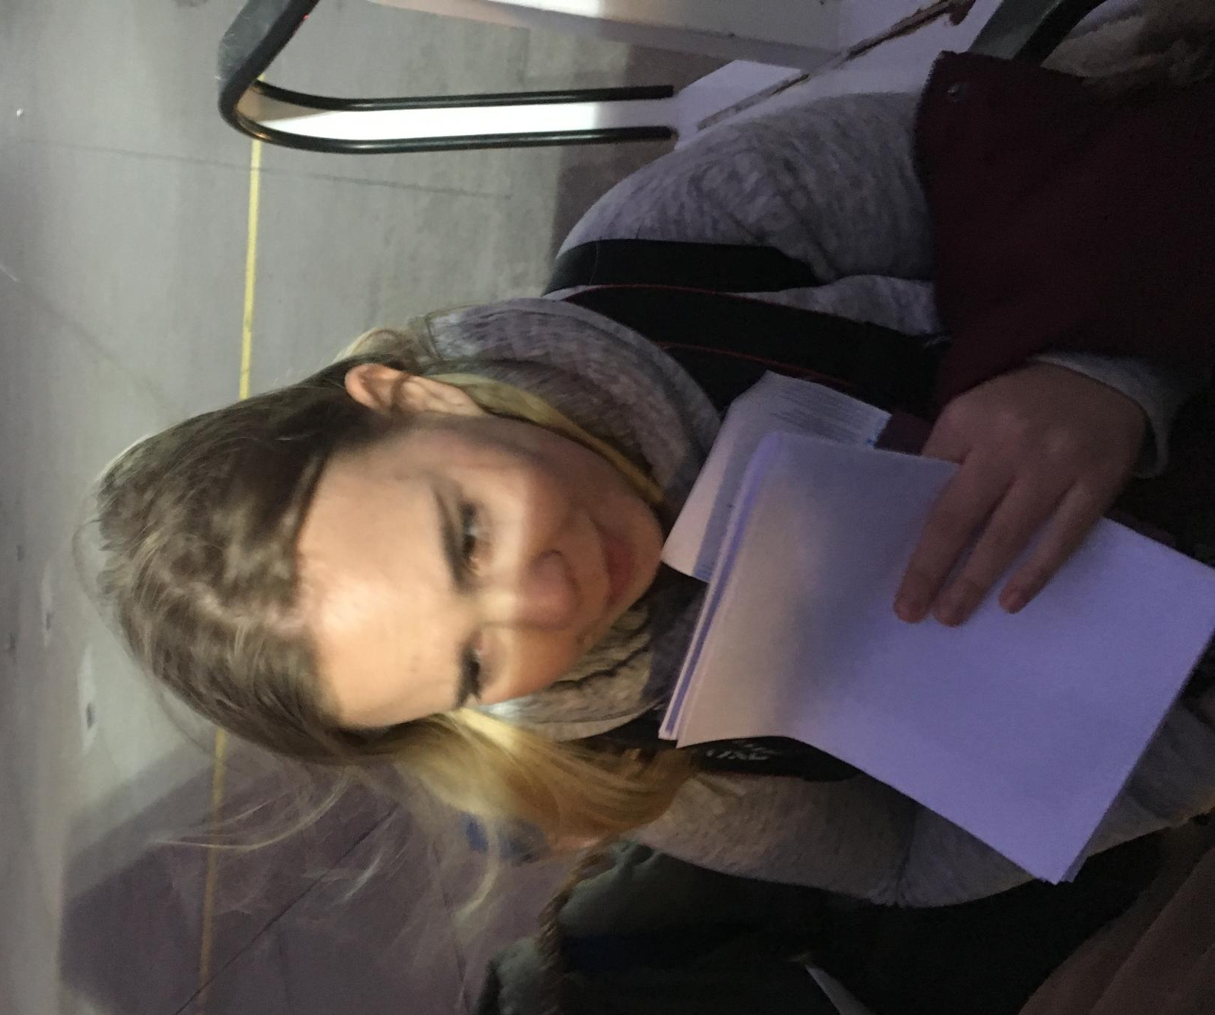
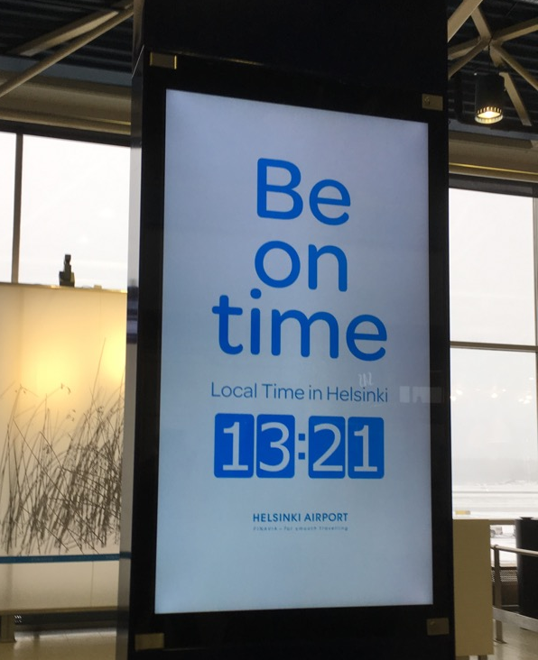
I looooooove airports! I love seeing all the people going to a new place or coming from somewhere or waiting for their journey to go on. All those lives are crossing in this one place and the atmosphere is so nice it’s hard to describe. It’s overwhelming. I also love airplanes because our family kind of has a thing for them, so it’s always nice to see some more of those beautiful works of art.
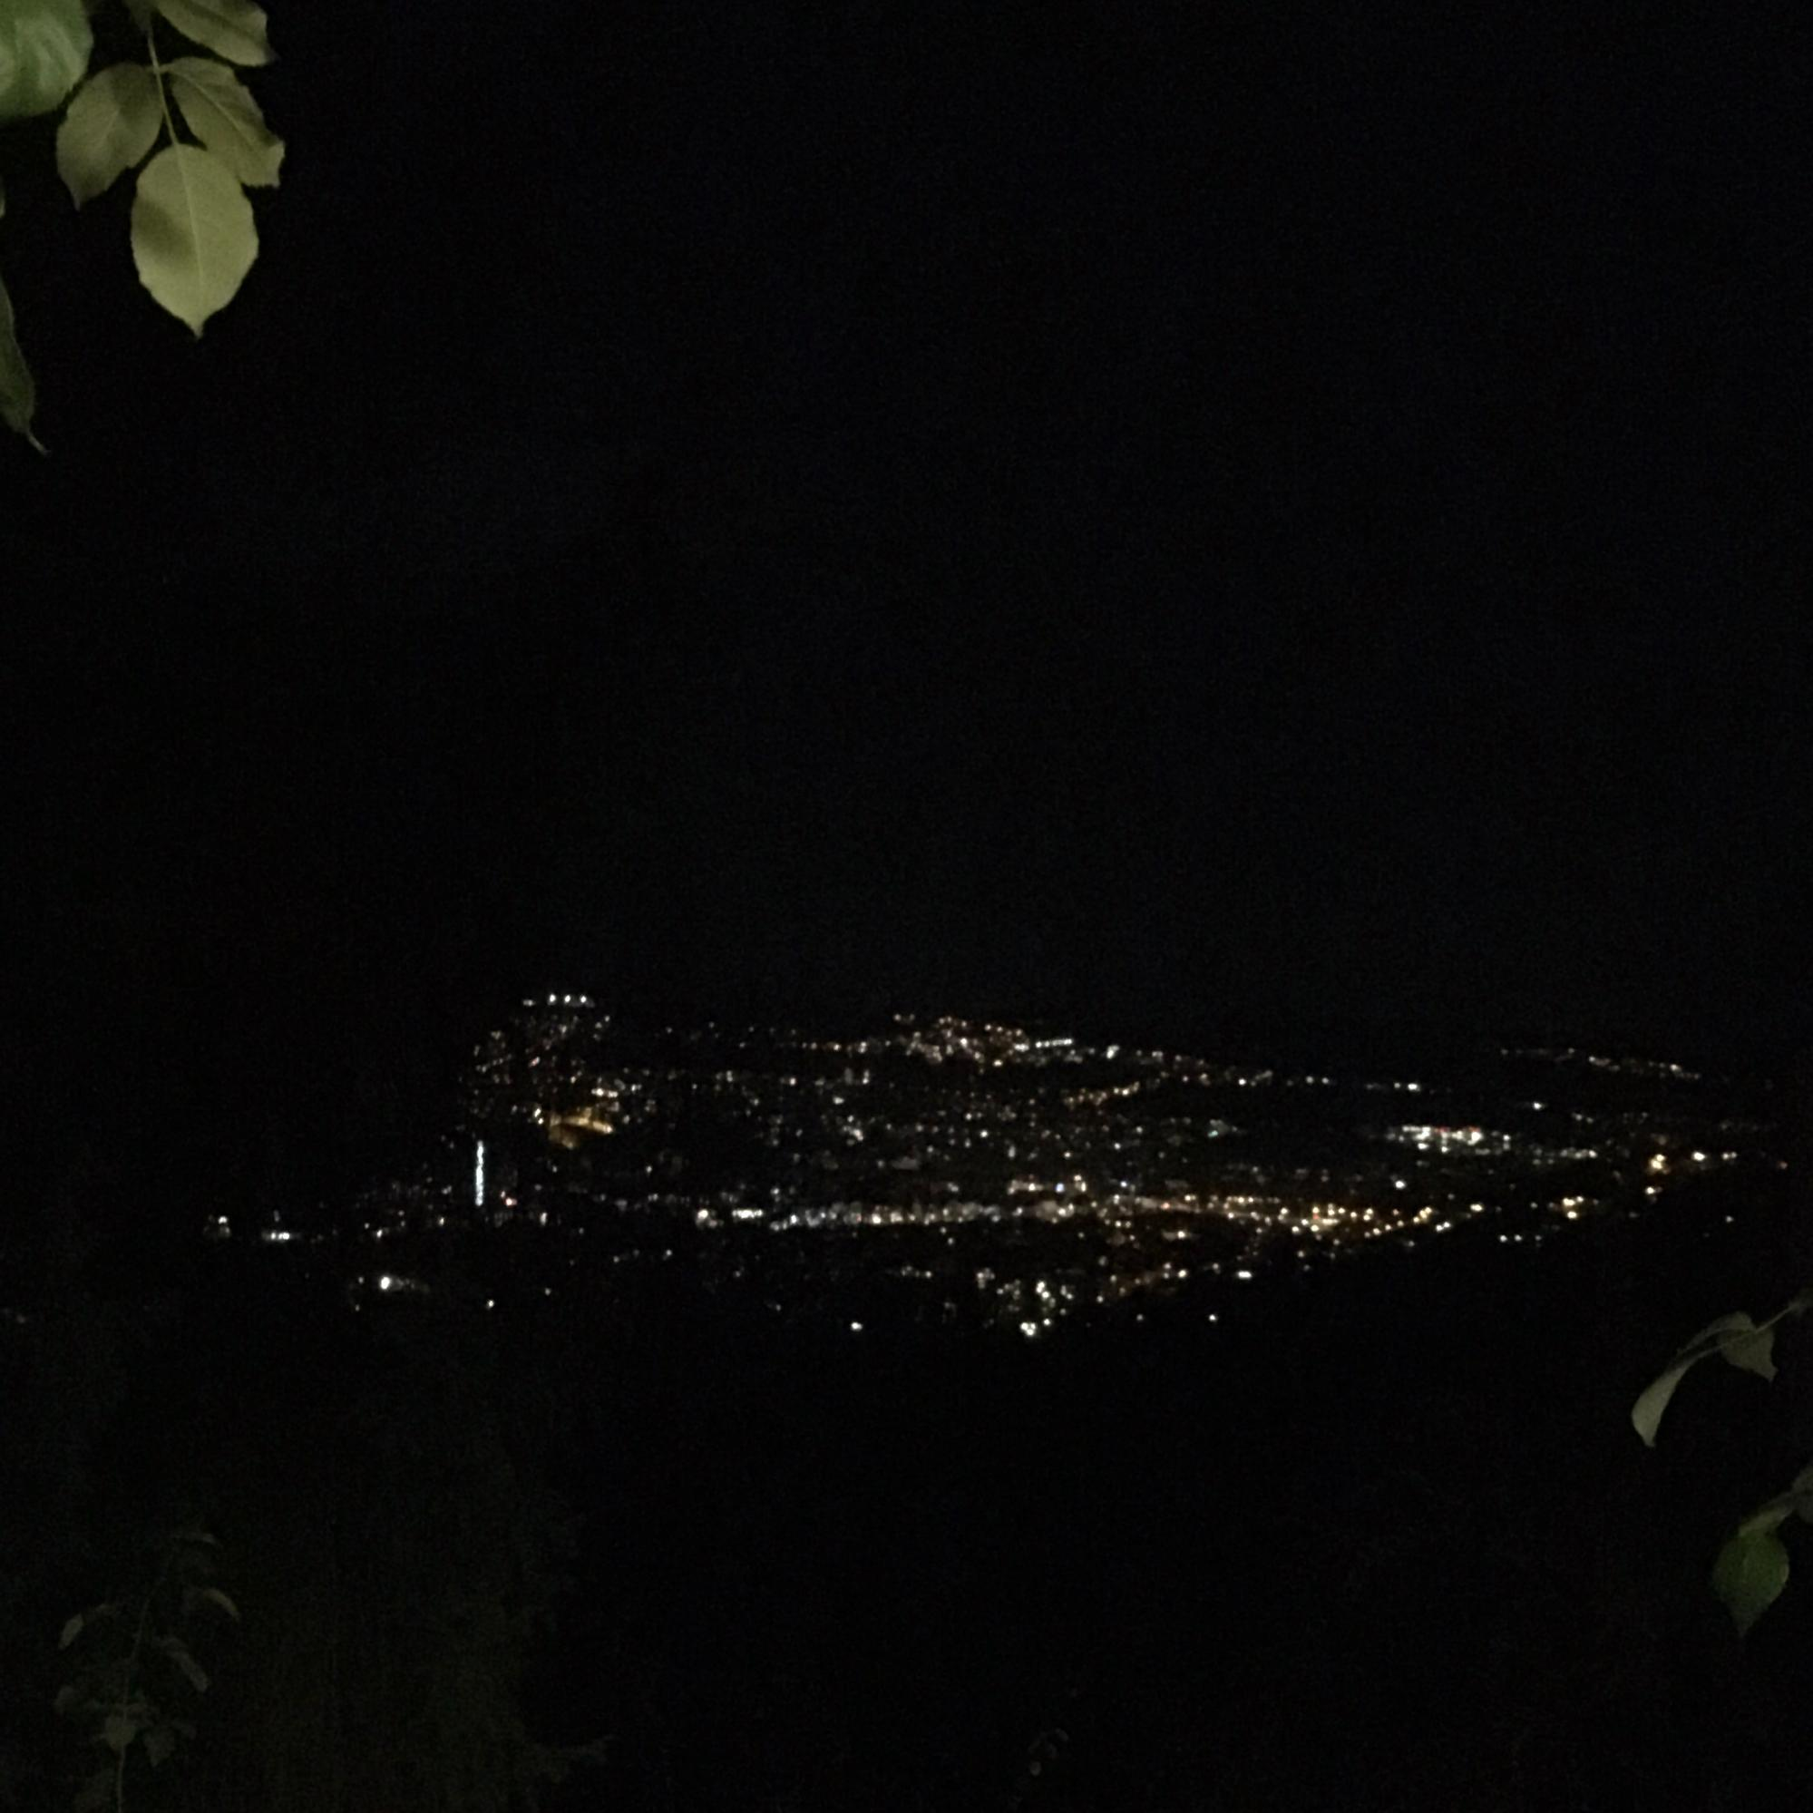
At the Helsinki-Vantaa airport, we ate at this lovely restaurant and, of course, did some minor shopping before our flight. We parted ways with our teachers and set a meeting time, and when our teacher were late (like ten minutes or so), we became quite worried. But fortunately they came after all and we got on the plane right on time. We had to change planes in Frankfurt, but we didn’t have much time before our next flight, so we just sat down and waited. The realization of meeting our hosts soon actually hit us when we stepped into the smaller airplane that took us to Stuttgart. I think that’s when we all felt the little twinge of panic in our stomachs.
So now we are in Ostfildern, I’m in my room, my stomach full of good German food (some kind of soup with meat wrapped in pasta in it and something with potato mash that they called salad. It really was good though, I’m not even joking!). I have the wifi password (of course) and my host sister, Henriette, and my host mother, Elke, are awesome and extremely nice. I also fell in love with the little streets that lead up to this house from the driving road and also the view from my window when the sky is all dark and the lights of the city can be seen.

24.11.2017 Friday, the first complete day in Germany

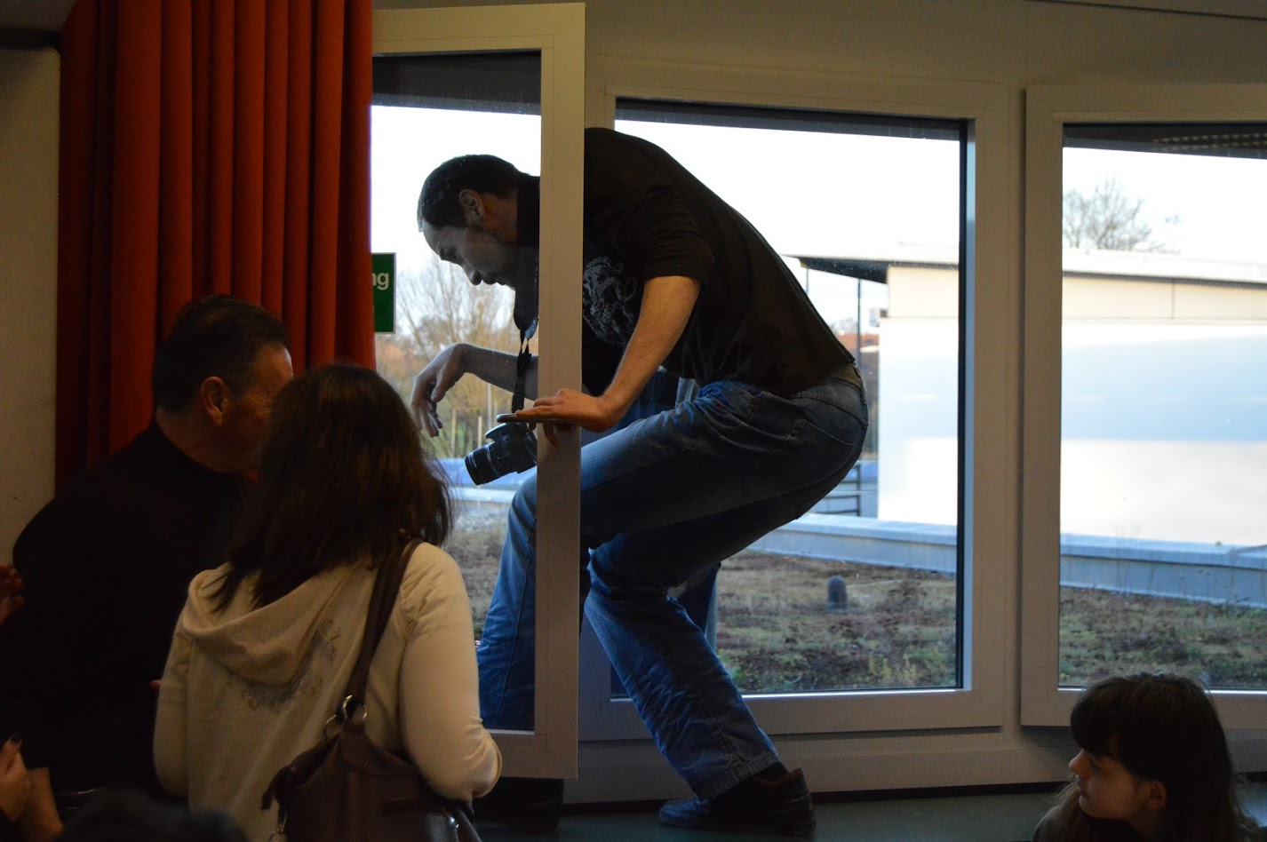
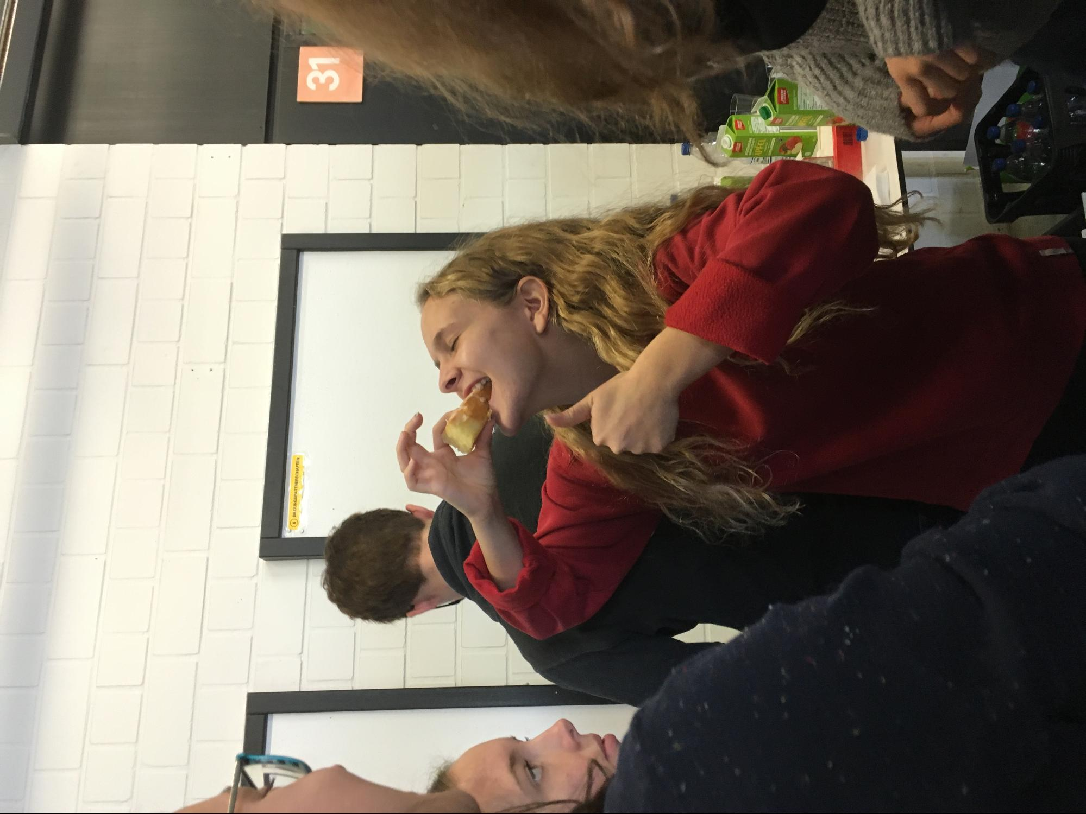
I woke up, and all I could think of was something along the lines of: “This is not my bed. This is not my room. Where in the name of Heaven am I?” Then of course I remembered where I am and getting up from the bed was ten times easier than it usually is when I’m home. My host mother showed me how their oh-so-perfect coffee maker works and I got to drink that magnificent coffee that I adore. German coffee is a lot better than the stuff we drink in Finland. We ate muesli for breakfast, and even that tasted much better than normal muesli in Finland. Salla-Maaria’s host father drove me and my host sister, Henriette, to the school, where we had a tour around the school properties. We were even shown the sun panels that they have on their roof, oh! and we had to climb on the roof through a window. It was funny seeing our teachers climb through the window.
After the tour around the school we had a small coffee-break and then we were introduced to our project work groups. In my group, there is Johannes and Lennart from Germany, Giovanni from Italy and Diana from Estonia. I really like my group members, and I am surprised that Germans speak such good English. Somewhat I thought that they wouldn’t be good at it and that it would be difficult to communicate with them, but there weren’t any problems after all.
Lennart is a huge Harry Potter fan and Johannes is clearly a know-it-all and likes science. I like these people. We played some different games with our groups, so that we would get to know each other. First we played a game called Taboo, which was practically Alias, so we had to explain words. Obviously I was the best at that, because I had had so much practice playing Alias.
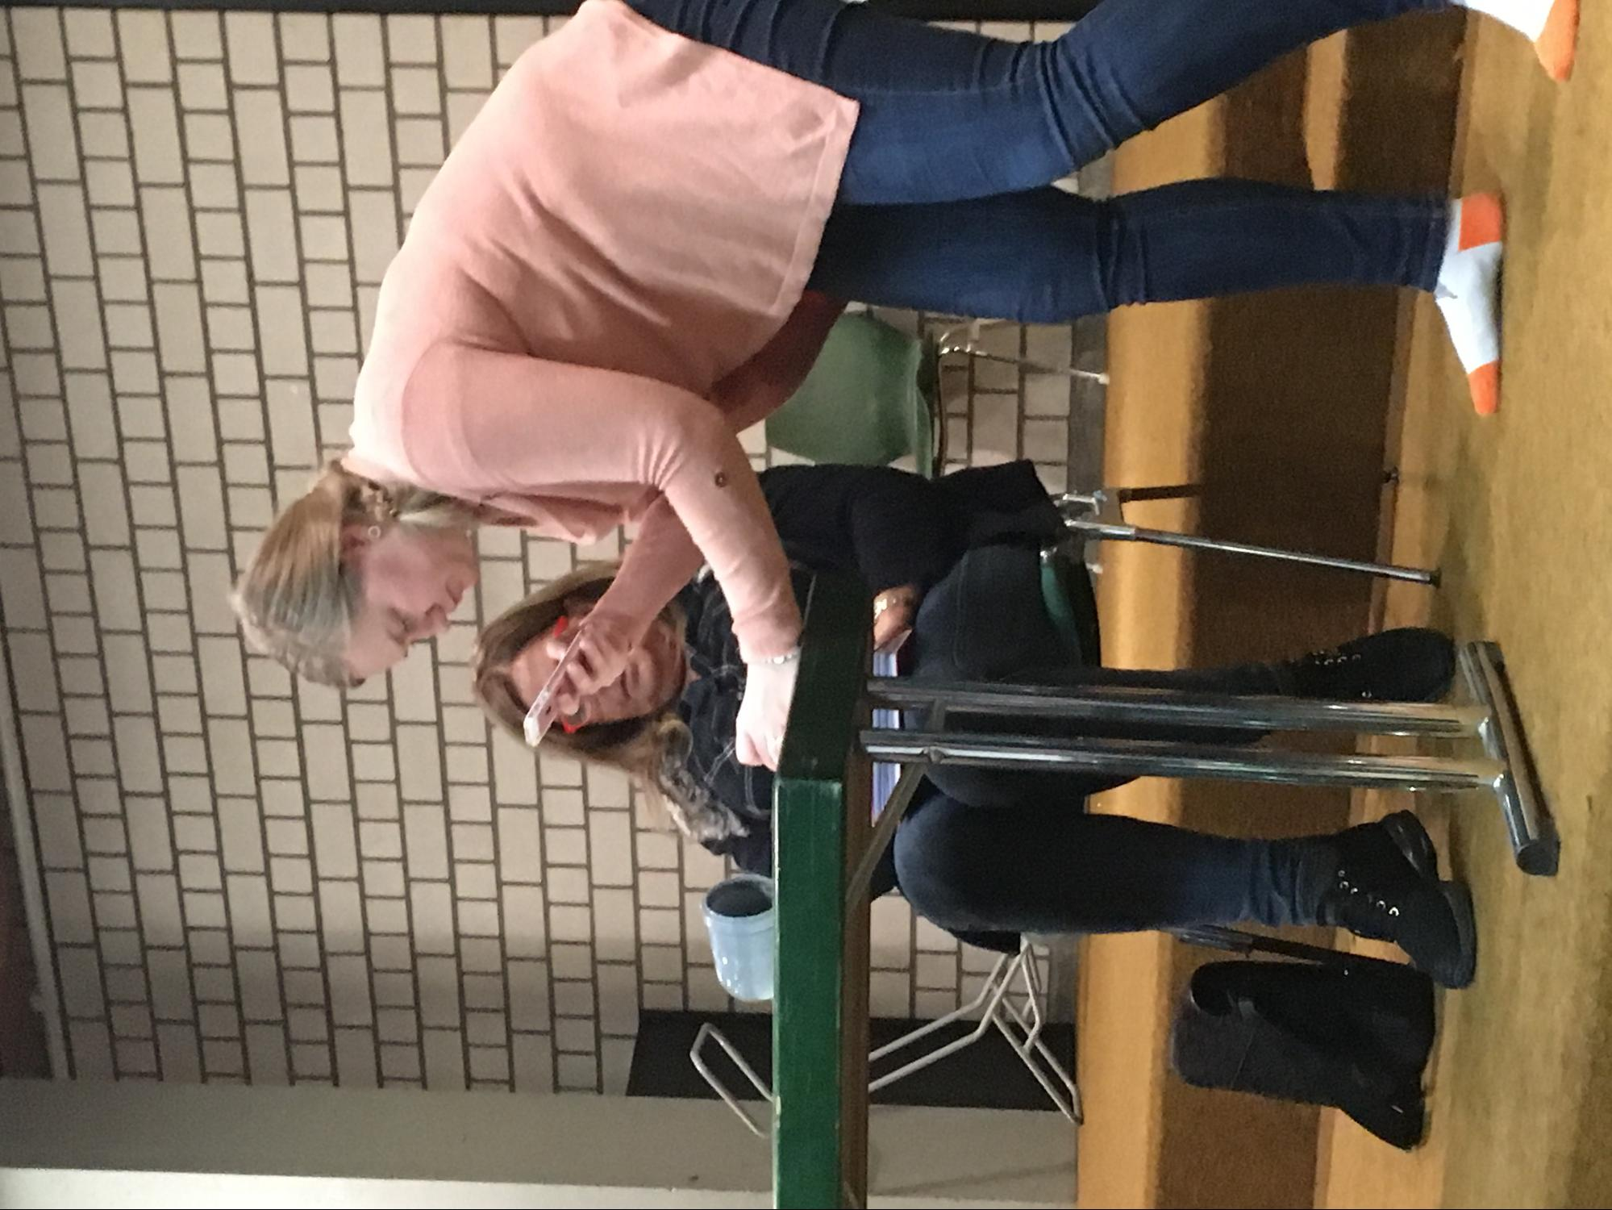
Then there was this other game called the why-game, where one person says a statement, like “I like dogs” and the others ask “why”, then they have to answer, and after every answer comes another “why” until they don’t know the answer anymore. I really liked that game even though I accidentally gave a statement “I like people” and right after that I thought to myself “That’s not true, Why on Earth would you say that”. But then again, I suppose it depends on people around me, because these people I do like.
We had pizza for lunch, and right after that a sport-session (we actually had to take the pizza with us because we were in such a hurry), in where we played games (once again) in our project groups. There was this game called “Round the Table”, which was kind of like ping pong, but much funnier and faster. At the end of the session, we all played it at the same time. I think I slightly hurt my thumb in volleyball.
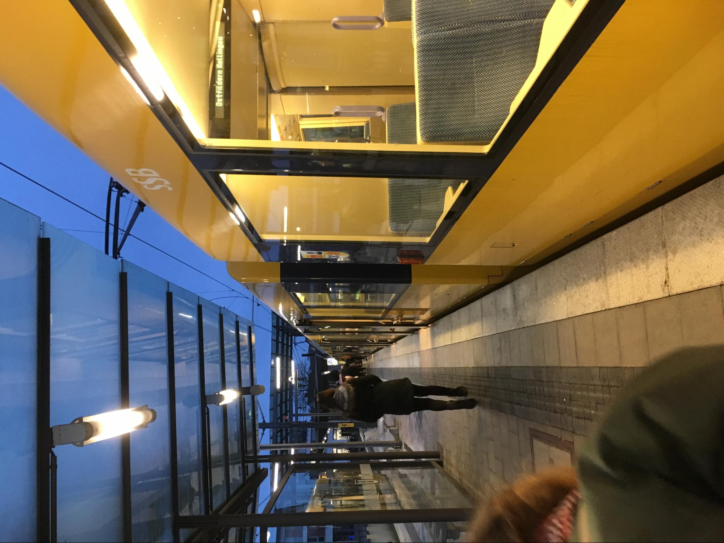
After the sport-session some guy from OK Labs gave us an interesting presentation about these sensors that collect data about the air quality. Our chemistry teacher, Saara, seemed to be really interested about them. We (me, Ellinoora and Ella) were very interested in this presentators shoes. They were really nice, I mean look at them.
We were then given the topics for our debates, and our group got to be against the statement that fresh air is a human right. It will be a really difficult task, but somehow I have this feeling that it will be just fine; we can do this.
After school, we took a train(-ish vehicle, might have been an S-bahn, but frankly I’m too confused about all these vehicles which look like trains, but apparently are not, therefore I’m just gonna call them all trains from now on) to get back home, and soon after that we left for Henriette’s cousins’ birthday. They were adult twins. My host family has a really nice car. It’s a big Volkswagen, which has this weird ceiling that comes down and can be transformed into a bed. Anyway, I met a lot of very nice people who talked with me in English and asked many things about Finland. Unfortunately, I have no idea of any of their names.
All in all it was a great and wonderful day. I met loads of lovely new people and we also saw a rabbit and three deer fawns. The views around here make me want to cry because I know I can’t live the rest of my life here watching them. Also, I seriously regret not taking a proper camera with me.

25.11.2017 Saturday, the day of Mercedes-Benz and Mr. X

In the morning we had to run to the train station, and we still missed our train. You can’t expect students to wake up early on Saturday now, can you? Elke gave us a lift to school. It was raining, but luckily Henriette had taken umbrellas for us both. From the school yard we walked to a bus stop with the rest of the project members. In the bus stop, I happened to mention to Johannes that I study French. He said one word in French, and accidentally kept on talking in French. Apparently he has studied it for four years now.
Henriette tried on my glasses, and I think they would fit her perfectly! She is already so beautiful with her long and soft locks of curly hair and her iconic green jacket and red scarf, and my glasses just make her look even cuter.
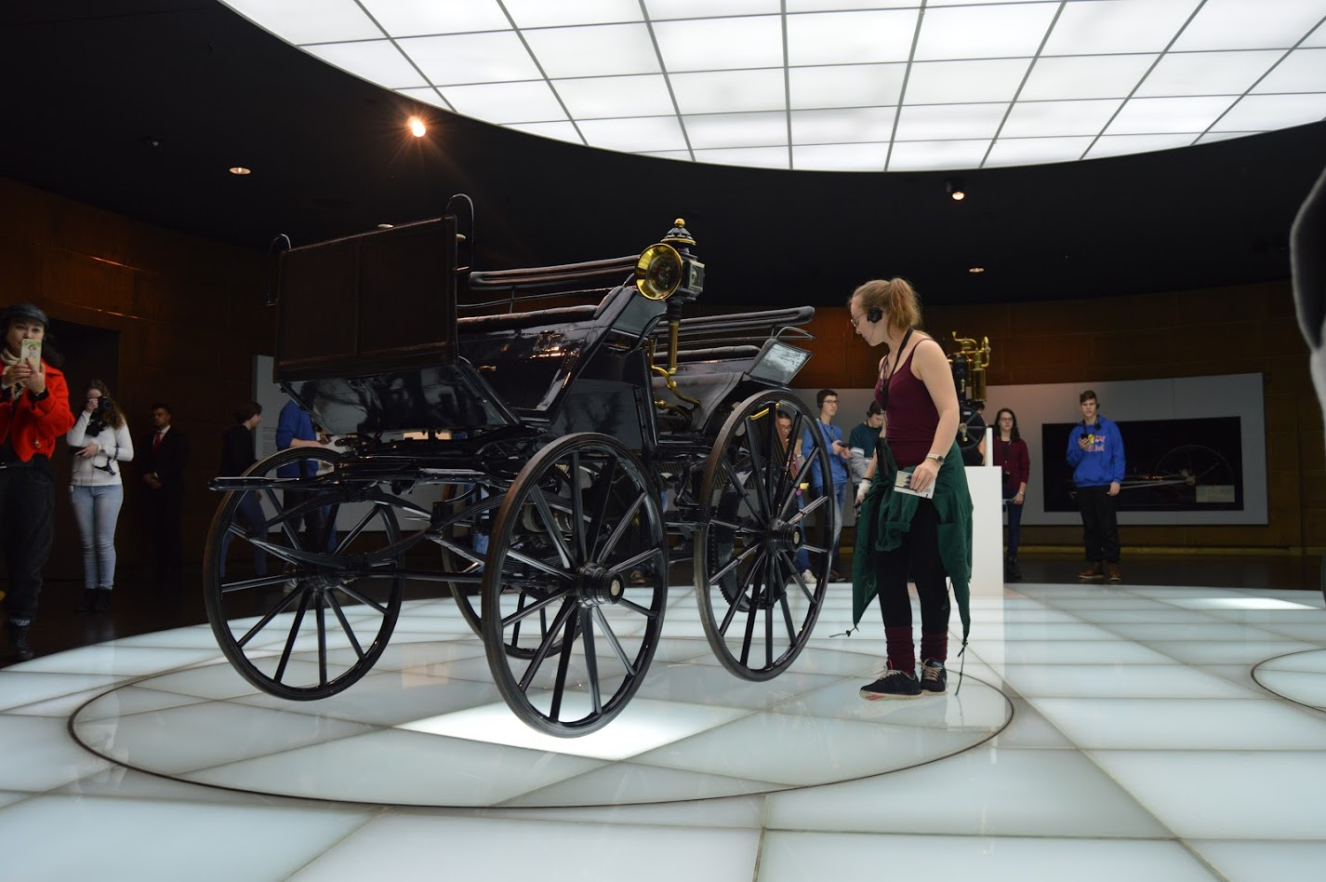
The bus that we finally stepped into, took us near the Daimler museum, where there was a lot to see, mostly cars of course, but I really liked it. Naturally, the first thing I did when I got to the floor where the exhibit started, was to get into this moving circle, where was a exhibition piece: a really old horse carriage. Apparently I shouldn’t have done that because some guard came and said something in German. Of course I didn’t understand that, but fortunately Henriette was near and told me I’m not allowed to stand there.
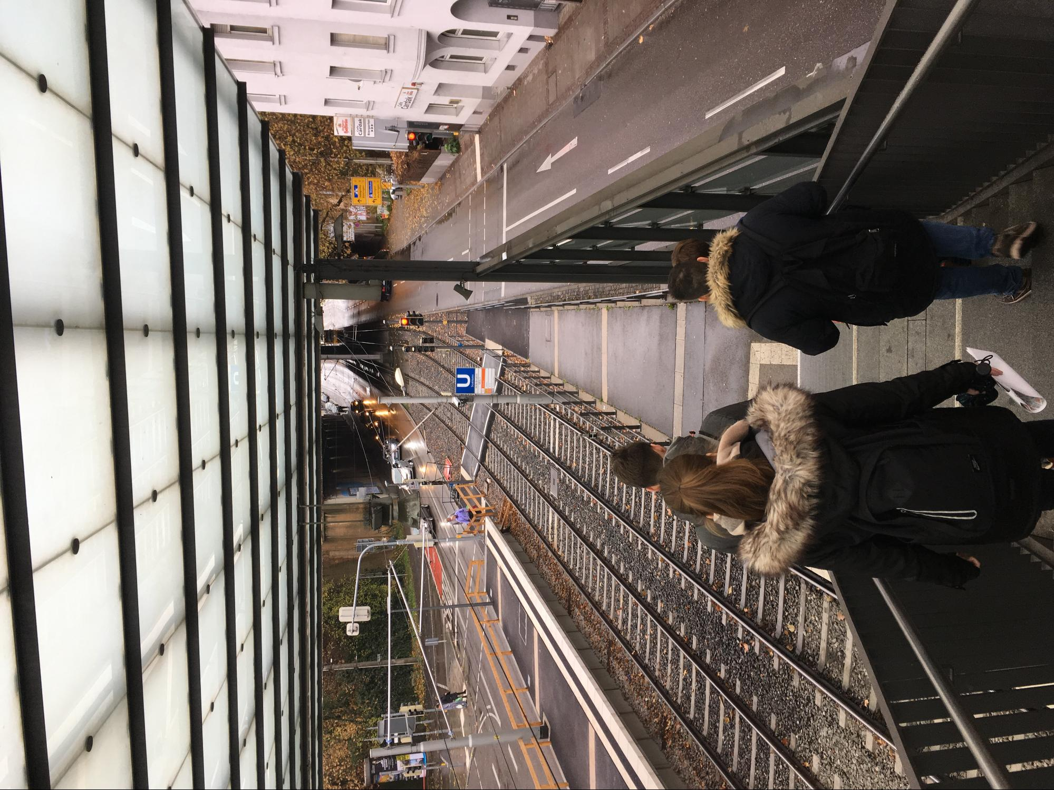
There were some cars that I actually identified, because we have a G-model Mercedes-Benz at home, and I have watched a lot of movies with cars in them. We also found some Finnish names from the Formula section, like Mika Häkkinen and Kimi Räikkönen. There was also some things about airplanes, so that was really nice.
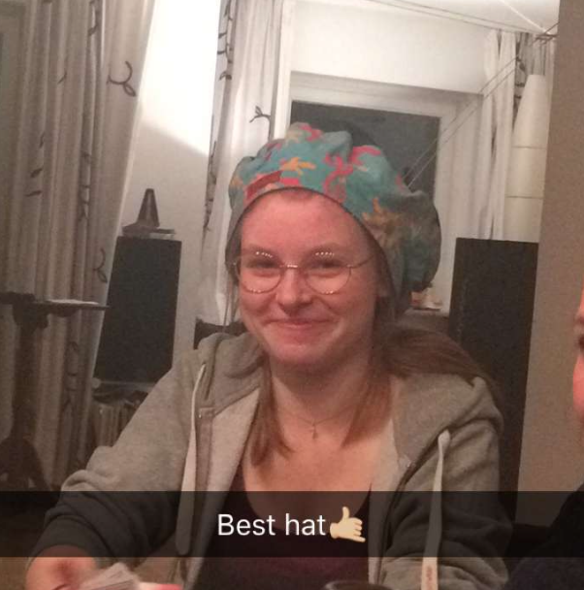
After the museum tour we went to Stuttgart and played Scotland Yard in live. They called it Mr. X, and we played in our project groups. The point was to find the team that was called Mr. X. The Mr. X -team left earlier than others and notified their location every ten minutes. It was fun for me, but I also understand that a lot of people said it was a little useless and boring, because we were just sitting in a train or a buss or an underground and especially we who weren’t Germans understood very little of the possible routes we could take so it was basically the Germans telling the group where we should go next and others following them. Our group came to a conclusion that we would never catch Mr. X and so we tried to go see the city library, but it was closed.
After the game had ended, we ran to the train again with Henriette, and we sat there with Johannes, Giovanni and Hannah. Hannah is Henriette’s good friend who is also part of this project. She is actually Diana’s host. In the evening, Giovanni, Johannes, Hannah, Diana, Francesca and Leonie came to party with us at Henriette’s. We played Scotland Yard the board game and one sofa game and also a card game where the loser had to wear this silly hat and for some weird reason I kept losing all the time.

26.11.2017 Sunday, Funday

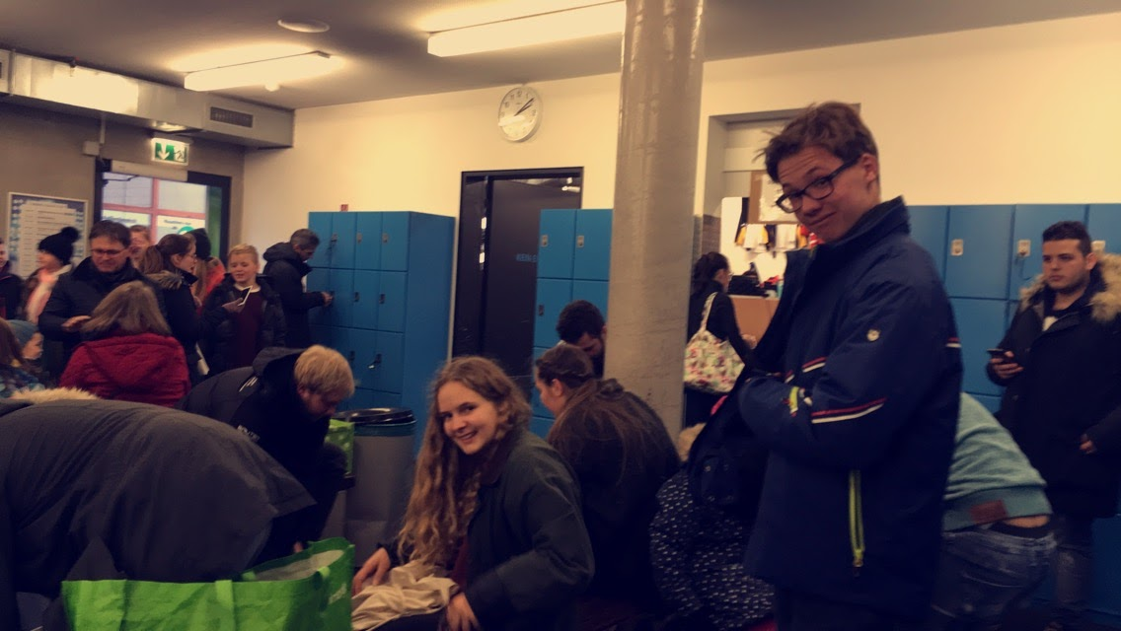
We slept long this morning and had bagels for breakfast. So apparently also Germans think that their bagels are sometimes a little too salty, so they take all the salt they can off the surface. And apparently they like to cut the bagels in half and fill them with butter or other fillings just like a normal bread. I thought they just eat them like some kind of candy.
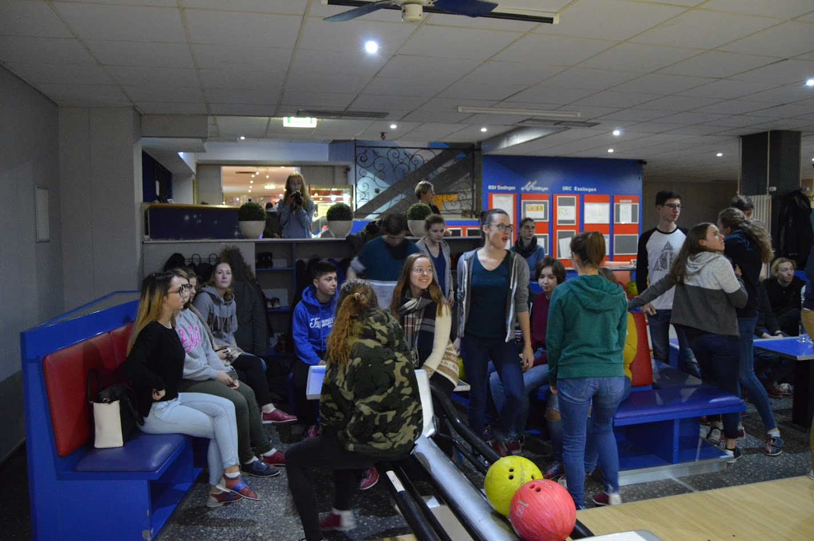
After breakfast we walked to the train and went to an icehall to go ice skating with Leonie, Francesca, Giovanni and Johannes. It was the first time on ice for Giovanni and Francesca, but they learned really fast. Surprisingly fast. Apparently Germans don’t know how to slow down and stop, so they just always go against the walls. Obviously I felt it my responsibility as a Finn to try and teach them something. For once, I felt like I was actually pretty good at ice-skating and it was really fun. I also got to prove Johannes that the Finnish chocolate really is good, as he had yesterday offered me German chocolate and I had commented that I still think the Finnish one is the best. And he did admit that it’s just as good as the German Ritter Sport.
Later in the evening we went bowling with almost all of the students in this project, only Johannes and Giovanni weren’t there. We taught some important bits of our language to the Estonians (Ken and Pille) and Germans (Leonie and Henriette) ; for example the words like “lentokonesuihkuturbiinimoottoriapumekaanikkoaliupseerioppilas” and “epäjärjestelmällistyttämättömyydelläänsäkäänköhän” and the statement “pohjanmaan kautta”. Not to forget the swear words... It was quite fun.
Using the public transportation yesterday in the Mr. X game and on other days as well has shown us how it works in here, and I think it’s much better than in Finland, or at least it’s better than in Sastamala. But people also use it much more here in Ostfildern and in Stuttgart, especially the morning train is really crowded.

27.11.2017 Monday, School again
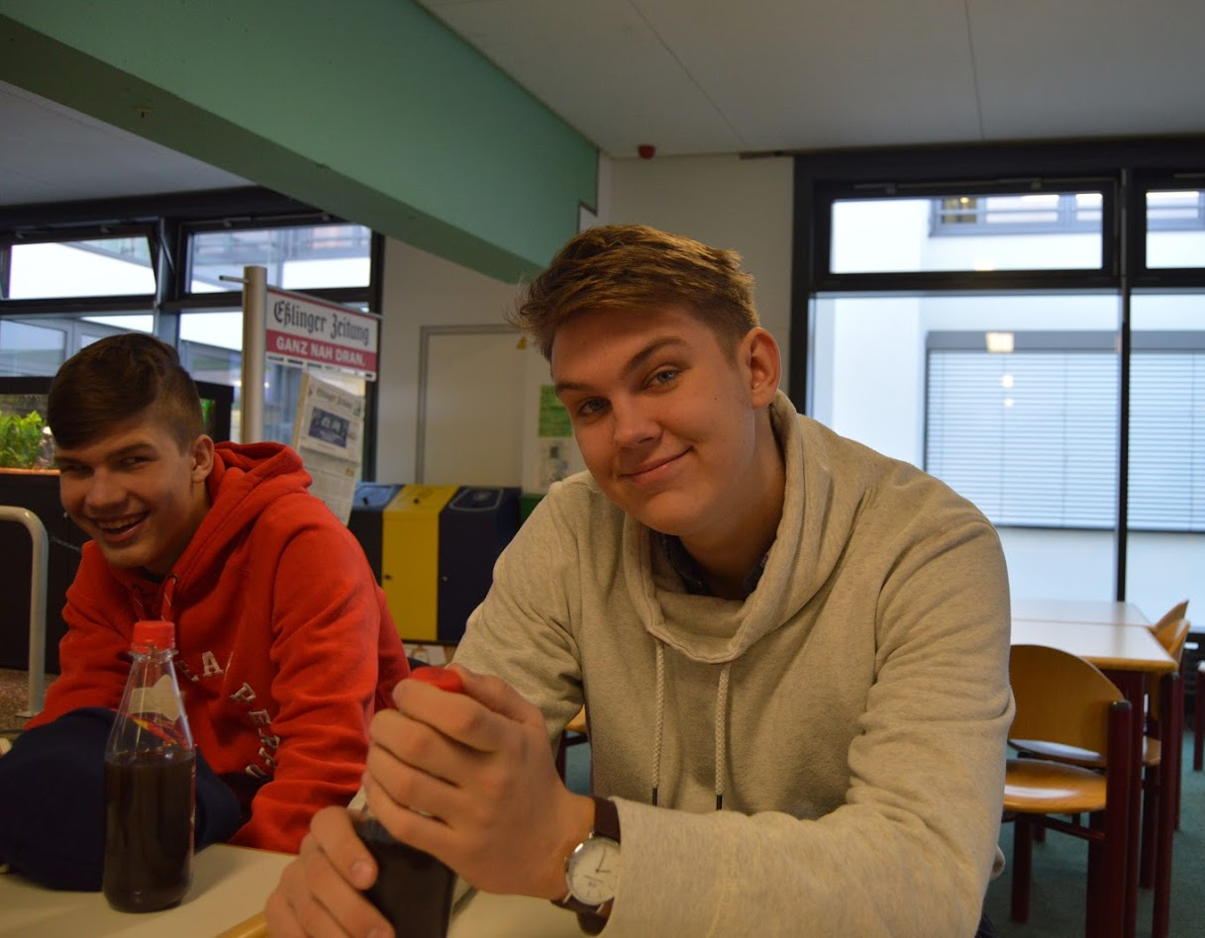
Okay, so, in the morning, we went to school by bike and I swear, Germans drive like crazy, even if it’s just a bike. We didn’t use any helmets or anything and we drove really, really fast on the slippery rock roads and down the slippery hills and I really felt like I was gonna die or at least hurt myself really badly. Luckily, we arrived at the school right on time without a scratch. (Other than the shock that I got.)
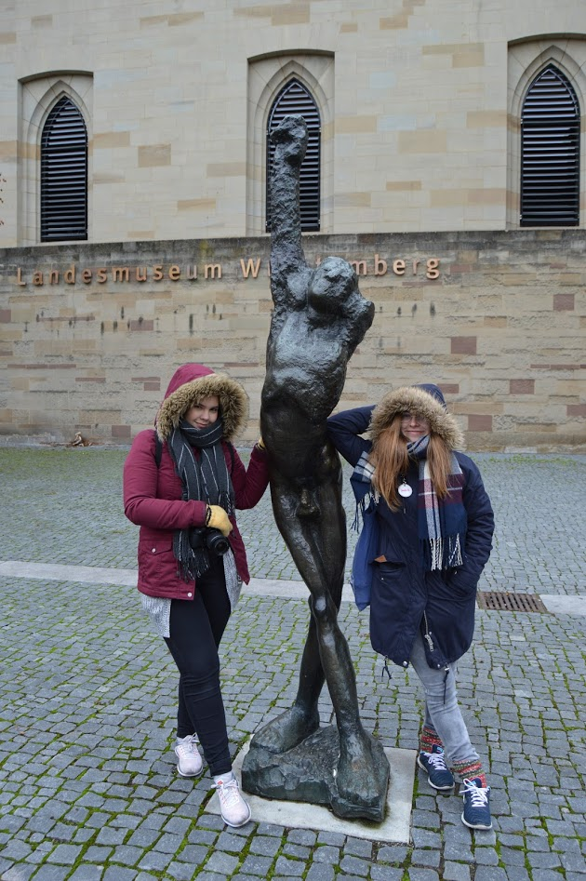
Henriette went to her lessons, and I spent a long time in the school hall just laughing and joking around with the Estonians and other Finns.
Then we briefly visited the mayor’s office after which we went on a guided tour in Stuttgart. Our tour guide answered our questions about our debate topics and told us about Stuttgart’s history and air pollution there.
It was extremely cold and windy in there, but it was still interesting and all in all a good tour. We got loads of good pictures.
After the tour we had some time for shopping. I went to Starbucks with Salla-Maaria, Ellinoora and Ella, and after some time warming up in there, we tried to do some shopping, but we mostly just kept weird noises when we saw something really nice and walked away really fast because it was too expensive and we could not pay so much for it.
After shopping, we came back to the school where we did some more work for our debates. After about an hour or so, we all went baking Christmas cookies together. It was loads of fun. I “accidentally” started a flour (and powdered sugar) war with Johannes. I must admit that he beat me like a fly, but then again he had the advantage of being much taller than I am. Ellinoora found out that she and Lennart are both part of the Ravenclaw house, which lead to a giant discussion about Harry Potter.
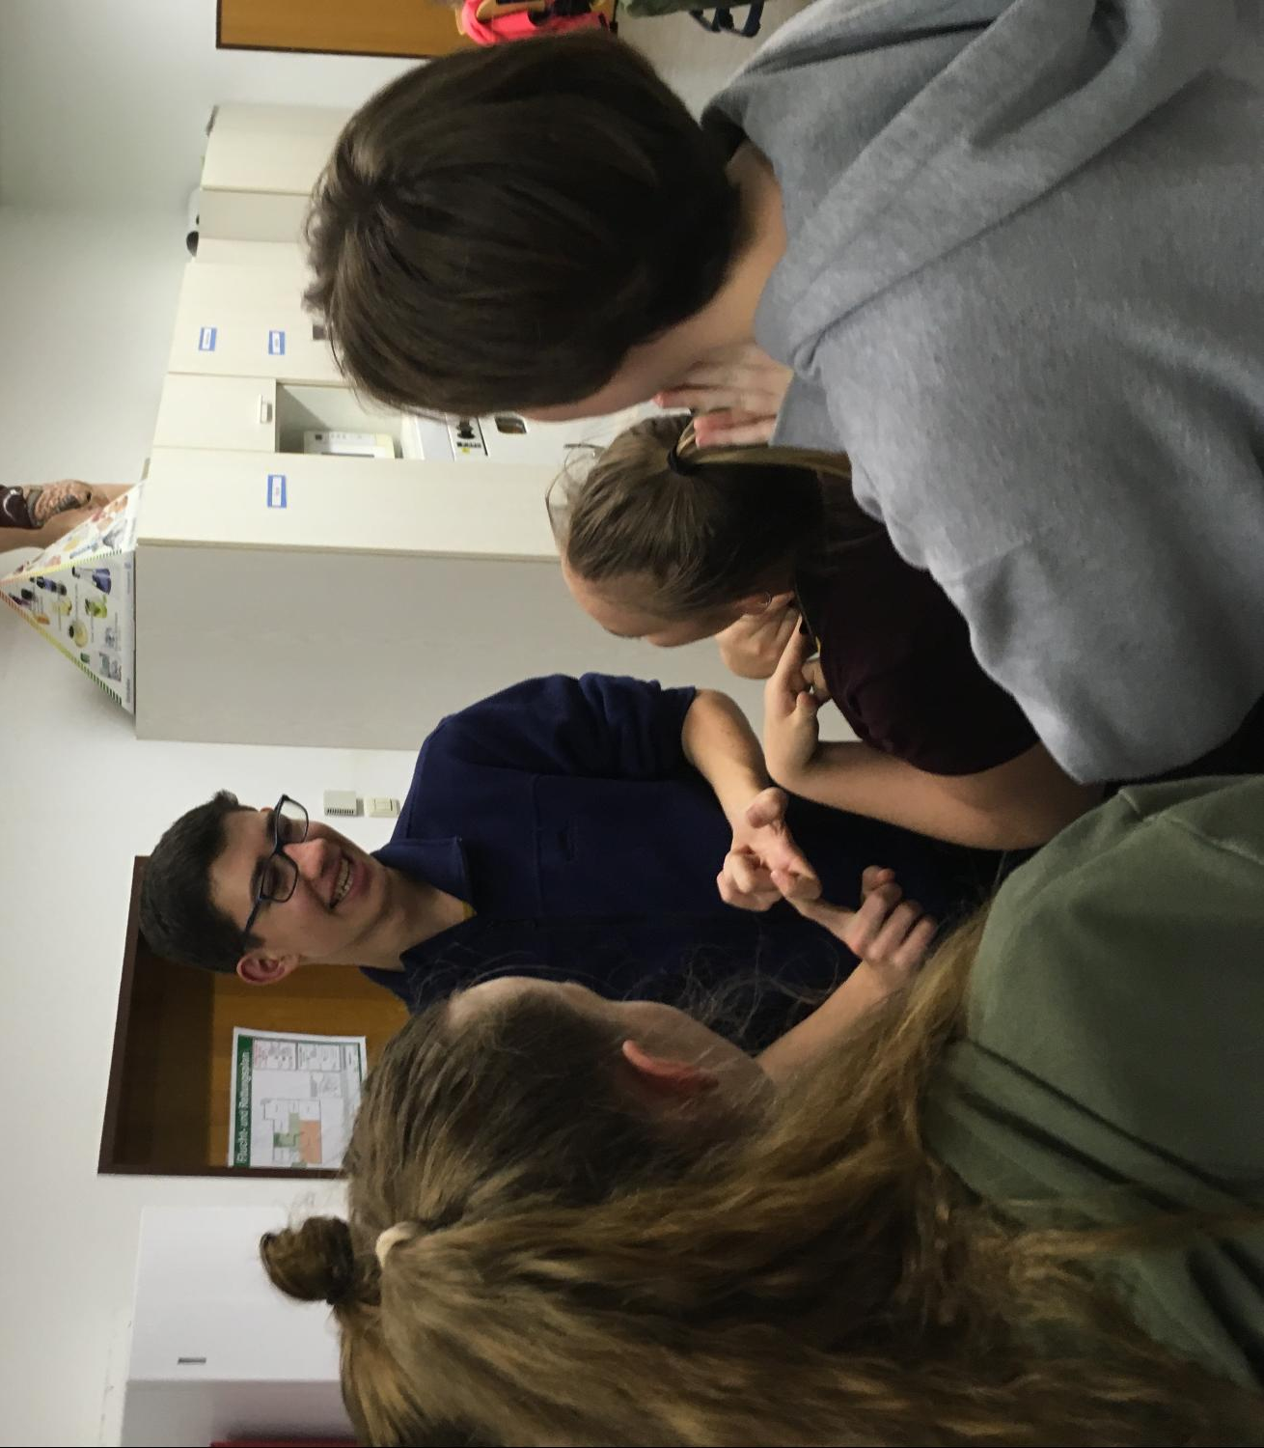
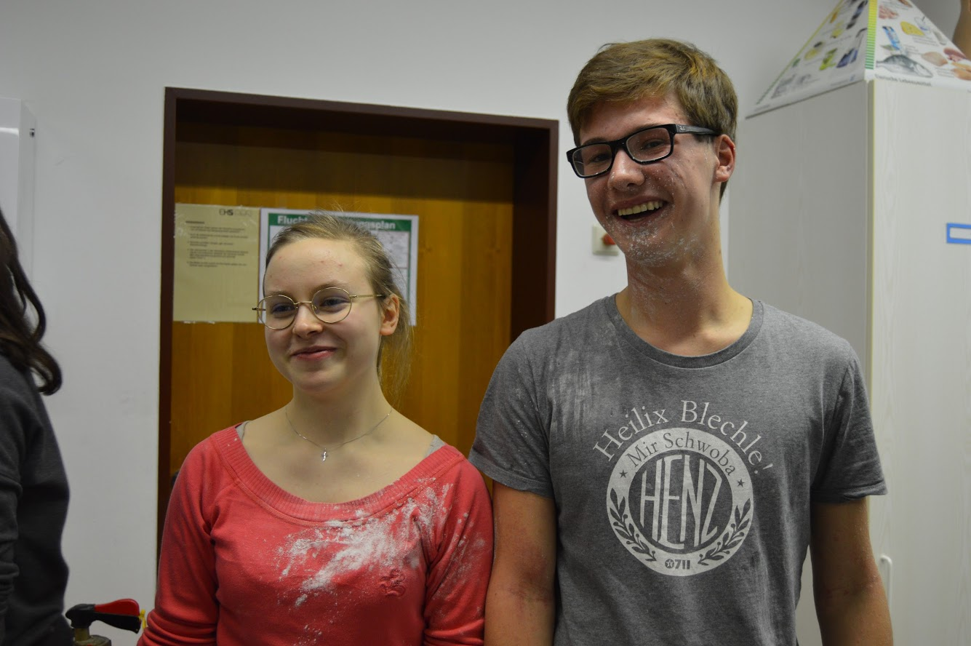

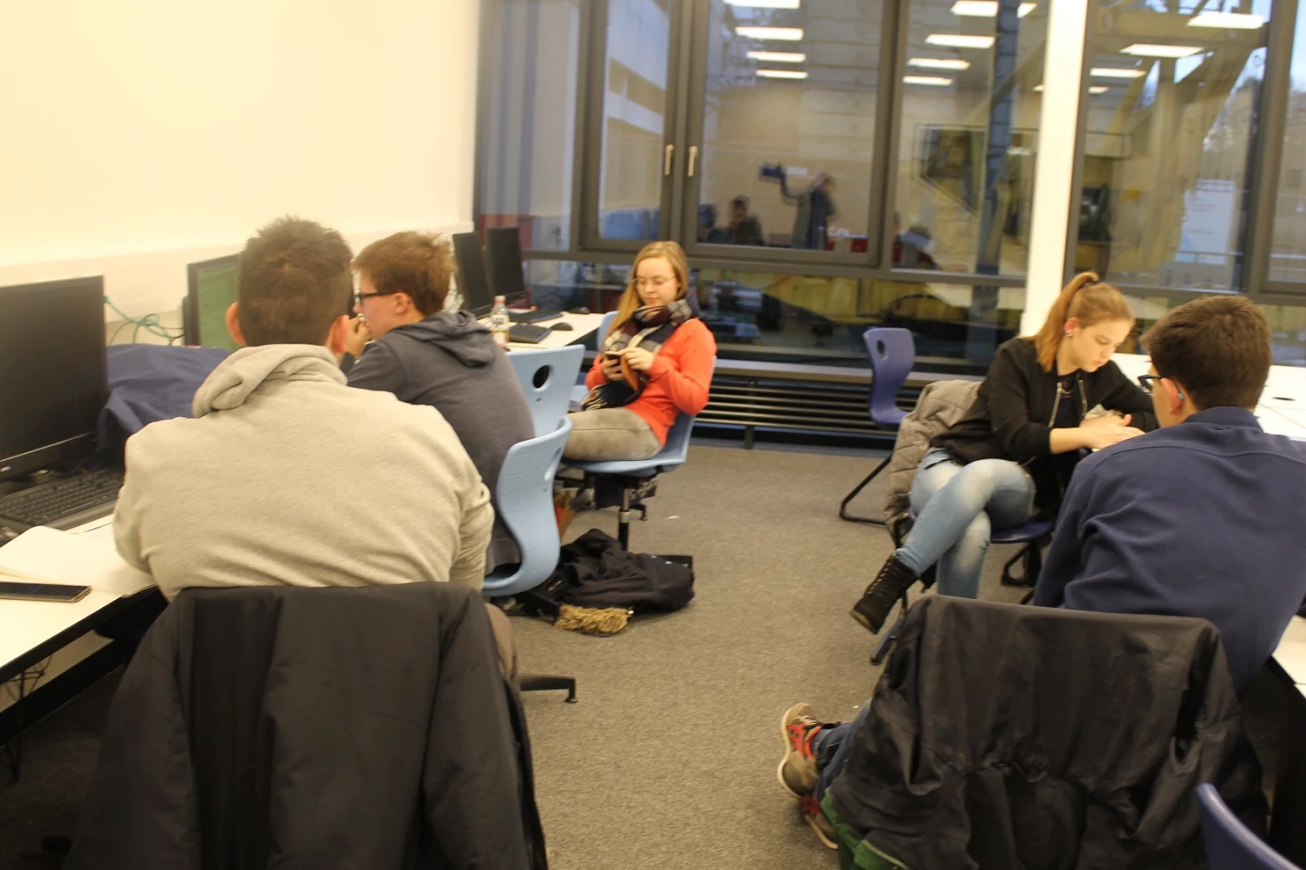
28.11.2017 Tuesday, The Last Day

In the morning, when we arrived at the school, we immediately started working on the last bits of our debates. I mean we practically did all the work for the whole project during this last hour. In spite of that, it was so much fun.
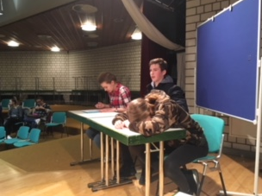
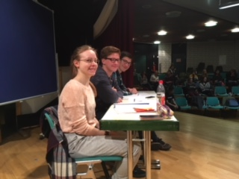
For some reason I wasn’t nervous at all. That is, of course, until there was about five minutes left before the debate. I was lucky to be the first speaker of our team, so I didn’t need to actually listen to anything or do anything after I had spoken. But I did still listen, because it was actually quite interesting. I was still kind of disappointed to see our English teacher sleeping in the back row (thanks for the support, Väisänen). This kind of gives me a permission to sleep on his lessons because, after all, he slept when my team was talking, so I can now sleep when he’s talking. After our debate, we had a quick coffee-break, after which we other debate started.
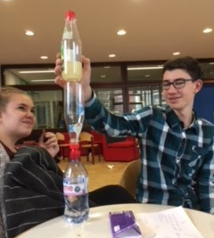
Both of the debates went surprisingly well and they really were interesting. I found myself actually thinking about the subjects and listening closely to the arguments. I think we kind of won our debate, though no one declared an actual winner. (But we had Johannes in our group and as Henriette would say, “If you have Johannes in your group, you have already won the debate.”) But we were really just having so much fun all the time, it’s too much to even write down. And I feel like I’m gonna start crying any minute now.
Anyway, after the debates we went to get some food, but we, (Ella, Ellinoora and me), weren’t hungry. We were just hanging out in the school for hours with more or less Rauno and Lennart.
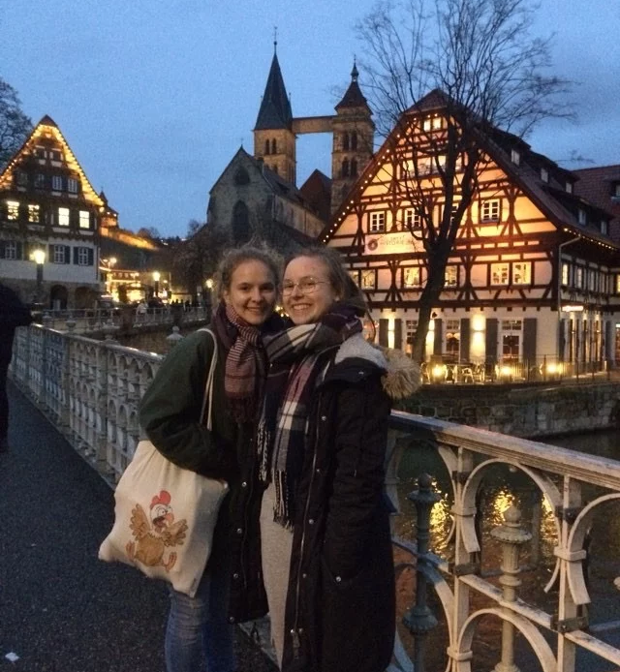
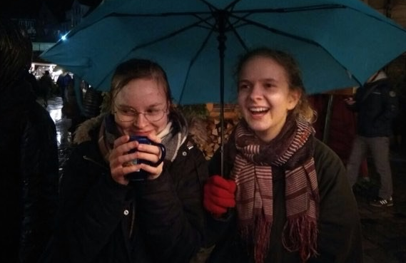
At four o’clock we all met in the school hall with everyone else and took a bus to Esslingen, to the Christmas market. The market was so, so beautiful! There were all these old-fashioned stands full of handmade things, foods, sweets and drinks.
There was also crossbow shooting, so I got to show my skills a little. When our time at the market was almost over, I saw this sad and oh-so-romantic scene: Ken had bought Leonie a heart-shaped necklace and he told her that it’s so she can have something to remember him by, and they were just hugging each other and leaning on each others foreheads and I almost died.
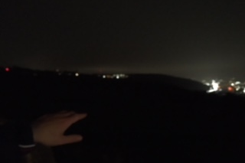
After the market, we took a bus back home with Johannes, Giovanni and Henriette. The boys left us at the end of this beautiful little road that lead to Henriette’s backyard. We could see all the lights of Stuttgart from up there and Johannes told what all the lights were and I almost died.
Now I feel so sad because this was the last evening and I can’t see most of those people again. I can feel that this trip has left it’s everlasting mark on my memories and my heart. I genuinely enjoyed these people and their company so much.

29.11.2017 Wednesday, The Day of The Great Sorrow

“You will never be completely at home again, because part of your heart will always be elsewhere. That is the price you pay for the richness of loving and knowing people in more than one place.”

Today it was harder to wake up, because I knew that once I would walk out that door, I wouldn’t come back again… but I did what I had to do. Henriette’s grandmother brought me some chocolate for the journey and Henriette herself gave me a fabric bag.
When we arrived at the school, the Italians and Estonians had already left, and most of the Germans were probably on their lessons. When I hugged Henriette, I started crying, a lot. And when I stopped crying, it didn’t take long for me to start crying again. Crying is supposed to represent that you have already started to heal, began to feel better, but I did not feel better at all when the tears came streaming down my cheeks. It was so painful to leave. For all of us.
It was painful to know, that we might never see these people again. And even if we would see them again, it will never be just the same again. Life will leave it’s marks on them, and every day these people and these places are going to change a little, and if we ever see them again, they won’t be the same people anymore. And we won’t either. From now on, they will live like this only in our memories.
And it’s even more painful to know that the memories will probably fade a little every day, and after a year or two we might be forgotten, and we might forget. It’s painful to know that it doesn’t matter how many times you keep telling yourself you will never forget and you will never let go, this was only a week of our lives. Just one of the 52 weeks of the year 2017, which is just a one year in the God knows how many years we’re gonna live. And whatever we do, the facts won’t change. Even if we could see some of these people again, it will never be the same. It will never be all of us together again. This will never be again. “That’s one of the greatest curses ever inflicted on the human race. Memory.” You can’t even decide if you want to remember all of it, because it was so good, because you felt so good all the time, or if you want to forget it all, because it hurts too much.

“Just remember that the things you put into your head are there forever”, he said. “You might want to think about that”
- You forget some things, don’t you?
“Yes. You forget what you want to remember and you remember what you want to forget.”

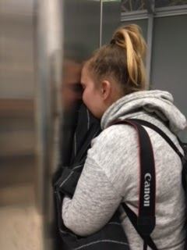
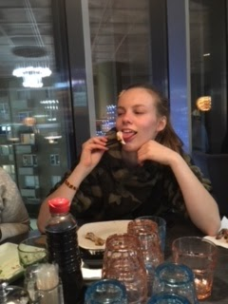
I cried when we got on the train. I was seeing the landscape as it was for the last time. The further away we got, the easier it was to breathe normally again. I wasn’t crying anymore. But we were all tired from shedding tears, and oh that could be seen. And heard. We were laughing at pretty much anything and everything. It was good to be with friends, because we had time to come to our own selves again before we would meet our real families in our real homes with our real beds and our very real education waiting to be continued next morning. And we had time for a brief rehab from all that crying and all the memories fresh in our minds. The journey home was exhausting and tiring, but if it wouldn’t have been, I don’t think I could’ve gotten any sleep at all.
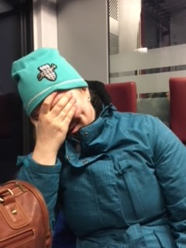
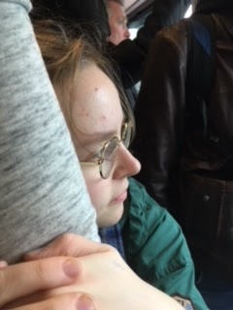
I don’t regret anything. Not a single moment of this journey, and I shall treasure this week in my mind probably more than what’s healthy. I’m so grateful for these memories.

“But the most beautiful things in life are not just things.
They’re people and places, memories and pictures.
They’re feelings and moments and smiles and laughter.”
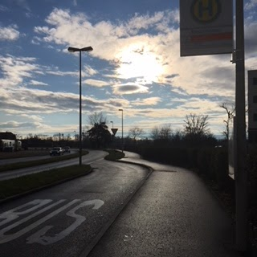
And now, when I’m spending time with my other friends the next week, they ask why I seem so sad. And when I say it’s nothing, I know, I’m not home.

