Erasmus+ Visit to Peebles, 25th November – 1st December 2018
Emily, Saara, Leevi, Ken, Geremia, Eilidh: Scotland, Finland, Estonia and Italy.

Something about the trip: First impressions of Scotland /Peebles? What you are looking forward to.
- Thought it was like a movie
- Nature is beautiful
- Tiny roads
- Nice people
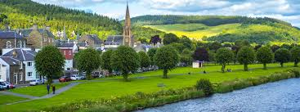
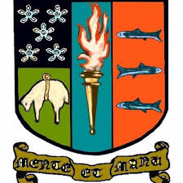
Monday 26th November: What are your first impressions of Peebles/Peebles High School, any differences you have noted between PHS and your own school? What surprised/pleased you most?
- Uniform is sophisticated
- Looks small from the outside but massive inside
- Unorganised lunch
- Food was good at Chinese; people are nice

Tuesday 27th November – Day in School: What did you do? What did you enjoy the most?
- Presentations in morning, classes in afternoon
- Enterprise fair
- English classes was interesting; smaller classes and more people contributed to discussion
- Physics was fun; Mr Campbell was really nice

Wednesday 28th November - Half Day in School & Free time with hosts: What was beneficial/interesting about the activities? What would have made it better?
- Panel discussion was very educational
- Common room is dirty because students are filthy
- Would have been better if there was some more organised activities
- Leevi and Ken went to classes; mechanics was easy
- Peebles would have been better if it was sunny
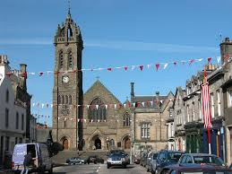
- Town is nice

Thursday 29th November: Day Trip to Edinburgh: What were your first impressions of the city? What differences have you noticed compared to your own or other cities you have visited. The streets, shops, people (behaviour, clothes etc. etc.)?
- Castle was amazing/magnificent/fantastico
- There isn’t a main town square
- Buildings look older
- People are chatty and friendly
- Christmas Market had a nice atmosphere; would have been nicer if it was in a town square
- Bus home was too late
- McDonalds served us quickly
- Tweed fabric everywhere
- A lot of people in suits

Friday 30th November: Scottish Dancing Lessons/Farewell Ceilidh/Brochure Making & Dancing
- Going to be so FUN
- Will miss my Scottish besties

