3.10.2018 Travelling to Tartu

My day started early in the morning, and after a little bit of panicking my dad took me and my girlfriend to the train station, where we met the other Finns. Train trip from Sastamala to Helsinki took about 3 hours with 1 change at Tampere. We got to the port by tram, which didn’t take that long, but we had to wait an hour for the ferry once we got there.
We dropped our luggage and went straight to buffet. After that we didn’t have much time, and we played some games in the game room. Only 2h after our departure we arrived in Tallinn.
We got a cab to get to the bus station, and I was surprised about the Estonian driving culture: quite a few people drove like lunatics.
Being without internet feels bad, but luckily there was a free Wifi at the bus station. Literally every one of us were on their phones for the whole time at the station. Our bus came and we hopped in. 2,5 hours in the bus wasn’t that bad, because we had free Wifi in there, too.Clock was 7 in the evening when we got to the hotel. Walk from the Tartu bus station to the Tartu hotel took like a minute. We got our keycards to our rooms and headed for them. My room was empty when I got there, even though there were someone’s suitcase.
After a while the owner of the suitcase came, and he turned out to be from Italy.
We were starving, so we went to get some McDonald’s. After that we went to Tasku (shopping centre) to get 3 extension cords, because the rooms only had 1 power plug.
We got back to the hotel, and I met my other roommate from Scotland. Then it was time to go to bed.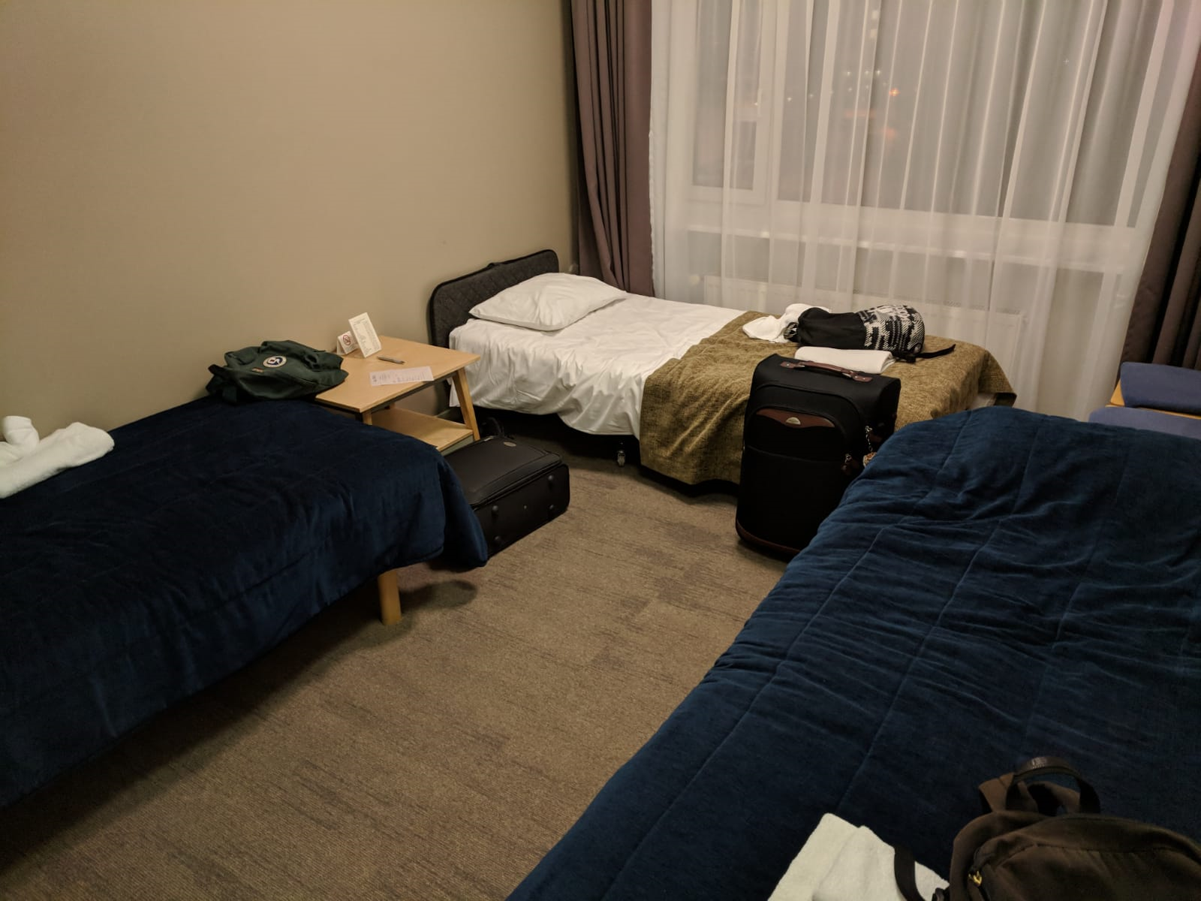

4.10.2018 First day at school

Thursday was the first full day in Estonia. We had breakfast in the hotel’s café (like every morning), and then went to Lähte Ühisgümnaasium by bus.
After a bit of talking in the hall, some Estonian students kept a short concert, which was quite nice. It was funny to understand few Estonian words, because they are similar to Finnish words. Estonians kept couple of presentations about their school and Estonia in general. Scottish, Germans and Estonians kept a presentation about their country’s renewable energy.
Everyone got a colorful name tag, and the colours represented our groups. I got red tag, so I was in the brochure group. We had very little time to work in our groups before we went to eat. After lunch we went back to Tartu, near the Town Hall to be exact. From there we walked almost an hour to the Estonian University of Life Sciences. Couple of professors told us about energy, and showed how boiler works and what is good fuel. We were able to go on the roof, where was solar panels and a wind turbine. In the highest story there were big accumulators to store the energy. After that we were free to go, and some of the students went to ice skating. I didn’t want to go with them, because ice skating is a bit “lame” for me, so I went to the shopping malls with 2 other Finns instead.

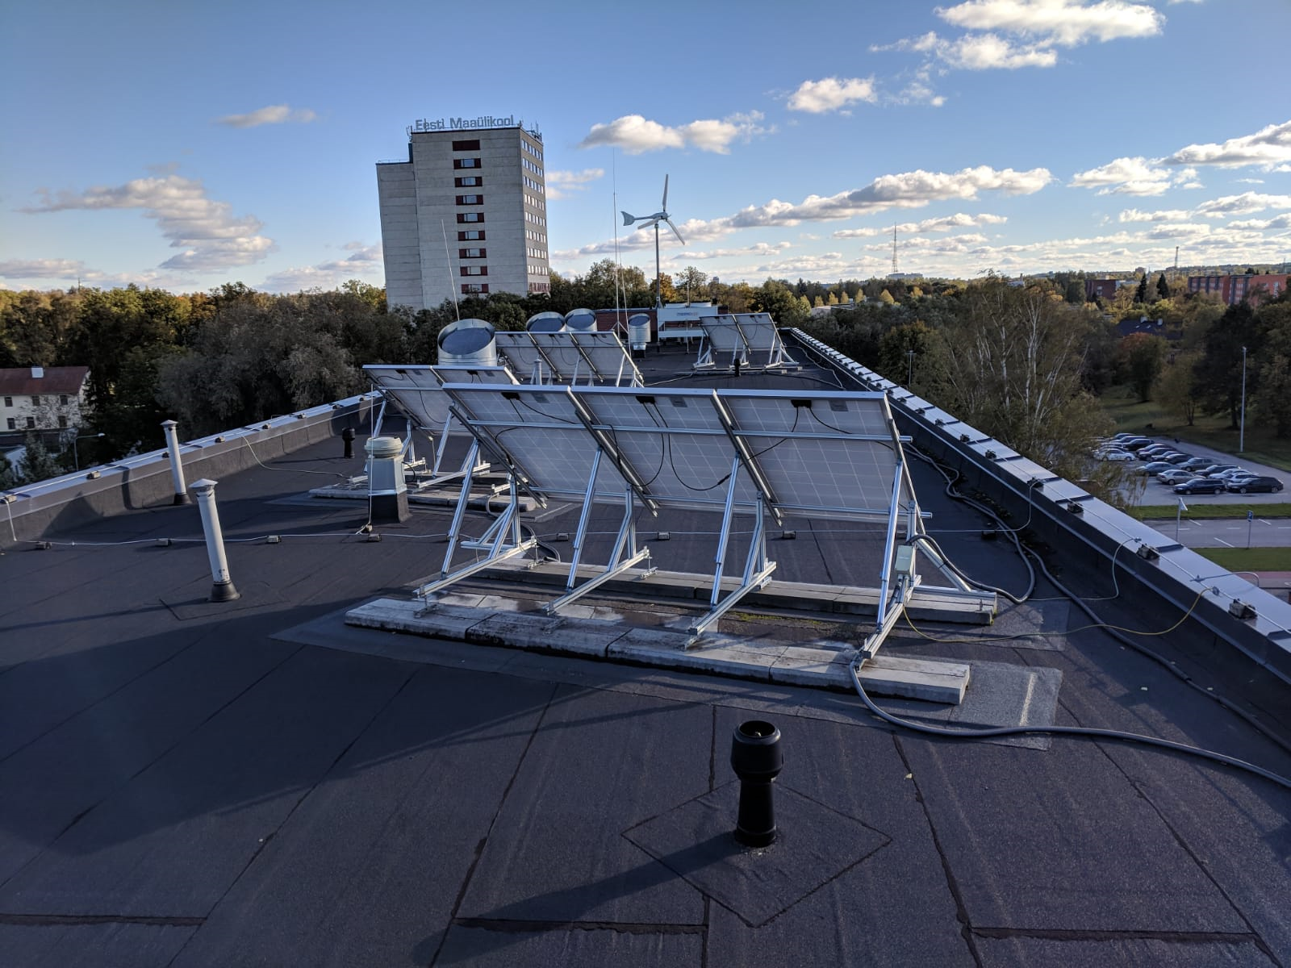
Roof of the Estonian University of Life Sciences

5.10.2018 Tartu and activities

On Friday morning we walked to the centre of Tartu to go on a city tour with a guide. We walked mainly in the old part of Tartu, and saw e.g. ruins of a church and tilted building. Weather was kind of horrible, but I think everyone was able to protect themselves from the light rain. The centre of the city was beautiful, so many old buildings everywhere. A bit further away the buildings got a lot uglier.
I was thankful to get in the Town Hall after the tour, because the weather was quite cold and windy. The mayor of Tartu kept very informative presentation about Tartu. Some gifts were exchanged, and then we headed off to Gunpowder Cellar Restaurant. Meal of the day was chicken pasta, and it tasted like heaven! A big dessert after that and I was ready to roll to Tartu Environmental Education Centre. There were a lot of weird little animals and a big garden with turtle tank. Our guide there told us a thing or two about energy producing and saving in that building.
We didn’t have much time there, because we had a bus to the Ice Age Center. It was pretty cool place, but I’m already quite familiar with the Ice Age, so it got boring very quickly. We had our second meal of the day there, too.
I was ready to go to bed, but we still had one place to go: AHHAA Science Center. I got a bit more energy there, and my inner 4-year-old child woke inside me.
All in all this day was a bit over booked, and I was really tired in the evening.

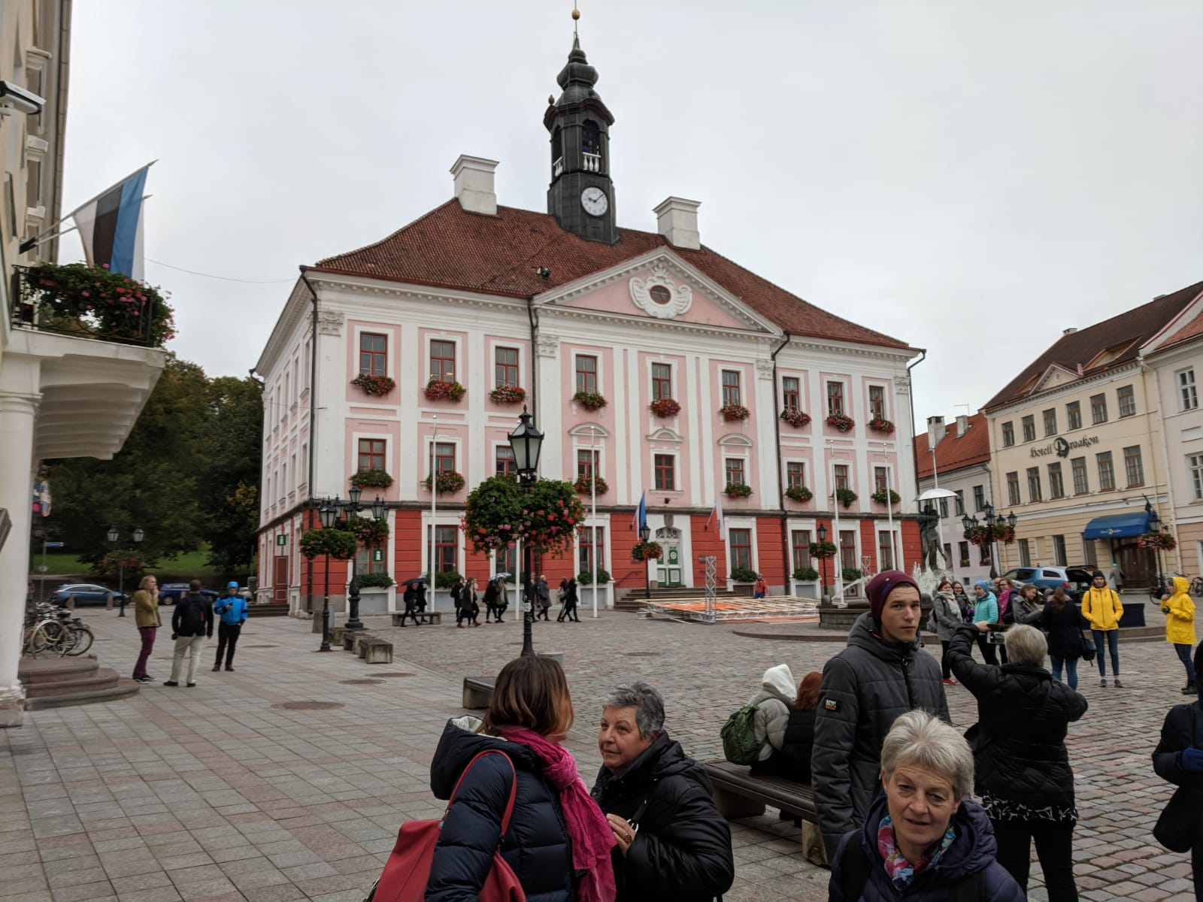
City Town Hall
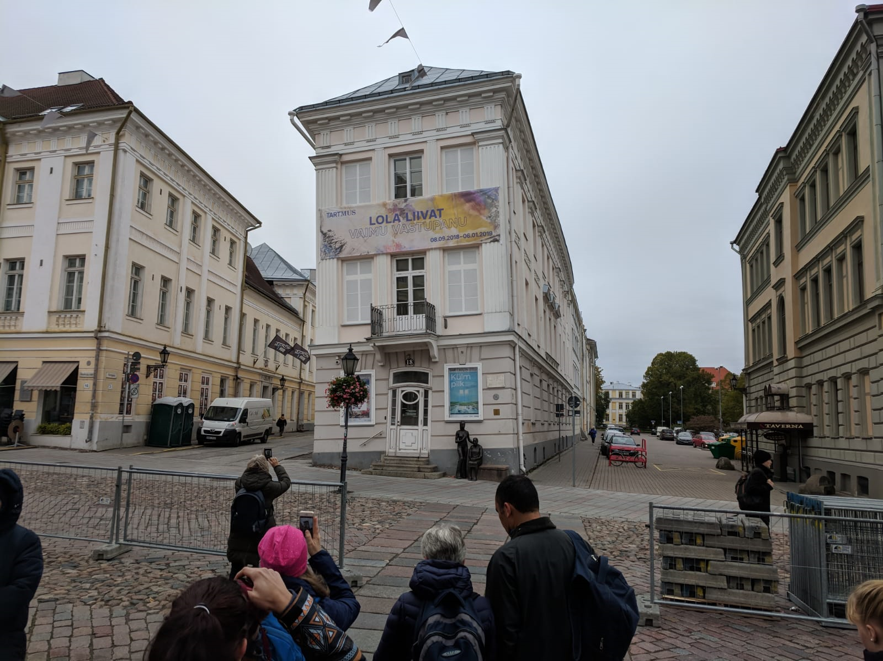
Tilted building in the Old Town
6.10.2018 Day in Tallinn

It was really a pain in the butt to wake before seven, but thankfully I was able to sleep in the bus while we were going to Tallinn. Once we got there, we had 2,5h tour around the Tallinn. First we went to see the castle of the president and the garden around it. The garden was big, but looked a bit rough at this time of the year. After that we visited the place where a music festival is held every year.
Then we went to the Old Town by bus. There were a lot of cool buildings, and I think it was the best part of the tour. But again, the Mother Nature wasn’t on our side, and it rained. We had some food in a restaurant, and then went to Energy Discovery Centre, where was many things about electricity and energy in general. They showed us a big tesla coil in action, and how static electricity affects your hair. After the show, we were free to go around the town.I and 2 other Finns went to a shopping mall, and we were there the whole time. I didn’t find anything nice to buy though. A short walk back to our bus, and then another 2,5h in the bus. We were back in the hotel around 21.00, so after a bit of homeworks it was time to go to sleep.

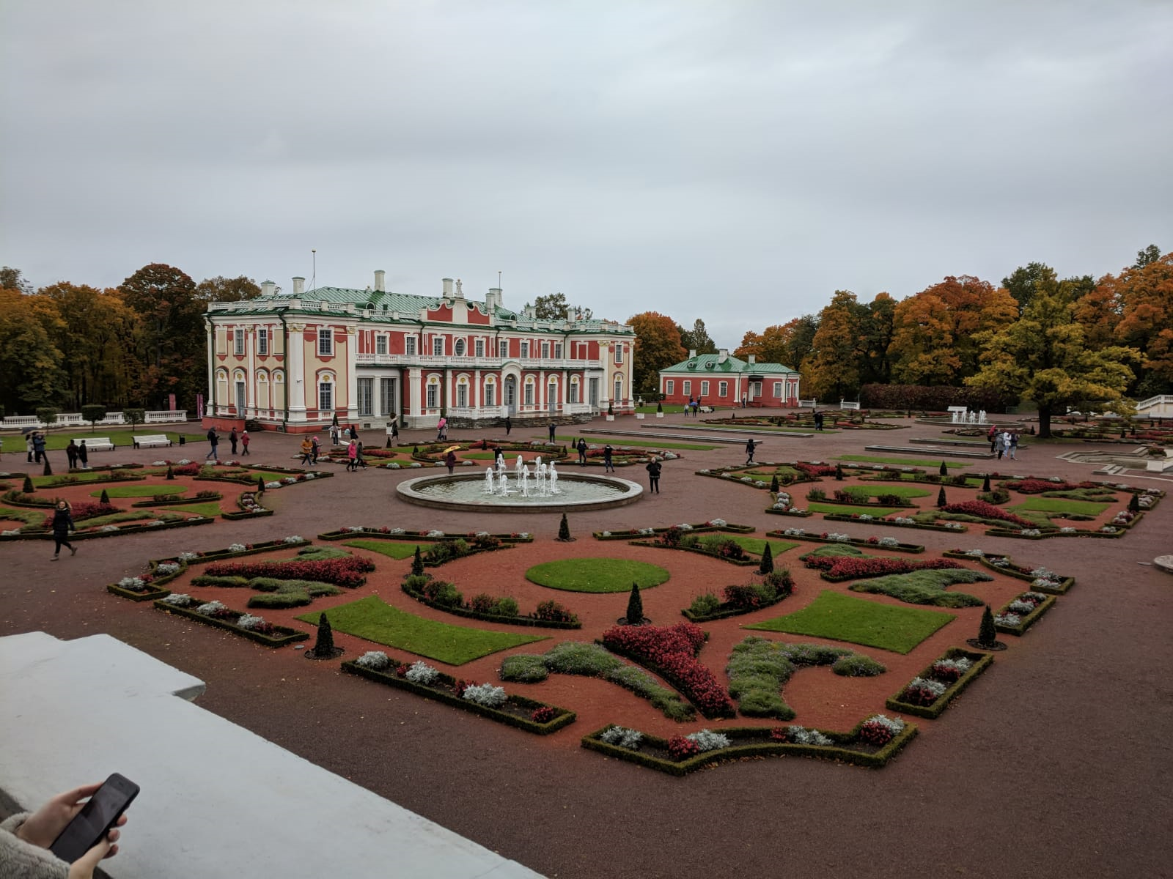
President’s castle
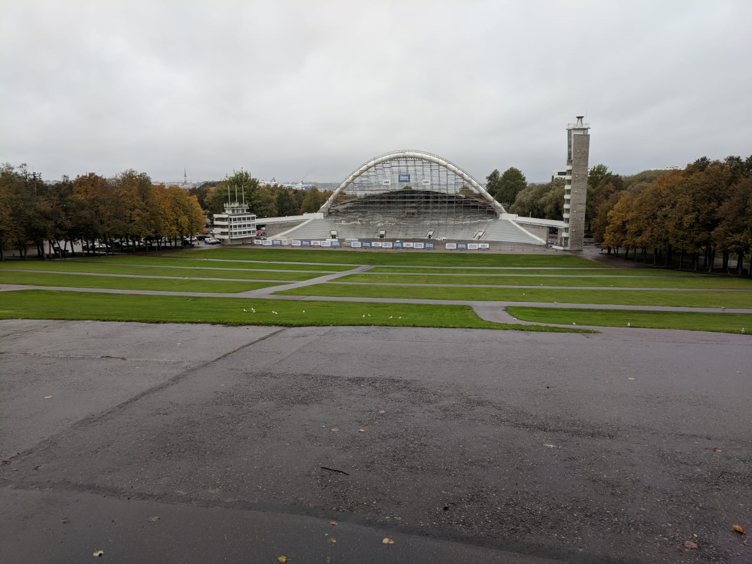
Place for concerts etc.
7.10.2018 Day in nature

After a long day it was nice to sleep a little longer. We had yet another long journey to southern Estonia. Our bus dropped us in the middle of nowhere, and we started to walk in the forest. There was a big wooden tower where almost everyone climbed to see the view.
A long walk in swamp (duckboards) to a small, very peaceful lake. A bit more walking, and we got some food in the woods. Even though the topic of the project was saving energy (and world), we ate our food in plastic dishes, and many found it a bit ironic. Short bus ride to another reserve, where we walked a bit more. Estonian nature was great, but not that much different from the Finnish nature, so I didn’t have anything surprising there.
After we got back to Tarto, every Finn went to AURA water park to swim and sauna. Others weren’t allowed to come, so they went to sauna in the hotel.
In the evening we went again to the shopping mall and one restaurant in the Old Town.

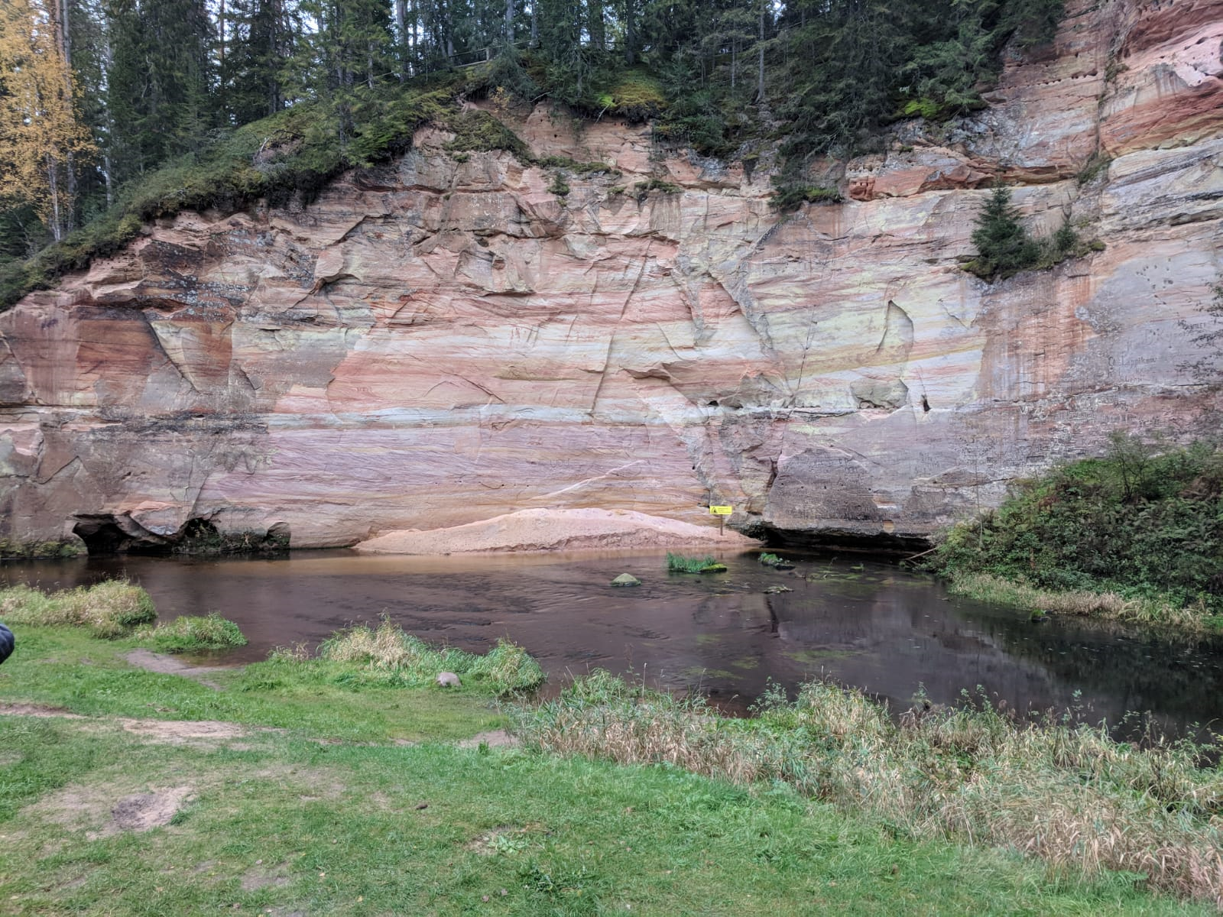
Bog reserve
8.10.2018 Full day at school

In the morning I packed most of my things, because I wouldn’t have much time in the evening. Then we went to the school to work on our project, which was creating a webpage about energy. But firstly Finns and Italians kept their presentations about renewable energy in our countries. Then we got into our groups and went to rooms full of computers. My job was to interview other groups with my friend for the brochure. Our job was quite easy and fast to do, we made our questions and asked them from every group. At 6 we showed the final result, and the rest of the day went with Estonian music and dances. Dancing was fun, even though it was very, very hot.
When we got back to the hotel, some Estonian students came to visit and say goodbye, because we weren’t able to see the last day.

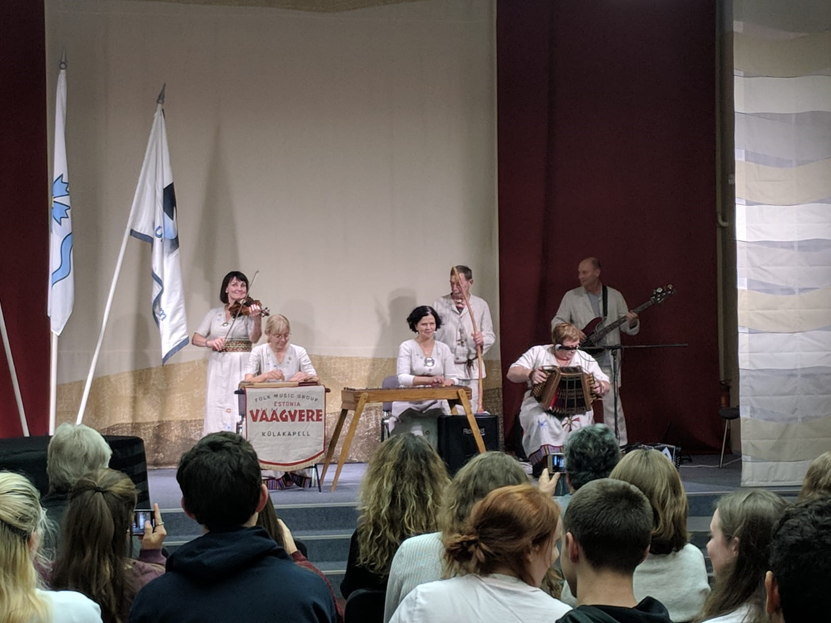
Estonian music
9.10.2018 Back to home

Our bus to Tallinn left at 9, and during the trip almost everyone was either sleeping or listening to music, so it was very quiet for the whole time. Firstly we dropped Scots, Germans and Italians at the airport and said goodbye. Finns continued with the bus a bit longer. We had to wait a little while for the ferry to arrive, so we went to the small shop in the port. Once again, when we got in to the ferry, we went to buffet. There was quite a wind in the open sea, and I started to feel a bit sick.
Our journey in Finland was very boring, firstly we waited the tram, and then the train. We got back to Sastamala at 20.50. When I got home, I just wanted to get back to my own bed.

