Friday, 17th january 2020

My Copy Media
Allée du Levant 9
66140 Canet-en-Roussillon

ORDERING

Dear Madam,

Our company is looking that would be grateful to make us 100 business cards according to our taste and 20 billboards according to our taste as well.

This is the model I would like to have on my business cards and billboards.

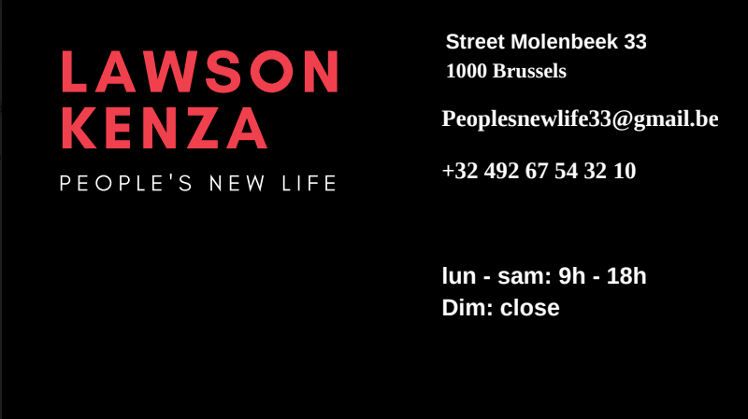

We have a few questions about your company and how it work. What are your opening hours ?

After how long will our order arrive and is the delivery paying ?
We would like to know more about your company.

We are looking forward to your reply

Your faithfully,

Lawson Kenza

KENZA

