Wednesday, 4 March 2020

My copy Media
Allée Du Levant 9
66140 Canet-en-Roussillon

ORDERING

Dear Madam

I m writing to you because I sended you a mail for my order but you doesn’t answer my questions.

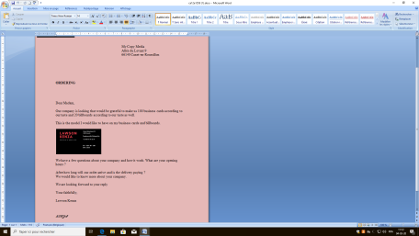
This is a prouve

And I sended you other mail about every informations about my company but you didn’t make your bill
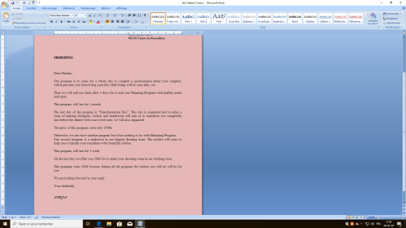
This is a prouve

Your sincerely
Lawson Kenza

