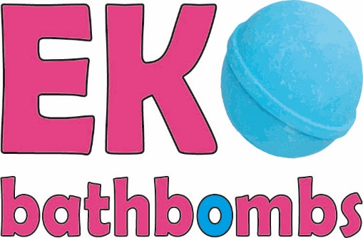
EkoBathbombs
Purkyňova 97
612 00 BRNO
Czech Republic

ENTHALPIA SOUD
OUEST
MENWAY RESSOURCE HUMAINE
3 Boulevard Kennedy
66000 Perpignan
17th January 2020
Dear Sir or Madam,
thank you for your leaflet. We would like to use your services. We need a course for our employees.
We would also like to ask if you are providing recruiting.
Could you please give us some more information about the subject matter.
We are looking to your reply.
Your faithfully,
Zuzana and Natálie from Team EkoBathbombs

