2. koutso – skala - king
Subject: Jumping on one leg
Materials - Means : 1. Chalks for king design
2. Flat stone for each player
The king is played by each child separately, but as many children as they want take part, mainly in small groups.
Each child has his own stone (usually plaque). In the older years, each child chose his stone very carefully and kept it for the next game, if it was "juicy", that is, lucky.
How the game was played: The children made a shape and numbered the steps.

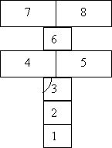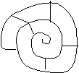
Each child put his stone on the first step and pushed it with the toe of his shoe to the end. He was limping (on one leg). Then they threw it in the second, third, etc. steps until they reach, to the last. If you reached the last step, you would gain a "chill", which you would draw on any step you wanted.
The "tsiullos" served as a step of rest, that is, you could press both your feet.
You lost, if, when you threw your stone on the step you were on, it stepped on the line or when you stepped on it when you kicked the stone or if your foot stepped on the line. Then you stopped the game, continued the next child in a row and started again when it was your turn.
The winner was the child with the most "chiuls".
The game was played mainly by girls and was a winter game.

