P17: Multimedia presentation of typical Easter, Christmas or seasonal dishes.

Students have been preparing this task since December. They have spent some of their free time during Christmas and Carnival collecting information about Canarian and Spanish traditional dishes. We have been working on English lessons with the vocabulary and grammar needed to create and follow a recipe. They have recorded a video where they specified the dish they were going to cook, the ingredients and the preparation of the meal. Here we have a few screenshots, but we have prepared a multimedia presentation to gather all the videos.

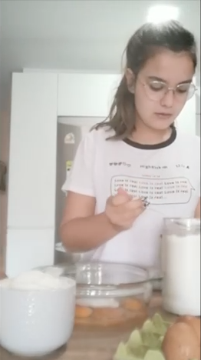
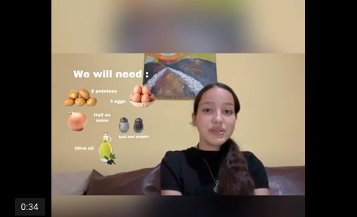

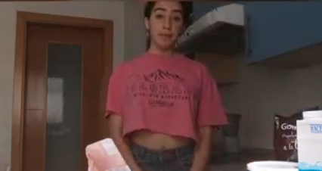

Students worked in the Arts lessons in the three drawings referred to three Canarian legends: La leyenda de Gara y Jonay (The Legend of Gara and Jonay); La isla de San Borondón (The Island of San Borondón) and El Jardín de las Hespérides (The Garden of the Hesperides). The three best were chosen to represent IES Pérez Galdós in the art exhibition of paintings and drawings that took place in the mobility to Cyprus. Students worked in groups and showed their creativity, mixing contemporary drawing concepts depicting old legends. They also worked with different materials: cotton, pencils and watercolour.

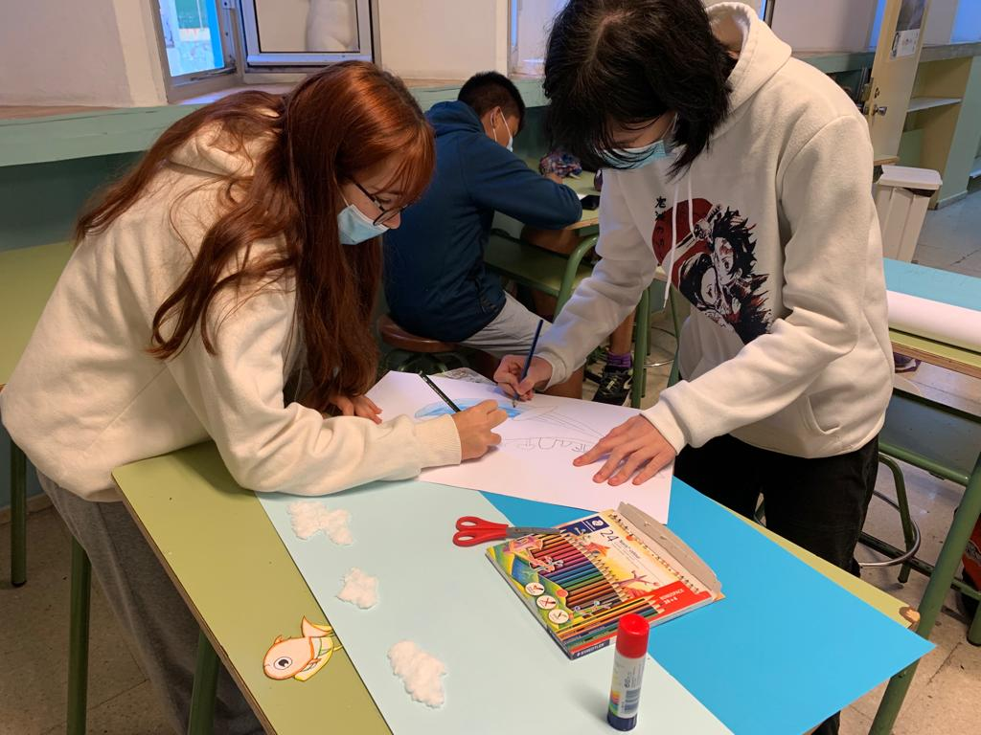
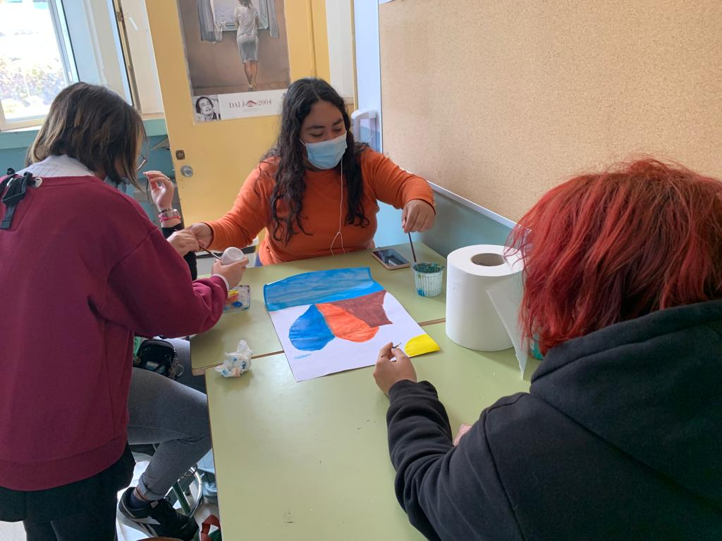
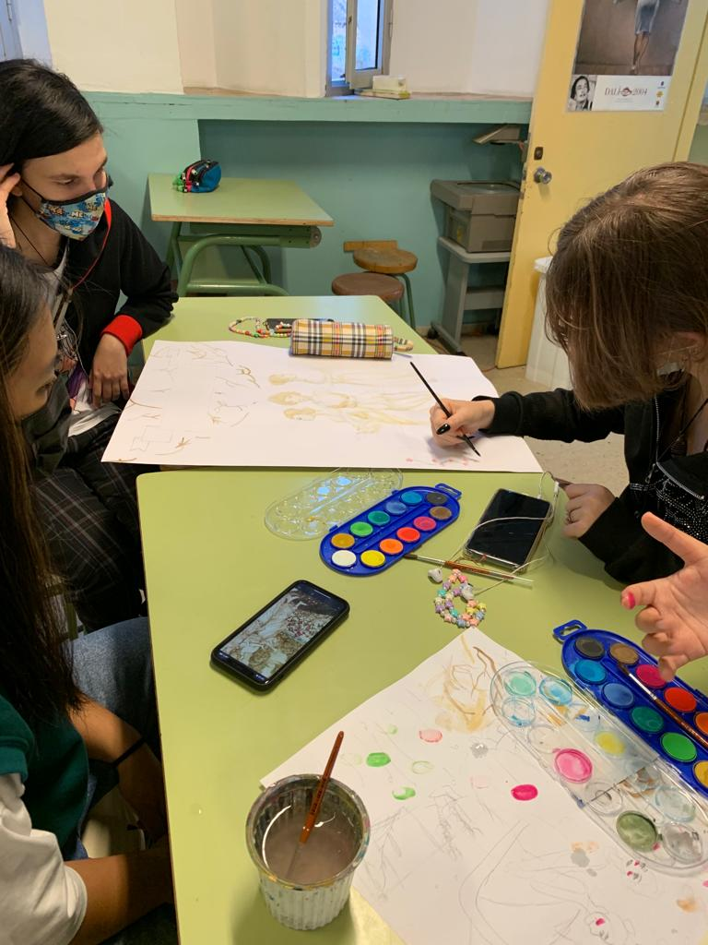

P21:

Although we started this activity during Christmas time, since students were able to gather with families and were going to be able to carry out this activity better, we can show some of their work, although it is still an ongoing activity. Students interviewed their grandparents, parents, aunts and uncles about traditions and customs that used to be respected in the past. They first thought about the questions they would like to ask. Secondly, we worked on those questions in English lessons. Then, once they have made their interviews, they prepared a report individually and we have collected them in different posters. We still need to decorate it with pictures and drawings related to the content students have written.

