My Extraordinary Experience in Romania
My trip to Romania has been an extraordinary experience. Upon arrival it took me a bit to talk to my host and get used to the cold. The first day we went to visit Alba Iulia; it was a very important day for the Romanians, since it was the national day of Romania, on December 1st. They left us some free time to visit some monuments with our teachers and I was very amazed how the wall that surrounded the city was in such good condition. In that free time we could have hot chocolate. Upon returning to the bus, we were taken to a cabin that took you to the top of a mountain, where a fortress was located and from where we could see the entire city. That day we ate a snack that our families made for us. That same afternoon, the family I was with decided to take me to the zoo. The next morning we had to wake up very soon since we had to visit the high school, where they did a project and taught us a little about the structure that was being reformed. I did not have the opportunity to see how they taught, since my host family had planned to go to a Christmas market where I could skate and eat a typical cookie there. Next day we participated in workshops at another high school, where they gave us a talk about the typical Romanian costumes, made a doll with a typical costume and disguised our classmates with each of the different costumes of all countries. That day I had the opportunity to get to know students from other countries better. The other days we did a little faster excursion with the project but the family took me to the mountain, where I touched snow for the first time. I liked the food there a lot; most of the time the mother cooked typical meals there that were very tasty. The best thing about this trip has been the fact of being able to communicate with my host and her big family. I would repeat this experience over and over again as I greatly improved my English and learned more about the culture of other countries.
Arianna Forti
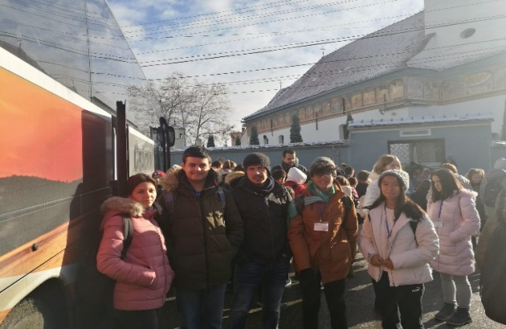
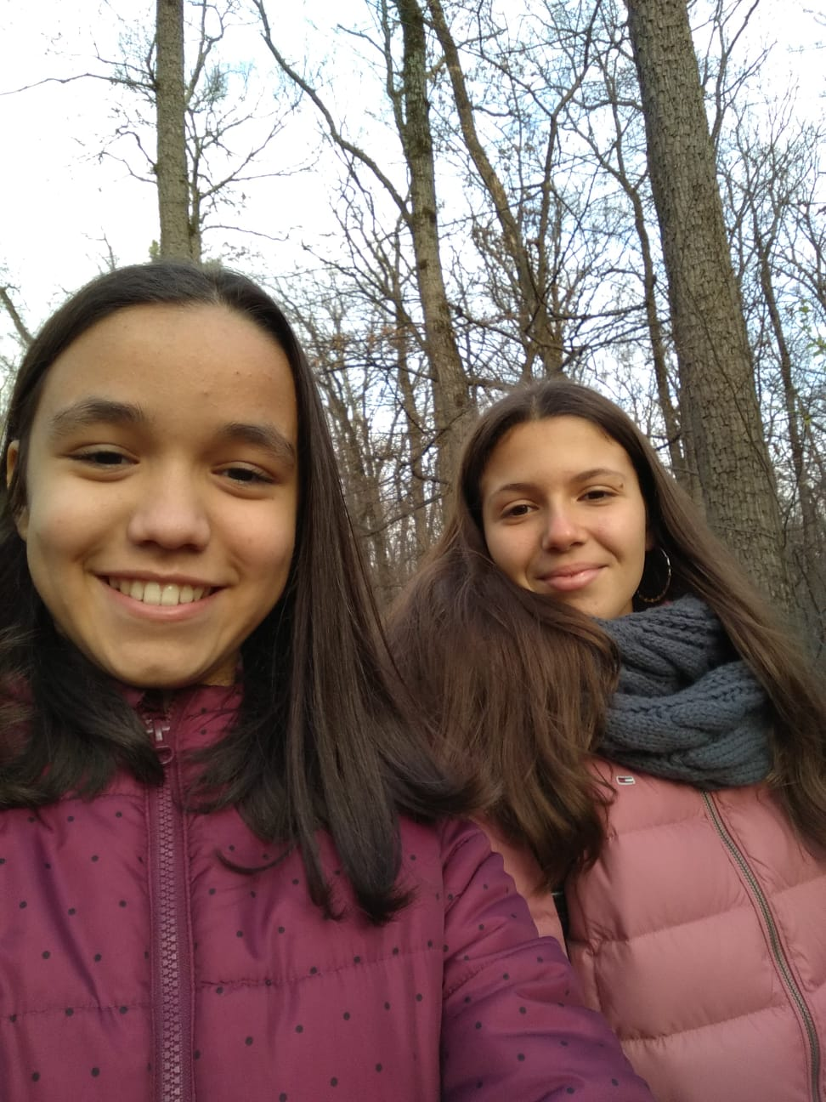
IES Pérez Galdós, Las Palmas de Gran Canaria, Spain
