Here are My Impressions about the Mobility in Poland
Michał Bogusławski, my friendly host pupil, and his school impressed me a lot during the mobility in Poland by his family’s hospitality and the multitude of activities and documentary visits we had there then.
One of the most impressive activity was that made by all participants in the Open Air Ethnographic Museum from Olsztynek. There, we were supposed to find some objects such as an old windmill or a small chapel and to take photos which were used to prepare a poster on the topic of that place.
I enjoyed a lot the visits we had in Warmia and Masuria, admiring the beauty of the region full of lakes and forests. I took part in a few lessons conducted at school which was for me and for all of the participants in the mobility in Nidzica a good way to compare the educational systems of this project partner countries.
In my memories will remain for a long time the creative workshop aimed to develop our artistic skills working with folk motives. I was proud to receive the Activity Certifificate for participating in this mobility.

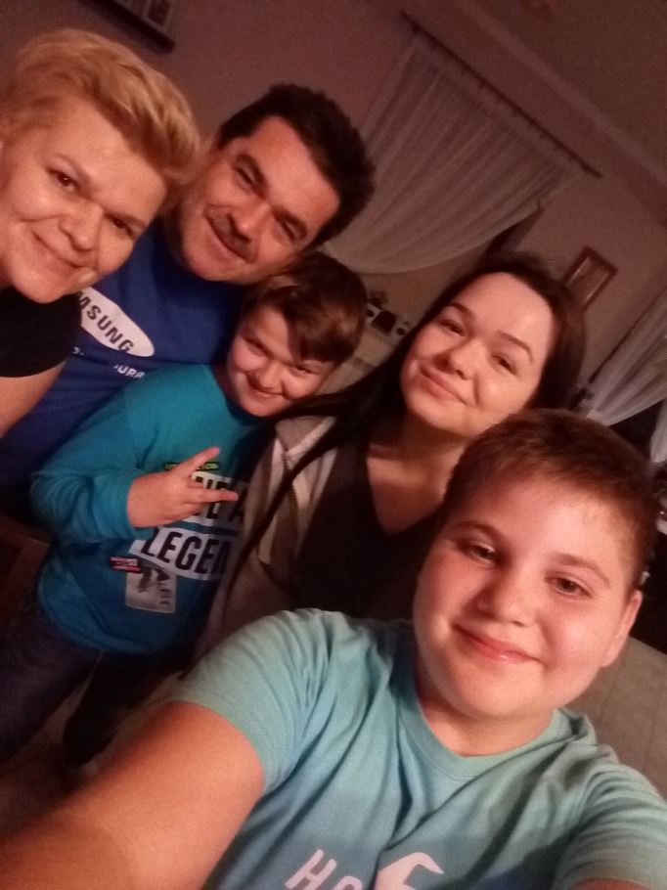
Alexandru Mihai Loloiu,
”Constantin Noica” Theoretical High School Sibiu, Romania

