A Really Nice Experience
In my opinion, it was a really nice experience because I could get to know a lot of people and try delicious food. I liked the weather because I really missed the snow. We went to a lot of cities but my favourite was Braşov. There I could learn about the Romanian culture and buy many beautiful souvenirs. I loved the people who participated in the Erasmus project, but I did not like travelling always in bus because I feel rather sick. I really liked my host family, they were very friendly and I felt like in home. At the beginning I was too shy, but then I did not mind talking in English. I think it is the perfect chance to practice English you cannot speak in another language! I could not imagine saying goodbye until I was in the airport. In that moment, we all were too sad we did not want to leave! I really enjoyed this experience and I hope to go to another unforgettable trip.
Diego de la Fuente Silva
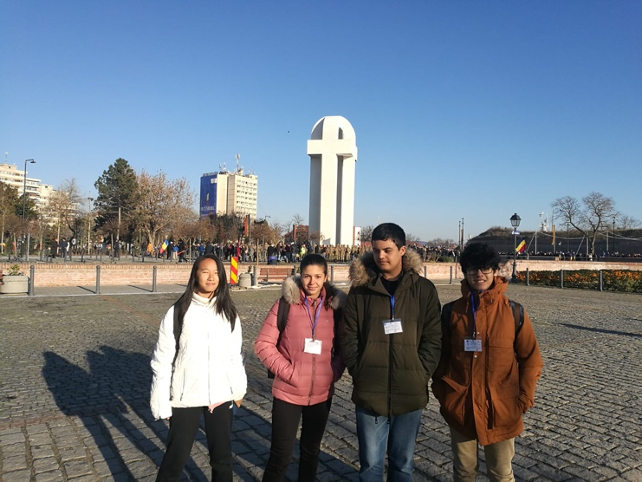
IES Pérez Galdós, Las Palmas de Gran Canaria, Spain

