My Mobility in Poland

In October 2019 I travelled to Poland as an exchange student. This was my second time participating in a project of the kind, and despite I was not sure at the beginning, I thought I did not have anything to lose anyway, so I gave my motivation letter and hoped to be one of the selected. And incredibly, it happened!
I felt as if I was in a dream, a fairly sweet one, and still could not believe it when we arrived in Barcelona. That night I was going to walk on Polish land and meet my host family! We got there around 12 p.m. and it was so cold, but they greeted me with a warm smile. A curious custom I noticed from the very first time was that we could not walk around the house with shoes, but with socks.
During the week, we did all kind of workshops: of clay, paintings, typical foods, etc. The one I liked the most was a workshop at a glass factory where we saw live how they shaped a molten of crystal ball and turned it into a swan. It was so amazing that I could not leave without buying something, so I took a swan like the one we were shown before.
We also visited two beautiful towns: Warsaw and Torun. In Warsaw we made our own chocolates at a chocolate manufacture and learnt about Polish history at the National Museum and the Palace of Culture and Science. While in Torun we made candles, soaps and gingerbreads, and we also went to The House of Torun Legends. Personally, I enjoyed more the day in Torun, mostly because it was more relaxing and also, because we were given some free time.
We did not stay much time at the school, but I learnt some things: their “primary” was from first primary grade until third secondary grade here, so there were also kids of our age, and that I was one of the only Asian people there. It felt pretty strange, because in the Canary Island there is a great mixture of cultures and races so you can see through the street people from all over the world. Apart from that, another thing that caught our attention was the climate, it was colder, perhaps it was just 8 or 10 degrees, but it was enough to force us to wear our warm jackets and sweaters. Although I was not used to that, I enjoyed putting all those clothes on.
In conclusion, it is an experience we have to live at least once in our life, because you meet new cultures, people and your own self. As the saying goes “knowledge does not take up space” so why do not we try everything we can and learn from it as the biggest life lesson.
Nguyet Nhi Trinh Hoang, IES Pérez Galdós, Las Palmas de Gran Canaria, Spain

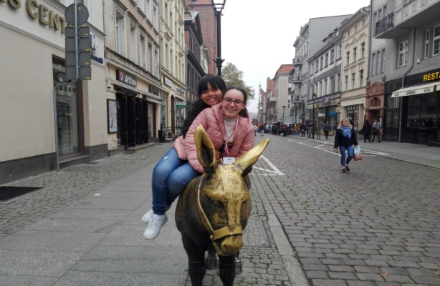 | 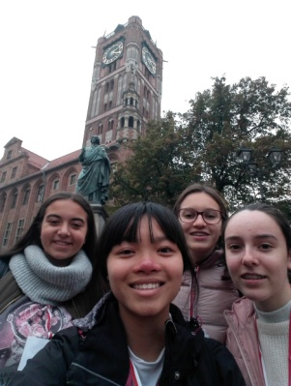 | 