Sara’s Impressions

Hello, my name is Sara and I live in the Canary Islands. I am going to talk about my Erasmus+ experience in Poland.
First of all, I have to say that this experience was wonderful and I would like to repeat it. I noticed that there were a lot of differences between both cultures. For example, at meal times, Polish people eat and have dinner earlier than in Gran Canaria, other differences could be the weather and the landscapes, it was so cold and there were almost no mountains. My host family treated me very well and they taught me their customs, I felt very comfortable with them and I still have contact with my Polish host.
I visited a lot of cities, factories and museums but my favourites were Warsaw and Toruń. Warsaw is the capital city of Poland. We visited a shopping centre that had a structure and bathroom that surprised me. Toruń instead was like a medieval city which covers many legends in its history. Also we did many workshops and my favourite was a chocolate workshop where you could do your own chocolate as you would like.
I tried their meals and I did not like it at all because they were flavours that I am not used to. Also I tried a typical Polish drink that was made of acid of wheat and I did not like it either.
In conclusion, I would have liked to stay longer because it was only a week, but I have a very nice and special memory.

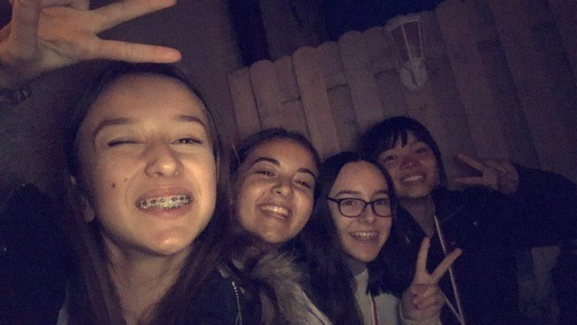
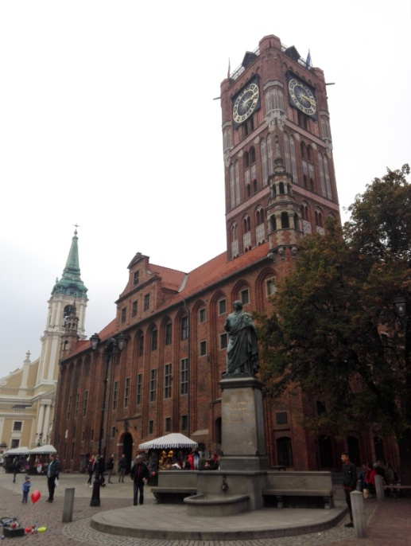
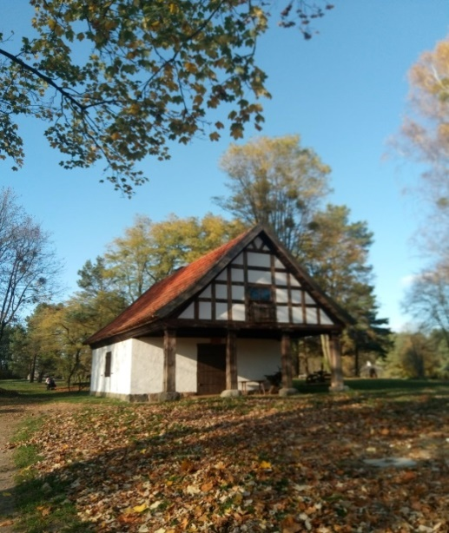
Sara Morales Vélez, IES Pérez Galdós, Las Palmas de Gran Canaria, Spain

