The 1st Romanian Menu
1. STARTER - Fried Cheese (in Romanian Caşcaval Pane)

Ingredients

2 eggs

63 g flour

1/2 teaspoon of salt

1 pinch of pepper

60-120 ml water

4 tablespoon of oil

250 g cheese

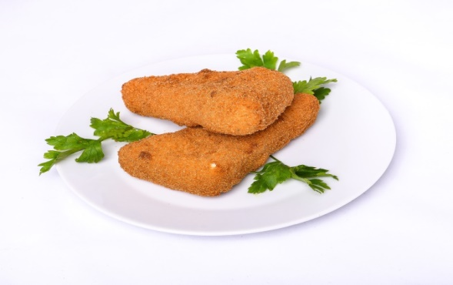
Directions

1. In a small bowl, break the eggs and beat them lightly.
2. Add the flour, salt, and pepper. Beat well.
3. Stir in enough water to make the mixture thin, but not too runny. It should be about the consistency of pancake batter.
4. In a small frying pan, heat the oil over a medium flame.
5. In the meantime, remove any skin or wax from the outside of your cheese.
6. Cut the cheese into ¾ inch slices or “fingers”. Dip each slice into the batter, coating it completely.
7. Heat a skillet and add oil. Fry the battered cheese in hot oil (over a high or medium high flame) on both sides until lightly brown. Serve hot.

2. MAIN DISH - Chicken Noodle Soup (in Romanian Supă de pui cu tăiței)

Ingredients:

2 tablespoons olive oil

1 cup carrots, peeled and sliced thin (about 1 1/2 large carrots)

1 cup celery, sliced thin (about 2 stalks)

1 cup sweet Vidalia or yellow onion, peeled and diced small

2 garlic cloves, minced

64 ounces (8 cups) low-sodium chicken broth, plus more if desired

2 bay leaves

1teaspoon fresh thyme (or 1/2 teaspoon dried thyme)

1/2 teaspoon dried oregano

1 teaspoon pepper, or to taste

12 ounces wide egg noodles (or your favorite noodles or pasta)

2 cups shredded cooked chicken

3 to 4 tablespoons fresh flat-leaf parsley leaves, finely chopped

1 tablespoon lemon juice, optional salt, to taste

Directions:

1. To a large oven or stockpot, add the oil and heat over medium-high heat to warm.

2. Add the carrots, celery, onion, and sauté for about 7 minutes, or until vegetables begin to soften. Stir intermittently.

3. Add the garlic and sauté for another 1 to 2 minutes.

4. Add the chicken broth, bay leaves, thyme, oregano, pepper, and bring to a boil. Allow mixture to boil gently for about 5 minutes or until vegetables are fork-tender. Note – If you like brothier soup, add additional broth, possibly as much as an additional 64 ounces because as time passes the noodles will continue to absorb broth.

5. Add the egg noodles and boil mixture for about 10 minutes, or until noodles are soft and cooked through. At any time while making the soup, if the overall liquid level is lower than you like and you prefer more broth, adding a cup or two of water is okay. At the end you will adjust the salt level.

6. Add the chicken, parsley, optional lemon juice (brightens up the flavor), and boil 1 to 2 minutes, or until chicken is warmed through. Taste soup and add salt to taste. I added about 1 tablespoon but this will vary based on how salty the brand of chicken broth used is, how salty the rotisserie chicken is, and personal preference. Make any necessary seasoning adjustments (i.e. more salt, pepper, herbs, etc.), remove the bay leaves, and serve immediately. Soup will keep airtight in the fridge for 5 to 7 days or in the freezer for up to 6 months.

3. DESSERT - Cheese Doughnuts (in Romanian Papanași)

Ingredients

300 g cow’s sweet cheese (or ricotta/cottage cheese)

1 large egg

70 g sugar

200 g flour

½ teaspoon baking powder

Vanilla extract

Lemon zest

500 ml oil for frying the papanași

200 g fruit preserve

200 g sour cream

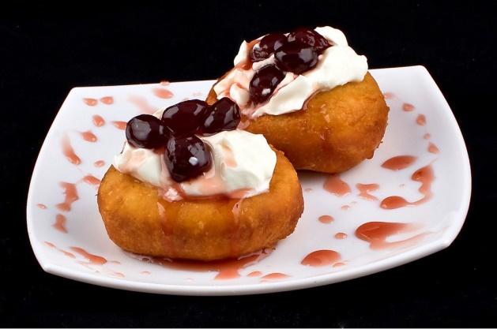

Directions

1. With a fork, mix the cheese, sugar, vanilla extract and lemon zest.

2. Separately, mix the flour with the baking powder.

3. Gradually add the flour mixture to the cheese mixture. Depending on the cheese you’re using, you might need to add more or less flour. The dough should be soft and just a bit sticky, but firm enough to form doughnut balls with your hands.

4. Spread some flour on your working surface and knead the dough for a bit to fully combine the ingredients.

5. Form 6 large balls and 6 small balls, like in the photo.

6. Using your finger, form a hole in each large ball.

7. Heat enough oil in a pot to cover the papanași. Make sure the oil is hot – to do this, drop a bit of dough in the oil and see if it sizzles.

8. Fry two large doughnuts ant two small doughnuts at a time, until they’re golden brown on each side.

9. Transfer the doughnuts to a platter covered with absorbent paper to remove the excess oil.

10. To make the papanași, use a large doughnut as the base, top with a spoonful of sour cream, then decorate with fruit preserve and put the small doughnut on top. You can also sprinkle some powdered sugar on top. There you have it, a traditional Romanian dessert that’s easy to prepare and bursts with flavor!

