The 2nd Romanian Menu
1. STARTER - Fish Roe Dip (in Romanian Salată de icre)

Ingredients
80 g (2.8 oz.) carp fish roe
200 ml (0.85 cup) sunflower oil
60 ml (1/4 cup) sparkling water
juice from 1 small lemon
25 g (1/4 cup) fine dry breadcrumbs
1 red onion
olives for serving

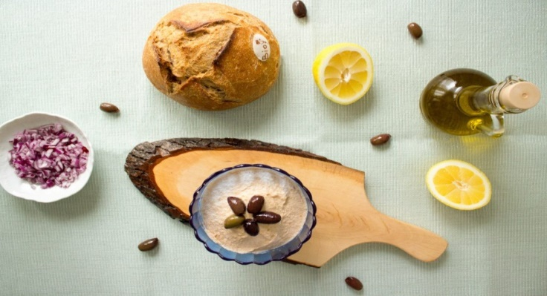
Directions
1. In a bowl, use a fork to start mixing the fish roe with the fine dry breadcrumbs until combined.
2. Start adding a few drops of sunflower oil, and fully incorporate them in the mixture.
3. Add a teaspoon of sparkling water, then incorporate it as well.
4. Add a few drops of lemon juice, then incorporate them in the mixture.
5. Repeat these steps until you get a fluffy composition which has changed its color from medium brown to a lighter, pinkish brown.
6. You can mix the finely chopped onion with the fish roe dip and serve it like that, or garnish it with olives and serve with the chopped onion on the side, in a separate bowl.

2. MAIN DISH - Beef steak with carrot purée (in Romanian Friptură de vită cu piure de cartofi)
Ingredients
Beef steak
700 g (1.5 lb) beef meat
200 ml (7/8 cup) tomato paste
4 garlic cloves
4 g (1 teaspoon) sugar
1 onion
2 bay leaves
30 ml (2 tablespoons) oil
Salt and pepper

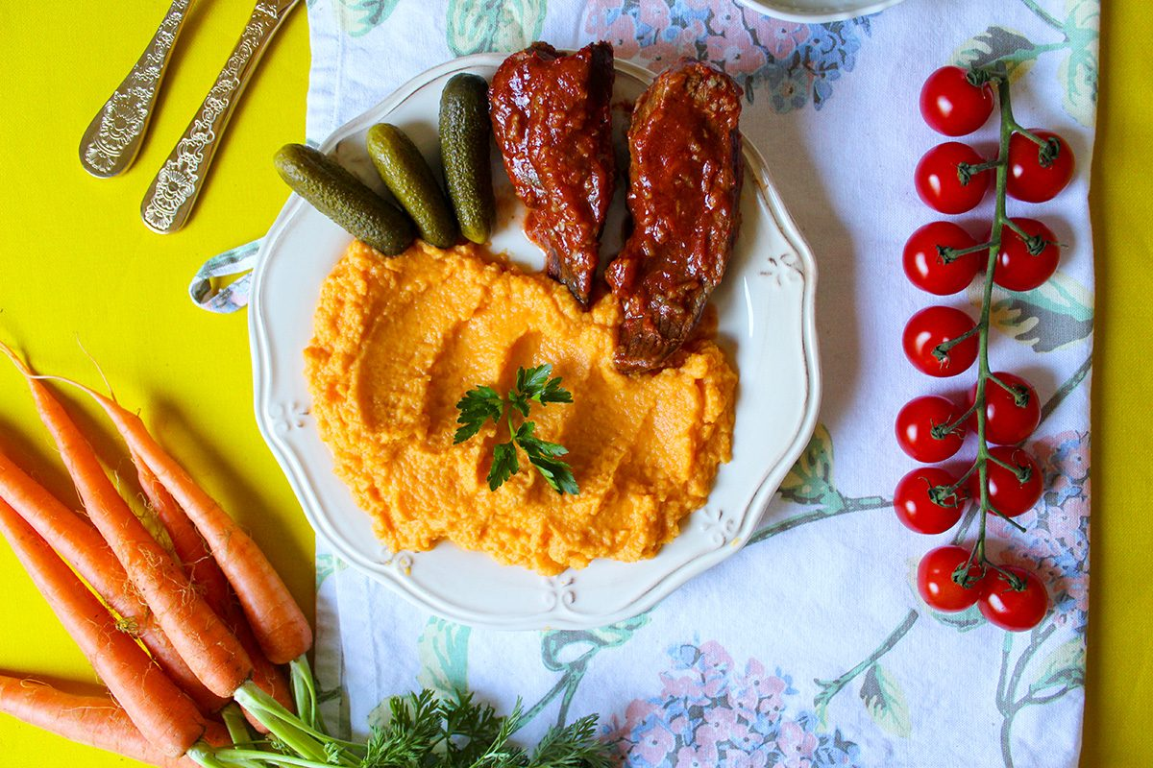

Carrot purée

3 carrots
½ celery root
80 ml (1/3 cup) heavy cream
Salt and pepper

Directions

For the beef steak

1. Fill a medium pot with cold water and add the beef steak cut into thick slices. Boil the beef on medium heat, skimming any foam that rises to the surface.
2. When no more foam rises to the surface, add the onion, the pepper and the bay leaves. Leave the beef to cook for at least 1 more hour.
3. Meanwhile, make the tomato sauce – mix the tomato paste with the crushed garlic, sugar, salt and pepper to taste and heat the oven to 180°C (360°F).
4. When the meat is cooked through, take it out of the stock and put it into an oven-safe pot. Cover the beef in the tomato sauce, then add some beef stock and a bit of oil, without pouring them directly over the steak.
5. Cook the meat in the oven for 30 minutes.

For the carrot purée

1. Chop the carrots and the celery into medium pieces, then place them in a saucepan, and cover with water.
2. Bring to a boil, and simmer until the carrots and the celery are tender. After 20 minutes of simmering, they should be cooked through.
3. Drain the liquid, then use a blender to mash the carrots and the celery, until the purée is smooth.
4. Add the heavy cream, salt and pepper, and mix them in the purée with a whisk.

3. DESSERT - Plum Dumplings (in Romanian Găluște cu prune)

Ingredients

1 lb/500 g potatoes
2 eggs
2 - 3 tablespoons flour
salt
1 lb / 500 g plums
3 tablespoons butter
2 tablespoons bread crumbs
½ cup confectioner's sugar

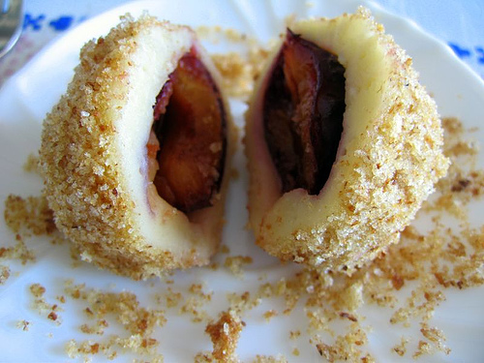

Directions

1. Boil well washed potatoes in their jacket.
2. When done, peel them and crush with the potato press or grind them.
3. Place the potato paste in a bowl and mix with the eggs, flour, one teaspoon of sugar and a little salt.
4. Make a three finger thick roll from this paste.
5. Cut one finger thick pieces from it.
6. Flatten these pieces with your hand and place one pitless plum onto each of them.
7. Then roll into a ball with your floured hand.
8. When all the dumplings are made, boil in salt water.
9. When they rise to the surface, they are done.
10. Remove with the slotted spoon and roll in breadcrumbs previously fried in butter, so that each dumpling is completely covered in breadcrumbs.
11. Place on a serving plate and powder with vanilla confectioner's sugar. Serve warm.

