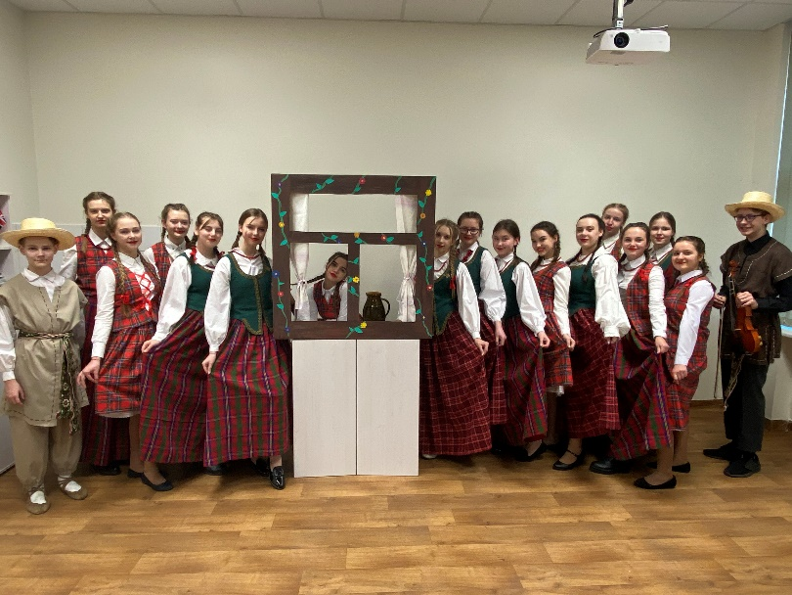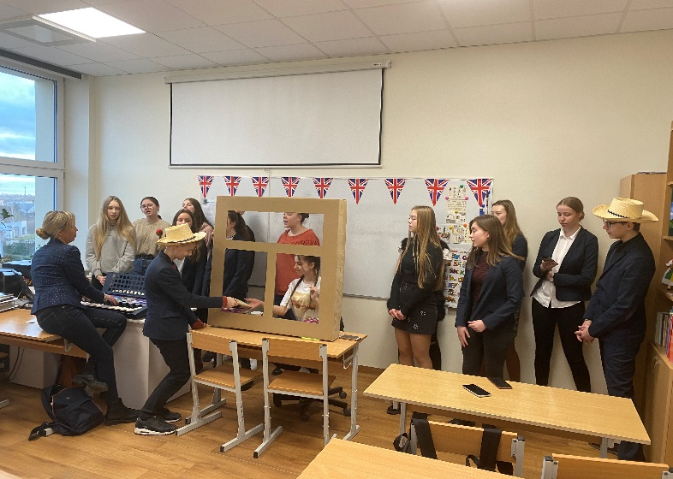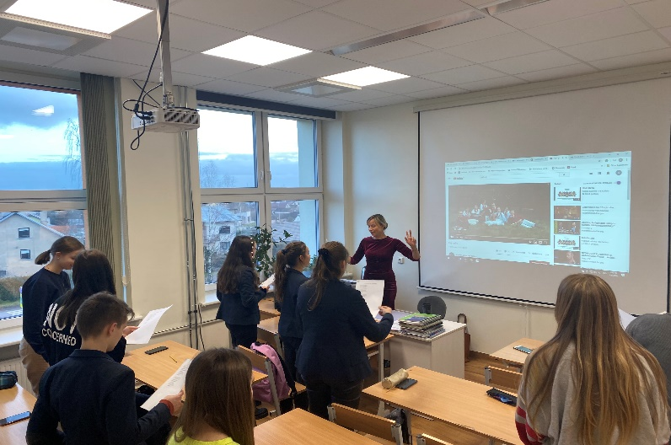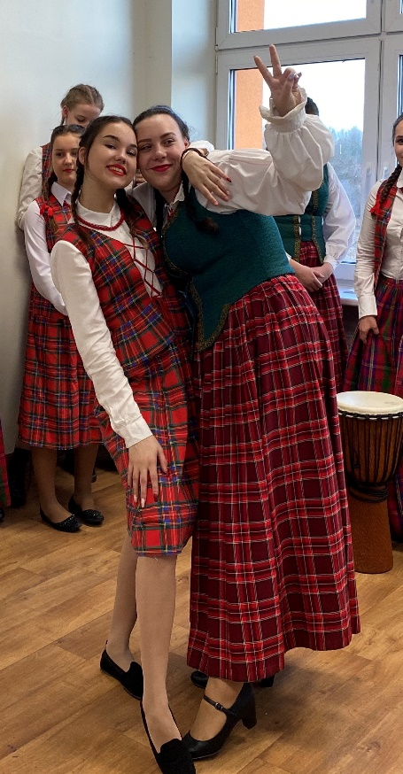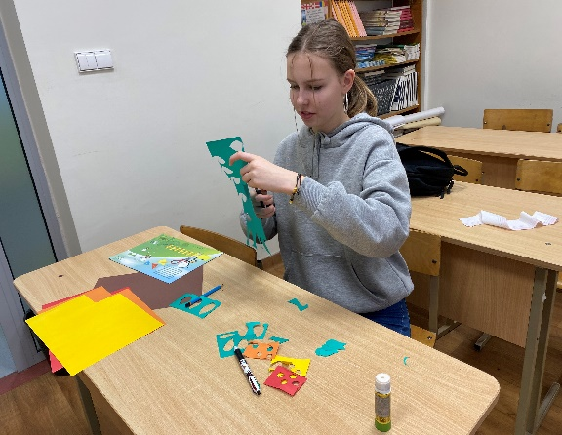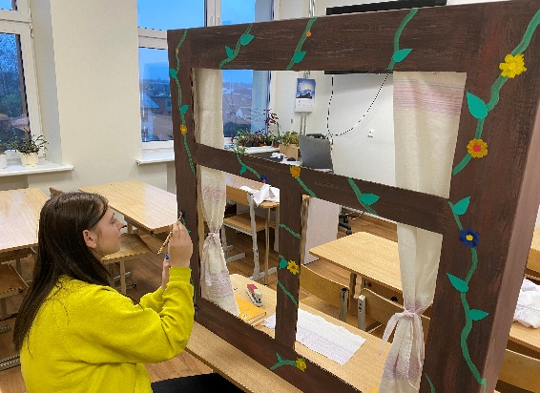

By Kamilė Stadalninkaitė and Kristijana Gelumbauskaitė, students of President Valdas Adamkus Gymnasium

Two months ago, we had a task to choose one Lithuanian song for the students of Erasmus+ FOLKLORICA projects to learn. First of all, each of us had to choose one Lithuanian song by ourselves and to share it with all Lithuanian students participating in the project. Next, we voted for the best one. The song "Žemyn Upe" was chosen. The lyrics of the song "Žemyn Upe“ (Down the River) express pride in being a citizen of Kaunas, a city considered to be the heart of Lithuania. The Lithuanian team sent this song to the project partners to learn. Everyone in Kaunas knows this song, so in our opinion it was the best choice, which is of great significance for us.

**International Song Contest**

Later, we had to choose a song sent to us by our project partners. We liked all the songs, but decided on the song from our neighbouring country Poland. At first, it wasn't easy trying to sing it. We had to learn the correct pronunciation, lyrics and melody of the song. We liked the melody best. Our Music and English teachers helped us to create a performance based on the lyrics of the song. We dressed up in our national clothes and all of us really enjoyed it. Everyone thinks this was a really fun task for all of us. We learned not only a new song in a different language, but also got to sing and spend time together. The performance was successful, everyone was involved in this creative challenge. It was a hard task, but we had such wonderful teachers, so it was an extraordinary experience!