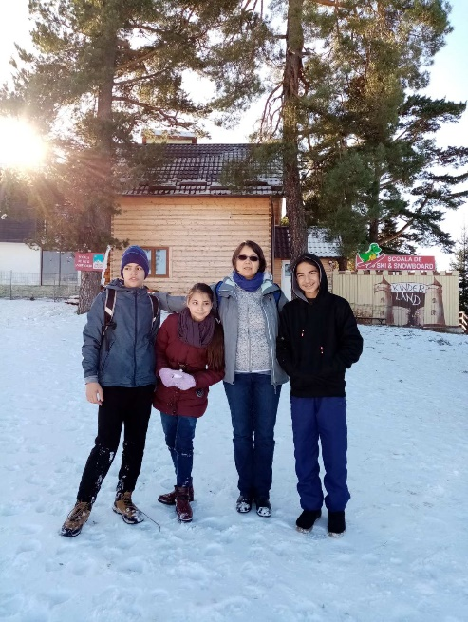
My Experiences from the Trip in Romania

Erasmus is a fantastic experience for everyone. My experience was fantastic. All the days of our visit in Romania were very active and we did many impressive things like going on a mountain trip.

One of my favourite days in Romania was when we went to the mall with my new friends from various countries. It was a great experience and I would recommend to everyone

Loukas Michael, Gymnasium Apostolou Paulou, Paphos

