My Impressions about Erasmus Experience in Romania
On the first day of our trip we drove to the beautiful city of Alba Iulia. There we got to see beautiful sights and buildings; we also got the chance to try some traditional Romanian sweets. Later we drove to Deva city. There we went on a funicular which lifted us to the top of a hill on which stand ruins of a magnificent castle. After that we drove back to Sibiu and went to spend time with our host families. On the second day we were going to school. At school we were warmly welcomed by the teachers and traditionally dressed pupils who offered us bread and salt. We listened to welcoming speeches by the Romanian teachers and watched pupils sing, dance and perform a play based on a traditional Romanian tale. Later we went to the city center. There we got to experience the lovely atmosphere of a city that’s preparing for Christmas. The city center was beautifully decorated; it felt like a winter wonderland. On the third day we went to Jina which was surrounded by mesmerizing winding roads. There we went to the Pastoral Museum, where we go to see many of their folk items and got to know how the Romanian people used to live in the past. Then, also in Jina, we went to a church that had beautiful murals on the walls and ceiling, it was really amazing to see the meticulous work of artists from the past. On the fourth day we went to a different building, where we got hand-carved, wooden spoons which we made into dolls by decorating their faces and putting them in our traditional clothing, which was quite a unique task. After we were done with our dolls, a participant from every country introduced their national symbols, for us it was the flag that we got after Lithuania reinstated its’ independence, our historical flag and our anthem. Then after everyone was done presenting, we had another really interesting task – making our traditional clothing with reusable materials. Later we decided to go horseback riding. Though it was quite scary at first, we got used to it and then it was really fun. We went through a forest, a small river, a beautiful field and also climbed up a hill. It was really amazing to see such magnificent scenery while riding the horses. On the fifth day, early in the morning we started moving towards Brașov city where we visited the beautiful Black church and also had some free time to walk around the Christmas market. Then we went to the Sâmbăta Village where we had lunch and went to a magical looking monastery. Afterwards we drove back to Sibiu where we got our certificates and had the farewell party. On the last day of our trip, we had free time with our host families. And so the day wouldn’t be very boring my host family took me to the mountains, there we went to a ski lift which we rode up to the higher point on the mountain, there we saw a beautiful view of the surrounding mountains and villages on them. It was truly a fascinating view. After some time in the mountains it was time to go back and prepare for the trip home. I am really thankful to my host family for letting me stay at their home for the week, for welcoming me so nicely and for giving me a good time in Romania.
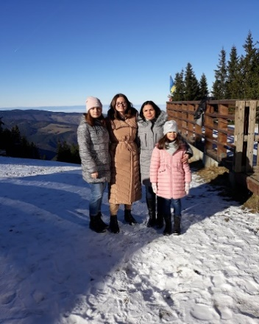
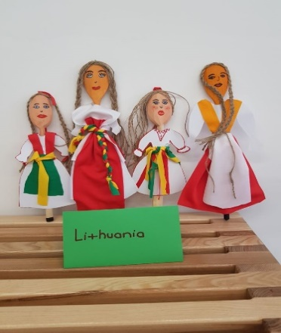
Ugne Jankauskaite, President Valdas Adamkus gymnasium, Kaunas, Lithuania
