Fluffy curd cake
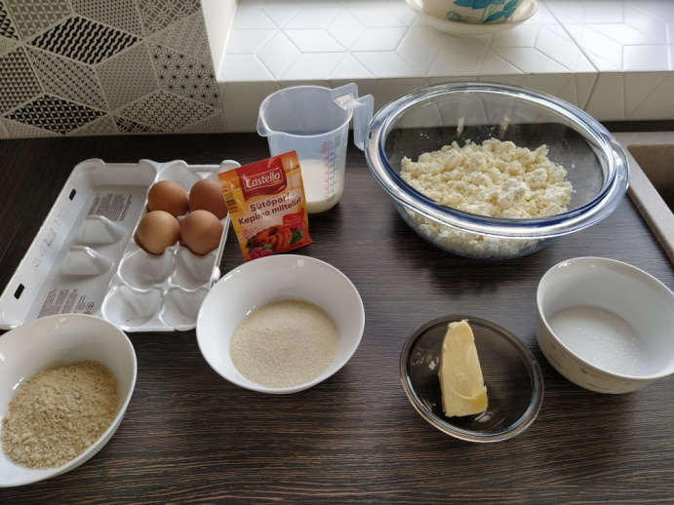
Ingredients for the cake:

400 grams of curd
4 eggs
80 milliliters of milk
4 tablespoons of semolina
30 grams of butter
2 tablespoons of sugar
0.5 teaspoon of baking powder
A bit of breadcrumbs

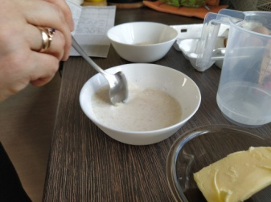
How to do:

1) Put semolina into in the bowl and pour milk. Then put it aside to rest.

2) Crush sugar with butter, but leave a bit of butter later because you will need it. Then separate yolk from egg white and add yolks to the butter-sugar combination. Then mix it all together and after that put curd.
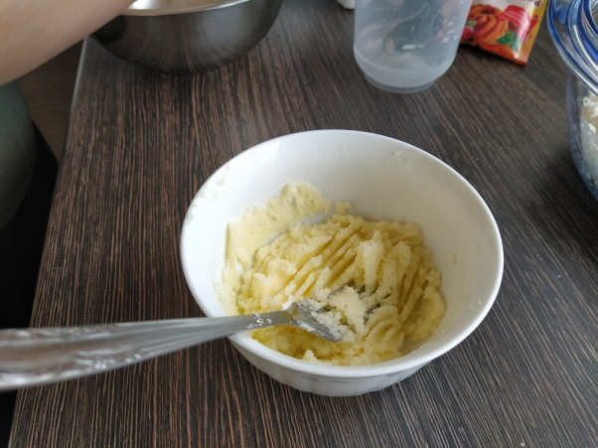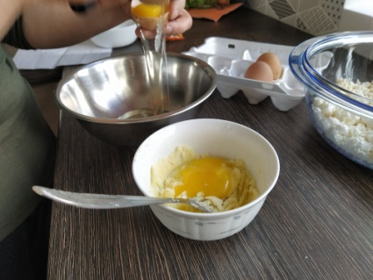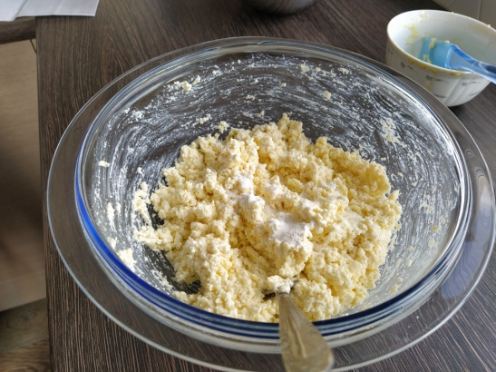
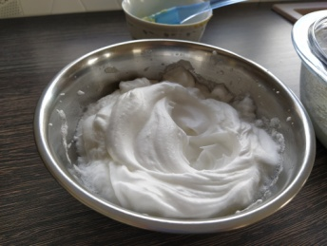

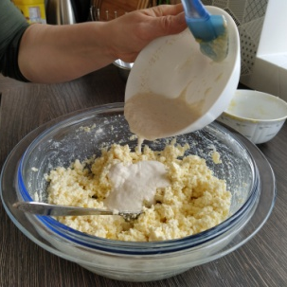
3) Whisk egg whites that after you turn a bowl upside down it wont fall.

4) Pour milk with semolina into curd’s mix and stir it a little.

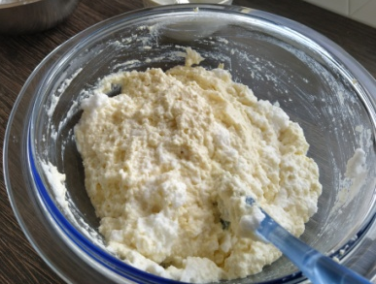
5) Put egg whites into the bowl and stir it. But do not mix too much because it will get too sticky.

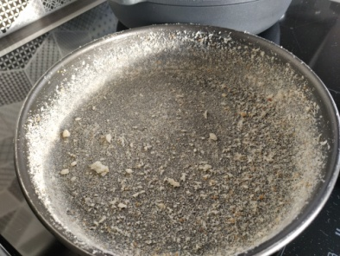
6) The saved butter spread in form where you are going to bake the cake and sprinkle some breadcrumbs. Put mass in to the form. Bake cake in 220C° and after 30 minutes reduce temperature to 200C°. Then the cake is done cooking, put it aside to cool off.

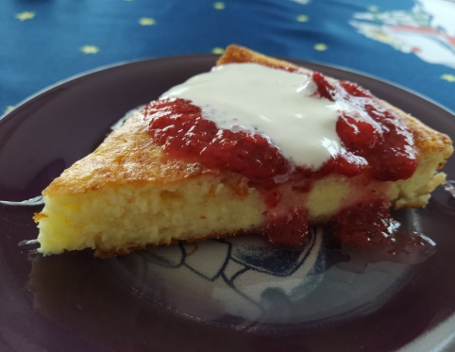

Bon Appétit!

