Orange pie
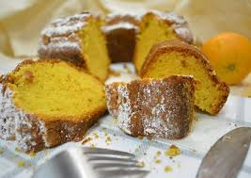
Ingredients:
1 glass of olive oil
4 eggs
1 glass of sugar
1 vanilla flavor
1 grated orange peel
1 small yogurt
1 packet of crust pasrty.
3 teaspoonfuls of baking powder

For the syrup:
2 glasses of sugar
3 glasses of water
1 grated orange peel
(The syrup is prepared when we boil all ingredients together in low fire.)

Preparation
We mix all the ingredients together except for the pastry
We cut the pastry in pieces
We add the cut pastry in the mixture and mix again
We bake in a warm oven for about 45- 50 minutes at 160º C until it is browned.
We take it out of the oven and pour the syrup on the top. We cut in pieces and serve when it gets cold.

