Cypriot Talaturi Recipe (Talaturi with Mint and Lemon)

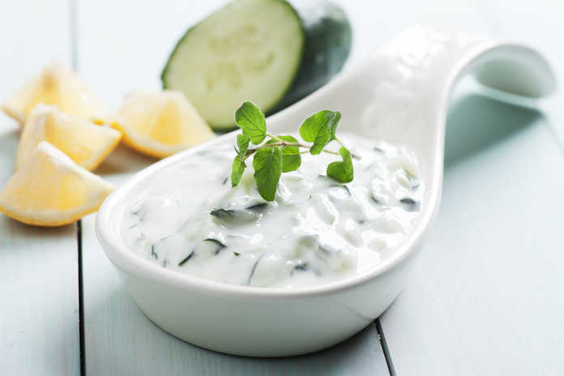
Ingredients
• 1 cucumber
• 2 cloves of garlic, melted
• Or the cup of olive oil
• 500 g strained yogurt
• juice of 1 lemon
• 2-3 tablespoons chopped mint
• some salt
Preparation
- Peel the cucumber, remove its seeds from the center and rub with the grater in a large bowl. Salt and pepper and set aside for 10 minutes.
- Put the grated cucumber in a towel and tighten it well to drain all of the cucumber juice.
- In a large bowl add the cucumber, melted garlic, olive oil, yogurt, mint, lemon juice, a pinch of salt and mix well with a spoon until the ingredients and flavors come together.
- Alternatively, if you have a blender, beat the garlic with the oil until combined, then continue to mix the garlic with the rest of the ingredients using a spoon.
- Keep it in the fridge and always serve cold. Bon appetit!

