Cyprus’ Salad (Traditional Recipe)
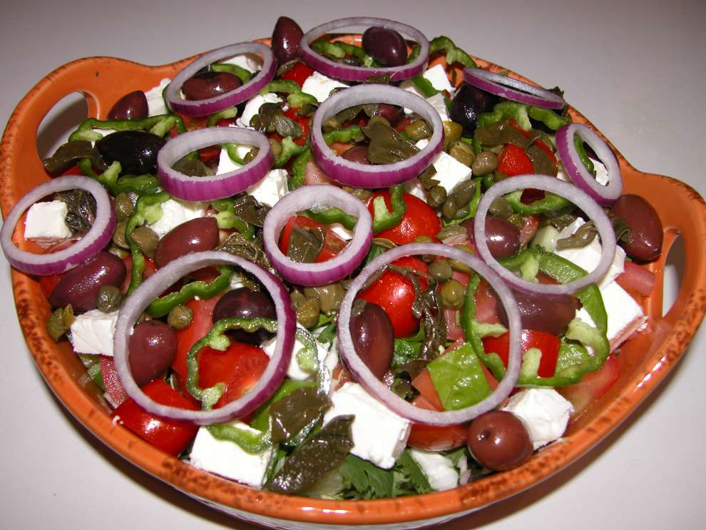
Ingredients:
10-15 lettuce leaves
½ bunch of fresh coriander
½ bunch of rokka leaves
1 cup sliced ​​white
cabbage (optional)
4 medium tomatoes
4 cucumbers
8-10 cherry tomatoes
2 green peppers
1 red onion cut in rings
150 g Cypriot feta
2 tablespoons of vinegar
5-6 sprigs of capparie vinegar
10-12 black olives
6 tablespoons extra virgin olive oil
2-3 tablespoons of red wine vinegar
Salt Pepper
Mint or oregano

Preparation:
1.Wash all the vegetables thoroughly and put them in a colander to dry.

2. Cut the lettuce, rokka, coliander, tomatoes and cucumbers into pieces and mix in a salad bowl.

3.Add the feta, olives, pepper, onion, cherry tomatoes and capparies leaves.

4. In a bowl whisk the olive oil, vinegar, salt and pepper to make the dressing.

Good appetite!

