PASTICIO
Materials
1 pack of thick spaghetti
1Kg of minced meat
4-5 tablespoons of olive oil
1 onion chopped
Salt Pepper
chopped parsley
1 cup halloumi or grated cheese
Béchamel sauce (8 tablespoons sliced ​​butter, 8 tablespoons flour, 4 cups warm milk, 3 beaten egg yolks, salt, pepper, 3 tablespoons grated cheese)
Preparation
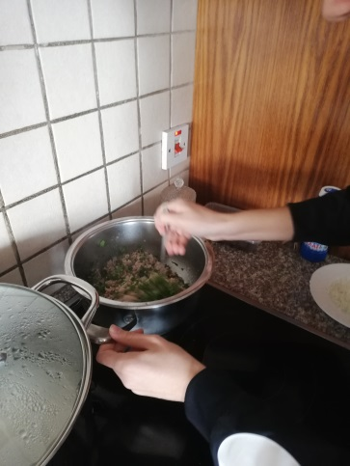
- Boil the minced meat, onion, salt, pepper in a saucepan and leave to simmer.

♥ When the minced meat is almost ready, toss the parsley.
♥ Remove from the heat and pour 1-2 tbsp halloumi.

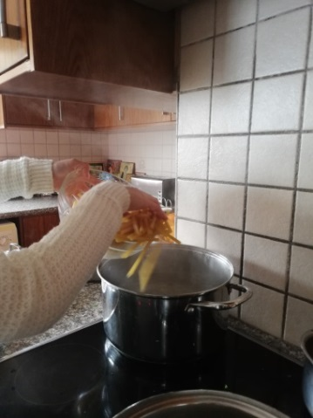
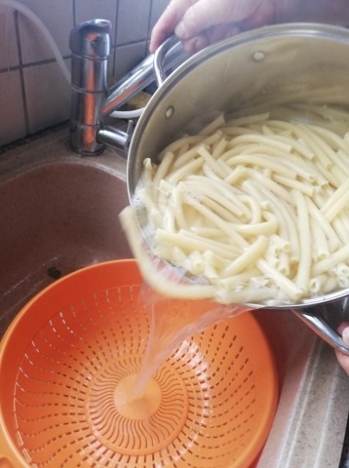
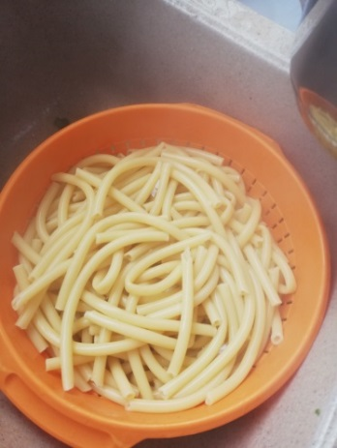

Boil the spaghetti in plenty of water with a tablespoon of salt and drain.
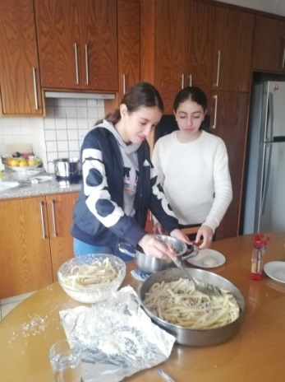
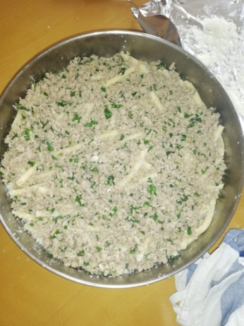
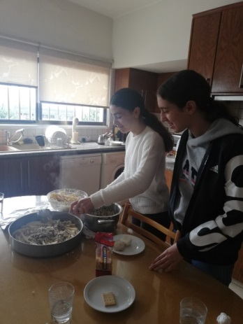

Put half the pasta on a buttered baking tray and sprinkle with half the cheese. Cover with minced meat.
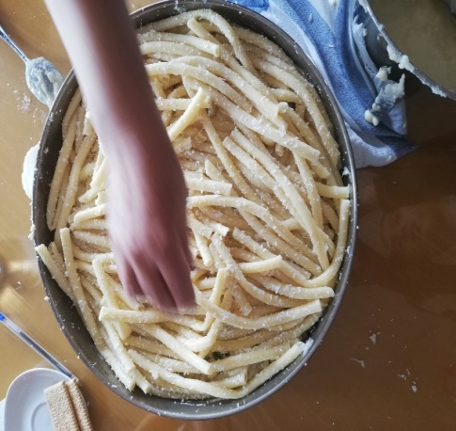

- Put the remaining spaghetti on top and sprinkle with the remaining cheese
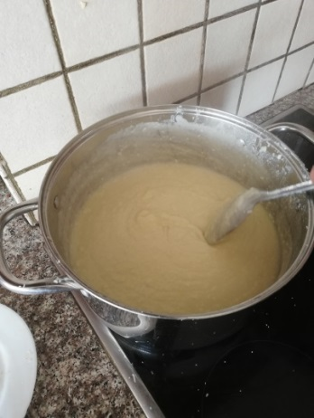
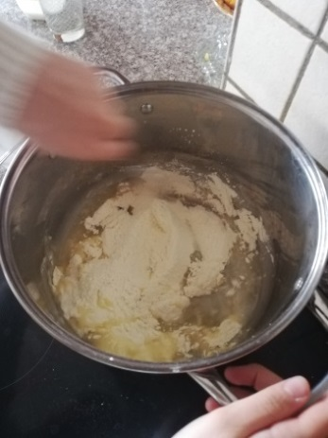

We are preparing the bechamel. Put the butter in a small saucepan, melt the flour and stir with a wooden spoon. Pour the milk little by little and stir until the sauce thickens and becomes smooth. Remove from the heat and add salt, pepper and whipped egg yolks. Pour the cheese

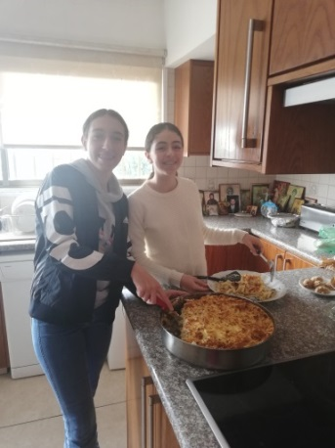
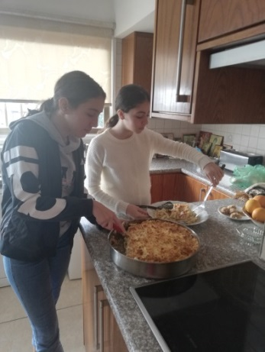
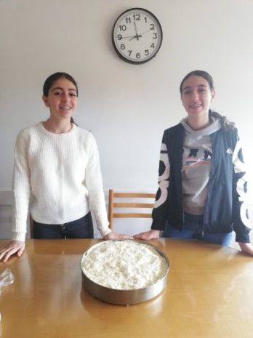

Cover the spaghetti with bechamel and bake in a medium oven until browned.
♥ Allow to cool and cut into squares

