Dear diary,
I'm thrilled to say that I'll be in Croatia for almost a week! I won't be alone, of course; my teachers, friends and classmates will also be a part of this journey. We are members of Erasmus+ project called Can you tell me the way to...? which allows us to travel, meet new people and their culture. Moreover, we'll be staying at our Croatian friends' homes to find out more about their customs and ways of living.
Your job is to help me preserve memories and experiences I make along the way. With you, the places I discover and sights I see will stay with me as long as possible by keeping my notes, thoughts and all the fun facts I come across.
Brace yourself for a marvelous adventure!

“Stuff your eyes with wonder, live as if you’d drop dead in ten seconds. See the world. It’s more fantastic than any dream made or paid for in factories.” – Ray Bradbury

This diary belongs to: __________________________
Dubrovnik-Neretva county
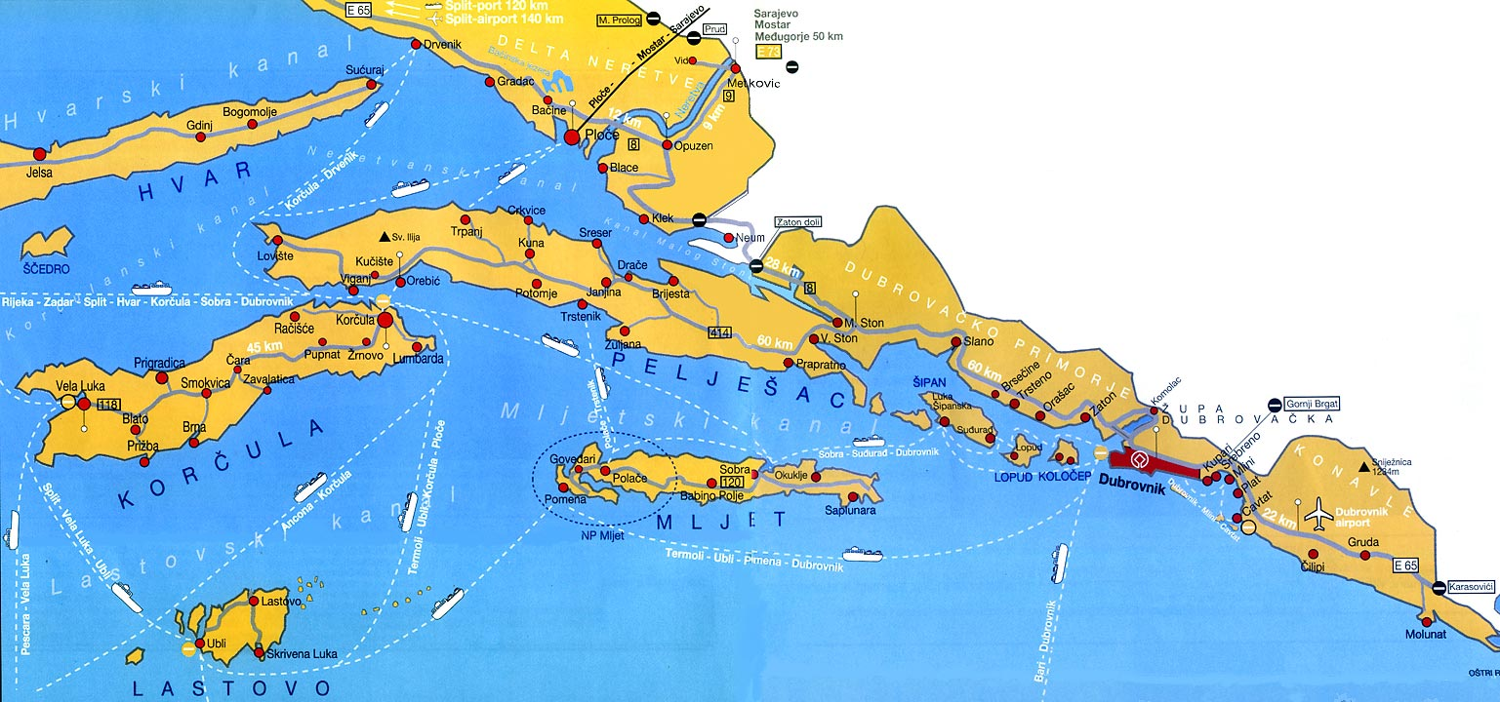

Mark your current location.

In which part of Croatia is this county located? South, North, East or West?
______________________________________________________________
______________________________________________________________

What do you think makes it popular with tourists?
____________________________________________________________________________________________________________________________

Due to its enjoyable climate, cultural heritage and sea influence on daily life and diet, it attracts tourists and inhabitants from all over the world. – jel ovo odgovor na gornje pitajne?

GIMNAZIJA
METKOVIĆ

M Y T R A V E L L I N G D I A R Y
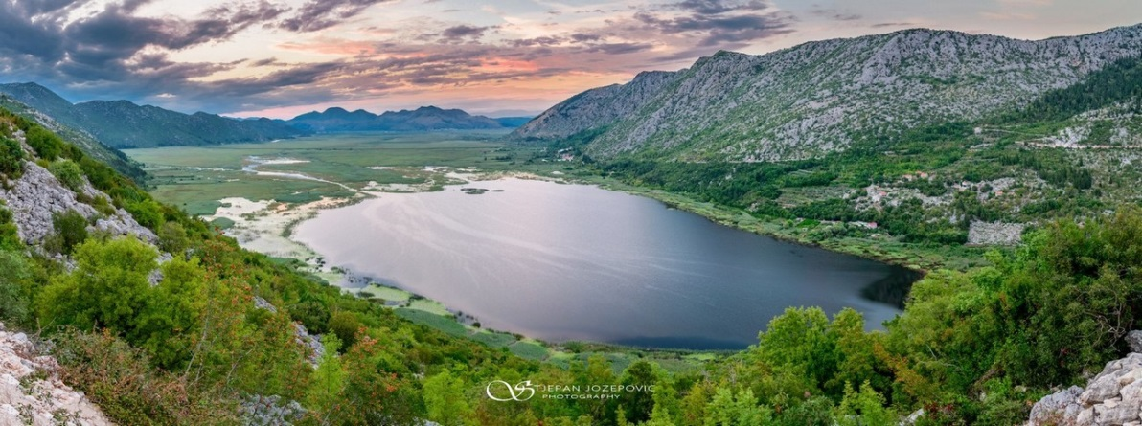
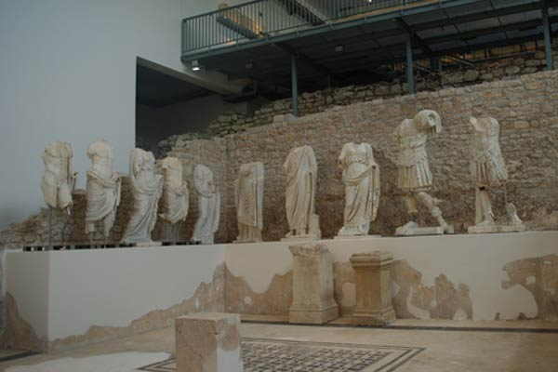
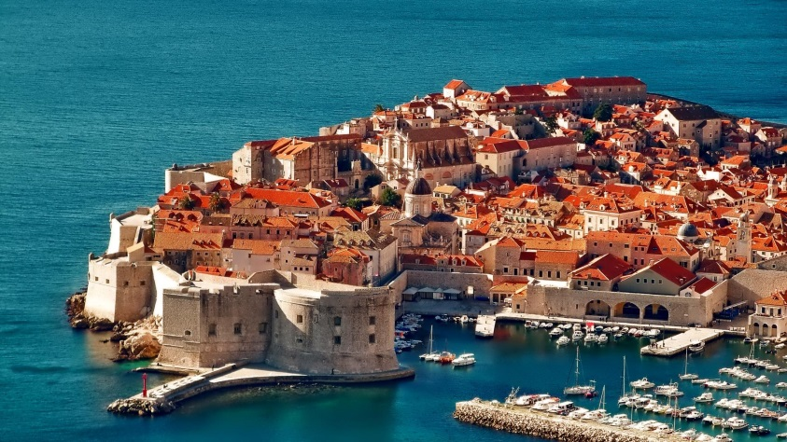
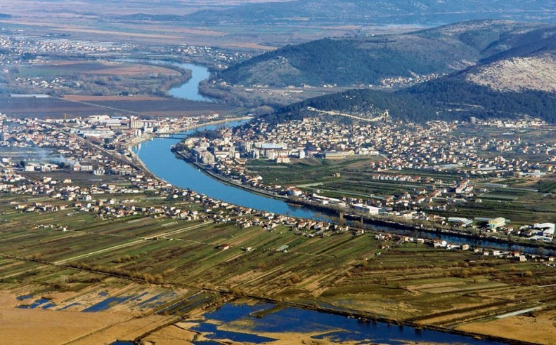
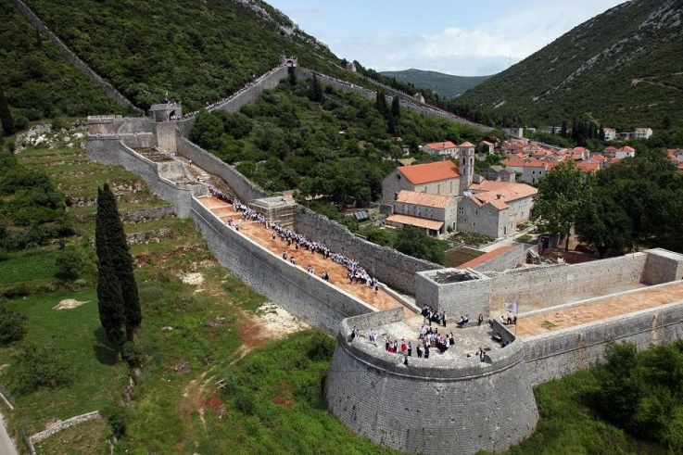
Can you tell me the way to...?
19th -13th September 2016
Day 1 19th September 2016
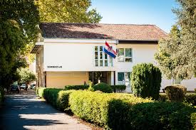
Gimnazija Metković, Metković

The first thing I notice about this school is ____________________________

From this day I expect ____________________________________________ ______________________________________________________________

I liked/disliked the school because __________________________________
______________________________________________________________

The chemistry class was:
- Boring
- Interesting
- About something I already knew

I met a lot of fun and interesting people like…________________________
______________________________________________________________

Day 2 20th September 2016
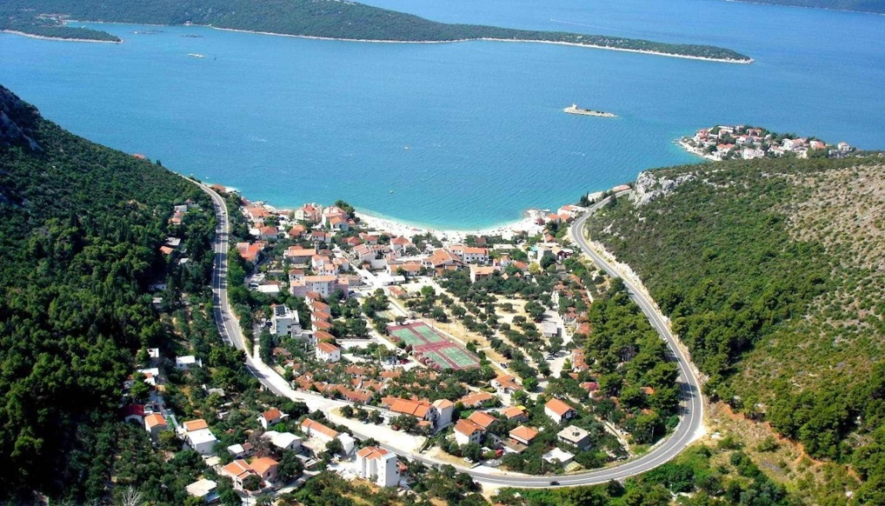
Klek

Klek is a seaside resort on the coast popular with tourists all over Europe. Its beutiful beaches, clear and clean sea and mediterranean charm won't leave anyone indifferent.
My trip was ____ long and ________________________________________

The weather was ________________________________________________

We were there for about _______________(time)

What I liked the most were_________________________________________
______________________________________________________________

Day 2 20th September 2016
Smrdan Grad
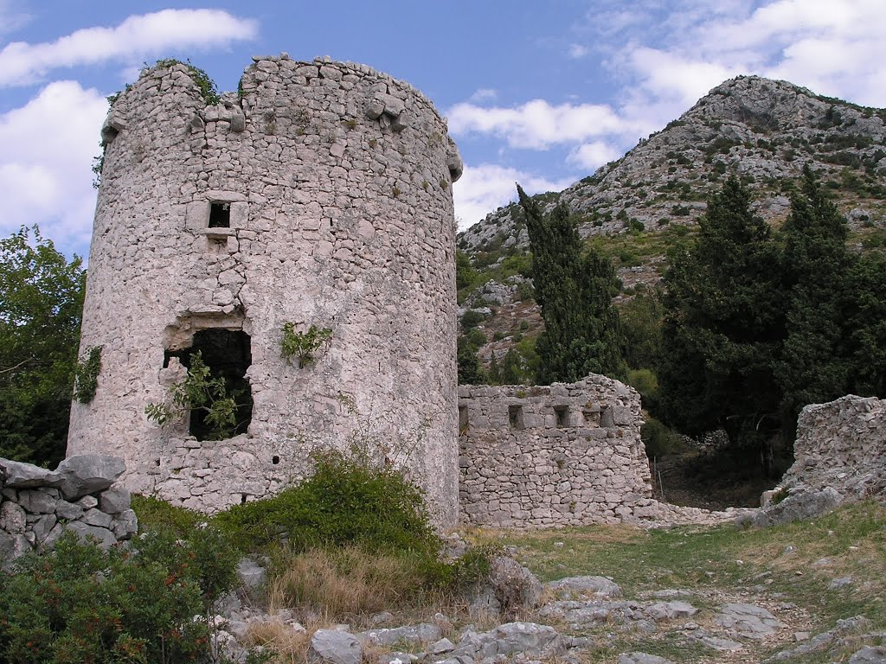

The first time I saw the ruins, I thought they were ______________________ ______________________________________________________________

Fill in the gaps with given words: Narona, stećaks, Klek, Pelješac, Venetian, pre-Roman
The ruins of old Smrdan Grad are located above ________. These are well preserved walls of what was probably a _________ fortress, which served for controlling the entrance into the Bay of Neum. Above the ruin on the steep peak, there is a belvedere of the fort Gradina from the __________ period, protected by three concentric dry walls, overlooking Ston, ________ peninsula, the Neretva mouth and _______. In the vicinity of Smrdan Grad there is a large necropolis with ________ (grave stones).

Day 2 20th September 2016
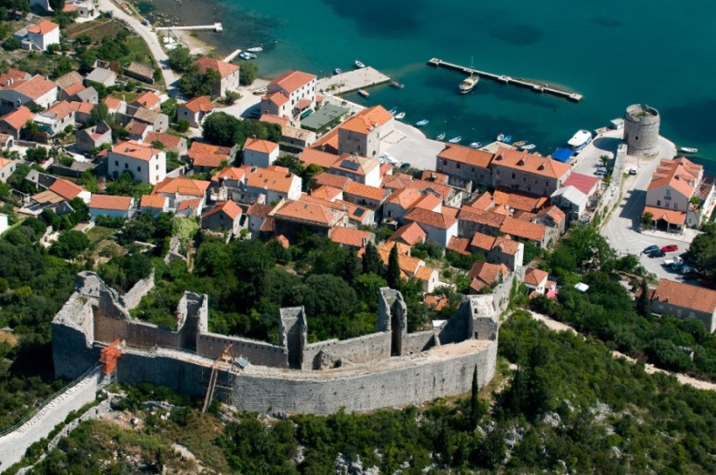
Ston
Ston is located on
____________________________
peninsula.
The Great Walls are/aren't visible
from space.
Their use was _________________
____________________________
Ston was a part of _____________
Republic.
I found the town to be ____________________________________________

There is a Salt factory in Ston which is one of the most respectable and reputable in Croatia.
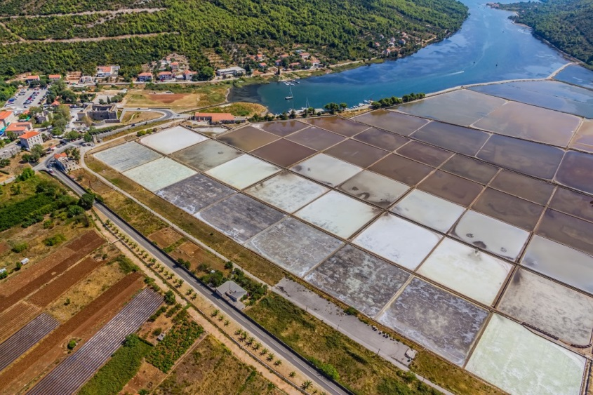

What I liked the most was/were ____________________________________
If you like the Great Wall, wait till you see Dubrovnik tomorrow!

Day 2 20th September 2016

Today was a ________________________ day.

I visited these places _____________________________________________
______________________________________________________________

The best part of the day was________________________________________
______________________________________________________________

I took a few photos, my favourite one is:

Put here a photo that you've taken or draw a picture of what you so

Day 3 21st September 2016
Dubrovnik
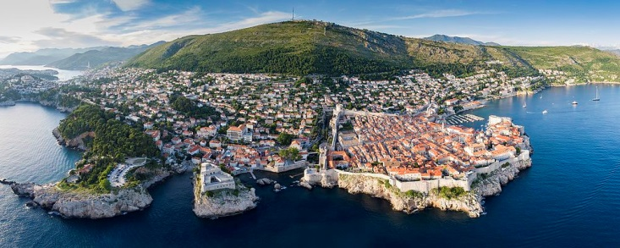
I have/haven't been to Dubrovnik before.
The first thing I saw in the city was _________________________________

Dubrovnik was founded in the ______ century, offering shelter for Roman refugees from ___________. It has a magnificent past. The Walls of Dubrovnik are from ________________ . In the Middle Ages the city became a _____________. Many famous Croatian Renaissance and Baroque artists are in fact from Dubrovnik.
If you have a 50 kuna note, you can see on it a famous Baroque poet from Dubrovnik, Ivan Gundulić, and a small picture of the city and the Rector’s Palace.
Dubrovnik’s most famous attractions:
The City Walls were built in 12th-17th century and they make Dubrovnik recognizable.
Minčeta tower is a fortress on the north of the City Walls, it is round and monumental.
Lovrijenac is a fortress on the western side of the City Walls, it was used to protect the entrance to the city.
Day 3 21st September 2016
Dubrovnik
St. Blaise church (Sv. Vlaho) is the most famous church in Dubrovnik, built in Baroque.
Dubrovnik Cathedral is very popular because its treasury contains golden and silver reliquaries, crosses and paintings from Italian and Croatian painters.
Rector’s Palace is a Gothic-Renaissance structure that displays finely carved capitals and an ornate staircase. It now houses a museum.
Sponza Palace was built in 16th century and it used to house National Archives.
Franciscan monastery has a wonderful Gothic portal; it was built in 14th century.
Stradun is the most famous street in the city and one of the longest in Croatia.
Onofrio’s fountains are situated in Stradun. They are two round fountains which can be used for storing water.
Orlando’s column is a display in stone of the great knight Orlando. It used to be a place where people would read the news aloud.

The monument I found the most exciting was__________________________
I liked it because ________________________________________________
There are _______ figures on the larger Onofrio’s fountain.
The great earthquake that destroyed many valuable monuments was in _____
The small river which flows through Dubrovnik is called ____________
The hill, beneath which Dubrovnik lies, is called ___________
Here are some famous artists from Dubrovnik: ________________________
______________________________________________________________
Day 3 21st September 2016
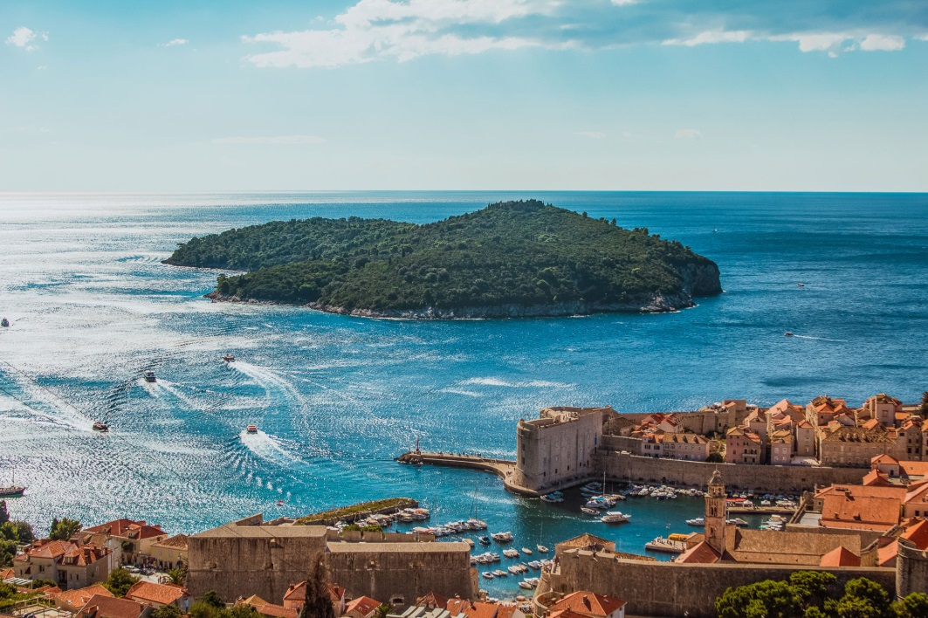
Lokrum

Lokrum is a small island near Dubrovnik.
Is it inhabited? ____________
On the eastern side of the island, protected from the open sea, there is a small natural harbour.
We visited the places the popular TV show ___________________________
was filmed. I watch / don’t watch the show.
The weather was ________________________________________________

After the day, I felt ______________________________________________
I want to / don’t want to come here again.

My favourite part of the day was ____________________________________
______________________________________________________________
Day 4 22nd September 2016
Lake Kuti
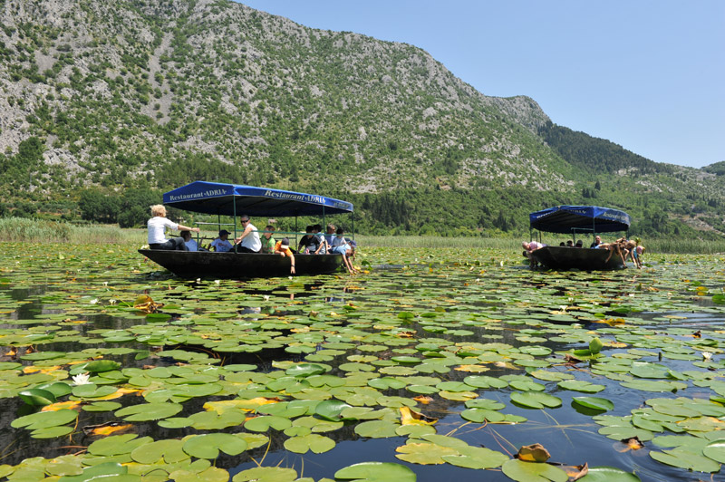

What do I expect from today?
____________________________________________________________
When I came here, I felt ________________________________________
The traditional boat from Neretva, called lađa, carried us across the lake.
I liked/disliked the ride.
We paid attention to the flora and fauna and my impression is _____________________________________________________________
Cross out the plant that you will not see at Lake Kuti:
a) Reed
b) Waterlily
c) Magnolia
What kinds of animals can you see?
______________________________________________________________
_____________________________________________________________
Day 4 22nd September 2016
Lake Kuti

There is a famous “Sunken city” below the lake. You can see the remains during your boat drive. There are some people who believe it was once a great Greek city named ___________.
I liked/disliked that legend.
There are also myths about the swamp about magical creatures such as:
______________________________________________________________

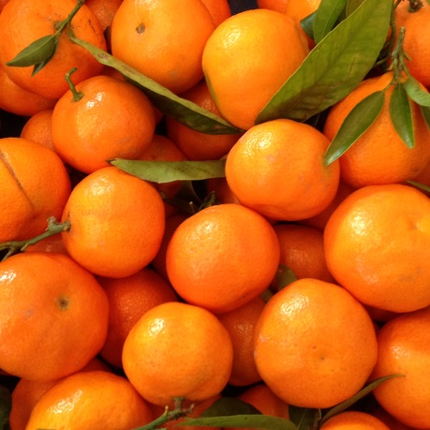
We visited tangerine plantations. Tangerine is a citrus fruit which ripens in autumn. I have / have never tasted it.

In the afternoon we went to the mouth of the river
Neretva.
The weather was __________________________
I liked/disliked it there.
Write what you did there:
________________________________________________________________
________________________________________________________________
Which sport is very popular to do in summer here?________________________
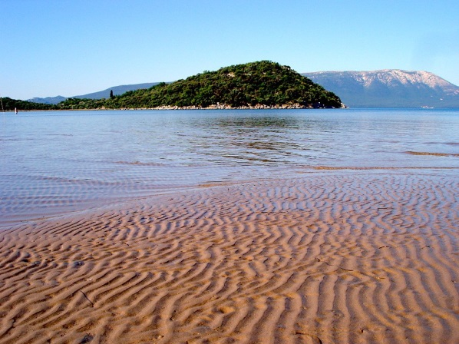

Day 4 22nd September 2016

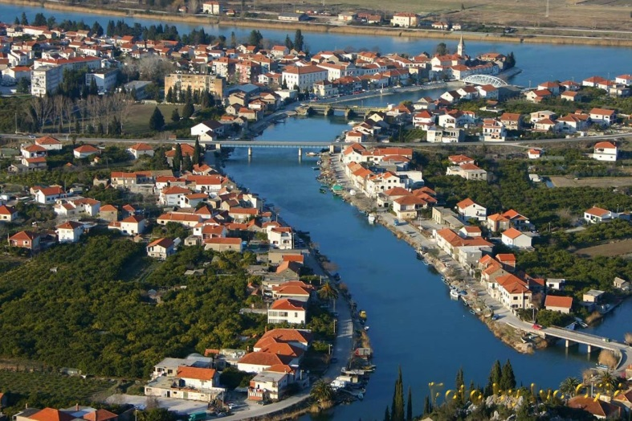
We visited a nearby town Opuzen.

I liked/disliked it there.
It was a ____________________________ day.
I visited these places: _____________________________________________
______________________________________________________________

The best part of the day was _______________________________________

Glue a photo that you've taken or draw the most impressing thing you saw today.

Day 5 23rd September 2016
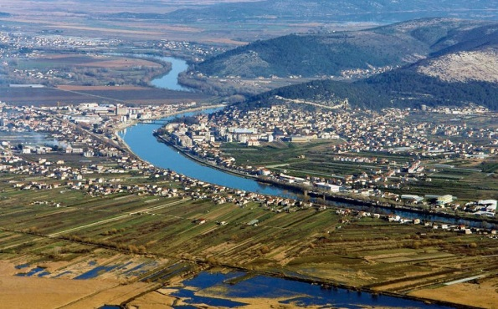
Metković

I've been in this town for 5 days and I find it __________________________
What I like the most is ____________________________________________
The patron saint of Metković is called ________________
We went to the Cave in the hill Predolac. We got there _____________(how)
I liked /disliked it.
I have / have never been in a similar place before.
Write what kind of new animal and plant species you just found out about.
____________________________________________________________________________________________________________________________
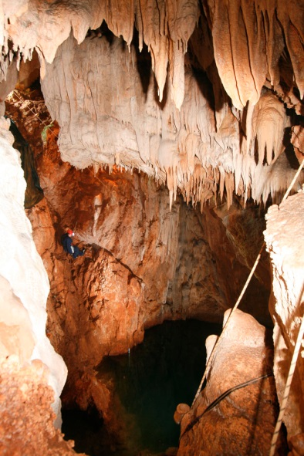
The cave is a home to the only underground shellfish in the world:
_____________________

Write what you liked the most about the cave
_____________________________________________
_____________________________________________

Day 5 23rd September 2016
Metković, Prud, Vid
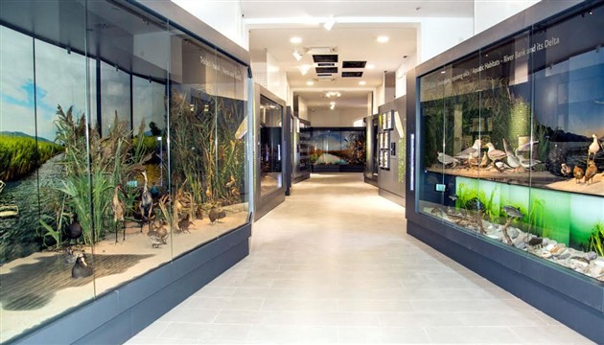
We also visited the Ornithological Museum in Metković.
I liked/disliked it.
What kinds of birds did you find the most fascinating?
_________________________
_________________________
Write down some other animals
that were in the collection:
____________________________________________________________________________________________________________________________
We had lunch in a village called _________________
The weather was ________________________________________________
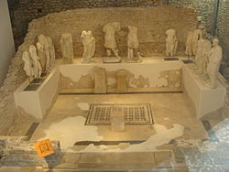
After lunch we went to ____________ to the Archaeological Museum where
used to be a Roman city called _____________
It dates back to _________ century B.C.
There are _________ statues in the reconstruction of the Augusteum, and the only one with a head is from the emperor
_________________
I liked/disliked it there.
Write down some interesting fact you found out about that period: ____________________________________________________________________________________________________________________________
The most interesting thing was: _____________________________________
______________________________________________________________
Day 5 23rd September 2016
Metković, Prud, Vid
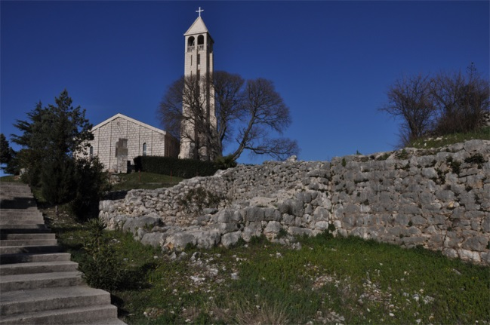

While in Vid, we visited the remains of old walls from the Roman time.
I thought that part of the trip was ______________________
We also visited the Ereš tower.
I thought it was ____________________________________________
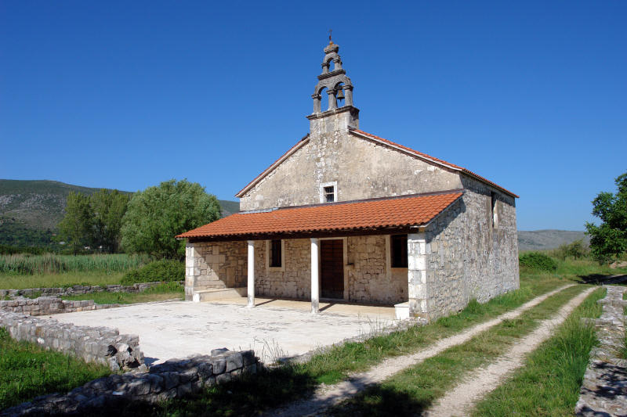
While in Vid, we paid a visit to the local catholic church of St Vitus located in the middle of the field at the entrance of Vid.
It dates back to ______ century, but it was built on the site of an older, much larger church.
There is an early Christian baptistery- a baptismal font from the _____ century with excellently preserved octagonal font – ovaj dio je malo dosadan.
During the walk through the village we saw the statue of a Dalmatian duke ______________ and his archers. He lived in the _____ century.

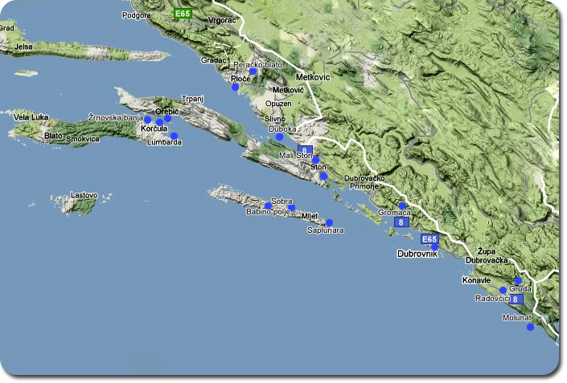

Mark all the locations you’ve visited during the past 5 days.
Write about your journey
__________________________________________________________________________________________________________________________________________________________________________________________

What is the most interesting thing that happened to you?
____________________________________________________________________________________________________________________________

Would you like to come back sometime? ______________________
Write how this journey affected your life
____________________________________________________________________________________________________________________________

Glue your favourite photo here

On this last page you can ask your new friends to sign and write a note so you never forget them.

