**Traveller´s diary**

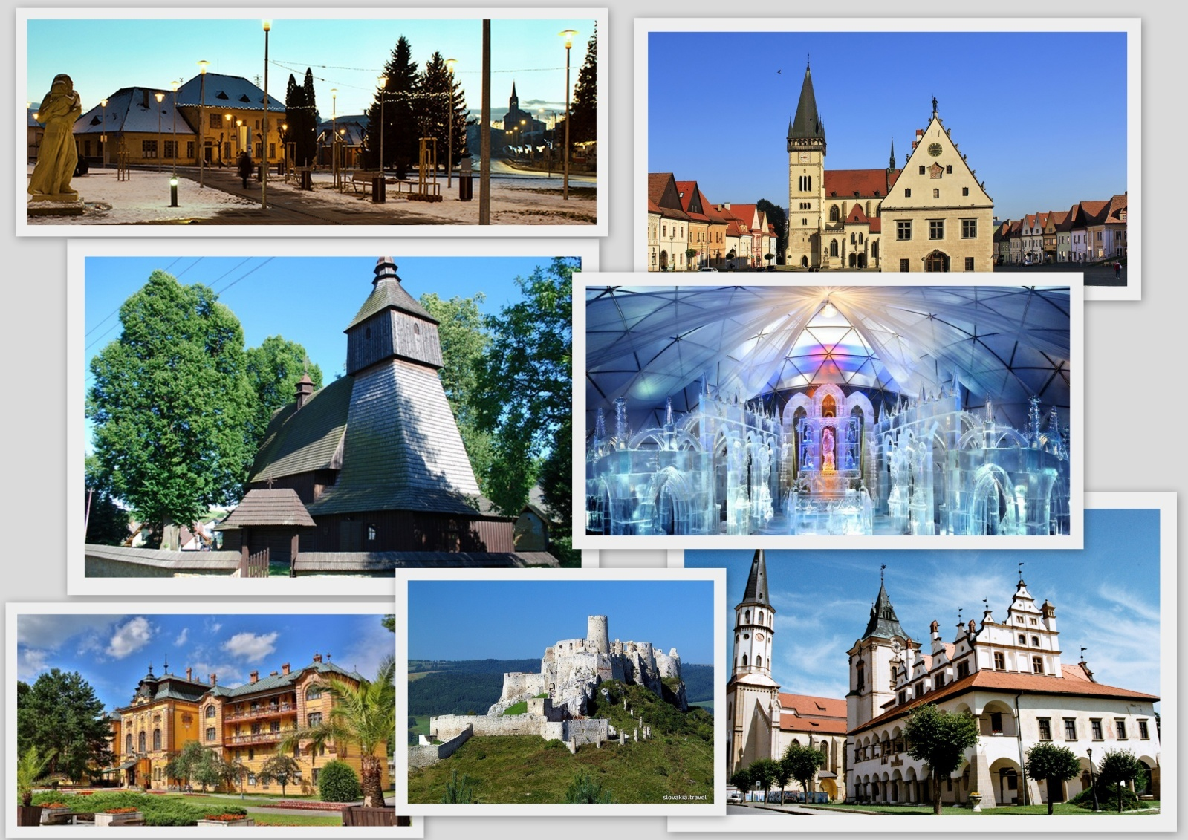

**Bilateral meeting Slovakia- France ( 05.- 10.02.2017) as a part of Erasmus + project Can you tell me the way to.... tracing our Europen heritage on foot**

**This diary belongs to:** \_\_\_\_\_\_\_\_\_\_\_\_\_\_\_

Dear Diary,

I am almost dying to say that I´ll visit Slovakia and meet some new friends. Me, my friends and teachers will be with me. This is our next stop on our Erasmus + journey. I am really proud that our project **Can you tell me the way to...? Tracing our European heritage on foot** gives me the unique opportunity to travel, learn new things, meet new people and get to know culture of the countries we are able to visit.

You´ve got couple of tasks to fulfill during your working week. I will help you to preserve your knowledge, memories and experiences. I will guide you troughout this week day by day. You will not only have to complete the tasks, but also add your own drawings, notes and feelings. If you are not sure what to do, ask your new mates to help you. They´ll be happy to assist you.

And now.....

It´s time to start. Have a great and memorable walk!

**DAY 1: GIRALTOVCE AND WOODEN CARPATHIAN ROAD**

1. **Only two schools take part in this bilateral Erasmus + project meeting. Write down their full names. Then, using stickers on the back cover of this notebook, show the correct position of each school.**
2. \_\_\_\_\_\_\_\_\_\_\_\_\_\_\_\_\_\_\_\_\_\_\_\_\_\_\_\_\_\_\_\_\_
3. \_\_\_\_\_\_\_\_\_\_\_\_\_\_\_\_\_\_\_\_\_\_\_\_\_\_\_\_\_\_\_\_\_

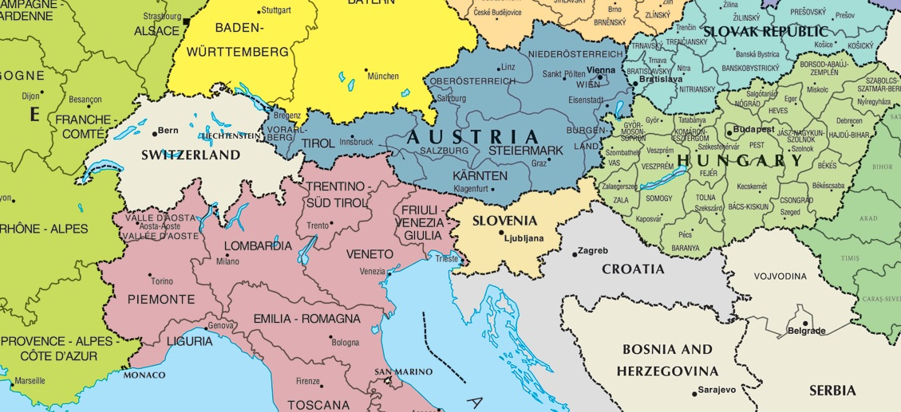

1. **Write down GPS coordinates of both schools.**
2. \_\_\_\_\_\_\_\_\_\_\_\_\_\_\_\_\_\_\_\_\_\_\_\_\_\_\_\_\_\_\_\_\_\_
3. \_\_\_\_\_\_\_\_\_\_\_\_\_\_\_\_\_\_\_\_\_\_\_\_\_\_\_\_\_\_\_\_\_\_
4. **How far did the students from France travel to reach their partner school? \_\_\_\_\_\_\_\_\_\_\_\_\_\_\_\_\_\_ km.**

**This is your first day that you spend here in Slovakia. We are going to explore our programme, school premises, town and you get to know Wooden carpathian road that crosses our area. Write down your notes.**

1. **The first impression of the school is: \_\_\_\_\_\_\_\_\_\_\_\_\_\_\_\_\_\_\_\_\_\_\_\_\_\_\_\_**
2. **I LIKED/ DID NOT LIKE school because \_\_\_\_\_\_\_\_\_\_\_\_\_\_\_\_\_\_\_\_\_\_\_\_\_\_\_\_\_\_\_\_\_\_\_\_\_\_\_\_\_\_\_\_\_\_\_\_\_\_\_\_\_\_\_\_\_\_\_\_\_\_\_\_\_\_\_\_\_\_\_\_\_\_\_\_\_\_\_\_\_\_\_\_\_\_\_\_\_\_\_\_\_\_\_\_\_\_\_\_\_\_\_\_\_\_\_\_\_\_\_\_\_\_\_\_\_\_\_\_\_\_\_\_\_\_\_\_\_\_\_\_\_\_\_\_\_\_\_\_\_\_\_\_\_\_\_\_\_\_\_\_\_\_\_\_\_\_\_\_\_\_\_\_\_\_\_\_\_\_\_\_\_\_\_\_**
3. **The first workshop at the school was:**
4. Boring
5. Interesting
6. Funny
7. Difficult
8. **I met some new people, for example: \_\_\_\_\_\_\_\_\_\_\_\_\_\_\_\_\_\_\_\_\_\_\_\_\_\_\_\_\_\_\_\_\_\_\_\_\_\_\_\_\_\_\_\_\_\_\_\_\_\_\_\_\_\_\_\_\_**

**Giraltovce is a small town which is situated in the eastern part of Slovakia. It has about 4200 inhabitants and it lies in the confluence of two rivers called Topla and Radomka. Town itself is situated in Saris region and it´s surrounded by 5 larger towns- Prešov, Bardejov, Vranov nad Toplou, Stropkov and Svidnik. 95 % of inhabitans are Slovak nationality. Other nationalities living in Giraltovce are : Roma , Ukrainian, Ruthenian and Czech. Most people are of Roman catholic, protestant and greek catholic religion.**

1. **In the afternoon you are going to explore our small town. You task will be to find and get us some proof of visiting these places:**

|  |  |  |
| --- | --- | --- |
|  | **Name** | **Proof: ( Picture, drawing, receipt....)** |
| **A statue** |  |  |
| **A cafe** |  |  |
| **A hotel** |  |  |
| **Town hall** |  |  |
| **A church** |  |  |

Carpathian wooden road is an exceptional example of folk sacral architecture on Slovak- polish border. Most churches are of Greek catholic or Orthodox church, however there are some of Roman catholic rite, too.

1. **Our plan is to visit two churches, find them on a map and mark it with a sticker.**

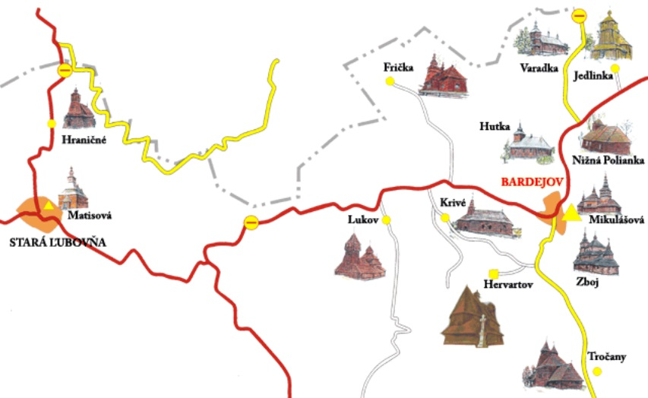

1. **Answer the questions.**
2. The patron of church in Hervartov is
3. St Francis of Assisi b) St. Nicolas c) the Saint Archangel Michael
4. The church is made of .................. wood.
5. Pine b) red spruce c) oak
6. There are a few small buildings near the church. What´s their use? It´s a..............
7. Barn b) stable c) cellar
8. Church in Trocany is probably the oldest church of the Eastern rite in Carpathian area. It dates back to...
9. Late 15- beginning 16. Century b) 18 century c) 17. century
10. How many wooden towers does the church have?
11. 3 b) 2 c) 4

**DAY 2- BARDEJOV AND BARDEJOV SPA**

Another Slovak town inscribed in the **UNESCO** World Heritage Listis the historic**Bardejov**, one of the oldest Slovak towns. The town of Bardejov was in the past one of the main trade centre of Saris region.

1. **Here is the map of Bardejov. Use the stickers to mark the important places in the city.**

**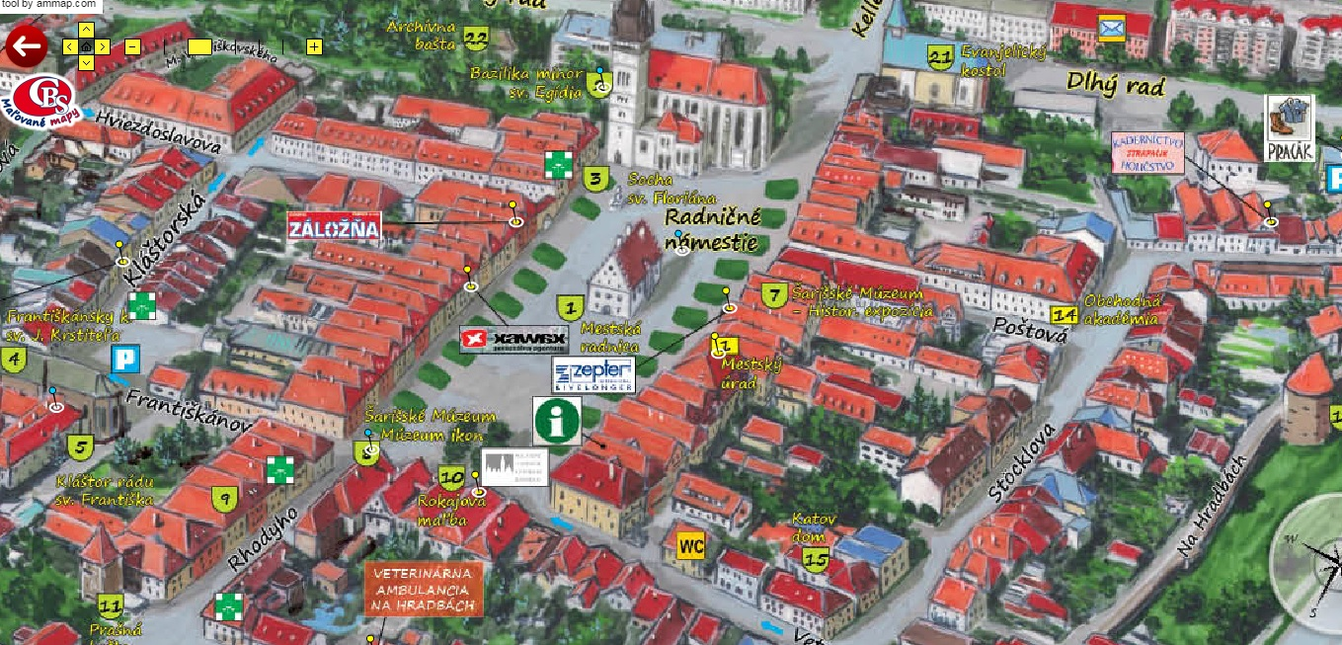**

**Stickers:**

1. **Town hall 2. The municipal winehouse 3. Grammar school 4. Lower gate 5. Gothic burgher house, *Gantzughof***
2. **Answer the questions.**
3. How many houses are there in the centre of Bardejov? \_\_\_\_\_\_\_\_\_\_\_\_\_\_\_\_\_
4. What´s the name of the church which dominates the city centre? \_\_\_\_\_\_\_\_\_\_\_\_\_
5. How many gothic alters are there in the Church? \_\_\_\_\_\_\_\_\_\_\_\_\_

The **Bardejov Spa** has a long history, with the first record from the 13.th century. Many rulers visited this place- for example Marie Louise, wife of French Emperor Napoleon I., Russian Tzar Alexander I., Empress Elisabeth (also known as **Sissi**), wife of Francis Joseph I., and other prominent European noblemen.

The biggest treasure of the spa is its **natural mineral waters**. Their composition ensures their place among the most important mineral waters in Europe. The springs in Bardejov are classified as hydrocarbonic, chloride, sodium, carbonic hypotonic with medium mineralization and relatively rich in boric acid.

1. **You are going to taste some mineral water. Write down the mineral source and describe wheter you liked it or not on a scale 1-10 ( 1 is great taste- 10 absolutely disgusting) and add a couple of adjectives which describe the tase of this natural spring .**

**Use these adjectives:**

|  |  |  |  |  |  |  |  |
| --- | --- | --- | --- | --- | --- | --- | --- |
| **sulphurous** | **tasty** | **refreshing** | **sparkling** | **bad** | **sweetened** | **smelly** | **bitter** |
| **salty** | **Without taste** | **Good** | **sour** | **drinkable** | **energizing** | **revitalizing** | **coolling** |

|  |  |
| --- | --- |
| **Natural spring** | **taste** |
|  |  |
|  |  |
|  |  |

1. **There are a few possibilities of accommodation. Your task is to find out the prices of single/ double room per person/ night in some of the hotels in Bardejovské Kúpele. Those who are not able to finish the task on site, use QR codes.**

|  |  |  |
| --- | --- | --- |
| **Hotel** | **Single room( person/ night)** | **Double room( person/ night)** |
|  |  |  |
|  |  |  |
|  |  |  |

  

**DAY 3 SPIS CASTLE and LEVOCA**

1. **Spot the differences(5) and name them!**

Correct anwers: wall, rotunda, tower, gate, stone

**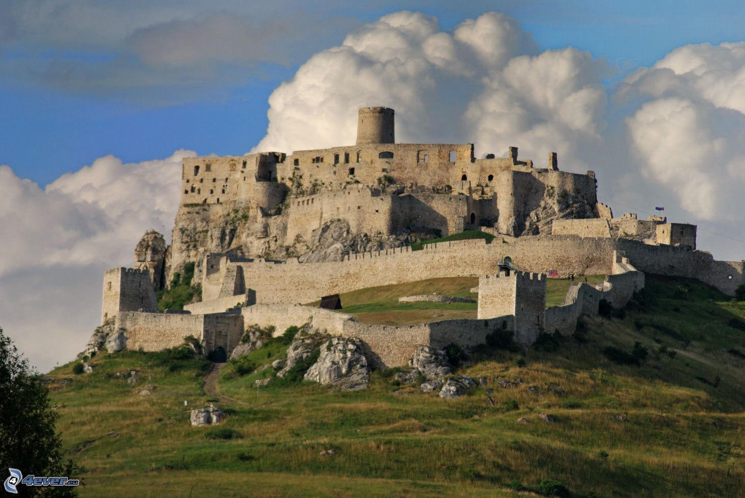**

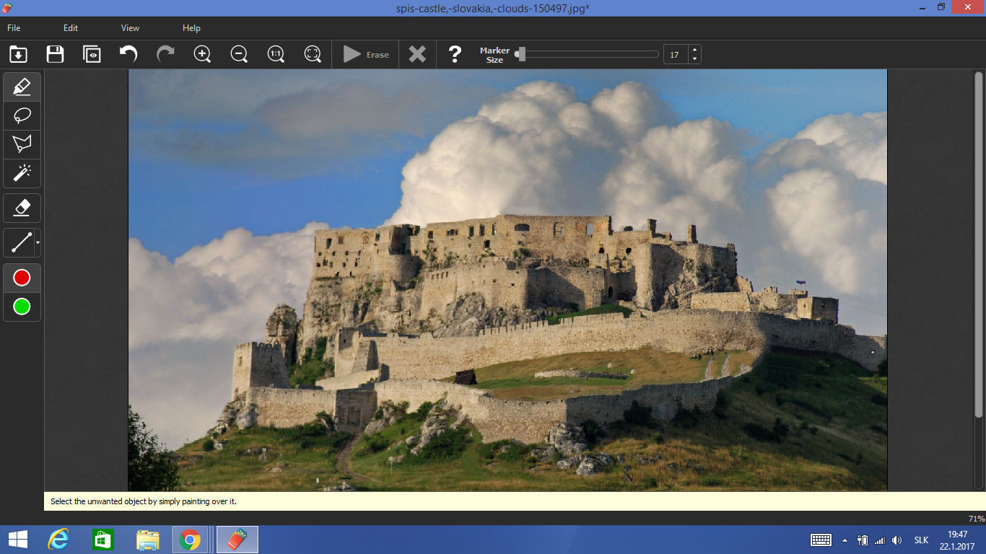

1. **Answer the questions!**
2. Why did people build castles on the hill?\_\_\_\_\_\_\_\_\_\_\_\_\_\_\_\_\_\_\_\_\_\_\_\_\_\_\_\_\_\_\_\_\_\_\_\_\_\_\_\_\_\_\_\_\_\_\_
3. What materials were used to build medieval castles? \_\_\_\_\_\_\_\_\_\_\_\_\_\_\_\_\_\_\_\_\_\_\_\_\_\_\_\_\_\_\_\_\_\_\_\_\_
4. How did they get all the materials to the top of the hill?\_\_\_\_\_\_\_\_\_\_\_\_\_\_\_\_\_\_\_\_\_\_\_\_\_\_\_\_\_\_\_\_\_\_\_
5. **What are typical features for Slovakia?**

\_\_\_\_\_\_\_\_\_\_\_\_\_\_\_\_\_\_\_\_\_\_\_\_\_\_\_\_\_\_\_\_\_\_\_\_\_\_\_\_\_\_\_\_\_\_\_\_\_\_\_\_\_\_\_\_\_\_\_\_\_\_\_\_\_\_\_\_\_\_\_\_\_\_\_\_\_\_\_\_\_\_\_\_\_\_\_\_\_\_\_\_\_\_\_\_\_\_\_\_\_\_\_\_\_\_\_\_\_\_\_\_\_\_\_\_\_\_\_\_\_\_\_\_\_\_\_\_\_\_\_\_\_\_\_\_\_\_\_\_\_\_\_\_\_\_\_\_\_\_\_\_\_\_\_\_\_\_\_\_\_\_\_\_\_\_\_\_\_\_\_\_\_\_\_\_\_\_\_\_\_\_\_\_\_\_\_\_\_\_

1. **Choose one from the list below and write what you know about it!**

Caves, castles, natural springs, unique fauna and flora, national cuisine and drinks.

**\_\_\_\_\_\_\_\_\_\_\_\_\_\_\_\_\_\_\_\_\_\_\_\_\_\_\_\_\_\_\_\_\_\_\_\_\_\_\_\_\_\_\_\_\_\_\_\_\_\_\_\_\_\_\_\_\_\_\_\_\_\_\_\_\_\_\_\_\_\_\_\_\_\_\_\_\_\_\_\_\_\_\_\_\_\_\_\_\_\_\_\_\_\_\_\_\_\_\_\_\_\_\_\_\_\_\_\_\_\_\_\_\_\_\_\_\_\_\_\_\_\_\_\_\_\_\_\_\_\_\_\_\_\_\_\_\_\_\_\_\_\_\_\_\_\_\_\_\_\_\_\_\_\_\_\_\_\_\_\_\_\_\_\_\_\_\_\_\_\_\_\_\_\_\_\_\_\_\_\_\_\_\_\_\_\_\_\_\_\_\_\_\_\_\_\_\_\_\_\_\_\_\_\_\_\_\_\_\_\_\_\_\_\_\_\_\_\_\_\_\_\_\_\_\_\_\_\_\_\_\_\_\_\_\_\_\_\_\_\_\_\_\_\_\_\_\_\_\_\_\_\_\_\_\_\_\_\_\_\_\_\_\_\_\_\_\_\_\_\_\_\_\_\_\_\_\_\_\_\_\_\_\_\_\_**

1. **After the visit write about one feature what you have learnt about today!**

**\_\_\_\_\_\_\_\_\_\_\_\_\_\_\_\_\_\_\_\_\_\_\_\_\_\_\_\_\_\_\_\_\_\_\_\_\_\_\_\_\_\_\_\_\_\_\_\_\_\_\_\_\_\_\_\_\_\_\_\_\_\_\_\_\_\_\_\_\_\_\_\_\_\_\_\_\_\_\_\_\_\_\_\_\_\_\_\_\_\_\_\_\_\_\_\_\_\_\_\_\_\_\_\_\_\_\_\_\_\_\_\_\_\_\_\_\_\_\_\_\_\_\_\_\_\_\_\_\_\_\_\_\_\_\_\_\_\_\_\_\_\_\_\_\_\_\_\_\_\_\_\_\_\_\_\_\_\_\_\_\_\_\_\_\_\_\_\_\_\_\_\_\_\_\_\_\_\_\_\_\_\_\_\_\_\_\_\_\_\_**

1. **Choose the words to their definitions! There are five extra words!**

Uncomfortable, completely, settlement,family, late, town, clan, village,

France, fortification, Slovakia, century, political

1. a few houses, usually smaller than a town. \_\_\_\_\_\_\_\_\_\_\_\_\_\_ VILLAGE
2. painful; irritating, negative of comfortable. \_\_\_\_\_\_\_\_\_\_\_\_\_\_ UNCOMFORTABLE
3. a group of families, it is connected with mafia. \_\_\_\_\_\_\_\_\_\_\_\_\_\_ CLAN
4. whole; entire; full. COMPLETELY \_\_\_\_\_\_\_\_\_\_\_\_\_\_ COMPLETELY
5. walls usually used around castles \_\_\_\_\_\_\_\_\_\_\_\_\_\_ FORTIFICATION
6. a period of 100 years  \_\_\_\_\_\_\_\_\_\_\_\_\_\_ CENTURY
7. adjective : of, relating to, or concerned with [politics](http://www.dictionary.com/browse/politics).\_\_\_\_\_\_\_\_\_\_  POLITICAL
8. a republic in central Europe, formerly a part of Czechoslovakia;  independent since 1993. It covers 49,035 sq. km. The capital city of this state is  Bratislava \_\_\_\_\_\_\_\_\_\_\_\_ SLOVAKIA
9. **Fill the gaps with appropriate words from PART D.**

Spiš Castle was built in the 12th 1)...................**century** on the site of an earlier castle. It was the 2)....................**political**, administrative, economic and cultural centre of [Szepes County](https://en.wikipedia.org/wiki/Szepes_County) of the [Kingdom of Hungary](https://en.wikipedia.org/wiki/Kingdom_of_Hungary). Before 1464, it was owned by the [kings of Hungary](https://en.wikipedia.org/wiki/List_of_rulers_of_Hungary), then (until 1528) by the [Zápolya](https://en.wikipedia.org/wiki/John_Z%C3%A1polya) family, the [Thurzó](https://en.wikipedia.org/wiki/Thurz%C3%B3) family (1531–1635), the [Csáky](https://en.wikipedia.org/wiki/Imre_Cs%C3%A1ky_(cardinal)) family (1638–1945), аnd (since 1945) by the state of [Czechoslovakia](https://en.wikipedia.org/wiki/Czechoslovakia) then 3)................[**Slovakia**](https://en.wikipedia.org/wiki/Slovakia)**.**

Originally a [Romanesque](https://en.wikipedia.org/wiki/Romanesque_architecture) stone castle with 4)....................**fortifications**, a Romanesque palace and a Romanesque-[Gothic](https://en.wikipedia.org/wiki/Gothic_architecture) basilica were built in the 13th century. The castle was 5)............................**completely** rebuilt in the 15th century. A late Gothic chapel was added around 1470. The [Zápolya](https://en.wikipedia.org/wiki/John_Z%C3%A1polya) 6)...............................**clan** made late Gothic transformations, which made the upper castle into a comfortable family residence, typical of late Renaissance residences of the 16th and 17th centuries. The last owners of the Spiš Castle, the Csáky family, left the castle in the early 18th century because it was 7).....................**uncomfortable** to live in. They went to live to the new 8).....................**village** castles in Hodkovce near [Žehra](https://en.wikipedia.org/wiki/%C5%BDehra) and [Spišský Hrhov](https://en.wikipedia.org/wiki/Spi%C5%A1sk%C3%BD_Hrhov).

**LEVOCA**

The historic town Levoča, situated in the east of the Spiš region, is a true cultural and historic jewel among the Slovak towns as it possesses a great number of architectural monuments linked with the glorious past of the town.

The Spiš town of Levoča (population 14,500) situated in the east of Slovakia below the mountain range Levočské vrchy, because of its rich history, is one of the most visited by tourist in the country.

**We are going to visit several places in Levoca. Write the names of the historical monuments described below.**

It is a three-nave church with a sturdy sanctuary. It is vaulted by Gothic cross corridors. It was built in the last quarter of the 14th century. In 1392, the St. George's Chapel was added to the northern part of the church . During the next century northern and southern entrances were added. They both have beautiful and rich porches with abundant plastic ornaments.

Name:

**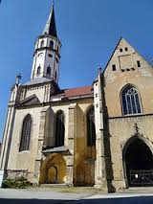**

It comes from the 16th century and it was used for punishing for minor delinquencies. Its original place was where the Protestant Church is situated now. It is situated in front of the town hall now.

Name:

The building is situated in the impressive surroundings of the monuments in the west of the square. The building, and esp. the theater, was given back its chamber character from the first half of the 19th century

Name:

 It is attached to a Renaissance tower, which was built between 1656 - 1661 as a bell-tower. There are some expositions of the Spis Museum on the first floor . Its Session Hall is used for representation purposes.

Name:

**THE WHITE LADY OF LEVOČA**

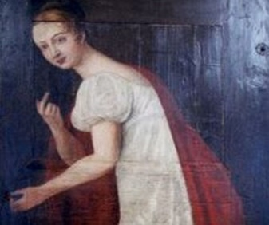The legend of the White Lady of Levoca says that a beautiful woman lived in the city. Her name was Julianna Korponay. Popular myth is that she was money and power hungry and she sold the town to the enemy that was outside the walls by leading them into the city through the secret underground passages that were built to supply the city with water during periods of siege. Her betrayal was punished and she was built into one of the walls in the underground.

**Have you noticed where the portrait of the White Lady of Levoca takes place? Pictures below can help you.**



 

**The portrait of the White Lady of Levoca is situated in ....................................................................................**

**DAY 4: BELIANSKA CAVE AND THE HIGH TATRAS**

**THE BELIANSKA CAVE**

The Belianska Cave belongs among the most visited show caves in Slovakia. Except for bizarre rocky shapes, it is known by rich occurrence of calcite fills. The cave is located on the northern slope of the Kobylí Hill in the eastern part of the Belianske Tatras Mts. It lies in the national nature reserve Belianske Tatras within the territory of the Tatra National Park.

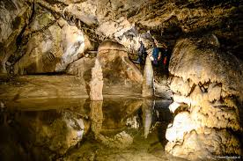

**What is the main difference between the pictures?**

**....................................................................................................................................................................................................................................................................................................................................................................**

**What animal can you see in the Belianska cave? How many spieces of this animal can you find in the cave?**

**..................................................................................................................................................................................**

**What form takes a special leant stalagmite in ,,Zruteny Dóm“, which is 2 m high and 1 m wide?**

### a) [Leaning Tower of Pisa](https://www.google.sk/url?sa=t&rct=j&q=&esrc=s&source=web&cd=&cad=rja&uact=8&ved=0ahUKEwjgpdnenePRAhXCOSwKHQt2CXIQFggzMAg&url=https%3A%2F%2Fen.wikipedia.org%2Fwiki%2FLeaning_Tower_of_Pisa&usg=AFQjCNGRrjKKOOnpeNYn15U2302QQLxXoA&sig2=3ojjq6RipBO36DvKcaf_Fw)

### b) Eiffel Tower

### c)Blackpool Tower

### What is the name of the Hall where concerts of reproduced music are being held?

### a) Concert Hall

### b) Music Hall

### c) Singers´ Hall

**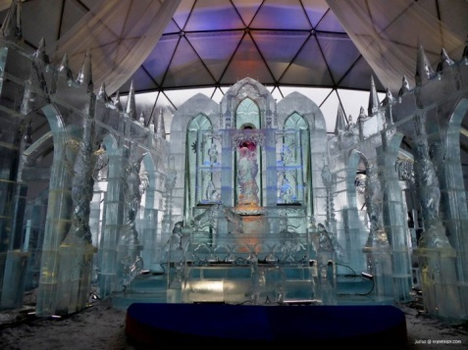HREBIENOK – TATRAS´ ICE DOME**

Apart from breathtaking mountains, glacial lakes, waterfalls, forests or first class ski resorts, High Tatras National Park has now been featured with one more attraction. And it was entirely made of ice! **Ice Church** known here as Tatranský dóm is definitely the biggest and coldest winter attraction in the High Tatras mountains.

It was made of almost 90 tones of ice bricks by the hands of 15 sculptors and their accomplices during three weeks of hard work. 720 ice blocks were modified and turned into a spectacular work. Its main author and designer was agian local architect Adam Bakoš. I tis made in Gothic style and one of its main attractions will certainly be a high quality altar with a statue of the Virgin Mary with Jesus and a statue of Master Pavol from Levoča which is located in the arch to the right of the altar.

**Which of the ice sculptures did you like the most?**

**................................................................................................................................................................................**

### DAY 5: NATIONAL PARK SLOVAK PARADISE

### THE SLOVAK PARADISE NATIONAL PARK

### 2007.05.12_01_Hrabusice_-_Myto.JPGThe Slovak Paradise is a unique mountain karst formation located in the eastern part of Slovakia. Its total area is 19,763 hectares and the most strictly protected area has 13,011 hectares. The landscape comprises plateaus, deep gorges and canyons as well as other karst formations, e.g. sinkholes, cliffs, rock pillars and caves.

**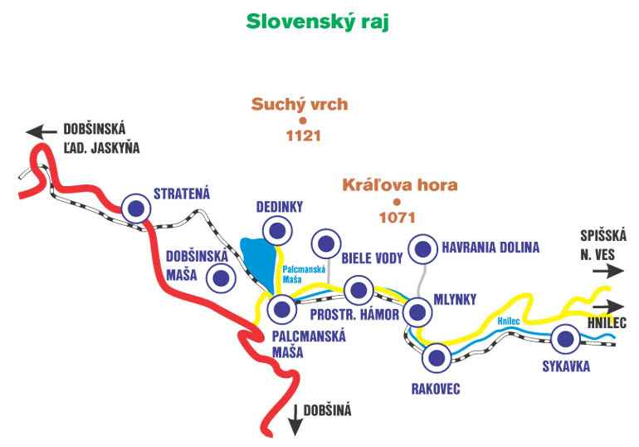**

**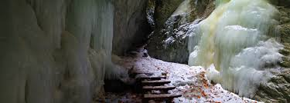**

**Write the name and the colour of the trail we are going to follow.**

**.........................................................................................................................................................................**