Lesson plan
Date: 14th April 2016.
School: Gimnazija Metković
Title: Wildlife of the Neretva River Valley
Goal: To learn the typical animals of the Neretva Valley, recognize them by appearance and to know the basics of their ecology
Outcomes: - recognize the Neretva River on the map
- Mark the delta of the river on a map
- name some of the wildlife
- recognize the species by picture and match the picture to the name of the species
- learn about the ecology of the mentioned species
- perceive the dangers of human intervention in the Valley
- suggest the actions that can help preserve the wildlife of the Valley
Methods of teaching: conversation, discussion, demonstration, writing and reading, problem solving
Educational technology: computer, ppt, presentation, projector, text, work sheets with assignments

Introduction: - about the location of the Neretva River Valley in Croatia
- geographical and ecological characteristics of the area
Main part: - presentation of the most common birds and other animals in the Valley
- student assignments (work in pairs)
- result analysis
Final part: - discussion about influence of human living and agriculture on wildlife

Worksheets
You will be working in pairs today. Please read the tasks carefully and write your answers in the place provided.
- Find and mark the Neretva River on the map below.
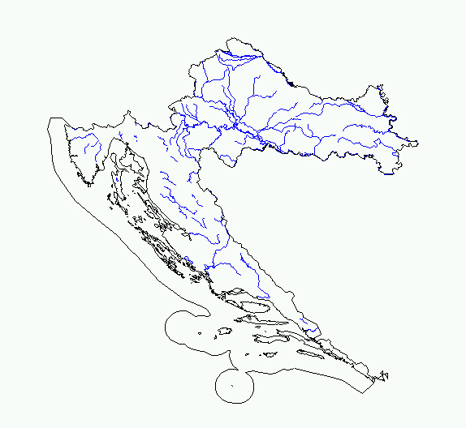
- On the map cycle the Neretva River delta.
- Name at least 2 species of birds and one species of other animals that live in the Valley.

____________________________________________________________________________
- Mach the following bird names to the correct picture: Coot, Grey Heron, Great Crested Grebe, Mallard.
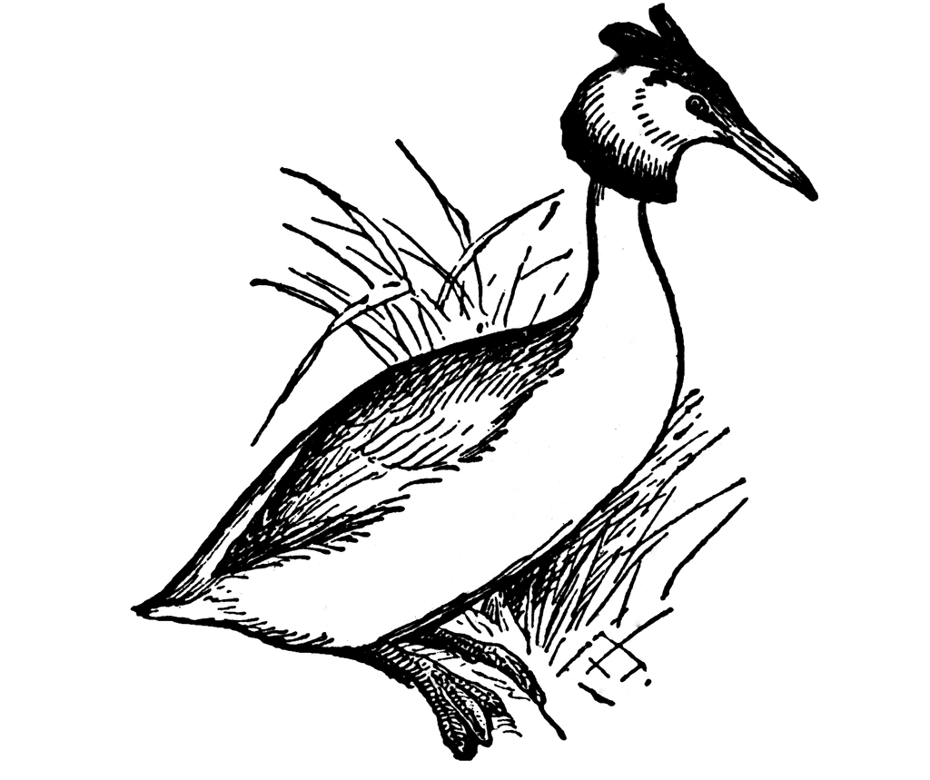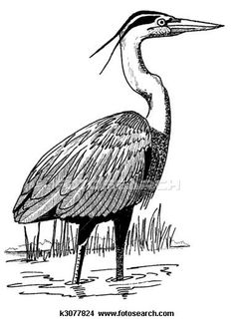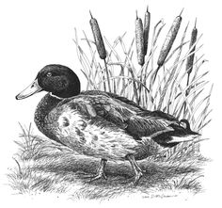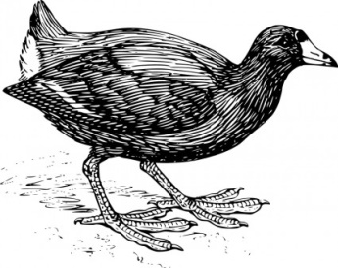
- Name at least 2 sources of contamination of the water in the Neretva River Valley.

____________________________________________________________________________
- Suggest a way you can help preserve the wildlife in Neretva River Valley.

