Porta Rusica- hidden jewel
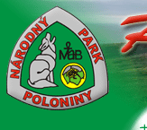
During next few days you are going to explore two thematic paths that are not well known even among Slovak. Both are situated in Poloniny national park. First, Slovak iron route, connects places of iron ores´ exploration as well as treatment and production of iron( other metal) products. Second cultural road is called Porta Rusica, an old trade route which connected Autrian- Hungary( Halič) and Poland (Baligrod). We wish you pleasant and memorable walk.
BEFORE THE ACTIVITY
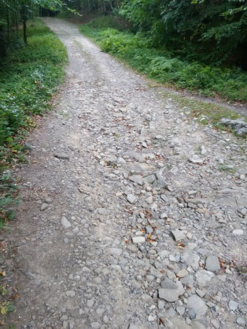
- Find information about National park of Poloniny and answer the questions.
- Where is the park located? __________________________________
- What three countries meet in Poloniny national park? ____________________________
- What is the area of national park? ___________________ ha.
- Write down three names of primeval forest situated in Poloniny national park: _____________________________________________________
- What towns are located nearby Poloniny? ___________________________________

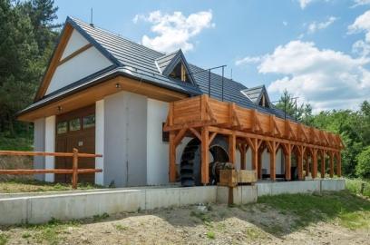
- Fill in the basic information about thematic roads that are situated nearby the easternmost park of Slovakia.
- What ore was exploited in area of Zemplin in the 19th century? __________________
- Who established the company which exploited iron ore in the area? __________________
- What was the original name of village Zemplinske Hámre? _____________________
- How many kilometers of the path of Porta Rustica is preserved in Slovakia? __________.
- When was Porta Rusica built? Between ______ and ___________ .

- As you know, we are going to Stakčín near Snina. Write down the address as well as GPS coordinates of a place we are going to stay. To find correct GPS coordinates please scan this qr code and it will redirect to www.gps-coordinates.net/gps-coordinates-converter:

a) address: _______________________________________________
b) GPS coordinates ( in DMS form): latitude: _____________________
longitude: ____________________
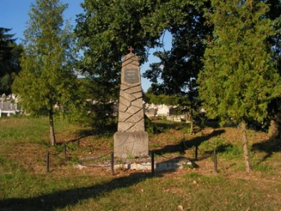

- We set off at 08.05 from Giraltovce. What time shall we arrive to Michalovce? ( write down your guess and it will be checked with the real time of our arrival).
________________________________________________________
FIELD TRIP LIST:
1. Date: __________________ 2. Time: ___________________
3. Temperature: ___________ 4. Weather ________________
5. means of trasport: _______ 6. Travelling time: ____h_____ min.
7. What towns have we passed? ________________________________________________

When at the place:
First day of our trip is devoted to exploring Porta Rusica and its surroundings. While walking with our guide fill in the gaps with the most appropriate words. Your walking tour starts nearby water reservoir Starina, continues via extincted village of Ruské to Porta Rusica.
- Choose the correct answer.
- Starina reservoir supplied by the river of PČOLINKA/ CIROCHA / LABOREC.
- Circle the villaged which were flooded in 1981 when biulding Starina.
STAKČÍN/ RUSKÉ/ STARINA/ OSADNÉ/ KOLONICA/ ZVALA/ VEĽKÁ POĽANA
- What town is mentioned as starting point of Porta Rusica in eastern part of Slovakia? HUMENNÉ/ SNINA/ MICHALOVCE
- Porta Rusica is made of ......... ASPHALT/ CONCRETE/ STONE
- At the beginning of the road there is a stone pillar. What number does it show?
74,6/ 76,4/ 47,6/ 67,4
- At what place does the road to Poland cross the state border?
SOLIŠTE/ RUSKÉ SEDLO/ BERBEČOV POTOK

- Look at the map and mark the hiking route you have just done.
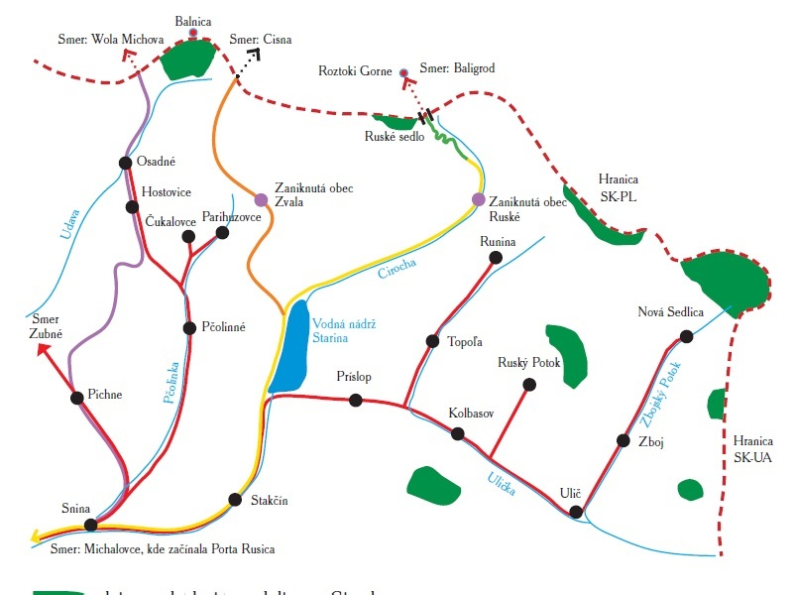

- Watch a video about Porta Rusica. Describe the countryside. You can download video on : https://youtu.be/NoxJwNDfyeo
___________________________________________________________________________________________________________________________________________________________________________________________________________________________________

- Match numbers to their meaning
- 1997 1. the lenght of Porta Rusica in Slovakia
- 247 2. Poloniny were added to the list of National parks in Slovakia
- 1861 3. they started to build water reservoir Starina
- 4 4. a year in which Porta Rusica started to be build
- 74,6 5. Altitude you have to overcome while hiking Porta Rusica
- 1981 6. sign on a stone pillar

- Fill in the gaps with the most suitable word.
Ukraine | world | 485.19 km² | northeast
Dark Sky Park | Slovakia | darkest part | artificial light

Poloniny has been also declared as . It is the first dark sky park in ___________. It became the 20th dark sky park in the ___________.
Totally natural dark night, unaffected by ______________ no longer exists in Slovakia because of light pollution. But there are still places where this influence is minimal. Such place is the Poloniny National Park, which is in terms of light pollution darkest area in Slovakia. Poloniny Dark-Sky Park is located in the _____________ of the Slovak Republic on the border with Poland and __________. The territory of the park itself is defined by area of the Poloniny National Park and villages of Kolonica, Ladomirov, Kalna Roztoka, Klenova, Ruska Volova . The total area is _____________. Area of the park is characterized by having an exceptionally small population density (6 inhabitants per km²). It is also the least visited national park in Slovakia, so the human impact on the environment is minimal.
In terms of light pollution is Poloniny National Park the _________________ in Slovakia. Natural night darkness and night biorhythms of all living organisms are least disturbed.

- Watch the video and answer these questions. Scan QR code to be able to watch the video. It´s avalaible only in Slovak language.

- In what city does the film start? ______________ .
- What can be observed by the people in the streets? ____________ .
- By the year _______ we won´t be able to see The Milky way in Europe.
- What are the main factors of light pollution? ______________________ .
- What healthy problems can people have in the places with the highest light pollution? __________________________ .
- When was the Dark- sky park established? __________________ .
- How many stars can you see there? _______________________ .

- Village Osadne is well known for the crypt of soldiers from World war I. Write down three information which you would tell foreign tourist about Osadne. You should mention location, nationality of inhabitants, religion, sights.....
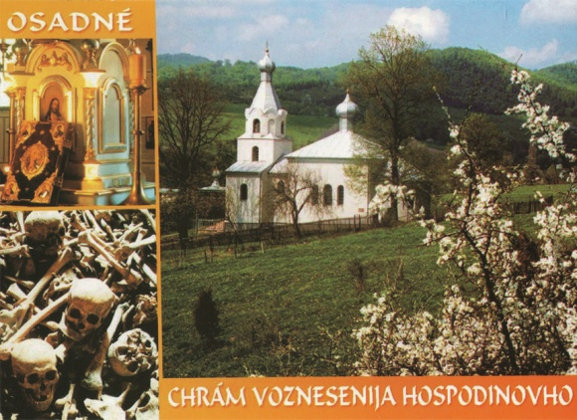
- _______________________________________________________________________________________

- _______________________________________________________________________________________

- _______________________________________________________________________________________

- Match pictures to the places.
Porta Rusica | Memorial of World war II in Stakcin | water reservoir | Bio natural swimming pool
Castle in Snina | Bieszcadzka narrow gauge | Observatory in Kolonicke Sedlo | Historic canal lock

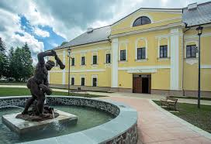 |  | 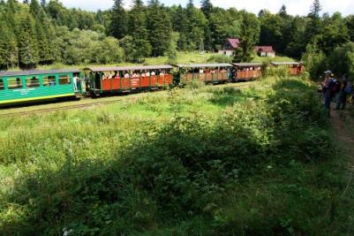
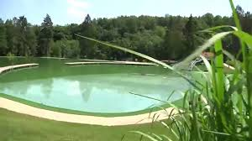 |  | 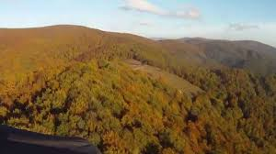
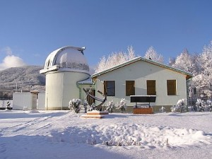 |  | 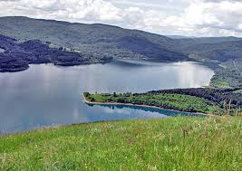
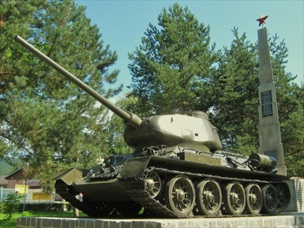 |  | 