Didactic tool: Board game (Institut Montbui)

Board: Geographical map of Europe with 8 routes dealed during the project: 1.Amber road, 2. Roman roads, 3. Viking raids, 4. Saint James’ Way 5. Mediterranean-Adriatic marine powers (Barcelona/Venezia/Dubrovnik) 6. Portuguese-Spanish discoverers’ route, 7.Salt route, 8. Magna Via route

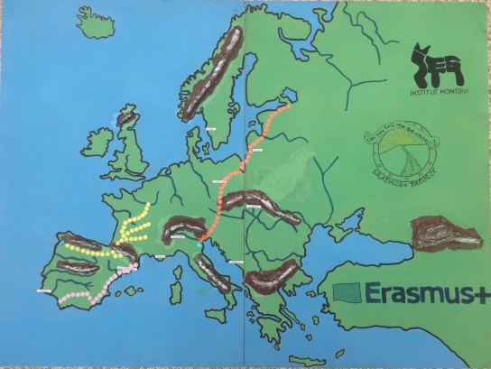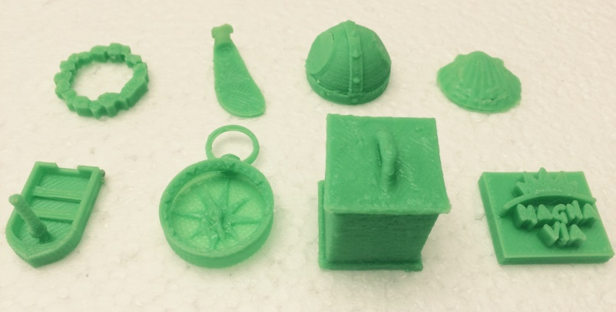
How to play. It can be played by 2 to 8 players (the player can be a person or a team).

To start the game, each player choose at random:

- a Counter representing one of the 8 routes (Amber road: bracelet, Roam roads: sandal, Viking raids: viking helmet, Saint James’ way: scalop, Mediterranean-Adriatic marine powers: boat, Portuguese-Spanish discoverer’s route: compass, Salt route: salt cellar, Magna Via route: Magna via logo)
- a Route mission card containing 10 questions related to one of the 8 routes
- a Country Factfile (with information about one of the 9 countries in the project)
- a Route missions summary (containing all the questions in the 8 Route mission cards).

Aim: The aim of the game is to get all the answers to the questions in the player’s Route mission card.

Before starting the game, the player will have 5 minutes to memorize the information in its Country Factfile and put it backwards. To start the game, each player locates his/her counter at the starting point -pointed with the letter B (Beginning)- of the route according to his/her mission. Then each player throws the dice and the one getting more points starts. Then, throws the dice and moves on his/her counter according the dice result. In order to fall in the M (Mission) squares, players can move counters forwards or backwards.

When a player –Player 1- falls in a square pointed with the letter M he/she will be able to ask (to the player on his/her rigth –player 2-) one of the questions of Player’s 1 mission. But in order to get the answer, Player 2 will ask to Player 1 one question about Player 1 country. Before listening to the question, Player 1 can turn on the Country Factfile and glance it for 30 seconds to remember the information on it. Then Player 1 gives the Country Factfile to Player 2, who takes –from the middle of the board game- one Country factfile question and reads it to Player 1. Then Player 1 tries to answer the question made by Player 2 (once the question is made Player 1 can not check the Country factfile!). If Player 1 answers correctly (to check the answer of Player 1, Player 2 reads the information in the country factfile) Player 1 can ask one of the questions of his/her mission to Player 2, that is obliged to answer it (the answers to all Route mission cards will be located –backwards- in the middle of the board game). Once Player 2 reads the answer, Player 1 -and all the other players!- writes down the answer in the appropiate place: Player 1 on his/her Mission card and the other players on his/her Route missions summary. It’s very important that each player write the answers to all questions because at the end of the game they will need them.

If player 1 fails to answer correctly, he/she looses the opportunity to ask and it is the turn of the next Player clockwise.

When a player gets all the answers to the questions of his/her Mission card, in order to win the game, he/she will have to answer 1 of the questions of each of the other routes that have been answered during the game. In order to do so, each of the other players choose one question of his/her route to be asked. If the player trying to win the game fails the answer to anyone of these questions, he/she looses the turn. When this player gets the turn again, he/she should only answer a new question related to the routes that didn’t answer correctly in the previous turn.

