CLIL LESSON PLAN- GEOGRAPHY
Ecotourism on MAGNA VIA

- PRE- READING
Label the pictures with these words. Then check your answers by doing an Internet search for holiday types. You can use these websites to help you:

http://www.tribes.co.uk/holiday-types
http://www.virginholidays.co.uk/holiday-types
http://www.macmillandictionary.com/thesaurus-category/british/types-of-holiday

camping holidays | wild life watching holiday | adventure holiday | beach holiday
winter holiday | honeymoon | sightseeing holiday | city break

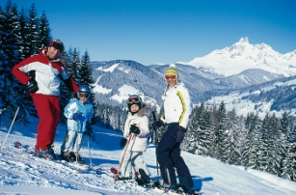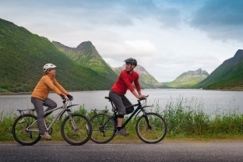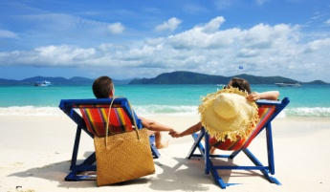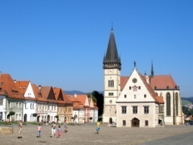
A B C D
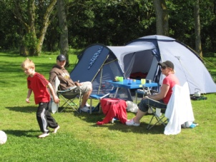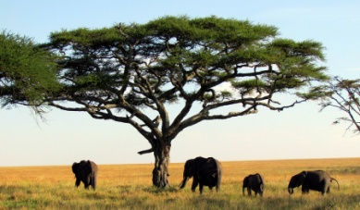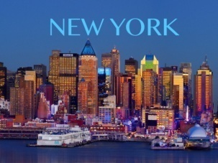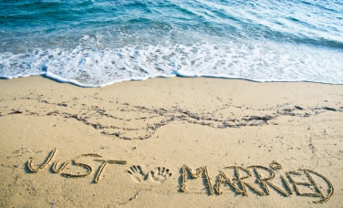
E F G H

A |  | E
B |  | F
C |  | G
D |  | H

- READING
Do you know what ecotourism is? Read the definitions 1–3 and choose the best definition. Then check your answer by doing an Internet search for ecotourism. You can visit these websites to help you:

https://www.ecotourism.org/what-is-ecotourism
http://www.nature.org/greenliving/what-is-ecotourism.xml
http://www.gdrc.org/uem/eco-tour/etour-define.html

- A holiday arranged by a travel company that includes the cost of your hotel and transport, and sometimes meals and entertainment.

- A holiday spent visiting another country and staying in places in the countryside, e.g. farms.

- A holiday that gives you the chance to learn about a natural environment or local culture, and causes as little

damage to the environment as possible.

- READING
'Magna Via'- a former Imperial-Royal mail route was an important trade road that was often used by travelling tradesmen, postmen and even nobility. In 1558, the year of its completion, the route was one of the longest postal and transport links and included fifty-six postal stations crossing five countries (Austria, Slovakia, Ukraine, Hungary, and Romania) and connection Vienna and Rumanian town of Sibiu. The route’s length was over a thousand kilometres, with 520 kilometres running though Slovakia. Naturally the route has soon become one of the most important business and postal roads in the monarchy.
As a part of our ERASMUS + project called Can you tell me the way to.... tracing our European heritage on foot we decided to explore this route as an example of ecotourism. By visiting the historically important places of interest we tried to highlight, protect and promote the cultural heritage, natural beauty and interesting sights, roads or ruins in eco- friendly way.
Tick the activities people do on an ecotourism holiday. Then check your answers by doing an Internet search for ecotourism holidays. You can visit these websites to help you:

http://accreditationonline.tourism.gov.ph/Downloadables/Standards/EcoTour.pdf
http://www.gdrc.org/uem/eco-tour/10-command.html
http://www.ecotourdirectory.com/ecotourism/guidelines_for_ecotravellers.php
- Behaving responsibly is necessity |  | 7. staying in big multistar hotels
- Everything should be touched, taken out |  | 8. staying in cheap hostel or local family
- Leaving rubish behind |  | 9. using local guides, transport, inns...
- Saving historical and natural sites |  | 10. travelling everywhere by plane, taxi or car
- Learning English or local language |  | 11. meeting and learning about new cultures
- Talking, laughing, dancing everywhere without knowing local customs |  | 12. trying to move too close to the wildlife, places of interest

- MAP OF MAGNA VIA
You can see a map of Slovakia. Draw a map of Magna via with its most important towns and places which crossed our country. To help you, please visit :
http://www.magnavia.eu/index.php?option=com_content&view=article&id=107&Itemid=217

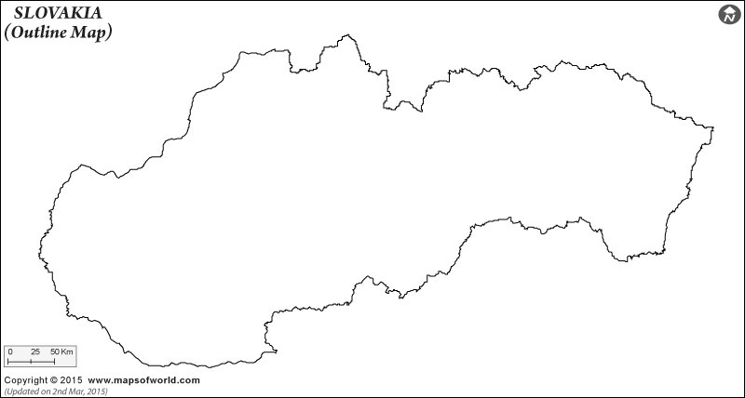
5 Reading
Imagine you are planning an ecotourism trip on Magna Via. Think about the things you are going to do on this thematic road. Read the statements and write Y ( Yes) or N ( No). Then, chceck your answers by doing an Internet search for ecotourism dos and don´ts. Visit these website to give you basic rules of ecotourism trips:

www.tourismconcern.org.uk
www.newgstcouncil.org
http://www.magnavia.eu/index.php?option=com_content&view=article&id=107&Itemid=217

I am going to experience Magna Via on foot
I am going to buy products that are produced locally
I am only going to use 4WD vehicle myself
I am going to learn about place´s history and culture before I visit it
I am going to stay only in Eco- friendly accommodation
I am not going to hire local guide with local knowledge. I´ll use Internet instead
I am not going to leave empty bottles, cans, tins and plastic bags behind me
I am not going to support local economy
I will try to enjoy each place I visit a bit longer, appreciate the local customs and language

6 Project
You have a great opportunity to go on an ecotourism holiday on Magna Via as a part of your education for a week. To attend this holiday, just describe your ecotourism holiday plans.

Include these things:

- What means of transport are you going to use
- Who are you going to travel with
- What places are you going to visit?
- What eco- activities are you planning to do?
- How are you going to save and preserve cultural traditions
- How are you going to protect the natural habitat
- How are you going to promote Magna Via in society
- Other relevant information

