Parque Rosalia de Castro
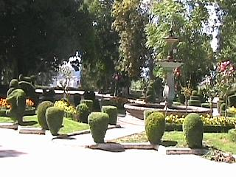
If you spend any time in Galicia, or reading guides like this one, you will quickly realize that it is difficult to travel anywhere in the region without encountering something dedicated to, or commemorating, this famous Galician poet. For its part, Lugo has named its alameda (main town garden or park) after her and you will find it just outside the city walls (see left).
The Rosalia de Castro park gets you out of the main hub of Lugo and into the dappled light of a gardened area with many trees, the obligatory fountains and some tasteful plantings. Originally built in1925 and named after Alfonso XII, this park is 23 hectares in area and is close to Lugo's Santiago gate.
There is a large café at the entrance to the park and if you wonder to its far end you will find yourself on a mirrador (balcony area) with views looking down to the "Mino" river below. You can also catch a glimpse of Lugo's Roman Spa (Termas Romanas) and an ancient bridge dating from a similar period. The park has a music stand plus children's play and picnic areas.
