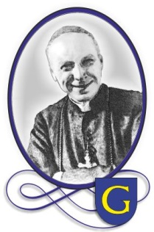



**Math Around Us**

Erasmus+ Strategic Partnership

2015 – 2017

flagi.jpg

**Math and Music**

SHORT-TERM EXCHANGES OF GROUPS OF PUPILS

Głogów Małopolski, 9-13 May 2016

This publication is in the copyright of its authors under the Creative Commons Licensing. Any reproduction of any part of this publication may be made without the written permission of its authors as long as it is properly acknowledged.

AUTHORS:

MATHEMATICS TEXTS: Katarzyna Gancarz, Anna Kuceł, Małgorzata Bazan

MUSIC TEXTS: Agata Płonka, Hanna Rzeszutek

TRANSLATION: Małgorzata Furman, Bożena Kluz, Ewa Tańcula

EDITOR: Sabina Malik

GRAPHIC DESIGN: Marek Kwas, Anna Lenart-Kulig

More information on:

<https://twinspace.etwinning.net/9782/home>

<https://www.facebook.com/MathAroundUs>



This project has been funded with the support from the European Commission. This publication reflects only the views of its authors and the Commission cannot be held responsible for any use which may be made of the information contained therein.

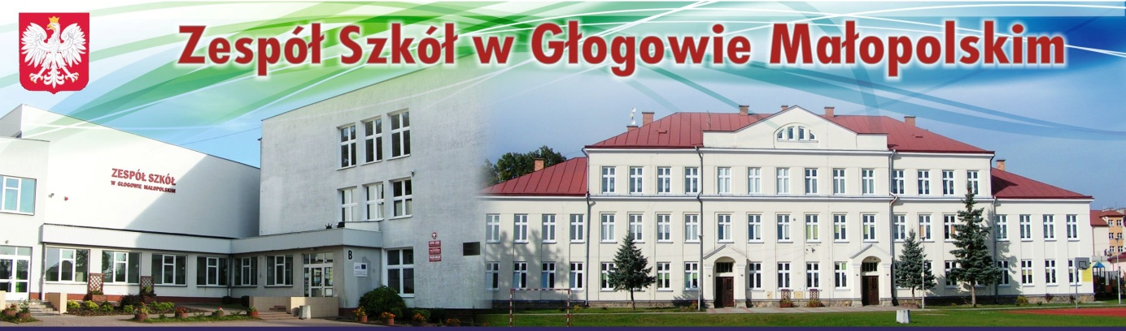**WELCOME TO ZESPÓŁ SZKÓŁ W GŁOGOWIE MAŁOPOLSKIM**

Our school has a long history. In 1791, when it was founded, there were 106 students. At first, the school was located in the building of the town hall. The number of students was increasing; in 1908 there were 650 students altogether. Due to the poor condition of the building, the authorities decided to build a new school. The building, which was erected in 1927, is now the primary school. In 1989 the school was extended. Now there are two separate buildings joined by a long corridor and that makes our school the biggest in the municipality of Głogów Małopolski.



Our school community consists of 937 students and 80 teachers. We try to follow the teaching of the school’s patron, Cardinal Stefan Wyszynski, who was a man of great wisdom and generosity. The role of our school is to foster values such as commitment, empathy, helpfulness, honesty, and responsibility.

Our school offers a wide range of extracurricular activities including an archery club, a folk group, and sports teams. We are proud of keeping a high level of education, innovative approach to teaching, preserving traditions and openness to the future.

It has always been important to our school to establish and develop international relationships in order to give the students the opportunity to broaden their experience and knowledge. We were partners in several projects including the Comenius Project “Training For LIFE: Leadership Initiative For Europe”.

**AGENDA**

**SHORT-TERM EXCHANGES OF GROUPS OF PUPILS**

**Głogów Małopolski, 9-13 May 2016**

|  |  |
| --- | --- |
|  | **Short-Term Exchange For Students** |
|  | **SATURDAY**  **7 May 2016** |
|  | Arrival: Greece, Romania, Portugal |
|  | **SUNDAY**  **8 May 2016** |
|  | Arrival: Denmark, Hungary, Italy |
|  | **MONDAY**  **9 May 2016** |
|  | *Arrival:* Lithuania |
| **9.15** | Induction session  Welcoming meeting, discussing practical issues, presentation of the agenda |
| **9.30** | Plenary session  Students presentations (PPT/PREZI/videos/etc.) on the topic of Math and Environment |
| **11.00** | Break |
| **11.30** | Ice breaking & Teambuilding at school |
| **13.00** | Attending a presentation “Discovering the hurdy-gurdy” |
| **13.30** | Lunch at school (canteen) |
| **14.15** | Workshop “Math Fun with The Möbius strip”. Students work in two groups. |
| **15.30** | End of school day. Students with host families. |
|  | **TUESDAY**  **10 May 2016** |
| **9.00 -11.30** | Application classes “Musical and mathematical symmetry”, “The golden ratio in the design of musical instruments”.  Students work in two groups. Each group will assist in turns a class/workshop together with Polish students.  Break at 10.00. |
| **11.30** | Tour of the town of Głogów Małopolski led by Polish students. |
| **12.45** | Lunch at school (canteen) |
| **13.30** | Trip to Rzeszów. Visit at the Faculty of Music at University of Rzeszów.  Presentation “The concept of time and space in a musical composition in relation to Newton’s and Leibniz’s theory of time”  Workshop “The rhythm of music” |
| **16.30** | Back to Głogów. Free time with host families. |

|  |  |
| --- | --- |
|  | **WEDNESDAY**  **11 May 2016** |
| **9.00-12.30** | Application classes: “Translation and transposition”, “Mozart’s fascination with math.”  Students will work in two groups. Each group will assist in turns a class/workshop together with Polish students.  Break at 10.30. |
| **12.30** | Lunch at school (canteen) |
| **13.00** | Workshop: Dissemination brochure |
| **14.30** | Teambuilding at the Gym. |
| **15.30-18.00** | Free time with hosting families |
| **18.00-22.00** | “Polish Folk Party” at the Cultural Centre organized by host families (folk songs, dances and games, costumes, traditional food, disco) |
|  | **THURSDAY**  **12 may 2016** |
| **8.45** | Visit at the Faculty of Mathematics and Natural Sciences at University of Rzeszów.  Math workshops held by university teachers: “Mathematical problem solving” and “Mathematics in the real world” |
| **11.30** | Break. A walk to the town centre. |
| **12.30** | Attending a classical concert at the Philharmonic in Rzeszów (J. Sibelius, Symphonic Poem *Finlandia* op. 26, A. Dvořák, Symphony 9 E minor op. 95 „From the New World”) |
| **14.30** | Lunch at “Stary Browar” restaurant in the Market Square in Rzeszów |
| **15.30-18.00** | Back to Głogów. Free time. |
| **18.00** | Evening Concert at the Cultural Centre performed by students and teachers from Głogów Małopolski School of Music |
| **19.00** | Festive dinner (Trzy Korony Hotel)  Theatrical performance “The Giving Tree”  Certificates Award |
|  | **FRIDAY**  **13 May 2016** |
| **5.45** | Leaving for Wieliczka and Kraków by bus |
| **8.00** | Visit to Wieliczka Salt Mine, taking a guided tour. |
| **12.00** | Lunch (Bistro Kampus in Wieliczka) |
| **12.30** | Attending a lecture “Math & Music” at Kampus Wielicki |
| **14.00** | Mobility Evaluation Session, assessment questionnaires |
| **15.00** | Visiting Kraków – European Capital of Culture |
| **18.30** | Back to Głogów |
|  | *Deperture: Denmark, Portugal* |
|  | **SATURDAY**  **14 May 2016** |
|  | Departure from Kraków: Italy, Romania, Hungary  Departure from Rzeszów: Lithuania, Greece |

*“There is geometry in the humming of the strings, there is music in the spacing of the spheres.”*

*Pythagoras*

The presence of mathematics is everywhere. Its application reaches far into other disciplines including music. Although music is thought to be artistic and expressive and mathematics is a scientific study, both are connected.

The two disciplines have been interlinked throughout history since antiquity. Pythagoras, Plato, Aristotle not only began to study mathematics and music, but they were the first ones who considered music to be a part of mathematics. It was Pythagoras who realized that different sounds can be made with different weights and vibrations. This led to his discovery that the pitch of a vibrating string is proportional to and can be controlled by its length. Strings that are halved in length are one octave higher than the original. In essence, the shorter the string, the higher the pitch.

Music itself is very mathematical. The scales and the rhythms, the design of the instruments, intervals, patterns, harmonies, overtones, tone, pitch – they are all connected to mathematics.

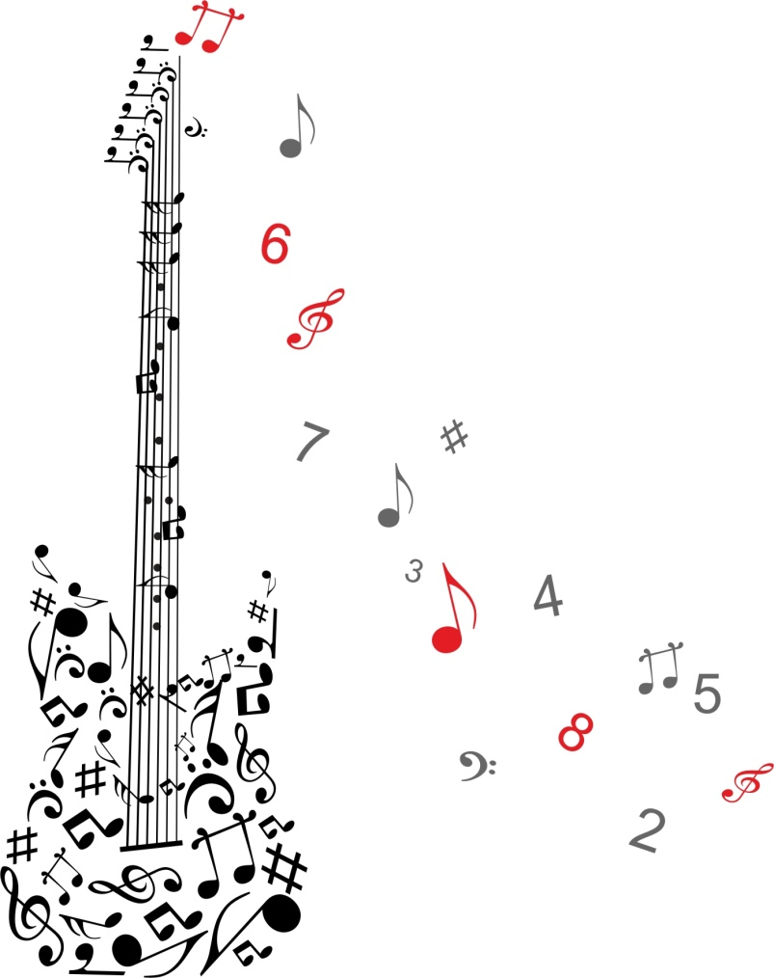

**THE MÖBIUS STRIP**

**DISCOVERING THE PROPERTIES OF THE MӦBIUS STRIP**

**ACTIVITY 1**

1. Take a piece of paper and make a ring out of it.
2. Join the two ends together.

Does this loop have an inside? Does it have an outside?

How many edges does it have?

1. Draw a line in the middle around the ring.

What is going to happen if we cut along the line? What shape do you think the paper will look like after you cut it?

1. Cut the ring along the line and confirm your predictions.

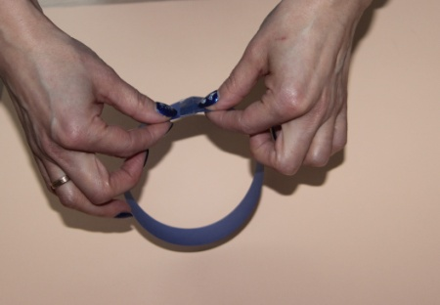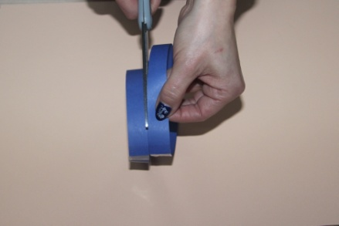

**ACTIVITY 2**

1. Take another strip and give it a half-twist.
2. Join the two ends together. The shape is called the Mӧbius strip.

Does it have an inside? Does it have an outside?

How many edges does it have?

1. Draw a line around the middle.

What is going to happen if we cut along the line? What shape do you think the paper will look like after you cut it?

1. Cut the loop along the line and confirm your predictions.

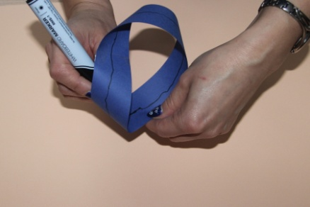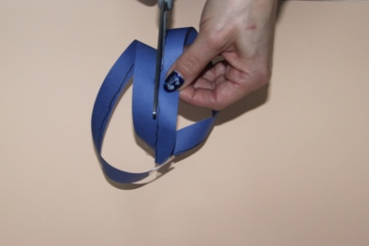

**ACTIVITY 3**

1. Make two Mӧbius strips. One has a clockwise twist in it and the other one has an anti-clockwise twist in it. It’s important that the twists go in the opposite direction.
2. Glue the two strips together at right angle.
3. Cut both loops lengthways down the middle.

What shape did you get?

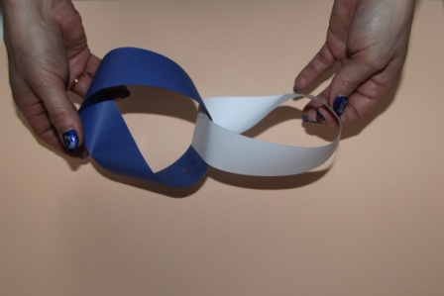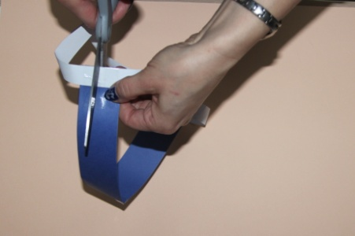

**ACTIVITY 4**

1. Make a Mӧbius strip but instead of making one twist, make two.
2. Cut the loop lengthways down in the middle.

What shape did you get?

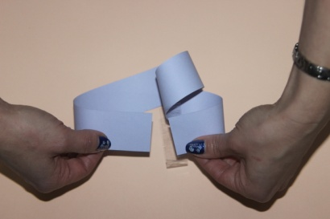

**ACTIVITY 5**

1. Make a Mӧbius strip but this time use a wider piece of paper.
2. Cut the loop lengthways around the edge (about a third of the way in from the edge)

What shape did you get?



Summing up, the Möbius strip has several curious properties. A line drawn starting from the seam down the middle meets back at the seam but at the other side. If continued the line meets the starting point, and is double the length of the original strip.

Cutting a Möbius strip along the center line with a pair of scissors yields one long strip with two full twists in it, rather than two separate strips; the result is not a Möbius strip. This happens because the original strip only has one edge that is twice as long as the original strip. Cutting creates a second independent edge, half of which was on each side of the scissors. Cutting this new, longer, strip down the middle creates two strips wound around each other, each with two full twists.

If the strip is cut along about a third of the way in from the edge, it creates two strips: One is a thinner Möbius strip – it is the center third of the original strip, comprising 1/3 of the width and the same length as the original strip. The other is a longer but thin strip with two full twists in it – this is a neighbourhood of the edge of the original strip, and it comprises 1/3 of the width and twice the length of the original strip.

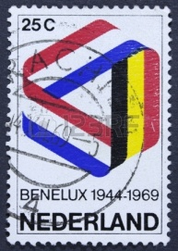**REAL LIFE APPLICATION, VARIATIONS OF THE MӦBIUS STRIP**

**THE MӦBIUS STRIP AND MUSIC**

J.S. Bach’s “Musical Offering” including the canon called "Quaerendo invenietis” is the musical version of the Mӧbius strip. It is made of two complementary, reversed musical lines. It was designed to be played forwards and backwards at the same time.

<http://www.youtube.com/watch?v=xUHQ2ybTejU>

# znak wodny.jpg

**MOZART’S MUSIC**

**FUNCTIONS AND PERMUTATIONS**

# MOZART’S PIANO SONATAS AND THE GOLDEN SECTION

The golden section is thought to offer the most aesthetically pleasing proportion. Such elegant proportions can be found in Mozart’s music, especially his piano sonatas. Sonata forms consist of two parts: the Exposition introducing the musical theme and the Development and Recapitulation in which the theme is developed and then presented again giving a straightforward image of the exposition.

Did Mozart divide his sonatas according to the golden ratio, with the exposition as the shorter segment and the development and recapitulation as the longer one?

|  |  |  |  |
| --- | --- | --- | --- |
| KV | Exposition  a | Development and Recapitulation  b | Total  a+b |
| 279 I | 38 | 62 | 100 |
| 279 II | 28 | 46 | 74 |
| 82 II | 39 | 63 | 102 |
| 283 II | 14 | 23 | 37 |
| 309 I | 58 | 97 | 155 |
| 311 I | 39 | 73 | 112 |
| 330 I | 58 | 92 | 150 |
| 333 I | 63 | 102 | 165 |
| 333 II | 31 | 50 | 81 |
| 533 II | 46 | 76 | 122 |
| 545 I | 28 | 45 | 73 |
| 547 I | 78 | 118 | 196 |

The above table shows the number of measures of the various parts of Mozart’s sonatas. Show the given data using a coordinate system. In the first diagram, each piece of music will be represented by the point with coordinates (a, b). In the second diagram, show the corresponding data for coordinates (b, a + b).

1. In both charts, try to draw straight lines passing through the greatest number of the given points.
2. Calculate the slope angles of the straight lines with the ox-axis and read the value of the tangent in mathematical tables.
3. Write the formula for the established linear function.
4. What does the value of the tangent of the given angle remind you of?

**Functions**

## Exercise 1

Make graphs of the following functions:

$\left\{\begin{aligned}\text{-2x+1} \text{if x < 1} \\ \text{-x} \text{if 1≤ x ≤4}\end{aligned}\right.$

$\left\{\begin{aligned}\text{x+1} \text{for x ≤ 0} \\ \text{2} \text{for x = 1} \\ \text{0} \text{for x = 2}\end{aligned}\right.$

## Exercise 2

Write down the right formula for the linear function, whose graph is parallel to the graph of a function y = $\frac{1}{5}$ x – 7 and goes through the point A = (15, - 3).

## Exercise 3

Write down the right formula for the linear function, whose graph is perpendicular to the graph of a function y = - $\frac{1}{3} x+2$ and goes through the point A= (-3, 1).

## Exercise 4

Which values of parameter m the function y = (2m + 4)x - 3 is:

1. increasing function,
2. decreasing function,
3. constant function.

## Exercise 5

Formulas y = $\frac{1}{3}$ x – 1 and y = $\frac{1}{3}$ x + 5 describe two straight lines. Give examples of two functions, whose graphs are parallel to those straight lines and lie between them.

## Exercise 6

Write down the formula for the linear function, whose graph cuts the OY axis in the point A=(0, - $\frac{1}{7}$) and number $\frac{1}{14}$ is the zero locus.

## Exercise 7

Draw the circle in coordinate system with the center in point S = (3, 0) and the radius r = 5, then its chord AB, where A = (-2, 0), B = (0, 4). Next, find the right formula for the function which has the graph with the line containing the diameter of the drawn circle, parallel to AB chord.

## Exercise 8

Lines y = a1x +3 and y= a2x + 7 cut in point (4, 1). Calculate the triangle’s area, which is bounded with those lines and the OY axis.

## Exercise 9

Calculate the triangle’s area bounded with axes of coordinate system and the line y = - $\frac{1}{2}$ x -6.

## Exercise 10

Prove that point (0, 0) is the only one in both rational coordinates which belong to the graph of the function y = $\sqrt{2}$ x.

## Exercise 11

Solve graphically inequalities composition:

$$\left\{\begin{aligned}\text{x + y > 3} \\ \text{4x - 2y > 6}\end{aligned}\right.$$

# MOZART’S MUSICAL DICE GAME

Wolfgang Amadeus Mozart was known for his sense of humour. One of the examples would be his work "Musical dice game", which was published after the author's death. Mozart’s dice game is a method for generating sixteen-measure-long minuets. There are 176 bars grouped on two boards. The bars are arranged in 11 rows and 8 columns. Playing a 16-bars piece of music takes about half a minute. For each measure, two six-sided dice are rolled, and the sum of the dice used to look up a measure number in one of two tables (one for each half of the minuet). The measure number then locates a single measure from a collection of musical fragments. The fragments are linked together, and “music” results.

a) How many different minuets can be generated using Mozart’s rule?

b) How long would it take to play them all?

## Exercise 1

The melody that consists of four different notes has been written on a stave. Draw a stave and write the same four notes in any other order. How many different melodies can thus be written?

We say that we have generated the **permutation** of the elements of a certain set, when we arrange all the elements of this finite set in a certain order.

Here are given all the possible permutations of a three element set



When we generate a permutation of an n-element set, the first element can be selected in the n - ways, the second in n-1 ways, the third in n-2 ways etc., thus, the number of all such permutations is:

$$n∙\left(n-1\right)∙…. ∙2∙1$$

The number of permutations of an n-element set is n!

## Exercise 2

Write down a few permutations from the letters in the word "MONDAY". How many different permutations can be made?

Note: Decide on, in how many different ways you can select the first letter, the second letter etc.

## Exercise 3

In how many different ways can ten weekly magazines be arranged by a shop assistant?

## Exercise 4

How many six-digit even numbers can be made using the digits: 0, 1, 2, 3, 4, 5 if each digit is used only once?

## Exercise 5

Out of the notes that have been written on a stave take any three and write them consecutively on a stave. Think of how many different melodies can thus be created? The notes cannot be repeated.

When we take k different elements from a set and put them in a certain order, we say, that we have obtained k-combinations without repetition of the given set.

These are all 2-element combinations without repetition of the set



## Exercise 6

Write down a few 4-element combinations without repetition from the letters in the word „MONDAY”. How many different combinations can be made?

Tip: The first letter can be selected in 6 ways, the second in 5 ways, the third in 4 ways etc.

When we generate a k-element combination without repetition of an n-element set, the first element can be selected in the n - ways, the second in n-1 ways, the third in n-2 ways etc. The last k-th element can be selected in n – k + 1 ways. Thus, the number of all such combinations is:

n·(n-1)·(n-2)·…·(n-k+1)

k elements

The same number can be written in a different way:

$$\frac{n!}{\left(n-k\right)!}$$

## Exercise 7

Justify the equation:

$$\frac{n!}{\left(n-k\right)! }=n∙\left(n-1\right)∙\left(n-2\right)∙…∙\left(n-k+1\right)$$

## Exercise 8

Write fractions in their simplest form.

a) $\frac{14!}{13∙14}$ = b) $\frac{(n+1)!}{n!}$ = c) $\frac{(n-3)!}{(n-4)!}$ =

## Exercise 9

In how many ways can three student-government members (chair, secretary and treasurer) be elected from 25 candidates?

## Exercise 10

A, B, C need to be coloured, so that no two adjacent areas have the same colour. In how many ways can you colour each of them if we use: a) three colours b) four colours?

….........................................................................................................

## 

## Exercise 11

Let’s say that, on the stave, you are writing three note melody, selected out of eight different notes, the notes can be repeated. How many different melodies can thus be written?

When we generate a k-element sequence consisting of the elements of a certain set (the terms of the sequence can be repeated), we say that we have created k-element combination with repetition of the elements of this set.

These are all 3-elements combinations with repetition of a set



## Exercise 12

Write down a few 4-element combinations with repetition from the letters in the word „MONDAY”. How many different combinations can be made?

Tip: The first, second and any other letter can be selected in 6 ways.

When we generate a k-term sequence of an n-element set and allow for the repetition of the terms, the first element can be selected in the n - ways, the second in n ways and any other also in n ways.

*n ∙n ∙… ∙n*

*k elements*

The number of all such sequences is:

The number of all k-element combination with repetition of an n‑element is nk.

## 

## Exercise 13

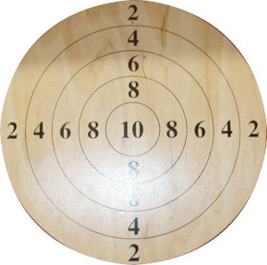How many different outcomes are there if you shoot three times at the target consisting of five concentric circles, to which the following points were assigned: 2, 4, 6, 8, 10?

## 

## Exercise 14

How many two-digit numbers can be formed if we randomly select with replacement two numbers from the set {1, 2, 3, 4}?

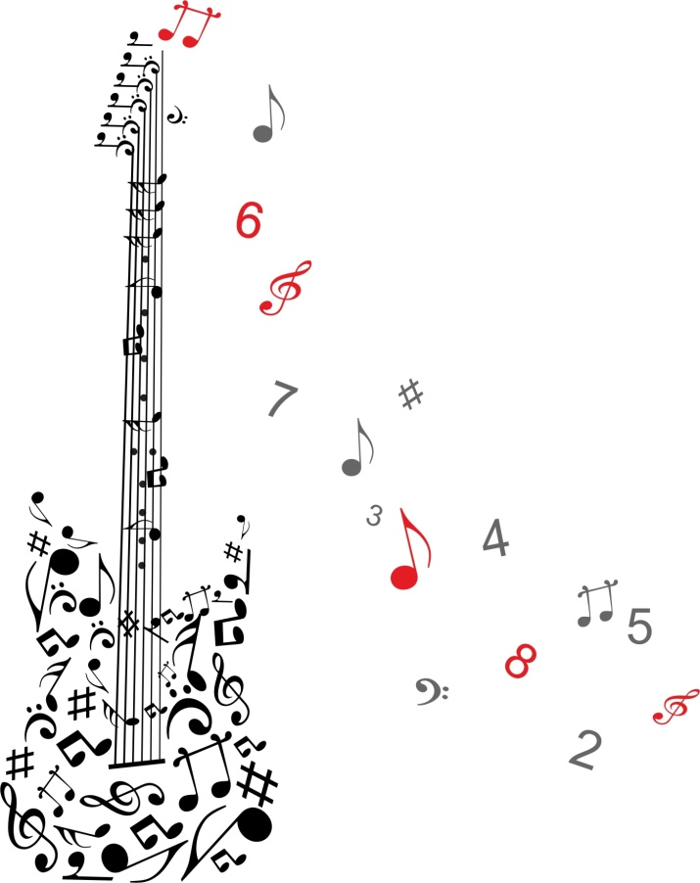

**THE OCTAVE**

**AND THE DESIGN OF INSTRUMENTS**

# THE OCTAVE AND THE DESIGN OF INSTRUMENTS

There are some connections between music and math on the example of the Fibonacci sequence and golden ratio. We are going to make students realize that in the octave the foundational unit of melody, and harmony, we see Fibonacci numbers popping up everywhere. The golden ratio can be found throughout the violin by dividing lengths of specific parts of the violin. What is more, the vibrations per second of different musical intervals are in Fibonacci ratios and some music pieces e.g. Music for Strings, Percussion and Celesta divided into sections reflecting the golden ratio.

## Exercise 1

This is the layout of musical keyboard. Musical keyboard is divided into octaves.

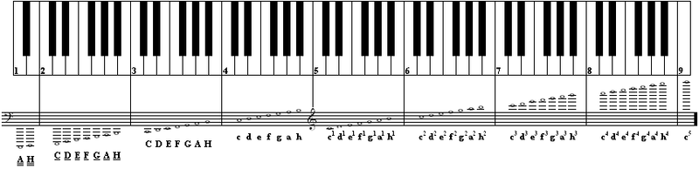

An octave interval is, for example, from the C on the left to the C on the right of the keyboard.

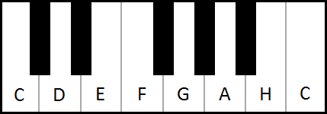

How many white keys in an octave can you see? ………………….

How many black keys can you see? ………………….

What is the proportion between white keys and black ones? ……………….…

How many keys are there all together? …………………..

What’s the proportion of all keys to the white ones? ….…………….…

What have you noticed? Is it a golden number? ….……………….

## 

## Exercise 2

This exercise presents a violin divided into different parts.

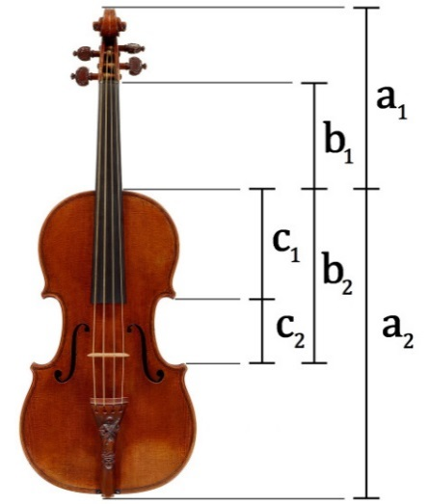

Divide the lengths of specific parts of the violin as you can see below.

(a1 + a2)/a2 =

a2/a1 =

b2/b1 =

b2/c1 =

c1/c2 =

What have you noticed? ……….….……….

Are the results a golden number? ……….….……….

## 

## Exercise 3

There are three stringed instruments in the class (2 violins and a cello). Measure the lengths of them in the same way as it was in the previous exercise and complete the chart.

|  |  |  |
| --- | --- | --- |
| **Violin A** | **Violin B** | **Cello** |
| **(a1 + a2)/a2 =**  **a2/a1 =**  **b2/b1 =**  **b2/c1 =**  **c1/c2 =** | **(a1 + a2)/a2 =**  **a2/a1 =**  **b2/b1 =**  **b2/c1 =**  **c1/c2 =** | **(a1 + a2)/a2 =**  **a2/a1 =**  **b2/b1 =**  **b2/c1 =**  **c1/c2 =** |

# znak wodny.jpg

# SYMMETRY IN MUSIC,

# SYMMETRY IN MATH

# SYMMETRY

Symmetry is not restricted to visual arts. We find symmetry in musical compositions of different epochs in rhythm, harmony, dynamics, song forms, tempo, recording or sound patterns. Music features all sorts of patterns. Melodies are groups of notes arranged to make up a tune, rhythm describes the repeating pattern of strong and weak beats, musical pieces often have repeating choruses or bars. In mathematics, we look for patterns to explain and predict the unknown. Music uses similar strategies. When looking at a musical piece, musicians look for notes they recognize to find notes that are less familiar. In this way, notes relate to each other.

When you hear Mozart, you hear the language of symmetry. He repeats the same patterns again and again. The music goes up and down and then up and down again. Sometimes he changes one note or moves it half a note up or down not to make the music boring. In music it is called transposition in math it is called a symmetry under translation which means you move from place to place you see the same thing.

The sound can be heard and seen in the form of musical notes. If you want to see something more, build the Chladni plate. Ernst Chladni found that powders sprinkled on a vibrating plate would settle in patterns that showed how the plate was vibrating. A plate will have a set of natural resonance frequencies just like a string, and when the plate is excited at one of these frequencies, it will form a standing wave with fixed nodes. These nodes will form lines on the plate, in contrast to points on the string. Chladni realized that sand sprinkled on the top of the plate would be pushed away from the vibrating regions and settle into these nodes, allowing the node patterns to be seen. The patterns that result are beautiful, and increasingly complicated as the frequency is increased.

**Exercise 1**

The area of ABC equilateral triangle is 6. It is transformed in symmetry in terms of straights including its sides. The triangle A’B’C’ is obtained. What is the area of the triangle?

**Exercise 2**

For which initial values of a and b, point A’ = (a - 1, 2) is reflection of point A= (-3, b + 2) in:

1. the line OX
2. the line OY
3. the origin of coordinates.

**Exercise 3**

Specify the coordinate system points P= (3, 2), R= (0, 2), S= (3, 0) and O= (6, 4). Establish the coordinates of the symmetrical points to point O in:

1. points P, R, S
2. straights PR, PS.

**Exercise 4**

Construct the image of o (O, r) circle in point symmetry with respect to S point, where |SO| < r. Is it possible that the circle and its image are tangential? Justify your opinion.

**Exercise 5**

Draw any obtuse angle and the point which is inside that angle. Construct an angle which is symmetrical to it in a selected point. What figure is the common part of both angles?

**Exercise 6**

For what numbers a and b points:

1. A = (a+3, b-2) and A’= (2a- 5, 2b+4)
2. A = (2 (a+2), 4b-3) and A’= (3a+7, 2(b-1)-a)

are symmetrical in the origin of coordinates?

**Exercise 7**

Points (2, 3), (-2, 3), (-4, 0) are sequential summits of hexagon, which is symmetrical in relation to the center of coordinates. Find coordinates of the remaining summits of this hexagon and calculate its area.

**Exercise 8**

Assign the equation of symmetrical circle in the line OX and symmetrical circle in the line OY to the circle of equation

x2 + 4x +y2 – 2y – 11 = 0.

**Exercises 9**

The coordinates of summits of C square are: (0, 0), (4, 0), (4, 4) and (0, 4). D square is the image of C square in symmetry in terms of y = x + 2 straight. Calculate an area of common part of both squares.

# znak wodny.jpg

# TRANSPOSITION AND TRANSLATION

# TRANSPOSITION AND TRANSLATION

**Musical transposition** is a type of repetition where the starting point (or pitch) of a chord or melody is restated at a different level than the original segment. This restatement may be higher or lower and may occur as many times at different levels as a composer thinks is appropriate.

Because transposition is a restatement, intervals of pitch relationships need to be preserved from the original segment to all subsequent segments.

The keyboard consists of a series of white and black keys, which make up what we call steps.

**Half step (H)** occurs - two keys directly adjacent to each other (with no other pitches in between)

**A whole step (W)** - moving the combined space of two half steps

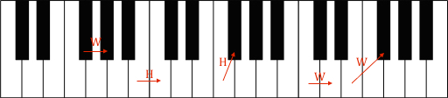

## Exercise 1

Look at the piano keyboard or a stave and find steps (H or W) between sounds.



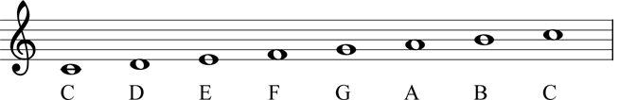

C to D = **Whole Step**

C to E = **2 whole steps**

D to E = **Whole Step**

E to F = **Half Step**

F to G = ? .............

G to A=? .............

A to B =? .............

## Exercise 2

Look at the melody *Twinkle Twinkle Little Star*. How many steps are there between sounds? Circle the right answer.

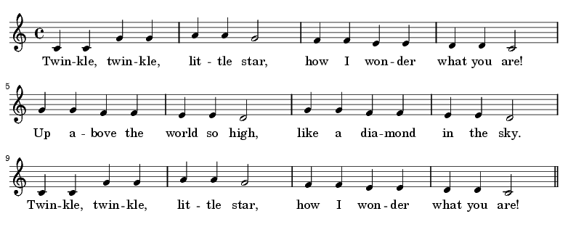

|  |  |  |  |  |
| --- | --- | --- | --- | --- |
| C to C | 0 | W | H | 5 |
| C to G | 0 | W | H | 5 |
| G to G | 0 | W | H | 5 |
| G to A | 0 | W | H | 5 |
| A to A | 0 | W | H | 5 |
| A to G | 0 | W | H | 5 |
| G to F | 0 | W | H | 5 |
| F to F | 0 | W | H | 5 |
| F to E | 0 | W | H | 5 |
| E to E | 0 | W | H | 5 |
| E to D | 0 | W | H | 5 |
| D to D | 0 | W | H | 5 |
| D to C | 0 | W | H | 5 |

## Exercise 3

Make the transposition of *Twinkle Twinkle Little Star. Let’s start the melody* not from **C** but from **G**.

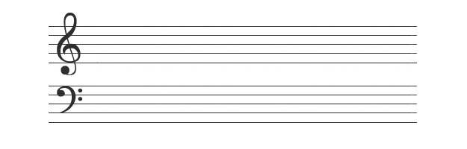

# TRANSLATION

A vector is an organized pair of two points.

**Vector is frequently represented by a line segment with a definite direction, or graphically as an arrow, connecting an *initial point A*with a *terminal point B*, and denoted by $\vec{AB}$.**

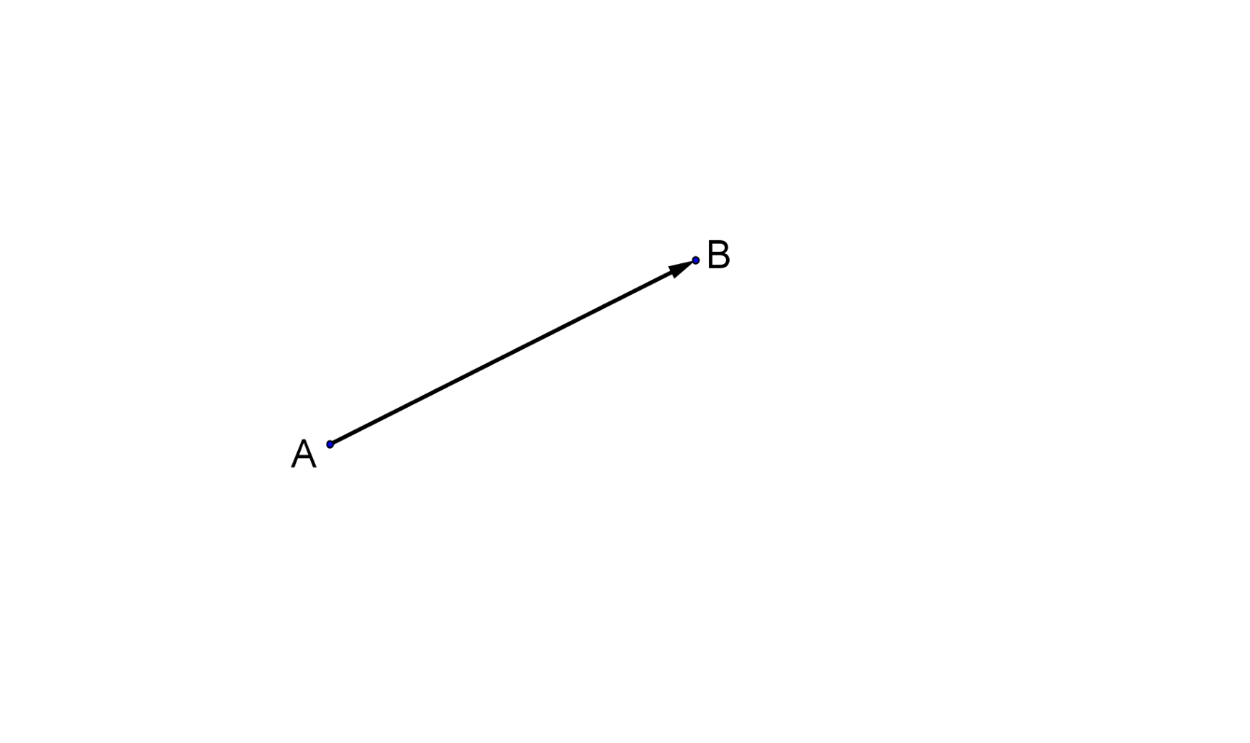

We have two points in coordinate system: $A=(x_{1},y_{1})$

and $B=(x_{2},y_{2})$.

**A vector is an organized pair of numbers $\left[x_{2}-x_{1},y_{2}-y_{1}\right]$.**

Graphically vector is presented by an arrow $\vec{AB}$.

Numbers $x_{2}-x_{1}, y_{2}-y_{1}$ are coordinates of the vector.

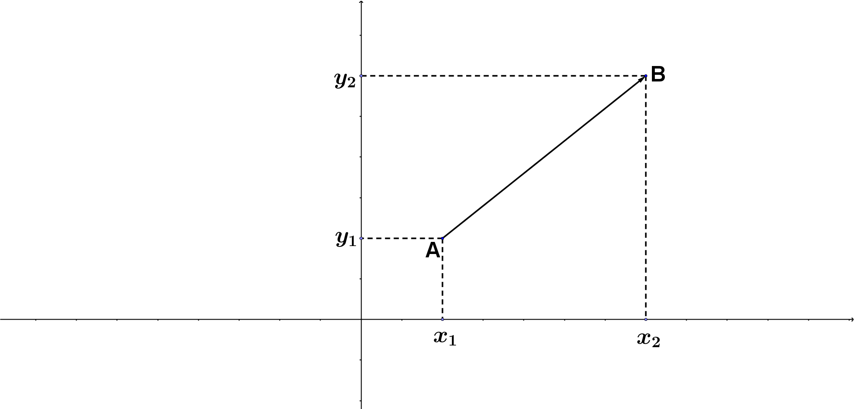

## Exercise 1

Using GeoGebra software create any polygon and a vector. Slide the image of that polygon parallel to vector you have chosen.

Step 1: Create polygon



Step 2: Create a vector



Step 3: Select the translate tool, then select the object to be translated, the polygon, and then select the vector of translation.



Here is the example of a triangle ABC translated by vector $\vec{DE}$.

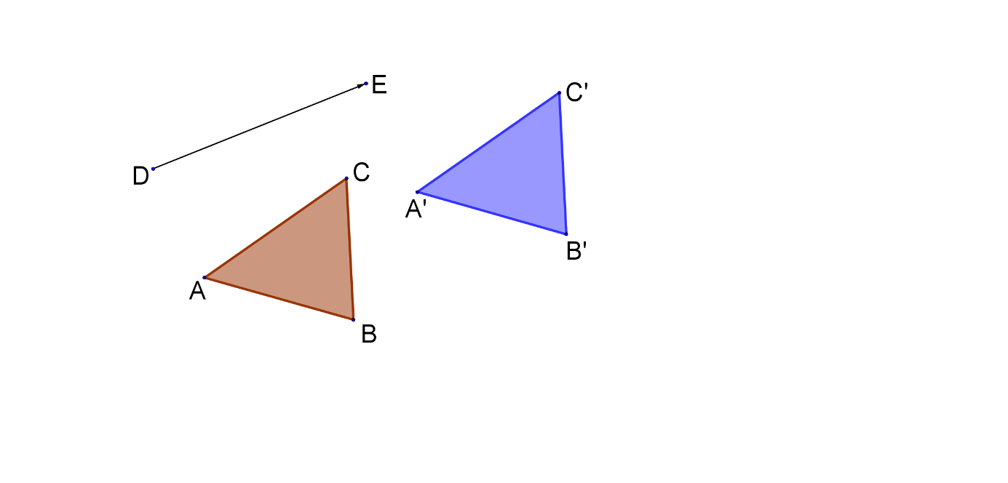

What are the properties of figures you have created in the process of translation?

**Translation by $\vec{u}$ vector is a transformation where each A point has an assigned point $A'$, where $\vec{AA'}=\vec{u}$.**

Translation of $\vec{u}$ stands for $T_{\vec{u}}$.

## Exercise 2

There is an ABC triangle and $\vec{u}$ vector, which does not have any points with a triangle. Design the drawing of that triangle and shift it by a given vector.

**Step 1**

Draw any ABC triangle and $\vec{u}$ vector, which does not have any common points with a triangle.

**Step 2**

Draw a half line with initial point A and a perpendicular line included $\vec{u}$ vector .

**Step 3**

Measure the length of $\vec{u}$ vector. Draw a circle. Point A is in the middle of the circle. The radius of a circle has to be the length of $\vec{u}$ vector.

**Step 4**

Mark the $A'$ point where the circle and a half line crisscross.

**Step 5**

Repeat steps from 2 – 4 for other vertex.

**Step 6**

Connect vertices $A^{'}, B^{'}, C'$. You will receive an $A'B'C'$ triangle which is a reflection of an $ABC$ triangle translated by an $\vec{u}$ vector.

In the rectangular coordinate system mark any $A=(x, y)$ point and an $\vec{u}=[p, q]$ vector. $A^{'}=(x^{'}, y^{'})$ has to be an image of A point translated by $\vec{u}$ vector.

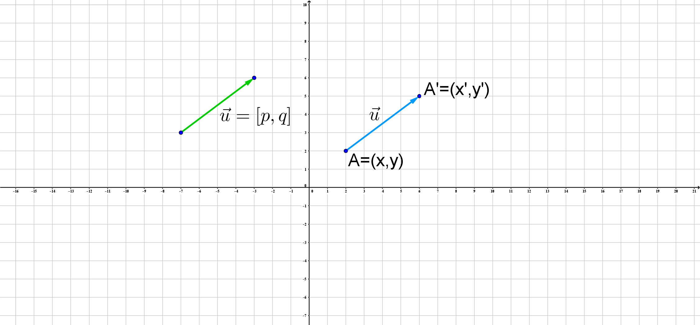

Look at the relationship between coordinates of $\vec{u}$ vector and coordinates of $A i A'$ points. Knowing that $\vec{AA'}=\vec{u}$ and

$$\left[x^{'}-x, y^{'}-y\right]=[p, q]$$

we get

$$x^{'}-x=p ∧ y^{'}-y=q$$

$$x^{'}=x+p ∧ y^{'}=y+q$$

**In the rectangular coordinate system an image of point $A=(x, y)$ is point $A^{'}=(x+p, y+q)$ translated by an $\vec{u}=[p, q]$ vector parallel to $A^{'}$.**

## Exercise 3

Find the picture of an $ABCD$ square where

$A=\left(1, 1\right), B=\left(2, 3\right), C=\left(4, 2\right), D=(3, 0)$. They are translated by vector $\vec{u}=\left[1, 5\right]$.

## Exercise 4

A picture of $P=(7, -3)$ is $P^{'}=(-3, 7)$ translated by an $\vec{u}$ vector. Find the coordinates of that vector.

## Exercise 5

Find the coordinates of vertices of an ABC triangle where

$A\left(-4, 1\right), B=\left(3, -2\right), C=(-2, 4)$ are translated by a vector $\vec{u}=[-1, 3]$.

Analyze a translation parallel to the graph of the function $y=f(x)$ by vector $\vec{u}=[p, q]$.

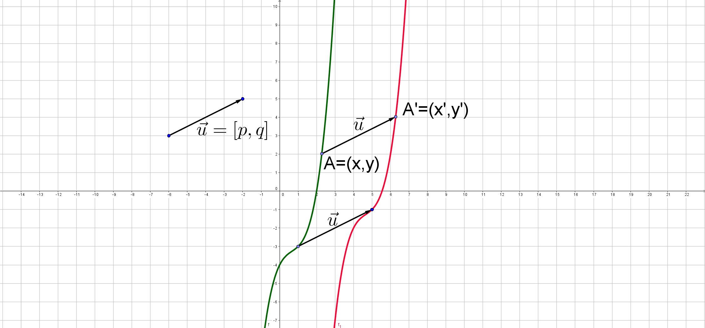

Point $A=(x,y)$ can be any point of the graph of the function $y=f(x)$. Shift parallel the graph of the function $y=f(x)$ by vector $\vec{u}=[p, q]$. $A^{'}=(x^{'},y^{'})$ is the image of that transformation.

The relationship between coordinates $A, A'$ and $\vec{u}$ vector are the following

$$x^{'}=x+p ∧ y^{'}=y+q$$

so

$$x=x^{'}-p ∧ y=y^{'}-q$$

When we substitute x and y to the graph of the function $y=f(x)$ we will receive

$$y^{'}-q=f(x^{'}-p)$$

so

$$y^{'}=f\left(x^{'}-p\right)+q$$

We get the graph of the function consisting of points which are the images of $y=f(x)$ translated parallel to $\vec{u}=[p, q]$.

The graph of the function can be written $y=f\left(x-p\right)+q$ (in order to place both graphs of the function in the same coordinate system)

**As a result of the translation of the graph of the function**

$y=f(x)$**by vector $\vec{u}=[p, q]$ we get the graph of the function $y=f\left(x-p\right)+q$**

## Exercise 6

In order to receive the graph of the function f give the coordinates of $\vec{u}$ vector and move the graph of the function.

$g\left(x\right)=f\left(x-1\right)$

$g\left(x\right)=f\left(x\right)-4$

$g\left(x\right)=f\left(x+2\right)+4$

$g\left(x\right)=f\left(x-10\right)-3$

## Exercise 7

Find an image of curved line $y=-x^{2}+x-1$ translated by $\vec{u}=[-2, 1]$ vector.

## Exercise 8

Find an equation of the curved line $y=x^{2}+1$ translated by $\vec{u}=[1, -1]$ vector.

## Exercise 9

Move parallel the graph of the function f by $\vec{u}$ vector and then write the formula of the function g you get:



$f\left(x\right)=2x-4$ $\vec{u}=[-4,0]$

$f\left(x\right)=3\left|x\right|$ $\vec{u}=[3,-8]$

$f\left(x\right)=2\sqrt{x}$ $\vec{u}=[-1,2]$

$f\left(x\right)=\frac{3}{x}$ $\vec{u}=[-3,0]$

$f\left(x\right)=x^{2}$ $\vec{u}=[0,7]$

## Exercise 10

Find the coordinates of a $\vec{u}$ vector that is needed to move the graph of the function f to get the graph of the function g



$g\left(x\right)=2\left(x-1\right)+4$

$g\left(x\right)={\left(x+3\right)}^{2}-2$

$g\left(x\right)=2{\left(x+1\right)}^{3}$

$g\left(x\right)=4\sqrt{x}-3$

$g\left(x\right)=\frac{2}{x-1}+1$

# CLASSICAL CONCERT

# AT ARTUR MALAWSKI PHILHARMONIC

# IN RZESZÓW

**Jean Sibelius, Symphonic Poem *Finlandia* op. 26**

*Finlandia* was composed in 1899, and was first played in February of that year in Helsinki. Sibelius composed his third symphony between 1904 and 1907. Sibelius himself conducted the premiere in Helsinki on September 26, 1907. No work of Sibelius is more immediately recognizable than *Finlandia,* tone-poem that has become the anthem of his homeland.

**Context:**

For centuries, Finland was dominated by other nations. From the Middle Ages through the18th century most of modern-day Finland was a province of Sweden, and for nearly a century it was a battleground in the struggle between Sweden and Russia. Throughout the 19th century, Finland was ruled by Russia, and by the 1890s, Russian control was becoming increasingly heavy-handed: the authorities were increasingly insisting on use of the Russian language in all official business, and Finnish culture was actively suppressed. Even when political activism was unsafe, Finns found sources of national pride in their literature and music, and Sibelius was among the most lionized figures in his homeland. In the wake of the Russian Revolution in 1917, Finland finally declared its independence, and after a bloody civil war, became a presidential republic in 1920.

**Antonin Dvořák, Symphony 9 E minor op. 95 „From the New World”**

Popularly known as the *New World Symphony*, was composed in 1893 while Dvořák was the director of the National Conservatory of Music of America from 1892 to 1895. He was sending "notes" back to his friends and family in Czechoslovakia from the New World, America. It is by far his most popular symphony and one of the most popular of all symphonies. Neil Armstrong took a recording of the *New World Symphony* to the Moon during the Apollo 11 mission, the first Moon landing, in 1969. Several themes from the symphony have been used widely in films, TV shows, anime, video games, and advertisements.

**Context:**

Dvořák was interested in the Native American music and African-American spirituals he heard in America. That African-American spirituals were a major influence on the ninth symphony. Upon his arrival in America, the composer stated: "I am convinced that the future music of this country must be founded on what are called Negro melodies. These can be the foundation of a serious and original school of composition, to be developed in the United States. These beautiful and varied themes are the product of the soil. They are the folk songs of America and your composers must turn to them."

# ACKNOWLEDGEMENTS

BEATA GRODECKA, School Headmistress, warmly thanks all who have contributed to realize and develop the Erasmus+ project MATH AROUND US in the phase that sees Zespół Szkół w Głogowie Małopolskim involved as hosting partner:

PAWEŁ BAJ, Mayor of Głogów Małopolski

JERZY KOMANIECKI, Vice Mayor of Głogów Małopolski

ANDRZEJ SUSZEK, Headmaster of Głogów Małopolski School of Music

AGNIESZKA GRZESIK, Deputy Headmistress of Głogów Małopolski School of Music

DARIUSZ LEWANDOWSKI-SOCHA, Director of MGDK in Głogów Małopolski

MARTA WIERZBIENIEC, Director of Artur Malawski Philharmonic in Rzeszów

EDYTA ŚLIWA, choreographer of the Folk Group of Song and Dance "Hanka"

STANISŁAW NOGAJ, the luthier of a hurdy-gurdy

Dr BOŻENA MAJ-TATSIS, University of Rzeszów, workshop “A creative approach to mathematical problem solving”

Prof. EWA SWOBODA, University of Rzeszów, workshop “A creative approach to mathematical problem solving”

Dr MARZENA LUBOWIECKA, University of Rzeszów, workshop “The rhythm of music”

Dr KONSTANTINOS TATSIS, University of Ioannina, workshops “Mathematical problem solving” and “Mathematics in the real world”

Dr ANTONI STRZELCZYK, workshop “The concept of time and space in a musical composition in reflection to Newton’s and Leibniz’s theory of time”

Dr BRONISŁAW PABICH, workshop “Math and Music”

REFERENCES:

[www.fwphil.org](http://www.fwphil.org)

www.matematyka.wroc.pl

www.freepik.com

"Zbiór zadań z rachunku prawdopodobieństwa" M. Chrapek, M. Czajkowska

"Matematyka 1 podręcznik dla szkół ponadgimnazjalnych" H. Ruszczyk

Notes

Notes

Notes